Streamlining Western’s Solid Waste

Jordan De Lanoy, Alexandra Larson Freeman, and River Starr
Project Sponsor: Amanda Cambre, WWU Campus Utility Manager
ENVS/UEPP 471 Fall 2022
December 8, 2022

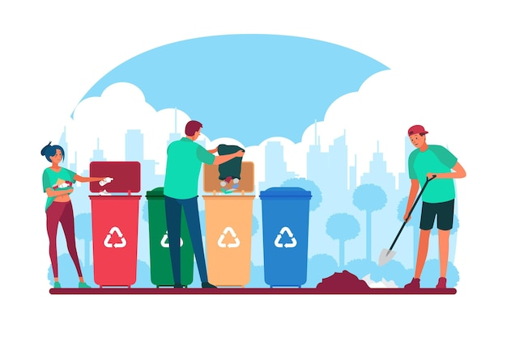
(Rawpixel, n.d.)

Table of Contents
Executive Summary 3
Introduction 3
Methodology 5
Results 7
Recommendations 11
Monitoring and Evaluation 12
Budget 13
Conclusion 14
Appendix 14
References and Citations 23

Executive Summary
Problem Statement
Western is paying a surplus of avoidable fees regarding solid waste disposal. The largest contributing factor to this is the lack of quantifiable data about Western’s waste stream. This includes limited cohesive mapping of waste disposal locations and excess contamination of specialized disposal vessels. The deficit of knowledge pertaining to Western’s waste stream has created difficulty in administrative communication, making it very difficult to address these issues on a campus-wide scale. Comprehensive data is necessary to inform future actions pertaining to Western’s waste stream.

Project Description
Western currently manages multiple waste streams including recyclable, organic compost and traditional landfill bound materials. The ability of Western to reduce and recover material from our waste streams benefits the environment and reduces Western’s costs. Currently, the WWU Associated Students Recycle Center collects and processes recyclable and organic materials. Western Facility Management’s custodial teams collect the landfill waste materials during their regular rounds as well as transfer recycling materials to the Recycling Center. Sanitary Services Company (SSC) provides the solid waste service contract that serves our landfill bound materials and offers transport services for our organic materials delivery to Green Earth Technologies in Lynden, WA. SSC also delivers sorted recyclables from the AS Recycle Center to Northwest Recycling in Bellingham, WA. There are opportunities to divert more organic materials, reduce dumpster sizes and consolidate collection operations among these various solid waste streams. This project will help to identify opportunities across the waste streams so that Western is able to best manage our waste in a coordinated and thoughtful way.

Recommendations Summary
Recommendations for the continuation of this project prioritize completion of the geo-reference map and Excel inventory. It is highly suggested that a student with GIS skills and training be involved in order to make a fully comprehensive and interactive map using the ArcGIS program. With a GIS specialist on the team, it will be much easier and faster to collect and input data into a map that is easily accessible to students and staff. Future groups should also examine additional variables in the waste stream, such as waste station max capacity and how this relates to costs of disposal. It is also recommended that future groups explore the possibility of creating a full- or part-time staff position to monitor Western’s waste. This will likely be best done in coordination with the group examining the implementation of a campus anaerobic digester. Finally, on-campus student living and residential services should revisit the educational content provided to freshman and first-year students who live in the dorms. This program was in place before the COVID-19 pandemic but has been discontinued since on-campus activities resumed in the Fall of 2021. Staff has reported a noticeable increase in improper waste disposal habits amongst students, especially those who live on campus, ever since the program was suspended.

Introduction
Statement of Need
Western is currently facing logistical and financial challenges with its solid waste collection system. The university is being fined for contamination in composted materials and could see significant financial benefits by addressing this issue. While there is some documentation on campus waste collection sites, university custodial and groundskeeping staff would benefit greatly from an updateable database of these sites, allowing them to track how much waste is being collected and from where. Multiple departments are responsible for the collection of waste and providing recommendations for policies that would be agreeable to all parties is essential.

Project Goals
The goals of this project are to quantify the waste streams of campus to provide actionable data for consolidating waste management operations, reduce materials entering landfills, and divert unnecessary costs from the university’s contract with the SSC to other sustainability initiatives. These goals follow two objectives from Western’s Sustainability Action Plan:
- Objective 1.4: Divert waste from the landfill by providing opportunities for campus to recycle and compost effectively and efficiently by 2025 (WWU Office of Sustainability, 2017, p. 77).
- Objective 2.7: Initiate systematic waste data-collection beginning winter 2019.
  - Strategy 2.7.3: Collaborate with all waste stakeholders on campus to determine best practices for data collection, verification, and analysis for improvements (WWU Office of Sustainability, 2017, p. 80).

This project builds on its previous iteration by presenting an inventory of disposal sites found in and around Red Square with a geo-referenced map and an easily repeatable methodology for future students and stakeholders.

Background Research
This project mainly builds on the work of the “Streamlining Western’s Solid Waste” report produced in Spring of 2022. This iteration continues the previous inventory and mapping of waste disposal stations across South Campus. The Spring 2022 report emphasized the need for optimizing cross-departmental communication regarding waste disposal on campus, as well as the benefits of creating a student position to coordinate campus waste management.
An analysis of other universities with a similar streamlined waste disposal program was helpful in informing possible solutions. Students at the University of British Columbia (UBC) researched the locations of frequented waste stations through mixed-mode surveys and GIS analysis to determine how the placement of the waste stations could affect their waste diversion and recycling rates (Luo, et al., 2015). Students wanted to determine how effective the existing waste stations were and where the optimal locations would be for additional recycling bins, by asking students and faculty about their habits, where they frequently went on campus, and their recommendations for new recycling bins (Lou, et al., 2015). UBC was able to combine data on current waste locations, which Western is lacking, and provide new information on high-density areas, which is useful for evaluating if their current waste stations are easily accessible. Having accessible and easy-to-spot recycling bins is critical for Western to achieve its zero waste goals.
The University of Texas at Austin created a waste streamlining program focused on education and access to recycling (Zero Waste Hierarchy, n.d.). The project encourages students to use reusable or compostable products such as water bottles and plates through infographics and increases access to recycling bins around campus. There are also infographics explaining and showing the importance of properly cleaning recyclables so they don’t end up in a landfill due to contamination. The campus instituted a new recycling program which doesn’t require students to separate their recyclables into glass, metal, paper, cardboard, etc. Instead, students have access to receptacles that accept all types, ensuring all materials make it to recycling centers and students don’t resort to trash cans when the correct container isn’t available. The educational resources also provide information on how to increase recycling and compost opportunities at home and in the workplace. This program introduces signage and educational content that is currently lacking on Western’s campus. Having this extra information is essential for Western to maintain a sustainable waste stream.

Methodology
Data Collection and Organization
The first deliverable for this project is a geo-reference map of all waste stations on campus. The inventory collected information on the waste station location based on building name, building type, latitude, longitude, floor, nearest room number, inside or outside, size, waste type, and number of receptacles, as well as the amount of time it took to inventory each building. This information was used to formulate names for the waste station as described in Figure 1.
Building on the work of Spring 2022 which focused on South Campus, the focus for this specific project is the Viking Union and Red Square, including Miller Hall, Bond Hall, Fraser Hall, Haggard Hall, the Humanities Building, and Wilson Library (see Appendix A). This project does not track waste stations in bathrooms, health centers, individual classrooms, private offices, or dorms.
The process of collecting inventory was quite simple. Using floor plan blueprints downloaded from Western’s Capital Planning and Development website, location and type of waste station was easily recorded directly onto the images. This was done using color coded marking with black markings representing landfill stations, green markings representing compost stations, light blue markings representing general recycling stations, dark blue markings representing paper only recycling, purple markings representing stations that included landfill, compost, recycle, and paper recycle in a singular unit, and orange markings representing Big Belly waste stations. This information was then converted to an Excel inventory spreadsheet (see Appendix C) as a data record using the variables described in Figure 1.

Figure 1
Variable Categories and Details to be Tracked by Collectors
Category | Details
Date | Date recorded
Building Name | What is the name of the WWU facility the waste station is in or near?
Building Type | What is the use of the building? (housing, academic, recreation, dining)
Inside or Outside | Is the waste station in or outside of a building?
Closest Room # | What room is it located in or near based on the building's floor plan? *
Floor # | What floor is the waste station located on? (1, 2, etc., basement, bins outside are considered on the “ground” floor)
# of Receptacles | How many bins or bin configurations are there?
Size Type | What type of bin or bin configuration is this? (Big Belly, dumpster, half dumpster, individual, multiple) (See Appendix B)
Waste Type | What waste types are being collected? (Landfill, paper, plastic, cardboard, compost, other (specify))
Bin Name | Naming conventions simplify the process of identifying waste station location, receptacle type, and waste type.  Building/area - inside/outside - floor # - # of receptacles - waste type  - For # of receptacles, record the total number of individual receptacles  - If there are multiple of the same types, have the number prefix the waste type.  - For waste type:  - R = Recycle  - R = General recycle  - Rpa = Paper recycle only  - C = Compost  - L = Landfill  - D = Dumpster  - O = other (specify)  - Examples:  - RS-OuG-3-RLC  - Red Square-Outside Ground-3 receptacles-Recycle Landfill Compost  - MH-In2-4-RRpa2L  - Miller Hall-Indoor Floor 2-4 receptacles-General Recycle Paper Recycle 2 Landfill
Time spent | How long did it take to survey the building?
*Floor plans for each building can be found on WWU’s Capital Planning and Development website.

Interviews and Billing Inventory
Interviews were conducted to inform additional information regarding the geo-reference map. This involved in-person and email conversations and facility tours with campus groundskeepers, custodial staff, facility and maintenance managers, Recycling Center staff, and resident life coordinators. Questions for these stakeholders focused on methods and noticeable trends regarding waste disposal across campus, training and procedures for staff involved in waste collection, educational information provided to students and faculty, and the individual concerns, interests, and recommendations of all interviewees. Specific billing information was gathered through analysis of SSC monthly billing receipts from September 2021 through September 2022.

Results
Waste Inventory
The waste inventory counted a total of 236 waste station in the Red Square section of campus. These are separated into landfill, mixed recycle (glass, plastic, and paper), mixed paper recycle, “4-in-1” (landfill, mixed recycle, paper recycle, and compost), Big Belly, dumpster, and other. The majority of waste receptacles are landfill, followed closely by each type of recycling (see Appendix D).
There are 70 singular landfill receptacles, most of which are concentrated in Wilson Library and Haggard Hall, as placing other receptacle types would be more disruptive to maintain and collect on quiet floors. All of these receptacles are inside, so they are managed by Custodial Services. There are 51 mixed recycle and 69 mixed paper recycle receptacles, all of which are managed by the AS Recycling Center. There are 12 compost only receptacles, all of which are outside so they are managed by the groundskeepers and SSC.
There are 25 “4-in-1” stations, which contain conjoined receptacles for landfill, general recycle, paper recycle, and compost. These are all inside so they are managed by Custodial Services. One thing to note about the 4-in-1 stations is that the recycling receptacles on each station is managed by Custodial Services and not the AS Recycling Center. This is important because it means that the recycling from these stations is not sorted and are often disposed of in dumpsters and landfill receptacles due to contamination.
There are four Big Belly stations. These are co-managed by groundskeeping staff, who monitor and dispose of the landfill and compost receptacles on these stations, and the AS Recycling Center, who collect and sort the material from both recycling receptacles. There are a total of three dumpsters in the Red Square section, all of which are managed by SSC. There are two receptacles labeled as “other”, which are used for electronic recycling. It is unknown which department manages these receptacles.

Geo-Reference Map of Red Square Waste Station
The geo-reference map of waste stations of Red Square (see Appendix E) is based off the inventory map created by the Spring 2022 group (see Appendix F). This introduced many challenges, as no members of the Fall 2022 group have GIS expertise or prior experience with the ArcGIS software necessary to create the inventory maps. Authors attempted to follow instructions in the Spring 2022 report (see Appendix G), but these instructions are difficult to follow, as they are incomplete and contain errors. The map of Red Square is a close approximation to visualize the inventory data and should not be considered a fully reliable source. It should be noted that the colors used on the map have no significance. The inventory itself (see Appendix C), is accurate and complete. Future groups must have at least one student with GIS expertise and experience with ArcGIS software to ensure all maps are fully accurate and complete.

In-person interview with Heidi Zeretzke, Grounds & Nursery Service Specialist 4, zeretzh@wwu.edu
An in-person interview with Heidi Zeretzke by Jordan De Lenoy, River Starr, and Alexandra Larson Freeman on October 17, 2022, gave background information on the types of waste stations found across campus (see Appendix B) and common practices that the groundskeepers have.

Summary of the conversation:
When asked on the maximum capacity of each waste bin found on campus, Zeretzke said that the blue recycling bins, typically found indoors, are 50-gallon drums but they’re not clearly marked with its recycling type. The outdoor caged trash cans have a capacity of 60 gallons. They're never completely full because they get too heavy, so the bag is larger than the actual canister. These standalone caged trash cans are leftovers and a lot were taken away and replaced by the Big Bellies.
The capacity of the Big Bellies is difficult to quantify because it can be compacted, but it has a maximum capacity of 150 gallons. The Big Bellies are emptied by gardeners typically once a week to five times a day. They are filled up more often when the weather is nice and are used less often when the weather is undesirable, as Zeretzke said. The placement of the Big Bellies depends on the amount of sunlight that the location gets because they’re solar-activated, and they need to be leveled and mounted. Another requirement is that thet must be in a place that gets more foot traffic for it to be used enough.
Zeretzke recommended to speak to groundskeepers in the North Campus, like Oskar Kollen, for more information on this project iteration’s quadrant.

Email Interview with Oskar Kollen, Grounds & Nursery Service Specialist 2, kolleno@wwu.edu
An email interview with Oskar Kollen by Jordan De Lanoy on October 20, 2022, provided information on working with the Big Bellies on North Campus, the section that he primarily works in.

Questions and Answers:
Which area do you typically work in?
“I work North Campus from Red Square all the way to the northern end of 3G lot, east of High Street.”
How often do you pick up each waste station (like landfill, recycling, and compost)?
“Weather dependent and time of year. When the fall quarter starts and as the spring quarter gets closer to commencement, the weather is typically nice and there is a lot of activity outside, I will empty the two Big Bellies twice a day. Once in the morning and again in the afternoon. The Big Belly between Humanities and Wilson is the most active as the one on the opposite end by Haggard looking towards Carver is about 30%ish less active.”
About how long does this take?
“Only a few minutes to empty and reload the bag per unit and then dump them behind Miller typically. I’d say if all four are full I give myself 20-40 minutes depending on if classes just got out.”
We heard that outdoor trash cans can hold a large amount of waste, but it gets difficult to empty them when they're at their max capacity. At what capacity do you typically empty a waste station?
“There is an indicator light that flashes red and I’ll typically empty the landfill bag then. It’s usually very heavy and it’s a challenge hurling it into the large dumpsters. The compost bin I can eyeball and will empty it when it looks like it’s about to get full or looks to be heavy. “
We also heard that during colder weather there are fewer students outside and they don't use the outdoor stations as often. How do the changes in weather affect your frequency of pickup, if at all?
“In the hotter months, I’ll empty it at least once a week even if it’s not full as the heat tends to break the compost bag down quicker, and having gross, food waste fall out of the bag onto your pants and shoes is enough to ruin your morning or afternoon. During the colder months, I can let that go for two weeks tops. But will still try and empty it weekly. Through COVID-19, that was a different story as the campus was a ghost town and morale was at an all-time low.”

Interview with Luke Mason, Viking Union Maintenance Mechanic 3, masonl@wwu.edu
Luke Mason is the Maintenance Coordinator for the Viking Union (VU). He supervises the custodial staff, coordinates projects with Facilities Development & Operations (FDO) and works with office occupants to make their spaces functional and personalized. He also works on development projects at the VU to shape its identity in the future, especially projects to promote sustainability. On November 2, 2022, an interview and tour of the VU and Viking Commons (VC) was held with Jordan De Lanoy, River Starr, and Alexandra Larson Freeman.

Summary of questions and answers:
What is the flow of solid waste? Where does it start and where does it end up?
On the general flow of waste, Luke pointed out an older model of a “multiple” waste station that had landfill, paper recycling, and glass/aluminum/plastic recycling. He described how in the “old school” bins, the openings for the plastic recycling bins were too small compared to the landfill bins, and so pedestrians were more likely to improperly dispose of recycling into the trash. Luke recognized this and designed a more efficient indoor waste station that prioritized having a larger opening for the recycling bins, a smaller landfill opening, and a closed lid for compost. He worked with CleanRiver, a recycling and waste company based in Canada, to develop a station that best suits the needs of Western’s students, faculty, and community members. Another component of these stations is easily updateable signage for new products that come in each year from the VU vendors. He stated that for consistency across campus, every sorting station should be similar to the ones used in the VU, with uniform shapes and signage.
What's the process of separating contamination? And how do you feel about WWU’s contamination?
He stated that contamination is the “worst it’s ever been” in recent history. He said there was an educational campaign from about 6 years ago that taught dorm residents sustainable living, but that education is now largely gone because of the COVID-19 pandemic. It disrupted the process of teaching students, caused a lack of resources for the program, and campus workers also lost specialized knowledge of how “[Western] used to do things.” Luke stressed that learning proper disposal habits starts with first-year students and that “they want to, but they don’t know how.”
Is waste handled separately from the Viking Union and Viking Commons?
There is no clear division between the waste produced by the VU and Viking Commons as it shares a 2-yard dumpster for compostable items, such as material produced by students within the VU, and pre-consumer and post-consumer waste from the Viking Commons.

Interview with Stephen Wadsworth, WWU Dining Services Resident District Manager, wadsworth-stephen@aramark.com
Stephen Wadsworth, Western’s Dining Services Resident District Manager, met with Jordan De Lanoy, Alexandra Larson Freeman, and members of the WWU Anaerobic Waste Digster group, Clara Copley, Liam Flynn, and Sienna Taylor, on November 7, 2022. This meeting was primarily directed toward the logistics of building an anaerobic digester on campus with some insights on Aramark’s policies on waste contamination.

Summary of the interview:
When asked how dining halls track the quantity and type of organic material at the VU, he deferred to the SSC and said that they would have the answers, although he stated that Aramark uses a “pretty comprehensive program tracking food waste” called Lean Path.
Aramark implemented a take-out program during COVID-19 where students used reusable containers due to limited seating in the dining halls. No educational program was used to reduce waste or to divert items from the landfill, but Wadsworth said that students were “sensitive to not wasting food” and would take what they wanted.
For meeting Western’s sustainability goals relating to waste diversion, he said that his concern mainly lies with retail operations where garbage and compost are mixed. He said that waste disposal sites may be labeled compost, recycling, or landfill, "but I don’t know if people are always disposing of their refuse in the proper manner". Dining services use a "holistic" approach to waste sustainability where they “try to work in a sustainable fashion at all times” and seek to keep as much out of landfills as they can, like with pre-consumer materials such as food packaging. Wadsworth emphasized that dining services are just one part of the larger solid waste stream on campus.

Summary of Inventory and Interview Findings:
Throughout the mapping and inventory collection process, there was a disproportionate amount of paper only recycling receptacles across campus. Many of these receptacles had inconsistent signage; many of the receptacles stated on the sides that they were for general recycling purposes while labels on the top of the receptacles stated they were meant for mixed paper recycling only. It was obvious that users of the receptacles were not following the correct signage and used them for general and mixed-use recycling instead of just paper. There was also a common trend of landfill garbage in the recycle receptacles. Most of these receptacles being used incorrectly did not have lids, while the receptacles with lids that made the opening smaller and signage closer to the top of the bin were better sorted and used correctly.
Interviews with custodial and maintenance staff revealed a consistent frustration with incorrect infographics on waste stations resulting in an increase of improper disposal methods on campus. For example, the Panda Express on campus no longer uses the containers that are printed on the sides of compost bins, so people are discarding the new containers and utensils in the recycling and landfill stations instead of the compost (L. Mason, personal communication, Nov. 2, 2022). Not only does this contaminate the recycling stations, it creates a less sustainable waste stream where compostable items are unnecessarily ending up in landfills. Incorrect signage is resulting in waste contaminating receptacles that are supposed to be sorted which incurs additional fees to the university and disrupts the effectiveness of sustainable actions in the campus waste stream.
Further interviews with custodial staff and groundskeepers showed a pattern of difficulties in completing tasks of emptying disposal stations. The maximum capacity of these stations holds an ideal amount of waste, but it is very difficult for staff to collect and empty the receptacle because of the excessive weight of the waste at full capacity (H. Zeretske, personal communication, Oct. 17, 2022; O. Kollen, personal communication, Oct. 20, 2022). This is especially true for the Big Belly receptacles, as these specific stations compress waste throughout the day in order to make additional room in the container for more waste.
An interview with Luke Mason proved the importance of education and informational resources when it comes to waste disposal habits on campus, especially in the dorms. Prior to the COVID-19 pandemic closing campus, residential life services provided a crash course for freshman and first year students living on campus on how to properly dispose of waste and correct methods of sorting different types of recyclables and compost to divert these materials from landfills. Staff expressed concerns that this program has been discontinued since on campus living services have been reinstated in Fall, 2021 and have reported seeing a massive influx of incorrect disposal habits. This has created a huge disruption to the previously sustainable waste stream on Western’s campus. Reinstating these programs and practices for first year students would likely return the waste stream to its previously environmentally friendly waste stream. At Western’s dining halls, Aramark’s sustainability record does not seem to be a matter of concern for staff members who work closely with them. A tour of the Viking Commons with Luke Mason confirmed that dining staff are correctly sorting recyclables and compost in the pre-consumer stage and composting all organic waste in the post-consumer stage. Contamination seems to be far more common in other areas of campus than in the dining halls.

Recommendations
The map of waste disposal sites and corresponding inventory spreadsheet will eventually be used by staff members to monitor the stream of waste at Western. This will require several key components, which will be addressed by future groups. One of the first tasks will be the identification of permanent staff members at Western who can take on the responsibility of updating the spreadsheet whenever a change is made to waste disposal sites. This may require the creation of a new staff position, and future groups will discover staff members’ preferences through interviews. Until that time, future student groups will update the map and spreadsheet until the entire campus has been mapped. If this task is the main focus of the Spring 2023 group, it can be accomplished in a single quarter. It is critical that this group has at least one member who specializes in GIS and has experience with ArcGIS software to ensure that all information and mapping is efficient and accurate.
The idea proposed by the Spring 2022 group of creating a student position to handle waste stream monitoring is not ideal, both due to the high turnover rate of student positions and the extra time spent training student employees. Additionally, increased cooperation between departments handling waste disposal reduces the need to have the person in charge be a neutral third party. Further discussion with staff members will build trust and finalized methods for data collection that are approved by all parties will cement their partnership in the program.
The ResLife training program for new students to correctly sort waste should be implemented again, as soon as possible. Throughout interviews this quarter, staff members have expressed disappointment in the lack of education of new students in sorting waste. Education also continues after freshman year, as changes to take-out containers (such as Panda Express) and other disposables may cause further confusion when signage is not updated. Future project groups will need to consider how education can be improved beyond these suggestions (See Appendix H). At the bare minimum, the standards of waste stream education need to return to pre-COVID-19 lockdown levels.
Tracking amounts of waste, especially organic waste, proved to be a more time-consuming task than expected and exceeded the scope of the Fall 2022 project. In the process of developing guidelines for staff members to track waste, future groups will also develop methods to measure the amount of waste in each container. This could be as simple as inserting a yardstick into the unit, or as complex as measuring by weight. Interviews with staff members (see Appendix I) will determine what is a realistic expectation for groundskeeping and custodial policy.
One component of the Spring 2022 group’s recommendations that should be implemented in the future is the development of a cost-recovery system. Less waste contamination will mean more funds for the university, which can be spent on education initiatives or infrastructure improvements to the waste stream (more consistent sorting systems, better signage, etc.). Policy will need to be developed to redirect these funds. Finally, after the administration of the map and spreadsheet has been handed off to professional staff, student groups will develop and submit a grant for new capital improvements, such as more Big Belly units, with proposed locations based on data collected and analyzed by previous groups.

Monitoring and Evaluation
Trackable Features
This project’s progress can be tracked using various deliverables assigned to the project group each quarter. We have recommended one to two deliverables per quarter, allowing students to focus their energy on fully completing their aspect of the project before handing it off to the next group. Progress can be determined by how many milestones have been completed at the end of each quarter. Later on in the project’s life cycle (Fall 2024), a more detailed analysis of the completed project will be a deliverable.

Project Timeline
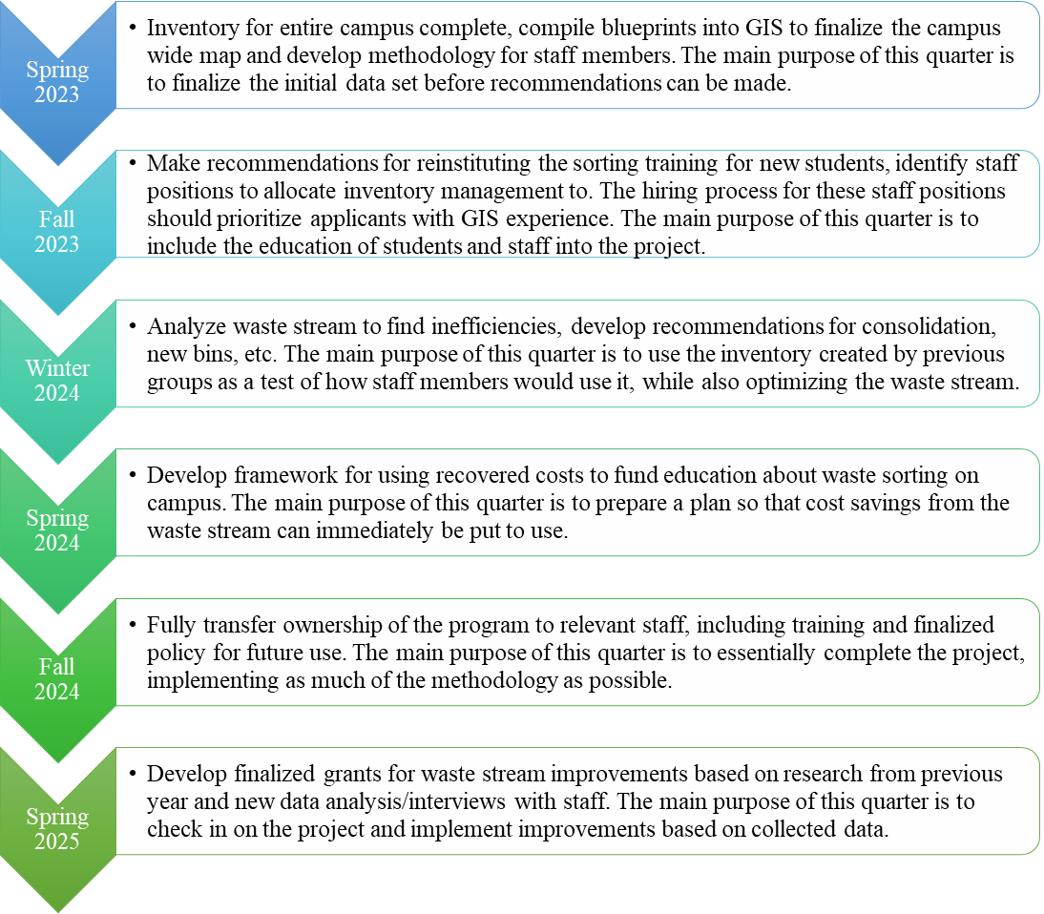

Budget
SSC and Dining Hall Billing:
For compostable waste, the Viking Union uses a 2-yard dumpster that’s picked up five times a week and is billed $930.60 per month. Ridgeway Commons uses a 2-yard picked up twice a week at $237.60 per month. The Atrium within Arntzen Hall has four 60-gallon totes picked up weekly, on Mondays, at $76.20 per month. And the Fairhaven Commons uses a 2-yard picked up twice a week for $237.60 per month (A. Cambre, personal communication, Nov. 2, 2022; See Appendix J). No information was given on the cost of contamination fees. The project sponsor, Amanda Cambre, has inquired into this and contacted Terrence Symonds, Associate Director of University Residences Facilities.
During the 2024 Winter Quarter iteration of this project, students will focus on analyzing the waste stream to locate inefficiencies, from issues with bin location and concentration to specific recommendations for labeling changes on bins. This will be the ideal time for students to take budget considerations into account. The student group will acquire specific receipts of SSC bills and confirm the financial burden of contamination fees incurred by the university. The inventory data and the budgetary data will be used in concert to determine which locations are most at risk of incurring fees, and what changes could be made to remedy that. We recommend that if this information continues to be difficult to obtain, the student groups for any quarter in 2023 may wish to begin the process of acquiring this data earlier, even if it is not immediately relevant to completing their deliverables.

Conclusion
The solid waste stream on Western’s campus is still in need of improvements. The development of an updateable map and corresponding spreadsheet will allow future groups to continue this project, following the recommendations proposed in this document. Education of students, both new and continuing, is a top issue for the staff members who directly deal with solid waste. Efficiency in waste collection can be improved, but limitations discovered through interviews should temper the expectations of future groups. Containers will still need to be emptied before they fill completely, but improvements can still be made to the distribution and location of units. Staff members seem willing to collaborate on shared policy, but difficulty in setting up interviews will continue to be a roadblock for future groups. Contacting key staff members at the beginning of each quarter will improve the chances that they will respond to an email. Overall, improvement is possible on campus, and Western will eventually make significant changes in collaboration with future student groups on this project. Each student group member will be able to notice better signage, more efficient distribution of units, and educational programs for new students with the satisfaction that they helped make it happen.

Appendix

Appendix A: Sections of Campus Arranged from South to North.
1. Far South Campus
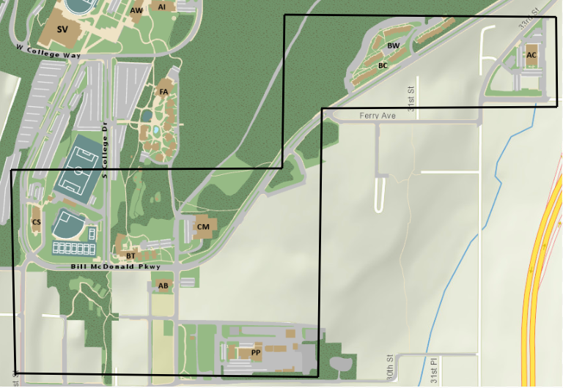
2. South Campus  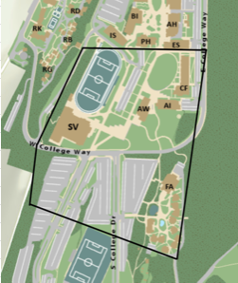 | 3. Top of the Hill  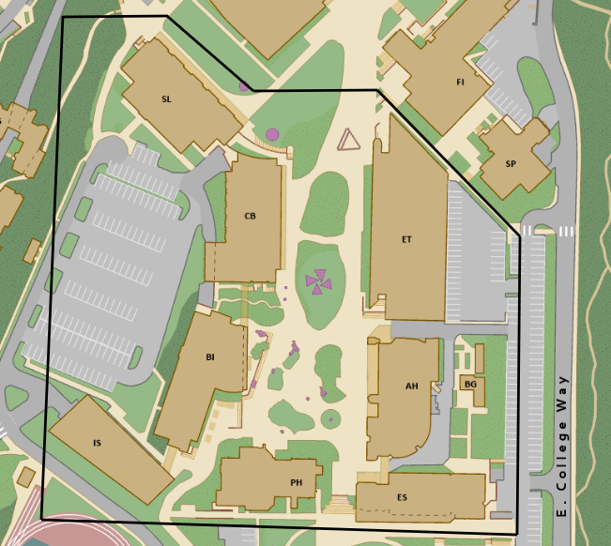
4. Mid Campus  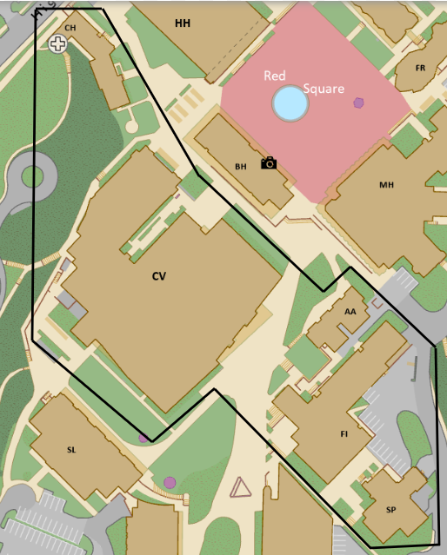 | 5. West Side  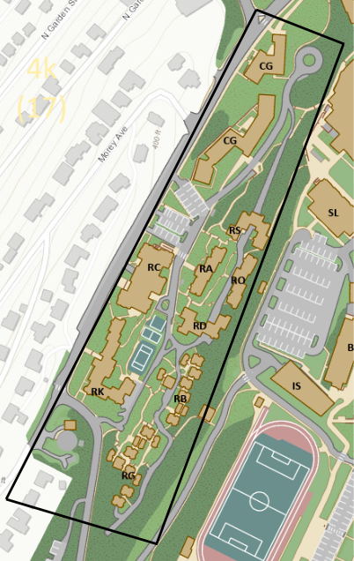
6. Red Square  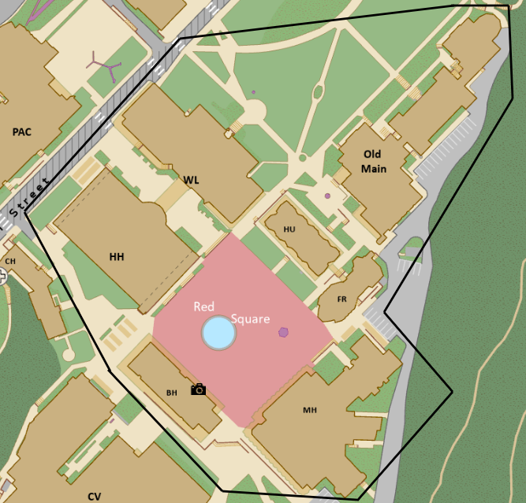 | 7. North Campus  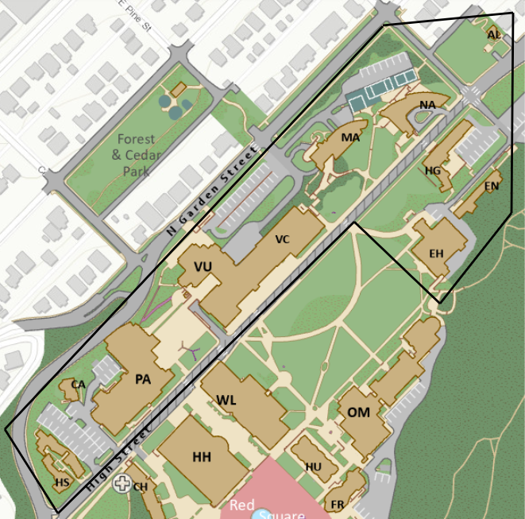
Note: Images sourced from Fick, S., et al., 2022, p. 14-16.

Appendix B: Examples of Size Types used in Inventory
Big Belly  Maximum capacity of 150 gallons  (Per individual receptacle) | 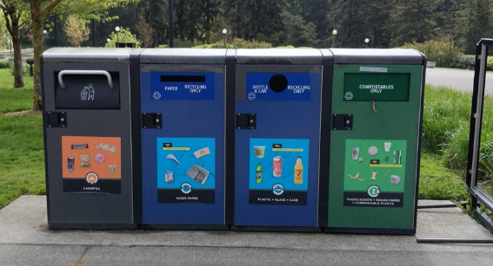
Dumpster  Maximum capacity of 400 pounds | 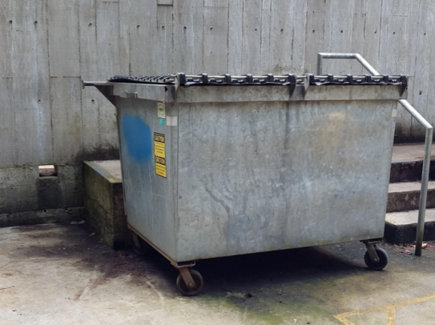
Half Dumpster - half as skinny as a full dumpster  Maximum capacity of 200 pounds | 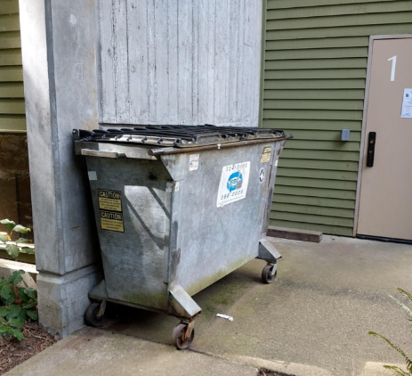
Individual  Maximum capacity of 40 gallons | 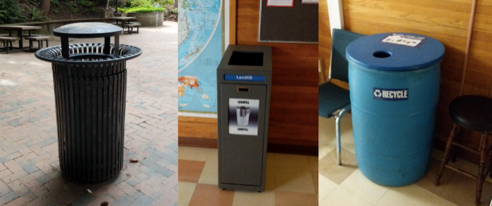
Multiple | 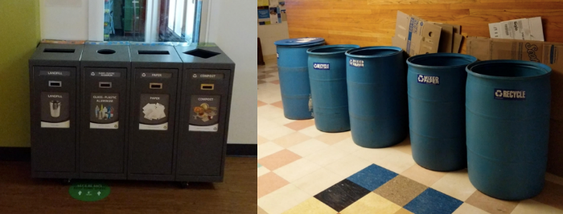
Note: Pictures sourced from Fick, S., et al., 2022, p. 16-17.

Appendix C: Inventory Excel Spreadsheet
Containing all the information described in Figure 1. Users should be able to double click on the spreadsheet to scroll and review the entirety of the data.

Appendix D: Waste Inventory Results Histogram
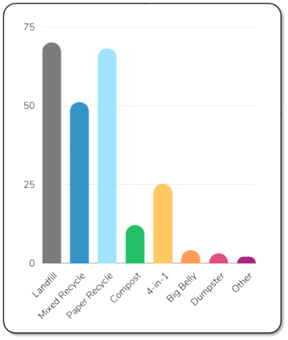
Note: Histogram by River Starr
Appendix E: Waste Type Inventory Map of WWU Red Square
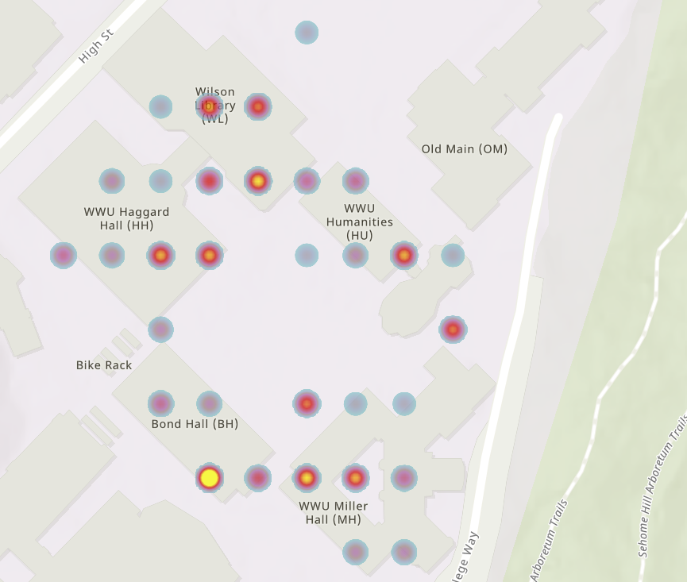
Note: Waste Types of WWU Red Square by River Starr

Appendix F: Waste Type Inventory of WWU South Campus
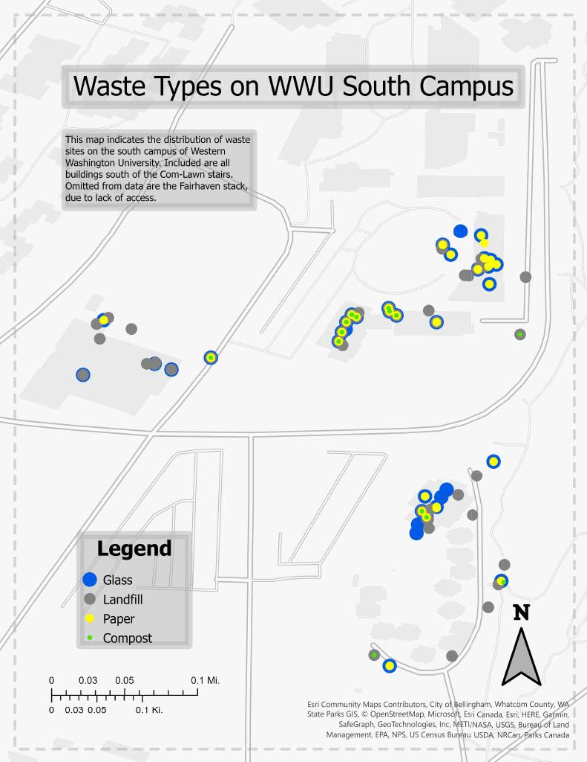
Note: Waste Types on WWU South Campus map created by Ben Fox (2022)

Appendix G: How to use ArcGIS Pro to display longitude and latitude data by Ben Fox (2022)(unedited).
- Download ArcGIS Pro (Link for WWU users in appendix)
- Create a new blank map and name + save accordingly (make a new folder, no spaces in name)
- Under the map tab, in the layers section click the add data pulldown, click data
- Find the Spreadsheet you created in the previous application, and click it, then ok, then a new sheet (S1) should appear in your contents pane
- Right click the S1, then click open to make sure it is all there, close it once verified
- Rick clicks the S1, data, export table, names a new sheet (this new sheet will be the one you use, I will refer to it as S2)
- Open the newly created S2
- With S2 open, under the data tab, under the data design window, click fields
- With S2 fields open, create a new field
- Under field name type lat1 “lat1”, under data type select Double
- Repeat steps 9 and 10 for “long1”
- Under the changes window hit save
- You can close the field view and you can go back to the S2 sheet, lat1, and long1 should be there
- Right click lat1 and click calculate field
- Click your cursor in the “lat1=” box, then right above it in the fields pane double click on the field that contains the latitude data
- Hit ok once the expression is filled, then close out the warning box
- Repeat steps 14-16 for long1
- Once you have seen the lat1 and long one columns complete you can close S2
- Right click S2, then click display xy data
- All fields should be correct, already so click ok
- This should display all the waste sites you have collected xy data on, this is completed, always keep at least one of these completely unedited
- Copy and paste one or two of these layers in the map
- Right click your new layer, click the properties, and under its name accordingly
- Still under properties click definition query and slim down the data you are trying to display (many ways to do this up to the user)
- The rest is up to you, the data is yours, use it to make some cool maps

Appendix H: Questions for the office of WWU Housing Sustainability.
WWU Housing Sustainability was contacted with the following questions on November 10, 2022, but was unable to answer them before the Fall 2022 quarter ended. After their response on December 6, 2022, the department was notified that future groups may reach out with similar questions.
- What policies does residence life have regarding composting/recycling in the dorms?
- What resources and information are given to students living in the dorms? And when are they given them (at the beginning of the year, throughout the year, etc.)? How did this change during the pandemic, if at all?
- What educational information have you provided in the past and how does it compare to your current educational program?
- How often do students participate in composting/recycling? How has this changed over the years?
- Are there any common issues or barriers for students?
- Do you have any other comments or concerns we should be aware of?

Appendix I: Staff and sources to contact for future information and interviews.
Name | Email | Phone | Position
Amanda Cambre | cambrea@wwu.edu | (360)650-2412 | Campus Utility Manager
Stephen Wadsworth | wadsworth-stephen@aramark.com | (360)650-2970 | Dining Services Resident District Manager
Wayne Galloway | Wayne.Galloway@wwu.edu | (360)650-3932 | Assistant Director of Building Services/Facilities Management
Kait Schultz | ZeroWasteAsst@wwu.edu |  | Zero Waste Club
Luke Mason | luke.mason@wwu.edu | (360)650-6501 | Maintenance Services Coordinator
Rich Neyer | richard.neyer@wwu.edu | (360)650-3088 | AS Recycle Center Program Advisor
Tim McLaughlin | mclaughlin-timothy@aramark.com | (360)650-6851 | Fairhaven Commons Director
Terrence Symonds | symondt@wwu.edu | (360)650-7322 | Associate Director of University Residences Facilities
Housing Sustainability | Housing.Sustainability@wwu.edu | (360)650-7474 | Office of WWU Housing Sustainability

Appendix J: SSC billing.
PDF of SSC billing for Viking Union, Ridgeway Commons, the Atrium, and Fairhaven Commons (A. Cambre, personal communication, Nov. 2, 2022).

References and Citations
Cambre, A. (2022, September-December). Personal communication [in-person and email communication].
Fick, S., Fox, B., Land, S., Thaxton, J. (2022). Streamlining Western’s Solid Waste. University of Western Washington Sustainability Engagement Institute
Kollen, O. (2022, October 21). Personal communication [email interview with Jordan De Lanoy].
Luo, A., Lewis, D., Yuen, M. Fazel, Y., An Lim, Z. (2015). Zero Waste Campus Project. UBC Social Ecological Economic Development Studies. https://blogs.ubc.ca/zhuanlim/files/2015/12/GEOG_371_distributiogroup_final.pdf
Mason, L. (2022, November 2). Personal communication [in-person and email].
Rawpixel. (n.d.). [People recycling concept]. Retrieved December 5, 2022, from https://www.freepik.com/free-vector/people-recycling-concept_7882883.htm#page=2&query=people%20sorting%20waste&position=11&from_view=search&track=sph
Stiller, J. (2022, September-December). Personal communication [email].
University of Texas Austin. (n.d.). Zero waste hierarchy. Facilities Services | The University of Texas at Austin. Retrieved September 28, 2022, from https://facilitiesservices.utexas.edu/divisions/support/zero-waste/waste-hierarchy
WWU Office of Sustainability (2017). WWU Sustainability Action Plan. https://sustain.wwu.edu/files/2021-03/Sustainability%20Action%20Plan%202017%20-%20FINAL.update02.06.2019.pdf
Zeretzke, H. (2022, October 17). Personal communication [in-person interview].

