ENVS 471
CLEAN POWER
RENEWABLE INVESTMENT STRATEGY PROPOSAL

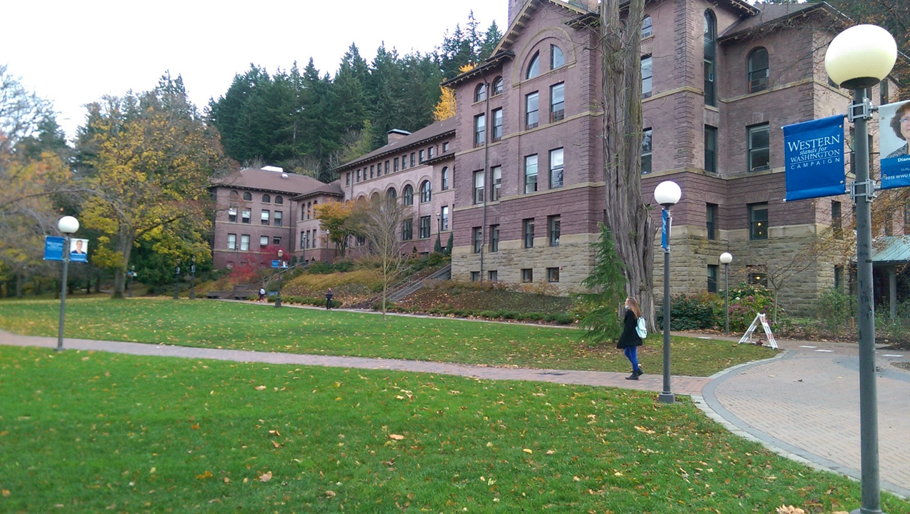

Courtney Crossfield; Sean Mertens

Table of Contents
- Acknowledgements
- Executive Summary
- Introduction
  - Background
  - Statement of Need
    - CAP Commitment
    - Western’s Sustainability Image
    - Financial Incentive
    - Renewable Energy Credits
- Methodology
  - Case Studies
  - Research
  - Decision Making
- Proposal
  - Investment Strategies
    - Direct Ownership
    - Energy Efficiency
    - Carbon Offsets
    - Outreach
  - Continued Research
- Summary
- Sources

Acknowledgments
The Western Washington University Clean Power team is grateful to the Sustainability Committee for paving the way to more sustainable campus initiatives and open minds, to President Morse for signing the American College and University Presidents Climate Commitment, and to the faculty, administration, staff, and students who were part of the collaboration of Western Washington University’s Climate Action Plan. The WWU Clean Power team is also indebted to the members of various departments on campus, local businesses, and fellow university’s faculty for their contributions and guidance in the research of this project. The project received valuable support from Campus Sustainability Coordinator, Seth Vidaña, who also oversaw the research process, as well as Masha Szaro, Research Associate in the Office of Sustainability.

Western Washington University’s Clean Power team would like to acknowledge the following organizations and individuals for their involvement with this project:

Greater Community:
Peter Lillesve; PSE
Heather Mulligan; PSE
Josh Williams; Western Solar
Chris O’Brian; Altenex
Monica Cowlishaw; Cascade Natural Gas
Marilyn Ostergren; University of Washington
Justin Rodegerdts; Whitman College

Western Washington University:
Reid Dorsey-Palmateer; CBE
Thomas Webler; Energy Institute
Joel Swisher; Energy Institute
Scott Dorough; Facilities Management

Executive Summary
The Clean Energy Project started as one of four projects in the Fall 2015 session of the Campus Sustainability Planning Studio. The project goal was to review Western’s policy of Renewable Energy Credit purchasing and then determine if there is a better option for Western in terms of offsetting its electricity usage. In this proposal we will first outline the need for this project and what Western is currently doing to address its goals. Then we will discuss how we gathered the data for our project. We will close by presenting our full proposed clean energy investment strategy for Western.

Introduction

Background
As the world beings to recognize the need to transition to a low-carbon society, the responsibility to initiate leadership rests within the educational system. The American College and University Presidents Climate Commitment has dedicated Western Washington University (WWU) to the belief that colleges and universities must exercise leadership within their community and society as a whole, modeling ways to reduce greenhouse gas emissions and providing education to students to achieve climate neutrality.

In 2005, students at WWU voted to tax themselves to purchase Renewable Energy Credits (RECs) in order to offset carbon emissions from Western’s electricity consumption. REC’s were chosen because they are a cheap way to invest in renewable energy to offset electricity usage and at the time, there was strong student support and a campus climate conducive to change. It is now time for the university to revisit this policy and explore other options.

The WWU Clean Power Project was created by Western’s Office of Sustainability’s Director, Seth Vidaña, as part of the Campus Sustainability Planning Studio course. The goal of the project was to research the potential for “greening” Western’s electricity consumption and then to propose a best-fit solution. The tasks included researching the potentials for aggregate power purchasing for clean power, researching the potentials to lease or buy a wind/solar power production plant, researching the potential to buy clean energy in a consortium with other campuses, and finally analyze the findings to develop a best-fit solution.

Statement of Need

The responsibility of a generation fighting to prevent monumental global climate change has fallen into the hands of universities across the globe, encouraging the creation of long term climate action plans. According to Western Washington University’s Climate Action Plan, “anthropogenic climate change is the most significant problem of our time” (p. 2) and action is needed in order to reach carbon neutrality by 2050. To meet its own goals, Western has struggled to find a truly authentic and affordable option to reduce its emissions from electricity consumption. The purchasing of Renewable Energy Credits (REC’s) is no longer enough for a university that has committed itself to being a leader in the “green” school movement. Throughout this paper we will present to you a complete analysis of Western’s options as the institution moves towards carbon neutrality.

CAP Commitment
Western Washington University has made commitments via their Climate Action Plan, created in 2010, that require further mitigation strategies in order to keep them. These commit Western to not only being the first University in Washington State to meet the Washington State legislation (RCW 70.235) 2035 standard of a 36% reduction in emissions from 2005 levels, but also the first to reach climate neutrality by 2050. This puts Western on an accelerated schedule to meet these state mandated reduction targets. It was written in the Climate Action Plan that this was due to seeing “an opportunity to seize a leadership position,” (Western Washington University CAP, p. 10).
In order to reach their goals, Western’s CAP encourages three types of emissions reduction projects: behavioral change projects, infrastructure projects, and university-sponsored carbon reduction projects.

According to Western’s CAP, the three goals that were set in order to comply with the inherent commitments of the President’s Climate Commitment were that of creating a carbon emissions inventory, assessing the feasibility of emissions reduction through campus initiatives, and creating an institutional model for emissions reduction to move toward climate neutrality. This committed Western to reduce campus energy use and costs, implement greenhouse gas reduction technologies developed by campus researchers, and create demand for low-cost renewable energy technologies through purchasing power, as well as prepare for future climate regulations and energy price volatility. It also committed Western to appeal to a campus community that has a strong culture of environmental ethics, and to collaborate with the City of Bellingham and other local communities.

WWU Gross CO2 Emissions with “Advanced State Standards” 2005 to 2050
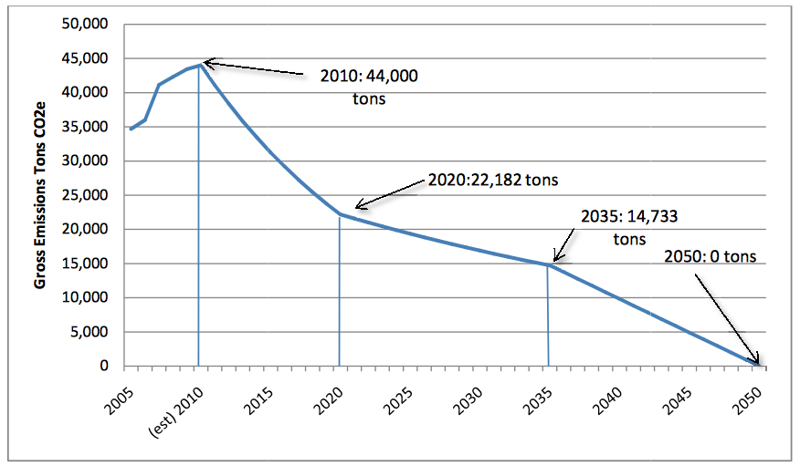

Western’s Sustainability Image
The various commitments that Western has made along with the coursework offered at the school, most notably in Huxley College, have helped Western to cultivate an image of sustainability that attracts new students from various backgrounds. Students and community members believe Western to be a “green” school, one that incorporates sustainable practices throughout the campus. Western’s goals are admirable and some sustainability initiatives have had considerable impact, but if Western wishes to maintain this image it needs to truly commit itself to sustainability. There are strict goals that need to be met and if they aren’t Western will surely lose the image it has worked so hard to maintain.
Leadership is a key factor in Western’s sustainability efforts. Western has committed itself to being not just a close follower of trend setters, but a true innovative leader. Purchasing enough Renewable Energy Credits to offset electricity usage may have been a first for a university but it wasn’t innovative or something that sets Western apart from the rest. Similar programs are in place across the nation; if Western truly wants to be looked at in the same light as other leaders it will need to implement a stronger clean energy investment strategy.

Financial Incentive
Other than the need to fulfill the promises made to the students and staff at Western and to the local community, a sound investment strategy will also address Western’s financial security. Part of Western’s CAP commitments is to make sound investments that reduce our susceptibility to fluctuating energy prices. Currently, Western has no program to address this issue. One benefit of our proposal will be protection for Western from these fluctuating prices. This proposal will also create a positive-revenue generating facility entirely under Western’s control which will provide the university with added security and funds for other projects.

Renewable Energy Credits
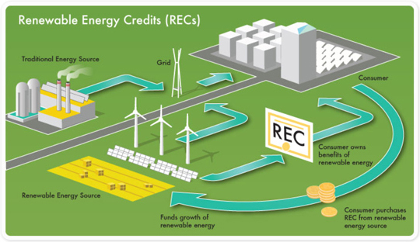
Western currently purchases $50,000 worth of Renewable Energy Credits, also known as REC’s. One REC accounts for 1mWh of green electricity, specifically the “green” attributes of it. These green attributes include the emissions it is potentially offsetting or preventing. Institutions can purchase these credits to effectively offset their electricity consumption by funding renewable energy investment. Western voted in 2005 to implement a student fee to fund the purchasing of these credits.
Unfortunately, REC’s have many issues that make them best as only a temporary solution until something better can be implemented. The main issue is known as “additionality”. The additionality of REC’s is referring to if the money from REC’s is going to additional voluntary expansion of capacity, or if that expansion was going to happen anyway. Another big issue is that even if it is voluntary expansion, the purchaser doesn’t know what the new electricity is offsetting. If newly installed wind power is offsetting relatively clean hydroelectric power then the emissions offsets aren’t what they would be if it was offsetting coal. The root problem for REC’s is the lack of accountability; the industry is not well-regulated so it’s nearly impossible to tell exactly what type of impact the money is having.
Throughout the corporate world, sustainability leaders like Apple, Google, and Microsoft have taken notice of the negatives of REC’s. There has been a steady shift over the last few years away from REC-purchasing and into more direct investment in renewable energy like on-site arrays. These corporations see this as a more effective use of their money because they can completely track and define what they’re doing, allowing them to maintain complete transparency. Western also needs to take notice of these negatives if it wants to maintain its image and fulfill its commitments.

Methodology
Following the advice of SethVidaña, we first approached this project by reviewing strategies used by other schools. We will outline the most relevant case studies first below, then discuss the follow up research and interviews we did to clarify Western’s current sustainability status and the viability of various investment strategies. Finally, we will explain the decision making process and how we interpreted the data and viewpoints we gathered throughout the research phase.

Case Studies
Duke University:
Duke University has taken an unique approach in order to reach their goal of climate neutrality by 2035. The university has invested heavily in carbon offset credits. Duke has specifically invested in at least three types of projects. The first, methane capture, involves capturing the methane at local pig farms then burning it which converts it into the much less potent carbon dioxide. They have also chosen to sustainably managed Duke Forest, which the university owns, and prevent it from being clear cut. The protection of forests maintains its carbon sequestration potential which offsets Duke’s emissions. Finally, they’ve invested in solar by helping to fund one farm off-site and by assisting faculty in the purchasing of their own residential system.
For each option, Duke does intensive cost-analysis to determine the cost of the project versus straight purchasing of these credits from the offsets market. In some cases the project came out to be slightly more expensive but the value of collaborating with the community and increasing the school’s “green” assets increased the value of the project.

Harvard University:
Harvard University has approached their sustainability efforts in a way that offers a few applicable points for Western but is not feasible for a school that doesn’t have the amount of funds that Harvard has. They have currently invested in a variety of renewable energy technologies on-site including several solar arrays, a handful of wind turbines, and a few solar-hot water stations. They have also, like Western, invested heavily in energy efficiency measures including several LEED certified buildings. Their most interesting piece of sustainability strategy is the implementation of a $12 million revolving loan program that allows faculty to request money for sustainability projects that will payback in five-ten years which has helped to include the whole campus in their sustainability efforts.
Interestingly, Harvard occasionally chooses to sell the Renewable Energy Credits of their onsite clean energy production to other local institutions. This means that some of their “green” electricity being produced on campus isn’t actually “green”, since the positive attributes of the electricity have been sold to someone else. This is a good example of the type of “double-accounting” that occurs with institutions that dabble in REC trading. Harvard is not producing much renewable energy at all despite their large investment in it.
Colorado State University:

Colorado State University’s 5.4 mw solar power plant that covers 30 acres generated over 8.5 million kwh annually, which was enough to power one third of their Foothill Campus. The plant has over 23,000 panels and reduced emissions by 6,600 tons annually, making it one of the largest solar plants at a US university at the time of completion. In order to achieve short-term economic success, the RECs from this production were sold from the plant to the local utility.

Though the solar farm is funded by a public-private partnership between Colorado State University, regional utility Xcel Energy, and its renewable energy developer, this is a good example of how a school can invest in renewable energy in an economically feasible way, making back their money spent as they sell their renewable energy credits. This received revenue can either go to paying back the renewable energy budget or go towards increased funds for future projects.

Appalachian State University:

Appalachian State students voted to implement a $5 fee per semester toward renewable energy technology on campus. The project was carried out by the Renewable Energy Initiative, a student-led group. This fee was able to fund 50% of the $533,000 project, while the other half was funded by local utility New River Light and Power. A Northwind 100 wind turbine was installed on campus, with a tower of 121 feet and 34 foot blades. It has a 145,000 kwh potential, and offsets 116 tons of carbon offset annually.

In comparison to Western’s energy usage, this turbine is actually quite small, and would not satisfy its energy generation needs. But what stands out about App State is not only that it is viable to have a wind turbine within the campus vicinity, but that it was the students who decided to implement this project, voting in the fee for future renewable energy investment.

Whitman College:

Whitman College receives income from wind power generated on one of their farms which they rented to Florida Power and Light. The partnership allowed FPL to construct wind turbines on the land and integrate it into their power grid. Whitman receives about $100,000 in royalty payments for the 62 turbines. The power itself is owned and sold by the utility, so Whitman is not able to claim its renewable energy to offset electricity or carbon emissions.

Whitman has been presented with proposals for further projects, with offers to co-invest in wind turbines on college land and leasing the rights to build wind turbines out to Puget Sound Energy on several Whitman farms. The existing turbines and any possible projects are not related to Whitman’s energy generation or use, but that is not to say that a future collaboration could be structured in such a way.

Research
Based off of what we encountered in the case study stage of our research we determined that there was a lot of research to be done to fully understand the options available for Western. At this point in our project we embarked upon independent and open-ended research to gather as much information as we could. We did this in two ways:
Interviews (In-person, Phone, Email):
Reid Dorsey-Palmateer; WWU Economics Professor
For our interview with Reid Dorsey-Palmateer we were at the very start of our project and have very little information to go off of. As a consequence of this we weren’t exactly clear on what questions to ask or what topics Palmateer would be most knowledged on. In the end, Ried provided us with some good questions for evaluating Western’s REC purchasing and the current goals. This helped us outline what we wanted for our project.
Thomas Webler; WWU Energy Institute
For our interview with Thomas Webler we had a slightly better understanding of where we wanted to take this project but we were still looking more for direction than anything else. Webler helped clarify some of the issues with RECs and told us that Western actually does targeted REC purchasing from areas where it's more likely for the renewable energy to offset coal. The points that Webler brought up about the time frame of projects and the systemic view of sustainability helped us narrow our research field.
Joel Swisher; WWU Energy Institute Director:
We were referred to Joel Swisher by Thomas Webler. Joel helped even further clarify and explain REC’s. He helped us establish a better understanding of the relationship between power purchasers and their utilities and how the grid works in general. This helped us rule out certain options while increasing the attractiveness of different renewable sources. He was also responsible for us pursuing carbon offsets as an option for investment.
Justin Rodegerdts; Whitman College Financial Analyst
Justin Rodegerdts was able to give us information on Whitman College’s own wind farm project. This was great information for us because we were able to see how an interaction between a university and a power generator played out and the costs of this. The case study is different than what we were looking for (they don’t own the wind farm, just the land) but it was an interesting look at the possibilities open to Western and the process.
Peter Lillesve; PSE
Peter Lillesve was our first contact with PSE. He ended up being more involved with the energy efficiency side than PSE’s green power program which surprised us but his willingness to help gave us lots of options for what to ask. We learned a good amount of PSE’s position on green power and the relationship between PSE and Western. He also did us the favor of putting us in contact with Heather Mulligan at PSE.
Heather Mulligan; PSE
Heather Mulligan ended up being our main contact with PSE. She was very helpful in determining what type of wind farm investments PSE has made and the viability of Western making its own investment. We talked with her over the phone along with Tom Maclean, also from PSE, and learned a lot about wind farm construction and how our relationship with PSE would change in a situation where Western produces all its power on-site or off-site.
Marilyn Ostergren; University of Washington
Initially, we were very excited to look into collaboration between universities. We reached out to the University of Washington’s Office of Sustainability and were able to email with Marilyn Ostergren. She was great help with establishing the UW’s progress towards their goals and she said that the school was open to collaboration. Unfortunately, we had to narrow the scope of our project so we had to put collaboration on the back burner.
Online Research:
For the online portion of our research we focused mainly on finding answers to questions that came up in our interviews and on finding more real-world examples of the type of strategies we want Western to implement. A lot of our data came from the Department of Energy and the Energy Information Agency websites. We also took a lot of information from sites of companies and non-profits involved in renewable energy production and financing like the websites of: Cannon Power Group, Puget Sound Energy, Portland General Electric, Altenex, Siemens, Shell, and various schools.

Decision Making
After gathering as much data on the variety of options available to Western, we evaluated what we had based on how well each strategy addressed the needs outlined earlier in our proposal. The goal of this project was to make sure that Western chooses a clean energy investment strategy that fully addresses all its goals and commitments in a way that makes financial sense. A few options like solar on campus were rejected because of the cost and lack of reasonable payback period. Other options didn’t make the cut because of the regulatory climate in Washington State despite the strong desire of our team to utilize it in our proposal (aggregate power purchasing). Still other options were passed over because of lack of time in our project which will be addressed later.
In the end we decided to pick a variety of strategies and combine them into one comprehensive proposal to fully address all the goals Western has made. It is the Clean Power team’s belief that if this proposal is adopted it will provide Western with financial security while maintaining and strengthening its sustainability image.

Proposal

Investment Strategies

After much research we have developed a multi-approach investment strategy that will better help Western achieve its goals and meet the expectations of its stakeholders. In our proposal we are encouraging direct ownership of wind power, more energy efficiency measures, utilization of carbon offsets, an increased push for campus outreach, and continued research to assure a best-fit strategy.

Direct Ownership
We chose direct ownership because it is a clear, complete, and more accountable form of investment. RECs make it hard to track where the money is going and exactly how much of an impact it’s having. With direct investment Western will know exactly what its money is going to which makes it easier to report on the effects of the investment. We chose wind specifically because according to the Department of Energy, Washington has a large amount of untapped wind potential.
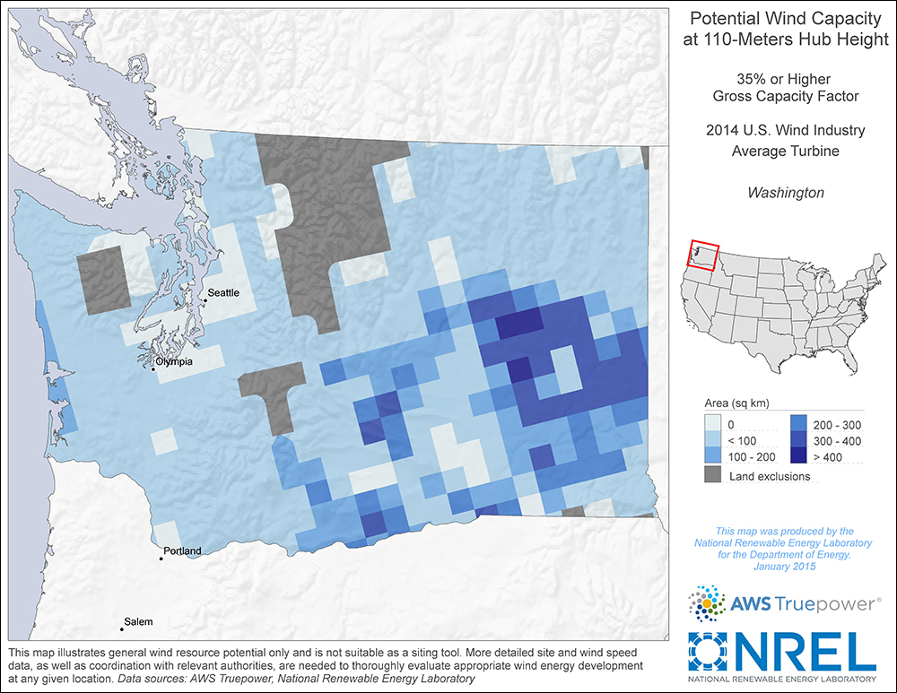
The Department of Energy also informs us that wind power is considerably cheaper per mWh over its lifetime than hydroelectric or solar, which we also looked into. This combined level of potential and affordability make wind the best option for Western moving forward.

We took Western’s 36,000,000 kWh annual electricity usage and then applied an industry standard average capacity factor of 30% which allowed us to estimate that Western would need a 15-mW wind farm to offset our electricity usage fully. This means we would need to purchase and construct 8 2-mW wind turbines. This could be done by working with a local company like the ones referred to us by Heather Mulligan at PSE. The offsite land used for this could either be purchased or leased by Western, or obtained possibly by partnering with a third party interested in collaborative wind power.

We have estimated using this information, case study costs, and the average cost of wind turbines determined by the Department of Energy using industry realized data, that this implementation would cost $28,000,000, with minimal operational and upkeep costs thereafter. This cost easily compares to building construction and renovation costs, and is viable if Western decided to make clean energy a priority.

To finance this investment, Western should look towards Clean Renewable Energy Bonds. These bonds were designed specifically for financing renewable investment projects like the one proposed for Western. They are tax exempt and low interest rate bonds which allows Western to take on large amounts of debt without worrying about accumulating massive interest payments. Debt financing should then be partnered with a quarterly student fee between $25-$45 dollars a quarter. This fee would allow students to share in the cost and participate in the clean energy investment project while giving the university revenue (in addition to the revenue being added from the project) to pay back the upfront cost. This fee can be compared to other student fees found below, taken from Western’s tuition site:

Required fees (not included in the tuition chart above) (1-5 credits):
Technology | 17.50
Green Energy Fee (.70 per credit) | .70 per credit

Required fees (not included in the tuition chart above) (6+ credits):
Health Service | 85.00
Non-Academic Building Fee | 39.00
Recreation Center Fee | 99.00
Technology | 35.00
Green Energy Fee (.70 per credit max. $7) | 7.00
Legislative Action Fee | 1.00
Alternative Transportation Fee | 26.25
Total | $292.25

An investment like this will be the first of its kind for a university and will establish Western as a true innovator and leader. However, until this piece of our proposal can be implemented there are several ways Western can reduce its emissions currently.

Energy Efficiency
Much of the energy that is wasted each year in the US is due to inefficient technology, costing more and increasing pollution. Investing in energy efficient technologies is the easiest and cheapest way to combat carbon emissions, while making back the money invested in savings. Western has already implemented some of these technologies; they have begun retrofitting buildings with LED lighting and are moving towards Energy Star appliances. But we believe continual effort towards a complete energy efficient campus by future retrofits, waste-reduction, and behavioral change is necessary to lessen Western’s energy costs and reduce their overall emissions.

Carbon Offsets
Carbon offsets represent one ton of greenhouse gas (ghg) emissions reductions. A credit is attained by investment in a project off site that offsets the emissions created by an institute throughout its sphere of influence. These projects can take a variety of forms and the credits can offset emissions from any number of sources including, but not limited to: emissions from student travel, emissions from electricity consumption, and emissions from corporate travel.
Western has many options for investment in projects that could earn offset credits on campus and in the local community. Methane capture is very feasible in Whatcom County thanks to the large amount of farmlands. Wetland restoration is also very poignant in the area and Western could assist in those projects directly to earn credits.

Outreach
In order for the latter steps to be successful, there needs to be a greater effort put forth towards campus outreach. Western prides itself in its involvement of students and utilization of their creative ideas and problem-solving, but it cannot benefit from that if the student are unable to find vital information. During our research process we went to great length to find relevant information needed to progress. There seemed to be a disconnect not only between departments on campus, but also within the information we were able to find regarding Western’s emission data and progress toward its reduction targets. We believe that it should not be that hard, especially at a school that also prides itself in its sustainability, to find this information. We also believe that there should be a general understanding among faculty of this information.
To further this goal of increased outreach we believe Western should revamp its sustainability website as well as include a noticeable link on the front page of Western’s website. A fun and interactive dashboard like the one found on the University of Washington's site will make it easier for interested stakeholders to find the information they want so they can track Western in its progress towards the various goals laid out in the Climate Action Plan.

Continued Research
The final part of our proposal is a simple but important appeal to Western Washington University and the Office of Sustainability. We on the Clean Power team are the first to admit that there is more research to be done on this subject to ensure that the right proposal is chosen. The proposal we have laid out for you is feasible, effective, and a great fit for Western but we cannot know for sure if it’s the best or how to fully implement the separate parts of this proposal without more research being done.
To continue this research, we are suggesting that a research group on campus be established made up of several students and a faculty advisor or two so every option for Western can be fully vetted.
There are several options we didn’t get to fully investigate during our research including increased collaboration amongst Washington universities, the possibility of other renewables like solar being more viable, the possibility of renewable investment on campus, the different ways of student involvement throughout the clean energy investment project, etc.

Summary
Our proposal above we presented to you what we have determined is the best clean energy investment strategy for Western, based on current levels of research. Directly owning a wind farm, continuing our energy efficiency investments, utilizing carbon offset projects, increasing outreach, and continuing research into this subject are great options for Western as it matures and moves forward with its sustainability goals. If we are to meet the demands of the Climate Action Plan we must make aggressive and well-devised investments like the ones in our proposal otherwise Western will be left poorly positioned in a world that is facing the greatest environmental crises of human history.

Sources
[1] AASHE Case Study Database
[2] American College and University Presidents Climate Commitment
[3] App State University Sustainability Webpage
[4] Colorado State University Sustainability Webpage
[5] Duke University Sustainability Webpage
[6] Energy Information Agency
[7] Environmental Protection Agency
[8] Interviews
[9] Harvard University Sustainability Webpage
[10] University of Washington Sustainability Dashboard
[11] US Department of Energy
[12] Western Washington University Climate Action Plan
[13] Western Washington University Sustainability Webpage

[2] American College and University Presidents Climate Commitment; [11] Western Washington University Climate Action Plan
[11] Western Washington University’s Climate Action Plan
[11] Western Washington University’s Climate Action Plan
[11] Western Washington University Climate Action Plan
[11] Western Washington University Climate Action Plan, [8] Interviews
[11] Western Washington University Climate Action Plan
[8] Interviews
Shell
[5] Duke University Sustainability Webpage
[9] Harvard University Sustainability Webpage
[4] Colorado State Sustainability Webpage
[3] Appalachian State Sustainability Webpage
[8] Interviews
[8] Interviews
[8] Interviews
[5] Energy Information Agency [11] Department of Energy
[11] Department of Energy
[11] Department of Energy [7] Environmental Protection Agency
[10] University of Washington Sustainability Dashboard,[13] WWU Sustainability Webpage

