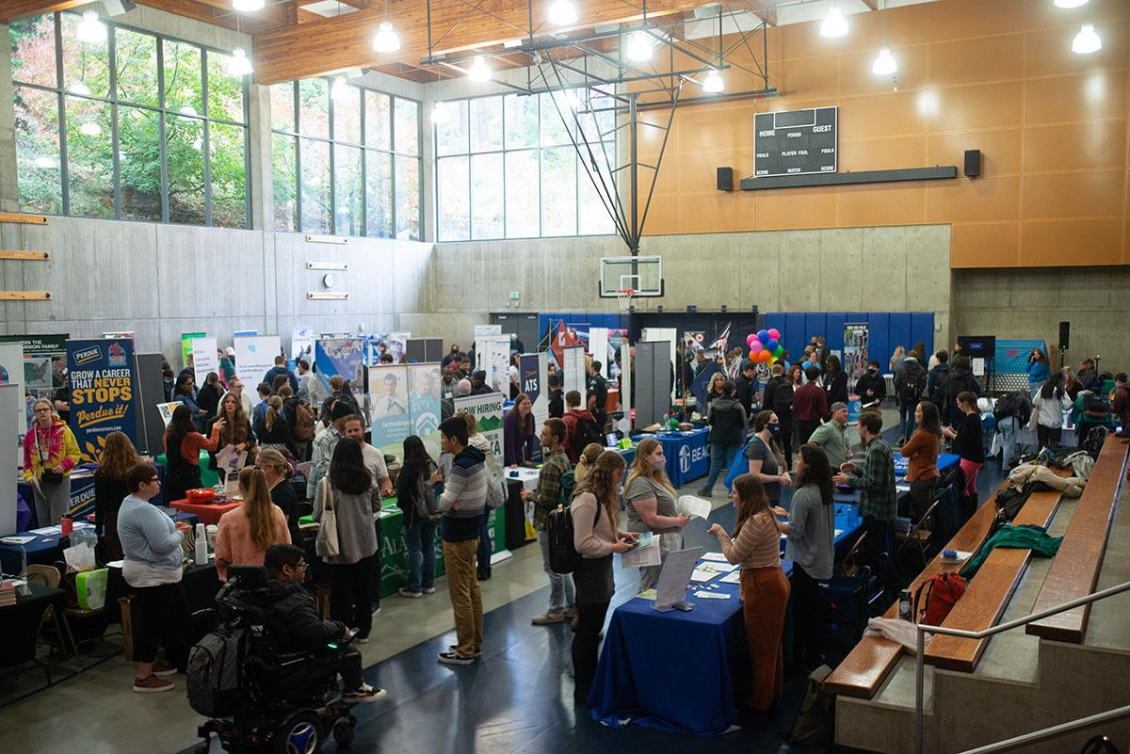

Zero Waste Events Planning
A Comprehensive Guide to Facilitating Events on Western’s Campus

By: Brenna McDaniel and Forrest Morris

Sponsored by: Dr. Grace Wang, Professor and Department Chair

Table of Contents

Executive Summary | 2
Introduction | 3
Methodology | 4
Results | 4
Recommendations | 10
Monitoring and evaluation | 12
Budget | 12
Conclusion | 13
Appendix | 14
References | 35

Executive Summary

Problem Statement:
Previously, the former Office of Sustainability supported staff and student groups to ensure that events were zero waste in an effort to align with the values upheld in Western’s Sustainability Action Plan (SAP). However, this was never adopted at an institutional level and was quickly phased out, leaving event organizers with no support with zero-waste practices in event facilitation. Recently, the Zero Waste program has been passed over to the AS Recycling Center and has lost momentum through the COVID-19 pandemic. Events on campus are large contributors to the overall waste stream coming from the University and hold real opportunities for carbon reduction and cost savings. If Western’s goal is to “Reduce waste every day” as stated in the SAP, then the University must adopt a Zero Waste event framework and provide resources and guidelines for event organizers. Otherwise Western will continue to

Project Description:
The goal of this project is to create a zero waste events framework for students and faculty when organizing events on campus that will provide a streamlined checklist to make the process as easy as possible. The comprehensive guide will include information on food recovery and diversion and develops the foundation for a volunteer program to assist in sorting at waste stations by ensuring attendees are disposing of material correctly. This project measures diversion and waste levels on campus to create a baseline for current rates, that are then to be compared to zero waste events rates. For an event to be successfully zero waste it must divert 90% of materials from landfill to recycling or composting (Environmental Protection Agency, 2022). This project outlines methods and processes for accomplishing the above rate.

Summary of Recommendations:
This report provides a detailed list of recommendations organizers should follow to their fullest ability. This includes beginning event planning with a zero waste lens in mind, limiting decorations, and providing compostable packaging for vendors who fail to comply with zero waste regulations. Additionally, common barriers to zero waste are addressed and creative solutions are provided. Organizers should update current, or create new, vendor contracts to include zero-waste policies that must be followed. It is also advised that Western create a program, or like other universities create an app, that can be used to give away leftover food from events, and help address food insecurity on campus. Due to the depth and the complicated nature of event planning, it is recommended to make the Zero Waste Coordinator position a full-time position, allowing organizers to gain assistance and further resources.

Introduction
Statement of Need
Traditionally, the facilitation of events considers the guests expectations for decorations, tangible incentives, freebies, and food to increase participation and to create excitement among event attendees. These items are commonly cheap to obtain, but they are intended to be single-use and more items than needed are purchased, creating unnecessary costs. Breaking the barrier to zero waste addresses environmental, social, and economic sustainability by diverting food to those who are food insecure, diverting waste from landfills into reusable commodity streams, and reducing over-purchasing to increase efficiency. Transitioning to a circular economy within the university builds resilience, combats climate change, improves access to nutritious food, supports the local community, and reduces net expenditure. Diverting waste at a rate of 90% through the institutionalization of a zero waste framework is an effective mechanism in the transition away from an expensive linear system due to its expansive cost reduction and carbon reduction opportunities.

Project Goals
The zero waste framework will provide a case study to show the potential environmental, social, and economic success of zero waste events that will set an example for other institutions. A guideline and checklist is designed to assist organizers through the facilitation method to ensure that the waste elimination process is as efficient as possible. For maximum efficiency in facilitation a volunteer program called Green Leaders will be created for the purpose of proper waste sorting assistance and education for attendees. Additionally, there will be a baseline of current compost and recycling contamination and amount of waste generated at events.

Background Research
The EPA found that roughly 30% of material sent to landfills could be composted. They also found that only 11.5% of plastic material is recycled annually(United States Environmental Protection Agency, 2018)(United States Environmental Protection Agency, 2018). Multiple universities have created zero waste programs such as Ohio State University., University of Wyoming, University of Calgary, Townson University, NC State University and the Harvard University, yet western has yet to support any kind of action. The Brookby School AG Day in Auckland, New Zealand had used a zero waste guide to facilitate this event of 1,800 people with a success rate of 80% waste diversion by taking a strategic approach from beginning to end (Auckland Council, 2021). The event organizers at this event demonstrate the feasibility of reaching zero waste goals when planning accordingly. Previously, the Zero Waste program was run and overseen by Western, but was recently handed off to the AS Recycling Center. Current custodial staff have no zero waste training and have limited communication between staff, faculty and students.

Methodology
Data was collected through various interviews with key stakeholders and persons with reputable experience on the topic of zero waste, and the gathering of information from universities that have implemented a zero waste framework. Sonia Cole, the Principal of Sehome High School, was valuable in learning about volunteer programs and the interest many high school students express in these types of opportunities. Gwen Larned, a former zero waste coordinator at Western, has years of experience in the facilitation of zero waste events and the biggest challenges within the organization of events. Larned shared her ins and outs of the barriers, success, and recommendations on the topic. Conducting interviews provided insight on the process to collecting data on issues surrounding waste management, what items are the largest contributors to waste, volunteer opportunities, implementation of apps, and education on the Zero Waste Western program.
Other data and information was found through other universities zero waste guidelines that had been successfully implemented. Most notably, Brookby School Ag Day, Auckland New Zealand, puts on an annual event that includes food and drink vendors, entertainment and animal judging. The event brings around 1,800 attendees every year and has an 80% diversion rate(Auckland Council, 2020). This school has used similar tools that are recommended for future events at Western including waste station sorters, identification of possible waste streams and logistics prior to the event to minimize setbacks, and preparation for vendors who do not adhere to zero waste principals and other setbacks that may arise. To implement a zero waste framework for events, the ability to discuss and learn about the stated issues provided insight on how to strategically move forward.

Results
WWU Fall 2022 Career fair
Career fairs are popular quarterly events held on campus that provide networking opportunities for students and scouting potential for employers. It is a widely attended event and could serve as a pilot to further institutionalize zero waste events on campus. During the time of the event, photos were taken to record “freebies” handed out by vendors, and to gain a general baseline for the types of waste that are created at career fairs and what can be avoided.
Overall the Career fair left many areas to be improved as basic zero waste protocols were not followed. Vendors had an over abundance of plastic freebies and free stuff that many students ignored. Waste bins were all contaminated and began overflowing by the end of the event. Organizers handed out unnecessary maps and information, name tags were placed in plastic coverings, but were not collected at the end of the event, creating unnecessary additional plastic waste. Below is a list summarizing key findings accompanied with possible solutions, and findings are organized from easy fixes to more challenging solutions.

Table 1
Key findings from WWU Fall 2022 Career Fair

Problem | Reason | Solution
Name tag upon entering | Name tags are given out upon entering, and students were to discard them when leaving. | Collect and reuse plastic covering for name tags, this can also reduce overall costs of the event.
Poorly labeled bins for recycling and compost | Without accurate images and labels on waste/compost/recycling, attendees are likely to be confused and contaminate bins, and dispose of waste incorrectly. | Properly label bins, and provide large images with specific materials from the event.
Cross contamination between three bins | if the compostable waste is not discarded properly it can sit in landfills and release GHG in the form of nitrous oxide. If recycling or compost is highly contaminated it will be thrown into the landfill. | Inform attendees about the event being zero waste and utilize volunteers to help and educate attendees at waste stations.
Food provided to vendors with single use plastic and plastic wrapping | Violates single use plastic ban, contributes to cross contamination and unnecessarily increases waste level. | Provide compostable utensils and packaging. Alternatively allow vendors to grab food on their own. Make a condiment station so there is no need for small packaged condiments. Inform vendors that all food products and packaging are compostable and should not be thrown away.
Attendee’s given a two page map of vendors and layout of the event | Not many students used the map as it was in a small gym. Adds unnecessary waste, many of the papers will be thrown away and not disposed of properly. | Provide QR code with information along with one large map or bulletin with resources, name of vendors, etc.
"Freebies" handed out at almost every table | Most freebies are cheap, disposable and made of plastic. Most students don’t need or use them and they likely end up in landfill shortly after the event. Also these cheap products are produced and bought in bulk. | Limit the amount of freebies, find alternative ways to attract attendees, possibly interactive décor that can be reused. Require vendors to minimize freebies and avoid packaging them in plastic.

Freebies
Giveaways, or “freebies” are a common practice at any tabling event, and tend to be one of the biggest barriers to achieving zero waste at events. The purpose of these free products is to attract students and to decorate tables. The below photos are documentation of these freebies and the excessive amount of plastic and useless trinkets handed out by vendors. As one can see the majority of these freebies have little use to students or vendors, and are generally not picked up by students. Although these products may not immediately end up in landfills, they speak to a larger problem about excessive and unnecessary consumption and production.

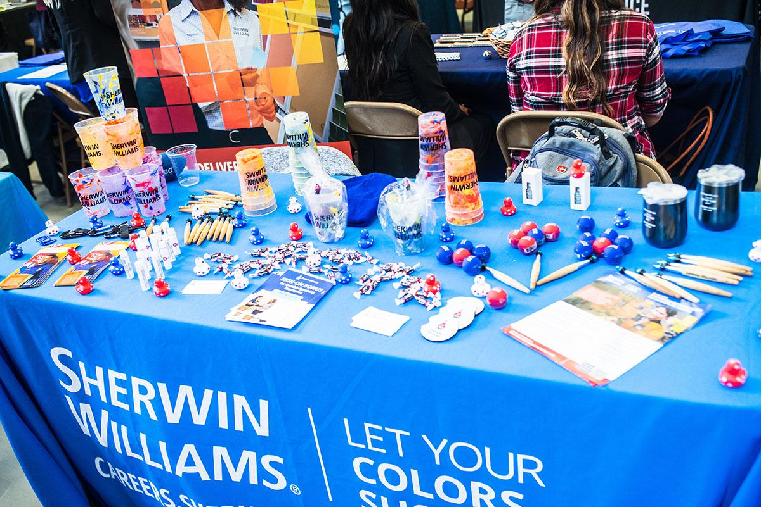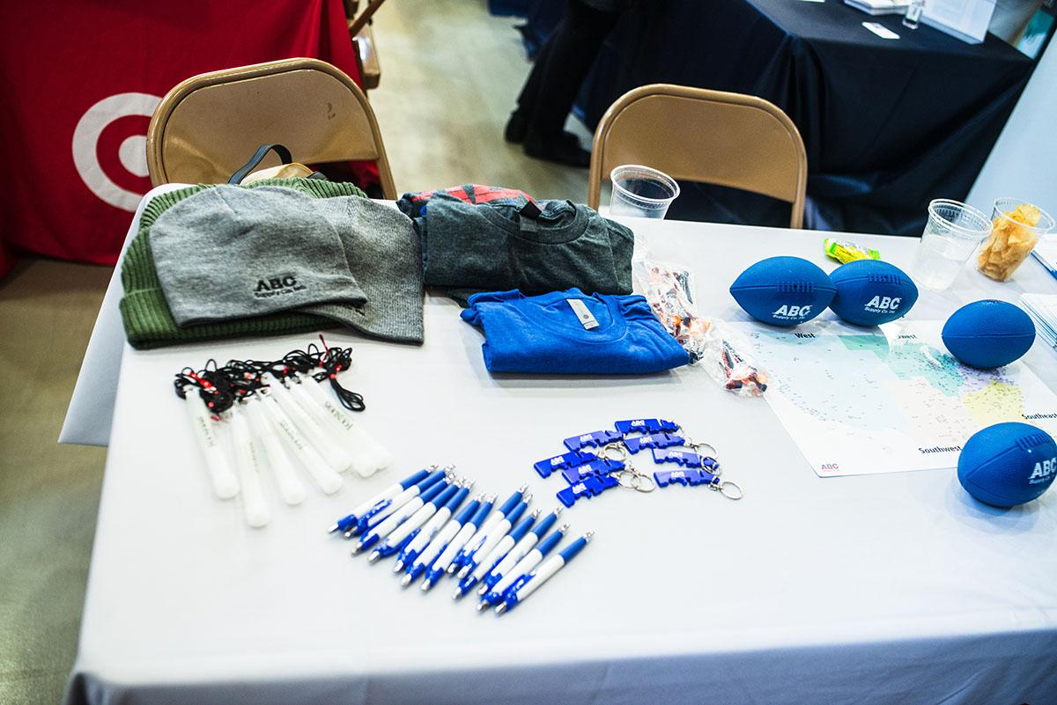
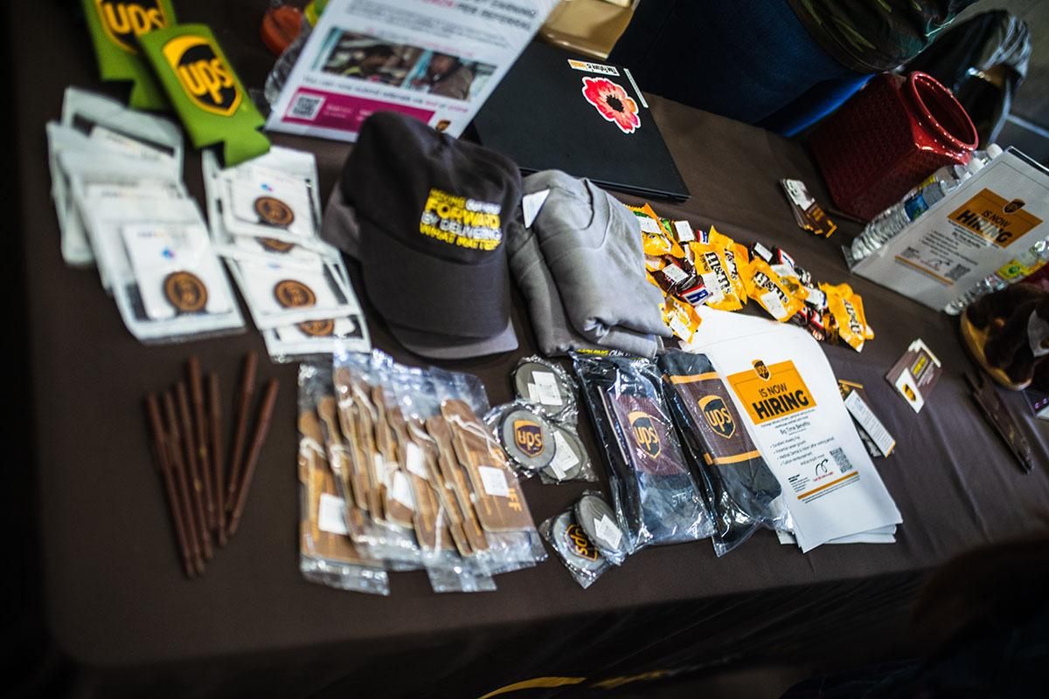
Photos By: Forrest Morris

Interview with Gwen Larned Zero Waste Coordinator 2015-2019
Following are key takeaways from an interview with Gwen Larned. Westerns previous Zero Waste Coordinator who held the position for four years. For the full transcript see Appendix B

Date: November 11th, 2022.
Interviewers: Forrest Morris & Brenna McDaniel

Can you tell us a little about your time as the Zero Waste coordinator for WWU? How long, what kind of projects, what were your goals, etc…?

- Started as the Zero Waste assistant for Western in 2015 and then moved into being the Zero Waste coordinator
- Had the position for the next four years.
- The Zero Waste program was in charge of generating outreach and education on how to start recycling and waste audits
- Stakeholders managing the waste on campus weren't well coordinated
- Sophomore year was getting these teams to come to the same table and talk
- Asked to be the lead on waste chapter for Westerns Sustainability Action Plan

What does a zero-waste event mean to you?

- The last thing an event planner will think about is trash cans, and what's going to happen with the trash
- If you want a zero-waste event, your first question has to be how is this going to be a zero-waste event?
- Need to weigh and measure rates
- 90% diversion rate.
- If everything provided by the event is zero waste and compost and recycling bins are management event should be zero waste regardless

What are the largest challenges to zero waste?

- Most food comes in packaging
- Preparing food for hundreds of people or food vendors
- Expectations around decorations and flair
- Convincing planning team zero waste can be fun
- Acquiring reusable dishware
- Freebies from vendors

How were those barriers overcome?

- Draft contract with vendors
- Bring back up materials in case vendors don't bring correct materials.
- Ask vendors to provide interactive game instead of freebies
- Developing waste stream logistics
- App for diverting leftover food

Do you have any recommendations for a zero-waste framework?

- Effectively measure diversion rates
- Acquire adequate funding
- Commit to developing waste strategies
- Custom signage at events and reusable decorations

Case Studies: Brookby School Ag Day, Auckland New Zealand
An annual event put on by Brookby Primary School which includes food and drink vendors, entertainment and animal judging. The event brings around 1,800 attendees every year and has an 80% diversion rate (Auckland Council, 2020). Organizers contracted vendors early in the planning phase to let them know the event was zero waste and assisted in sourcing compostable utensils and packaging. Back-up compostable packages were also purchased in case vendors did not comply or were not reached before the event. Bins were strategically placed with clear signage, and color coding to separate waste, compost and landfill. Attendees were also informed prior to the event, aligned with signage and announcements over an intercom to remind attendees to dispose of their waste properly. Key takeaways gathered from event organizers are as followed:
- identifying all possible waste streams and logistics before the event can minimize setbacks.
- Bin monitors are essential to the proper sorting and need to communicate clearly with attendees about expectations, this can be a learning opportunity for the general public as well.
- Bins need to be routinely emptied to avoid overflow, otherwise contamination is likely.
- Some vendors will likely still bring non-compostable – prepare by having a backup of compostable utensils, and packaging.
- Prepare for strange or unexpected waste that wasn't anticipated, for this event it was coconuts, another example may be tinfoil butter wapping hidden food clamshells.
Brookby’s Ag Day is a successful example of a school-sponsored zero waste event. Planning the event with a zero waste lens, from start to finish, can lead to a high diversion rate with low additional cost, and improve the experience for all attendees.

Recommendations
Recommendations are broken into two categories. Those that are within the zero waste guideline provided, or planning recommendations, and those outside the parameters of this report that would require policy change through the University, policy recommendations. Most of these recommendations are easily achievable by event planners if they begin planning with zero waste in mind. The success of zero waste events depends on planners' ability to follow specific recommendations laid out by the zero-waste event guideline and checklist.

Planning Recommendations
The overall goal of zero waste events is to divert 90% of materials from landfill. To achieve this, event planners must first commit to reducing overall consumption at events, rather than mitigating and diverting high waste levels after the event has occurred. This can be done with responsible planning and a combined effort between organizers, attendees and vendors.
Decorations–Generally decorations are specific to events and are disposed of after the event. Organizers can avoid this by creating general decorations that are not specific to any event. For example, for events that occur annually or quarterly, organizers can create banners or decor that can be stored and reused the next time the event occurs. Organizers are strongly advised to avoid things like single-use plastic such as balloons or flyers, rent instead of buying large items or eliminate items completely. Use QR codes or digital alternatives to flyers, maps and general information.
Food and Catering–Try to get an accurate measure of the food that will be needed to prevent excess. If food will be provided by the school, make sure to follow all local laws and mandates, this includes the single-use plastic ban. Try to use metal utensils and BPI-certified compostable products. If food will be provided by independent vendors, tell them to use similar products and avoid single-serve packets, such as ketchup or butter– these have the potential to be missed by waste sorters and can easily contaminate compost.
Sorting Stations–Clearly label recycling/compost/and waste bins with large and easily identifiable signage. Photos of material can help reduce confusion, ideally photos of products that will be at the event, alternatively consider taping physical products to signage. Use smaller bins for waste and always place compost and recycling next to them.
Waste Logistics– identify high-traffic areas and place sorting stations strategically. Create a map showing the locations of the stations and central dumping locations. Lay out the process for emptying bins and plan the most efficient and quickest route. Limit the amount of sorting stations to one per 50 attendees. Ensure all custodial staff and student volunteers are aware of sorting stations' locations along with routes to the central dumpster/consolidation area. Supply all food vendors with small compost bins, or tell them to bring their own.
Vendors–vendor compliance may be one of the largest hurdles to overcome when planning a zero-waste event. To avoid problems down the road contact vendors as early as possible to inform them the event will be zero waste and clearly explain what the means for them and what is expected of them. This includes limiting the number of free giveaways or “freebies”. Instead, propose interactive material or possibly a game to gain attendees' attention. Freebies are not intended to last long or hold real value, hence the reason they are free.
Sorting Station Volunteers– For zero waste events to be a success, volunteers at sorting stations are essential. Aside from educating attendees on proper waste management, part of their role will be ensuring compost and recycling do not become contaminated and communicating with custodial staff when bins need to be emptied or replaced. Volunteers should be recruited from local high schools, targeting students interested in attending WWU, those looking for volunteer hours, or those in sustainability clubs. Alternatively, many intramural sports require players to volunteer a specific amount of hours each quarter, and volunteering as sorters could be mutually beneficial. Planners should also reach out to any sustainability or zero-waste clubs on campus for volunteering, or support.

External Recommendations
Event planning can only go so far. To ensure zero-waste events are widely successful on campus, it is recommended that the University implement its own zero-waste policies and procedures. This includes institutionalizing the zero waste guidelines, standardizing the process and providing support and resources for students and staff event organizers, designing an app that can reduce food waste and to address food insecurity on campus, and making the Zero Waste Coordinator role a full-time position.
Standardization– Aside from a direct link to GHG emissions, proper waste management can reduce University’s overhead by lowering waste bills, increasing profits from sold recycling and reducing the number of products purchased for events. To make the process as streamlined as possible, it is recommended that Western either adopts these zero waste guidelines or design its own, along with reintegrating the zero waste program back into the university. Currently, the zero waste program is run by Western's AS Recycling Center, which itself is run by students through AS. Although this structure may promote leadership and accountability via being student-run, it can lead to a lack of organization and funding.
Food Recovery App– a large barrier to zero waste events is leftover food, either when the school itself is providing food and beverages or outside vendors are contracted. A solution to leftovers, as done by other universities such as Santa Monica College, is creating an app that can be used by students to find leftover meals across campus after events(Santa Monica College, 2022). In theory, organizers or vendors can post to the app the amount and type of food, and the location it can be picked up. This solution can also help feed students who lack food security, don't have a meal plan, or can't afford groceries.
Zero Waste Coordinator–Currently, Western does have a zero waste coordinator position, but it is a part-time position that is staffed by a full-time Western student. The position is a great opportunity and learning experience for students. It allows students to gain real-world knowledge and develop leadership skills, but not without complications. Full-time students already have their hands full with lectures, homework and exams. Assigning them a part-time position with the responsibility of making the campus zero waste is an extra burden that many students can't handle effectively. Students also lack the hands-on experience required to make a campus-wide program function smoothly and properly. By creating a full-time Zero-Waste Coordinator position, the University will attract experienced professionals with a successful track record running zero-waste programs.

Monitoring and Evaluation
The success of this project will be tracked through the institutionalization of the zero waste framework that will reduce accumulated waste following university sponsored events. Waste should be diverted at a rate of 90% when the framework is implemented into the planning process as the use of nonessential disposables will be prohibited, excess food will be redistributed, and proper waste sorting practices will be in place. The redistribution of leftover food will be achieved through a free app marketed towards students that will be notified when and where leftovers will be available for pick-up. The Green Leaders program will be responsible for overseeing the disposal of waste and educating event attendees on proper waste sorting practices. Zero Waste Western currently conducts waste audits on recycling and waste disposal stations to analyze the rate of contamination and mis-sorting of items that will be crucial in determining if the 90% waste reduction goals are met.

Budget
The Zero Waste Coordinator is already an active position at part-time employment, and no additional funds will be needed if this position remains part-time. However, if the Zero Waste Coordinator transitions to full-time employment, the cost will double (if the hourly rate remains) and additional funding may be needed. It is recommended that there are backup supplies for vendors who do not adhere to the use of compostables. Included are the estimated costs of these items from Eco Products (Eco Products Store).

Zero Waste Events Framework Budget
Item | Quantity | Annual Cost
Green Leaders volunteer program | N/A | $ -
Zero Waste Coordinator (full-time) | 30 hours/ week | $ 23,832.00
Food Waste Diversion App | N/A | $ -
Sugarcane Clamshell 8 x 8 x 3" | 1,000 | $ 701.65
Sugarcane 12oz Bowl | 1,000 | $ 269.52
Sugarcane 6" Plates | 1,000 | $ 181.41
Plantware 6" Knife | 1,000 | $ 155.63
Plantware 6" Spoon | 1,000 | $ 155.63
Plantware 6" Fork | 1,000 | $ 155.63
GreenStripe Hot Cups, 8oz | 1,000 | $ 159.89
GreenStripe Cold Cups, 9oz | 1,000 | $ 193.38
Total |  | $ 25,804.74

Conclusion

Zero waste practices have been institutionalized across many universities with high rates of success without sacrificing attendees' expectations. Implementing a zero-waste framework into the facilitation of events encourages environmental, social, and economic equity by addressing food insecurity, climate change, and reducing university spending. Eliminating disposables, vendor compliance, waste management, and a backup plan for the risk of zero waste practices not being used are essential to the success of a 90% diversion rate in post-event waste audits. The Fall 2022 Career Fair demonstrates the over-purchasing of disposables for large events and contamination of waste stations when there are no designated sorters. The goal of this project is to expand on the values of sustainability in the SAP by ensuring that the current practices will no longer be tolerated. University policy changes are encouraged in the external recommendations to determine the highest level of efficiency and resilience through standardization, a food recovery app, and the transition from a part-time student-held Zero Waste Coordinator to a full-time position for quality assurance. No additional funding is currently needed as the Zero Waste Coordinator position is already in effect. However, funding may be required if the position transitioned from part-time to full-time.
The institutionalization of this project can inspire neighboring institutions and students to engage in sustainability and zero-waste education. Transitioning to a zero-waste environment on campus reflects the values of the SAP, and builds resilience and equity in the local community.

Appendix A

Photos and documentation from Career fair
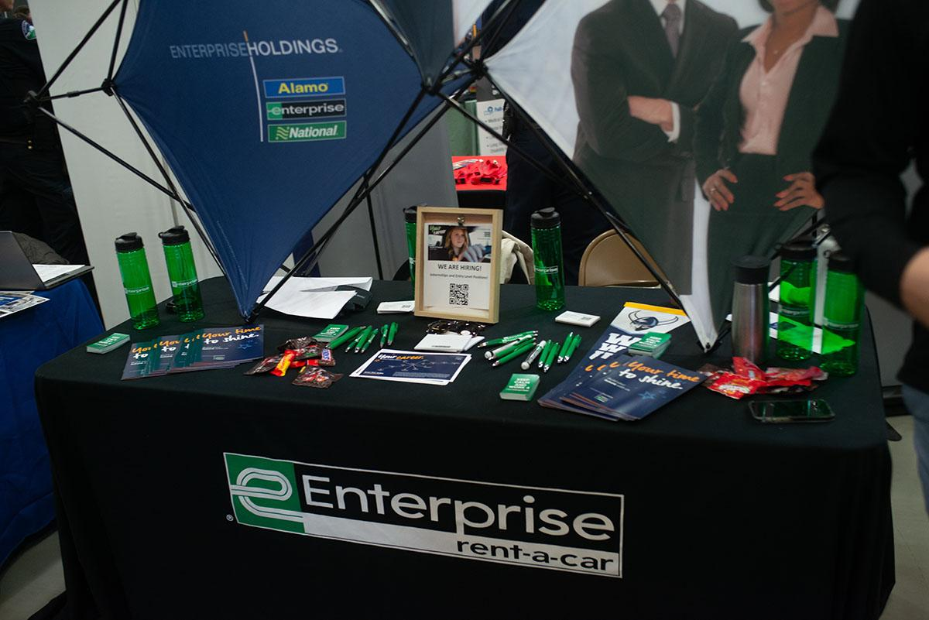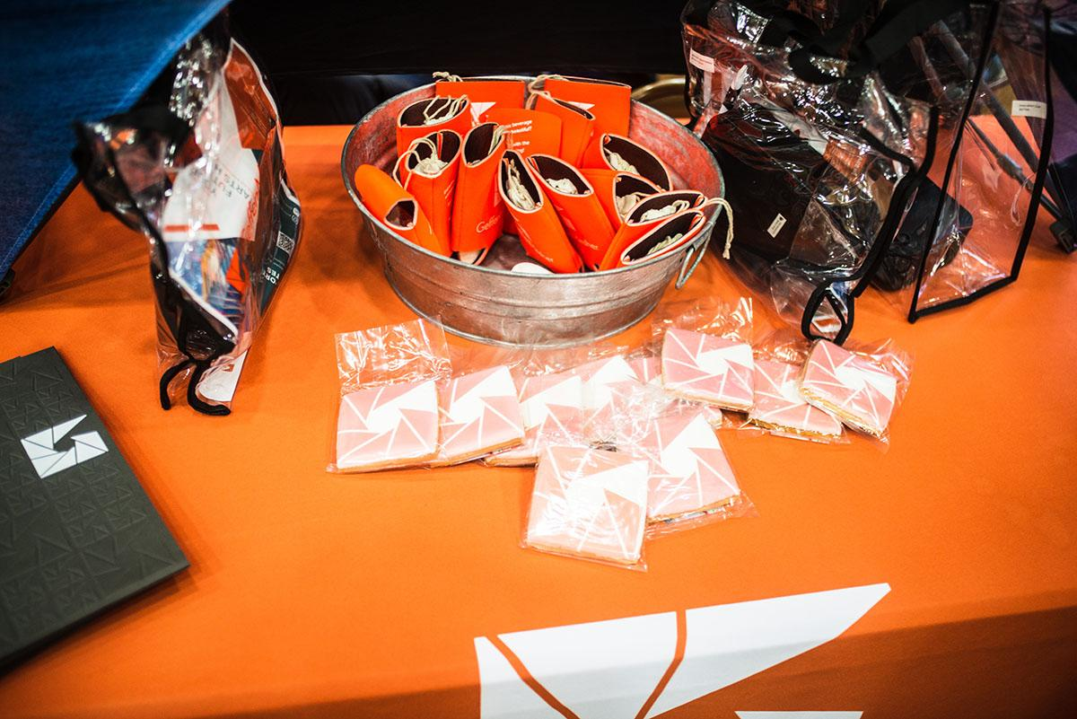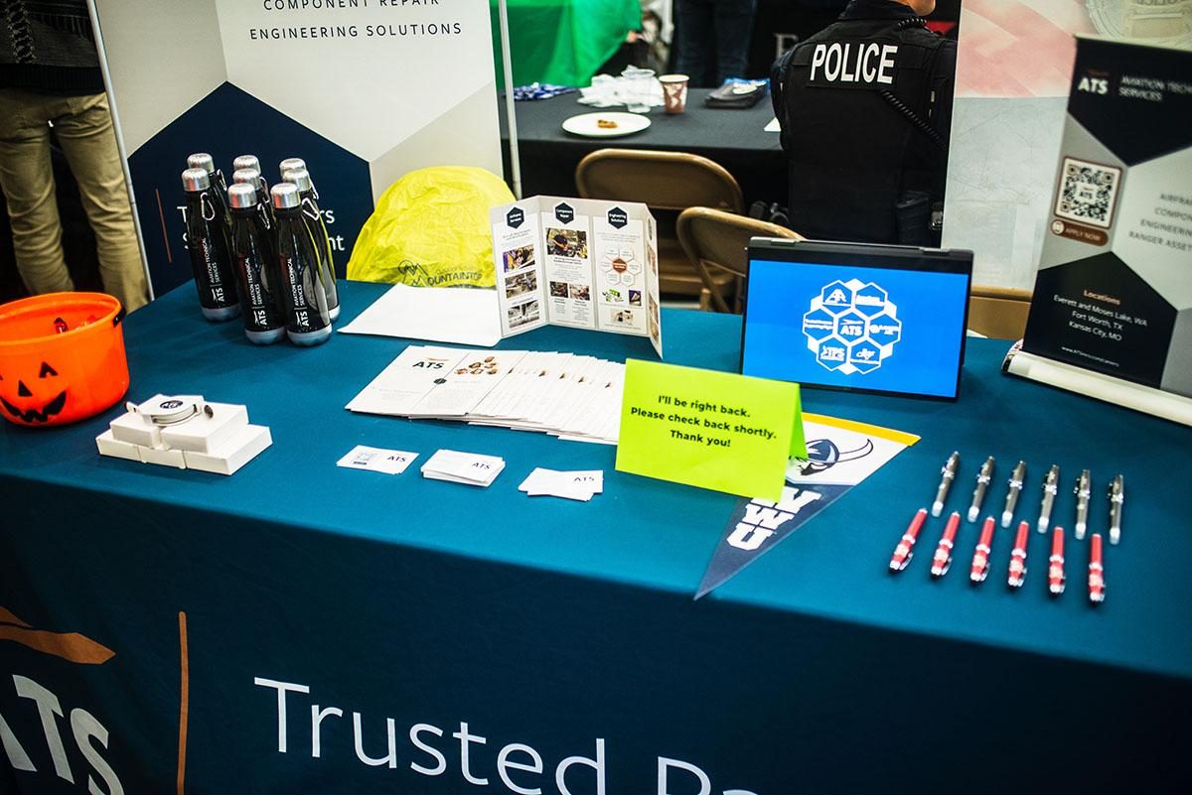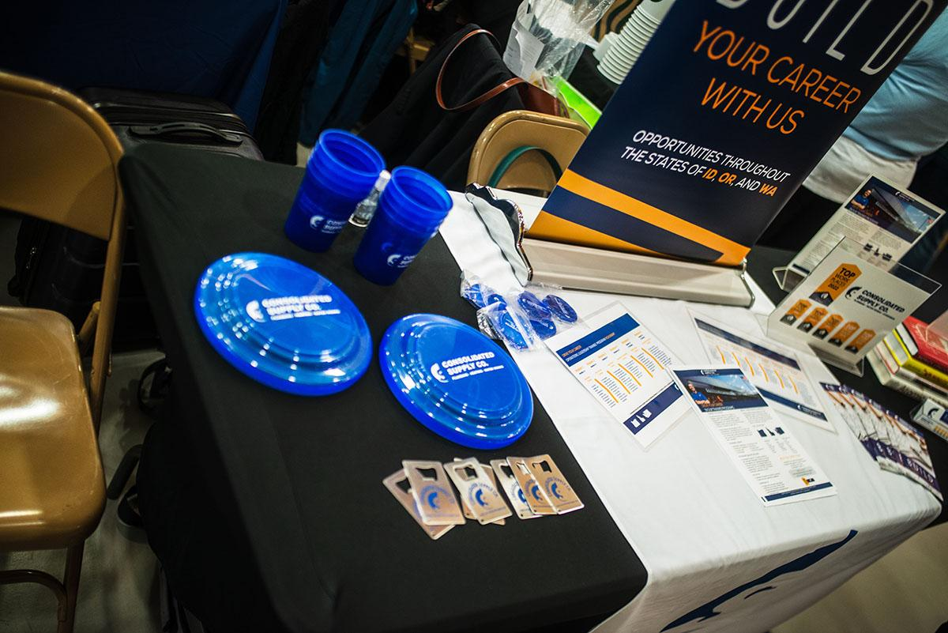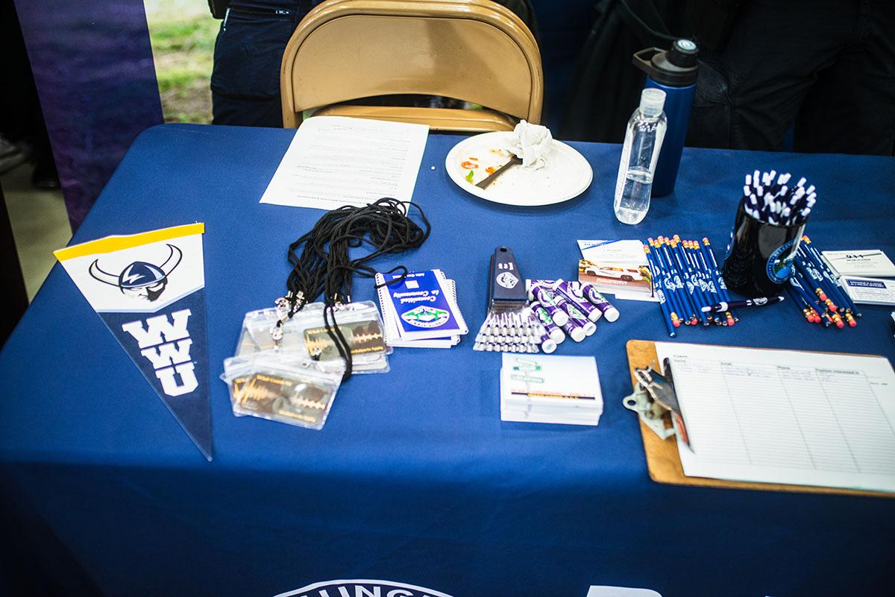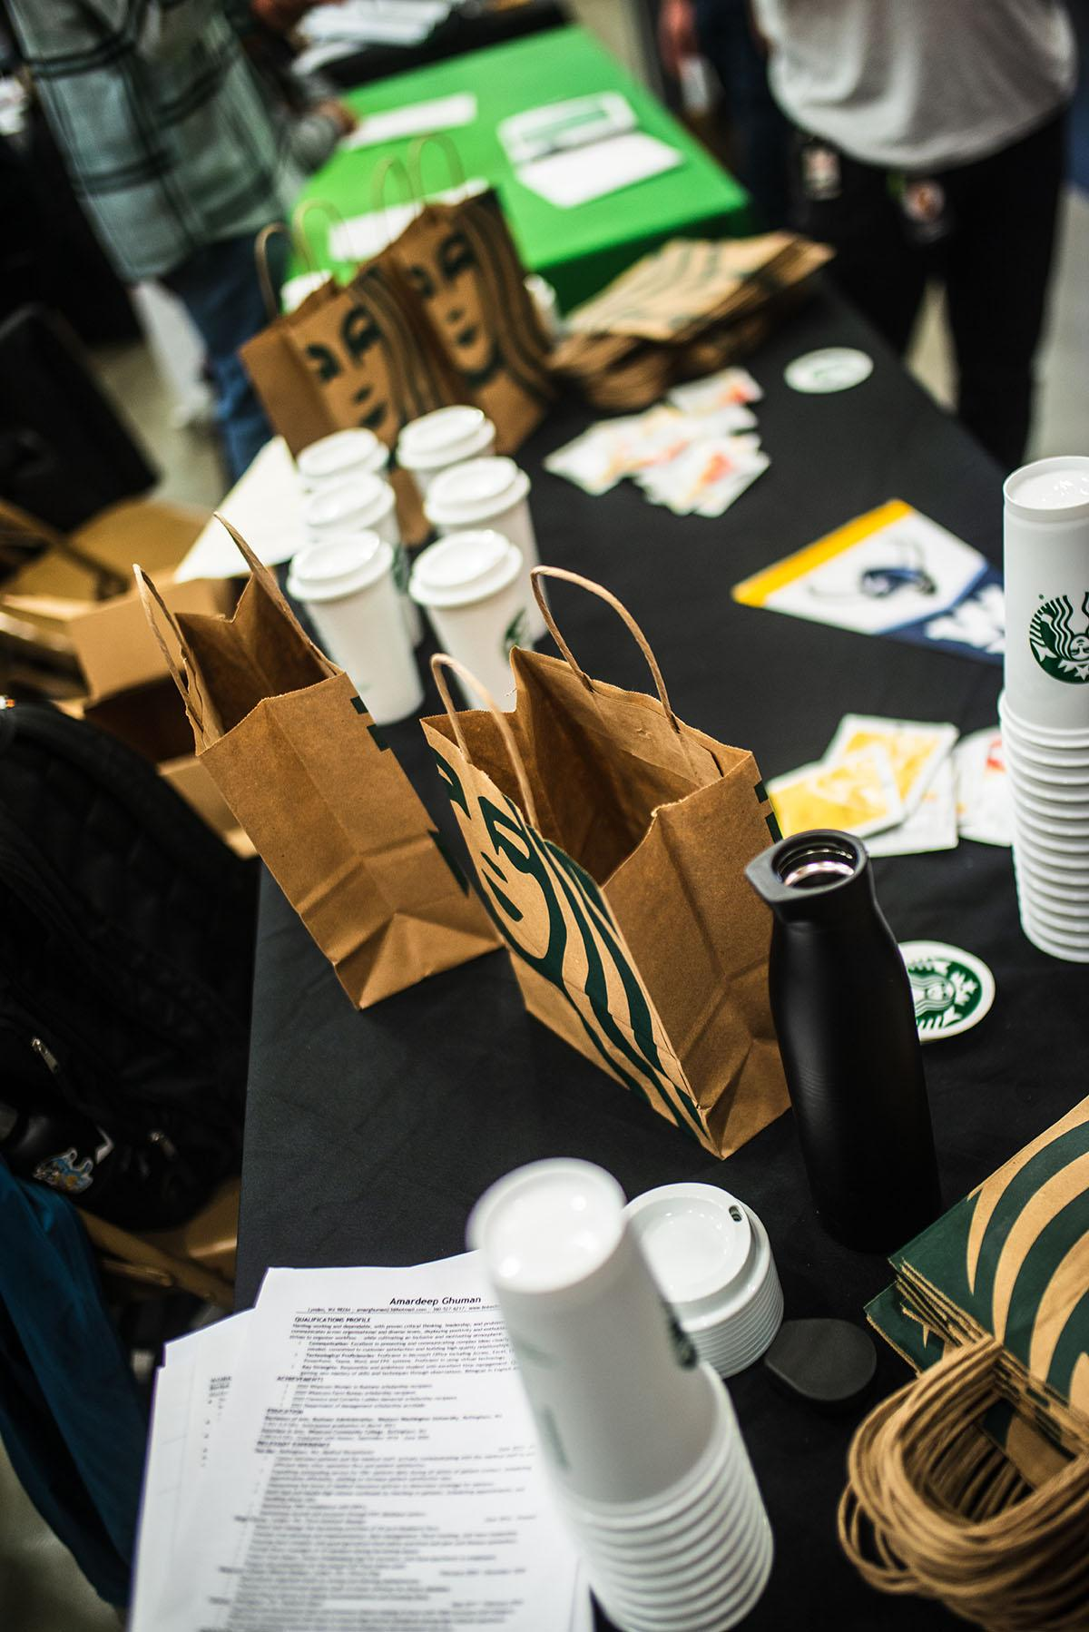

Appendix B

Full transcript of Interview with Gwen Larned
Gwen Larned
Yeah, I started as the Zero Waste assistant for Western in 2015 and then moved into being the Zero Waste coordinator like a few months later. So by like, the beginning of my sophomore year, which I guess was like the fall 2015, I was the zero waste coordinator. And then I had the position for the next four years because I was at Western for four and a half years. And so I was a student at the time, of course, and it was a part time job. And I was studying business and sustainability at the same time. And then when I took over the program, basically the Zero Waste program was in charge of generating just like outreach and education on how to start recycling. And then we also did waste audits which is like sorting trash from different places on campus to analyze it to see what type of trash we are dealing with. And then when I took over the program, I realized that really the stakeholders managed the waste on campus weren't really well coordinated, like they didn't talk to each other ever. For example, like the recycling center is its own unit. The recycling center works independently. It's its own. It's an independent business actually, it's funded through the AS and so it's managed by like the recycling center manager, which is whatever his name is, like, Rich, I can't remember his last name anymore. Anyways, so the AS is independently funded and has their own funding stream and everything and they report to whatever VP oversees the AS. But then like Dining Services, which of course dining produces most of the waste at Western. So Steve at the time was in charge of dining services. And Steve never talked to the recycling center. But the recycling center had a lot of issues coming from the dining halls. And then just like the residence halls in general, of course, like they have their own. I don't know if you know this, but the residence halls have their own funding stream. Separate from the AS they're under a different VP from the AS as well. So like, oh, and then the custodial teams. There's multiple custodial teams at Western. The gym has its own custodial team because the gym is owned and funded by the AS. Then the academic buildings have their own custodial team. And then the residence halls have their own custodial team. And all of those custodial teams have different funding sources and managers and different VPs even and so within an institution like Western when you have different teams reporting to different vice presidents, but hypothetically they should all be working on a goal like zero waste together. It's really impossible to get them to align on that goal unless you have like, you know like Game Plan lined out were like, agreement from the VPs. But this is important. And so that's what I started working on. My sophomore year was like, getting these teams to come to the same table and talk about our long term game plan. Because at the time Western was saying they had these big goals for zero waste, but they didn't really have a game plan. And so, at the same time, Western started its planning process for its sustainability action plan. And I was asked to be the lead on the waste chapter because I had already been talking with all of the stakeholders. And the sustainability Action Plan took two and a half years to write as a team, which was stakeholders from all across campus that came together to write a sustainability action plan for the campus. So that is a lot of what I worked on was doing those meetings with people and creating the long term like 20 year plan for how we were going to go zero waste. But I also worked on reviewing waste data for our campus and communicating with our waste hauler, the garbage company. SSC, I think, is what it is. Yeah, sanitary sanitary services company. And so like, for example, one of the things I found was I think this was also my sophomore year, I was doing data collection, just checking how full dumpsters and compost bins were on campus to see if we were being over serviced or under serviced by our trash hauler. And so I liked reviewing our billing and everything to see how much we were paying on each account and stuff. And what I found every week was that the green compost bins for academic buildings were always empty. And I was like, Okay, what's happening here like, why where's the compost? And it turned out that the custodians from the buildings were not putting the compost into the compost bins, because the college stopped paying for compost bags a couple of years prior because compost bags, like they biodegrade and apparently they ordered a ton of them in bulk at first and a bunch of them like biodegrade in storage. And so the college decided it was a waste of money to buy them again. But then the customer so they told the custodians to like turn the bags inside out and toss the compost into the bin and then throw away the trash bag but of course that's like really inefficient and messy and unsafe for a custodian to do and of course no one was like making sure they were doing that. And over the years. That training just wasn't even explained. And so people just stopped putting like compost and compost fancy like, you know, Miller Hall has sorting stations. And like all of the hallways like for recycling compost and trash. Yeah. So Miller Hall for a whole year basically. I mean, and I don't know how long this is happening before I noticed it. But all of the compost bins were just going into the trash. And so I for a few months had to collect data to prove that this was happening. And then it had to be escalated to the VP that was in charge of the academic custodial team. And then basically, I just like had to show him my data and then he was like, Well, yeah, this was pretty obvious that we need to do more training and we need to create a funding stream for buying compost bags. But it was just like stuff like that where there basically just wasn't somebody looking at what was actually happening in the trash in the compost. The recycling center does a great job with the recycling program. But again, like they because the recycling center started out as a student program in the 70s. The recycling center has always stayed intentionally independent of the university, and intentionally independent from the garbage company, they don't want to be incorporated into the college, they want it to stay being a student owned program and like student run, but in that they haven't done a good job. Creating relationships across campus to improve recycling. And they were all self funded. So the recycling on campus funds the recycling center, so they sell the recycling. I also did a lot of grants during my time at Western through the sustainability Action Fund grant program. A lot of them were in collaboration with the recycling center. The biggest one I did was to buy five more big belly sorting stations. So the original four big belly sorting stations are in Red Square. Those are the solar powered trash cans. I don't know if you know that they have solar panels on them.

Forrest Morris
Yeah, I didn't know that.

Gwen Larned
So the solar panels enable the trash cans to track how full they are. Well, the solar panels power sonar to track how full it is. And then it communicates that information to the cloud. So then the grounds crew only has to empty full bins instead of partially full bins. And so it significantly reduces ground crew labor time. And when the trash cans, the recycling and the compost don't do this, but the trash cans compact like it, it pushes down on the trash so that it can hold like 10 times more trash, which also reduces labor time. So anyways, those were the first four were a pilot project also funded through the SEJF, but it was really effective. Both the recycling center and the grounds crew said it was cutting down a lot on their service time because there used to be like 20 trash cans around Red Square that they had to service and now they go to four sorting stations. So it's a lot less. And so my proposal was to get five more to cover the rest of campus. And I haven't been to Western in a while. I'm assuming they didn't complete my project. But the concept was to put five more of the big belly bins out and eliminate all of the other outdoor bins. So hypothetically, there shouldn't be any outdoor trash cans or recycling bins except for the fancy ones at Western.

Forrest Morris
I have noticed there's a few solo trash cans which I've kind of wondered like, I don't think we should have any single trash cans anywhere. There should always be recycling compost together, right? We have a new, interdisciplinary science building, and I've noticed what they're doing is they're putting trash bags in the recycling and then the recycling center has to take the trash bags and dump them out and then throw away those trash bags, which seems really inefficient. I think they're doing it to keep the waystation cleaner?

Gwen Larned
So another big issue is that this was like a whole thing. The recycling center uses the blue, Big Blue barrels. Those round bins you see in hallways, sometimes. Back in the day, those were the only bins used for recycling. And so those were just in all of the hallways and over time the college has tried to quote unquote, beautify the waste system. And so as they remodeled buildings they built sorting stations. So Miller Hall is the best example. They don't have trash cans. Well, they do have some random ones that shouldn't be there. But there's just like the built in sorting stations in all of the hallways with trash recycling and compost. But those obviously do not fit these giant 50 gallon barrels. And so then in Miller Hall, there's some random Big Blue barrels too, but not very many of them. And that's just because aesthetically the college doesn't want big blue barrels in the hallways anymore. Yeah, and technically because of fire code you're not supposed to be using the 50 gallon big blue barrel anymore. Like five years ago the state said you can only use a 35 gallon bin for recycling because of fire hazards. Because it's like a hazard to have a giant binder full of paper in your hallway. But anyway, Rich refuses to get rid of the big blue barrels because he gets them for free from someone and they're super durable, like they work really well. For the way that they handle them with the recycling center. But anyways, so the recycling center just like yeah, hasn't adapted to how the college wants to work with them. It just like hasn't really evolved much since the 70s

Forrest Morris
Do you think it should be run through the school or do you see the benefits of like kind of student you know as run?

Gwen Larned
In terms of achieving zero waste, I don't think the recycling center in the way that it's managed is well equipped to accomplish that. Largely because okay, like other schools that have achieved or like I would say are great examples of zero waste. UC Boulder is a really good example of a school that has an amazing student run recycling program, but when you look them up, UC Boulder has a full on recycling center. Like what a city has with real equipment. At Western the students sort everything by here. And so when you're talking about I mean, Western’s recycling rate is probably around 35% right now. It needs to be at least 75% like 75% of the waste at Western shouldn't be recycled. So that means they need to increase how much they can process by three times. And they already have like 20 Students working there 20 hours a week. And it's no, I mean, I don't know if you've seen the recycling center but it's not big it's one building and a parking lot. And like a few pickup trucks, so I just don't think that the school values it enough to give it the investment that it needs to have the technology it needs to scale up that well. Yeah, that would be my biggest concern. And I just think more and more colleges are turning over their recycling program. To be managed by the waste hauler in their city because it is just more efficient and more cost effective. And as we move towards zero waste, we're really moving more and more towards standardization. I don't know if you're aware of this but technically Western has different recycling rules than the city of Bellingham. And that's because Western sells different recyclable material than what the city is willing to accept in their recycling program. So Western’s recycling center only wants to accept materials they can sell for value, and like at a market rate, whereas the city is going to accept anything that is quite unquote recyclable because they want to increase their recycling rate as much as possible. But the recycling center is always going to focus on profit because it's a profit driven business, but Zero Waste isn't always going to be profitable. Like recycling, the closer we get to zero waste, and the more you're going to be recycling, types of things that are not super easy to recycle. You know, you have to start accepting plastic bags if you're gonna get to zero waste, but the recycling center will never be able to make money off with recycling plastic bags. So anyway, I could probably talk way too much about that specific issue.

Forrest Morris
Yeah, that's a lot of interesting stuff that I did not know about. So is there kind of any kind of like baseline standardization between these custodial groups and different facilities? Are there any interactions or communication? Are they just all kind of doing their own thing?

Gwen Larned
So, as far as like when I was there, it was pretty separate. Like, for example, academic custodial I once asked the head of academic custodial, which custodial team was in charge of the health center, I think, and he didn't know. Well, and then he emailed it to somebody on his team, and they responded and they said, Yeah, that's us. And I was like, damn, I really feel like academic custodians should know they're in charge of the health center. Right. And then same with like the gym and the AI or the AES building. So like the Viking union, that is the same custodial team as the gym, because they're both student funded. So yeah, like, like I said, these teams, I think it's yeah, it's the residence halls, the academic buildings, and then the student owned buildings. So there's three teams and all three of those teams respond, not just to different managers and different directors, but to different VPS. So their bosses don't even have the same bosses. So like their, their funding streams within the institution are totally siloed. They don't really communicate. They don't buy things together. They don't train together. They don't meet together. Like

Forrest Morris
Yeah, it sounds very ineffective and inefficient, honestly.

Gwen Larned
Yeah. And there's no official like, zero waste training that is given to the custodians or the grounds crew. So that is something that's written in the Zero Waste Plan. But I assume that the institution has kind of forgotten about the sustainability action plan since committing to it five years ago.

Forrest Morris
There's been a little work with the action plan, but in terms of the zero waste, it seems like there hasn't really been much at all.

Gwen Larned
Well, because after I left, they got rid of the Zero Waste program. So there's not even a zero waste coordinator now. Right?

Forrest Morris
Now there is a zero waste coordinator. Their role I don't think is very big, and I don't know if this they just got a new person or this is like they recently brought it back. But yeah, there isn't much. I think they're trying to get back, you know, on track. But yeah, so I guess that's kind of what we're hoping to do with this project, and that kind of comes to the next question. What would a Zero Waste event mean to you? What would you like to see at a zero waste event?

Gwen Larned
Yeah, so I mean, the most important thing I would say about zero waste planning at Western is that so often, and I saw this at my last job, too. I moved down to live in Los Angeles now and I managed the recycling program for Santa Monica College. And the biggest issue I see with event planning, is that the last thing an event planner will think about is trash cans, and what's going to happen with the trash. And if you want a zero waste event, your first question has to be how is this going to be a zero waste event? Because you can't plan waste out after you're already creating it. You know, like if you're already going to give away a bunch of trash as like giveaway items and all of your plates and bowls are trash and your cutlery is trash then it's not a zero waste of it. So the first thing is making sure that whatever they're going to purchase and give away at the event has to be recyclable or compostable. So most of it's going to be food products that have to be in recyclable or compostable packaging. But if they're giving away any freebies to attorneys, that's like a big one. Western often does T-shirts for events. That's a huge thing I would do away with because people don't wear event T-shirts again, and people get event T-shirts for every event. And those types of T-shirts don't do well in thrift stores. Like they ended up in developing countries like Yeah, so I would just say like Western should just figure out how to color code people without having to give them a t- shirt. Like give them a name tag or something you know? Or just tell people to wear blue. So that's a big one. And then obviously, making sure they have recycling and compost bins available is important and figuring out where they're gonna get those from is going to be important. So when you're talking about events on campus, you're going to have to figure out which custodial team they're working with. And make sure that that custodial team knows that that waste needs to go to a compost and recycling bin. If you want it to actually be counted as a zero waste event you should technically weigh the waste after to see if it was truly zero waste or not. And you would need to have a 90% diversion rate. But hypothetically, like if everything provided by the event is zero waste and then you provide recycling and compost bins, then it's pretty much zero waste anyways, as long as people mostly put stuff in the right bins, yeah, you know, so that makes it easy. But then also having like people stationed at the sorting stations to teach people what goes and what then depending on the size of them that I would say for your planning guide. Put in some kind of detail that's like for events above 50 people you need or like per per 50 people you need a sorting station. And per sorting station, you need one educator or something like that, because depending on the size of the event, you're going to need more sorting stations. And yeah, it's best to have an educator standing at each sorting station when there's a big crowd. But if it's an event like under 50 people, you probably don't need a waste educator. You just need somebody to make an announcement that says this is what we're providing you, this is what's recyclable and compostable and this is where you're going to find the bins. So that's the other big thing is to say like make sure that announcement is made. Ideally like at the beginning and at the end of the event. Like if there's going to be a time when everybody stands up and cleans up, that's a good time to remind them again how to sort. Yeah, they need to make an announcement about what's being provided and where people can find recycling and compost. I think that's like the big things.

Forrest Morris
we've actually been in contact with Sehome High School and we're trying to create this like volunteer system with high school students to kind of give them some face time with Western, or students are interested in going to Western or who need volunteer hours or who are just, you know, in a sustainability club at the high school, we thought that'd be a great way to get younger people involved into the sustainability movement. It's kind of a win win.

Gwen Larned
Also, intramural sports. A bunch of sports teams at Western are required to get a ton of community service. Specifically, I think the row team has an email address, where you can be like we need the row team guys to do work for free. Yeah, and I don't know why that is. But I definitely remember one of the big events I hosted was the move out program move out madness. I don't know if they still do that.

Forrest Morris
Yeah they do. Were everyone brings their furniture and you can trade furniture?

Gwen Larned
Yeah, yep. Cool. But yeah, we use the row team guys one year for that to move furniture.

Forrest Morris
You mentioned some difficulties but could you summarize some of the biggest challenges to zero waste events?

Gwen Larned
Great question. I would say one of the challenges obviously, it's just that most food comes in packaging. So I guess when you're talking about a zero waste event, it's like how quote unquote Zero Waste is it truly going to be because if you're providing food for hundreds of people, like I guess if a caterer brings in food, like you can maybe work with the caterer to mostly use recyclable and like reusable packaging or something, but like, that's going to be a hurdle is to figure out what kind of snacks or food you can provide. It's not just like fruits and vegetables. Or pizza because like pizza comes in a compostable box. So you could just have pizza parties all the time. You know? Like, you have to work with vendors to get them to have packaging, zero waste. think that'd be the biggest thing. I also think the other big thing is just like, with events, people have expectations around decorations and like flair, and all of that flair. is usually garbage. Balloons, people frickin love, and you can't have balloons at a zero waste event. Obviously. People love to get free shit and giving away free shit is not very zero waste. So convincing a planning party, that these are going to be like that zero waste event is still fun. Like that's a hurdle because there has to be like some compromises around how you're going to decorate and stuff. But yeah, I would say the biggest probably the biggest thing is getting people to like buy into the Zero Waste idea and fully commit to it with creativity in mind. Because I mean, if you're doing like a big event and you need big cool decorations, like it's harder to go and find reused upcycle material than to just go to Amazon and buy party streamers or whatever. And especially in an institution like Western where it's like just do the cheapest, fastest thing to make it look nice. I mean, like any college is going to be like that, you know, like Amazon gets so much business from colleges because it's easy to set up the purchasing system. So like professors can easily track their spending in Amazon and like buy whatever they want with their accounts. Whereas if they want to, like the state won't even let colleges buy secondhand materials, because of like liability issues. Like you can't go to a thrift store with college money and spend it. I'm pretty positive. Interesting. Yeah, so there's there's hurdles to that in general. Yeah, I think the other like, key thing we struggled with at Western was getting reusable dishware at events because the dining hall or dining services, like can provide reusable dishware for any event, but it's an extra fee for cleaning it, obviously. And so like then who's going to front that fee is a question. But doing reusable dishware is technically or like hypothetically cheaper in the long run for the university than using a ton of compostable plates or whatever. So making that case somehow would be important I would think. Okay. But yeah, making it like an easy system for getting reusable. Dishware

Forrest Morris
was when you were at Western was Aramark doing all the food.

Gwen Larned
Yeah, yes, it is pretty difficult working with them. Steve was I don't know was last Steve Wodsworth. Wow, so many random things coming back to Steve Wadsworth was the director when I was there. And he was kind of a tool, but I would just walk into his office whenever I needed to talk to him and he didn't like that, but I don't think any I don't think any other student employees ever just walked into his office expecting to get to talk to him. So I think he gave me attention just because I bothered him so much. But he is like if you can get things to not cost more than it's easy. I don't think it makes a difference to Aramark, whether or not they use reusable dishware it's just whether it like who's going to cover that expense. Yeah. And like Western should just pay for it. Yeah. But I don't know what I don't remember what the cost is anymore. For paper towels to go to the compost. And then it was such a successful pilot the first year they said they would expand it to all of the other campus buildings. So hopefully by now all of the paper towels at Western are getting into the compost. But that was like a big one because at the time our waist on it data showed that 20% of the waste by volume going to landfill was just paper towels really. And that's just because paper towels are so fluffy. Like it's not a lot of weight, but it's a lot of volume. And when you think about it, like everybody washes their hands multiple times a day on campus. Yep. And I mean with COVID Hopefully way more. And so it amounts to like a shit ton of paper towels and for trash, you pay for your trash based on volume, right because you pay for a full dumpster. And so reducing the volume is the most important part in order to start seeing savings. And so in terms of waste diversion, technically, it wasn't diverting, like 20% of our waste, because waste diversion is based on weight, not volume. So you get into this weird thing and zero waste where it's like well

Forrest Morris
Do yu have any experience with food recovery?

Gwen Larned
Um, yeah, in California, there's a new state law, SB 717. Oh man, I don't remember what it is. But anyways, it's going to require everyone to divert like 75% of student waste from landfill by 2025 and recover 20% of edible food for human consumption. And so 20% of edible food has to be donated to food banks or food and food service program. And so at Santa Monica College, we were beginning to work on those planning programs. But and part of that was making sure that any leftover food from events gets donated to food banks, or gets eaten by students. So one of the things that SMC did they have like a, an app for communicating with students on different channels, and they started a channel called the campus food bell. And basically if a staff member hosted an event and they had leftover food they would post on me like app saying there was free food and students can come get it. And that would be a super cool thing to see Western incorporate because Western often has leftover food from events. And sometimes students get lucky and stumble upon it, but not always. And that's like the easiest way to get rid of leftover food is to have somebody come eat it right away. Yeah, it's like hard to package it and donate it. But there's like usually hungry students somewhere on campus. And like, they'll take a weird amount of leftovers at home with them, you know? Yeah.

Forrest Morris
So where was this because I know I read about San Diego's I think San Diego State or whatever St. The University of California, San Diego. They had a similar app. But it was part of the school's app. It was like within it but it was called like food notifications. And so what was the one you were talking about? What was it called something Bell works?

Gwen Larned
I worked for Santa Monica College they had an app that was like through this. I don't know what the apps called. But they called the channel on the app, the campus food bill.

Forrest Morris
Okay. So but it was it was through it was part of an app that Santa Monica College like created in like, okay,

Gwen Larned
so there would be like different channels for like sports and clubs and astronomy and, and one of the channels was for leftover food.

Forrest Morris
And I don't think Wes has any kind of app. So

Gwen Larned
yeah, they didn't when I was there, yeah. Even if you put like post on the website somewhere. Yeah. And like post an alert or send out an email to students. Were maybe you know why you can't true

Forrest Morris
or like a discord channel. Maybe could work yeah, and let students know that there is a discord and to check it. Totally. Okay, cool. Yeah, cuz we yeah, we want to figure out ways to Yeah, kind

Forrest Morris
We have a few food pantries around campus. But also again, I don't think a lot of students know of them. And even like, for people who do know them, I only know the one in the common building. I don't know where the rest are and I don't know what like

Gwen Larned
VU had one.

Forrest Morris
today. It's not like really, okay. I know the habitat or sustainable connections is also doing a fridge program where it's like a food pantry but it's a fridge. Yeah, and that would also be really cool. To get on campus. Yeah.

Gwen Larned
So yeah, Western could totally and that would be an easy thing to do with leftover food, from events to would be to take it to a communal fridge that people could access. Because yeah, the biggest hassle with leftover food from anything is is the packaging it and storing it before it gets donated. Yeah. Yeah.

Forrest Morris
So in terms of zero waste events, is there anything that you tried and didn't really work or kind of would recommend to avoid or anything?

Gwen Larned
I think one of the biggest things that's like always a problem is working with vendors. So like, I remember, like I also have y'all ever been to this update Stringband jamboree?

Forrest Morris
I haven't but um, I know but yeah, okay.

Gwen Larned
It's sick. You should go sometime. But I managed waste for them too, for a few years. And they have a bunch of food vendors. And we always put it in the contract that they had to use recyclable or compostable utensils, cups and bowls and plates and stuff. But they wouldn't it always sometimes they would just show up and they thought they bought compostable forks, but they weren't actually compostable. You know? And so we always brought backup materials so that if a vendor didn't have the appropriate materials, we supplied it for them. And then in the contract, said they were required to read like to reimburse us for that expense. And so that's something that I would recommend is putting it in the contract for vendors that they need to be prepared to test materials and then if they don't do that, there needs to be a backup plan. Yeah, I think that's like the biggest thing.

Forrest Morris
What about like condiments? Because I know I know the little individual condiment packets. When I worked with sustainable connections that was a huge problem at events, and it would kind of contaminate all the composting was Yeah. Would you recommend like a just like condiment station where everybody could use I know it's kind of COVID era and, you know, Sherry, and stuff like that, Aaron, it's

Gwen Larned
weird. Yeah. I mean, in terms of it being a zero waste event, technically, you only have to hit 90%. So you do get like that tiny bit of flexibility. The biggest thing is just making sure that people sorted correctly. So I would say that the way that you set up sorting stations with your food station is really important too. Because sometimes like if, if your food display for example, if only your coffee area is going to have little trash things like little coffee creamers, and like I don't know what else you would have in a coffee station. But if that's the only like trash only put a trash can next to that area. And then like make sure that like there's a sign that says this is trash put it right here same with like, yeah, if you have like food coming from a specific area, having a compost bin right there. That kind of thing is is useful. And then also like customizing signage for events is really helpful, but not exactly an easy thing to do for every single event event that's happening. So that would be something to consider is what school is it that does this. One of the universities somewhere in this country has a really cool app on their website. It might be UCLA, honestly. But they have like a template for their waste signage. And then you can drag and drop whatever images you want. So like, you're gonna have soda cans, and you're gonna have chick bags and you're gonna have apples, like you put all of those on your sign. And that way people know like this stuff is at this event and it goes in this bin because I think oftentimes people look at waste sorting signage, and there's too many images and they just get overwhelmed. So it's easiest to just like give people a sign that only has the things that the event. The other alternative is to provide a Velcro sign and they can belt velcro things to the sign

Forrest Morris
with the physical the actual Yeah, stuff. Yeah. Yeah. Okay, cool. Um, in terms of so we went to the career fair, and we're kind of just scoping it out and seeing you know, what was going on there and so yeah, in terms of like the freebie stuff do you see value in in some of those things? Or do you think like, they're, you don't really need any kind of freebies or what's your kind of thoughts?

Gwen Larned
I don't think people I think people like frame you just from like the, you know, I don't know, like people just do. Yeah, I don't think people actually give a shit about them and the reality like, it's always the cheapest version of any chapstick. And, like, I don't know, pens, people have plenty of pens. Yeah, I think it's honestly just like shitty little cheap knickknacks. And the worst part is that like that stuff is like bought in huge bulk. And it's like, the cheapest produced thing you can get. And so it's like very much so intended to be trash. Like I think that's a good way to like, look at it and you know, is like, well, how much is it worth? Like how much effort that the company put into it and like there's a reason these people are giving it away for free is because literally not worth anything to anyone.

Forrest Morris
It's almost just like decorating your table so it doesn't look. There's nothing on it. Right?

Gwen Larned
Yeah. And then it does become a question. Like, well, what do you get tablers to do? I think it's worth a conversation. I mean, now we get into like, the more philosophical side of this, right? Like, when you start talking about why are we going zero waste and like, what does it really look like? Then we have to talk about like, well, what's the real function of the event to begin with? Why the fuck do we invite all of these random people to give away the free shit? What is the point of that? What are they actually trying to get out of being there? They're trying to connect with students as customers. So what's a more effective way that we can encourage them to do that than giving away free shit? You know, like, and having that conversation with the vendors about like, this is the point to the event. You're not allowed to give away free things. Here's ways that we encourage you to connect with the students instead. One of the things that the Sustainability Office did was that we have a carnival each year where we invited like different sustainability programs, and we didn't, we didn't tell people they couldn't give away freebies. I don't think, but it was like, I think it was, like we said they shouldn't but they could, but we asked everyone to make a game. Um, and it had to be like, a unique game related to what they did, or like explaining what they did. And so like having some kind of interactive table or something, it's like cool to look at beyond just like random free things would probably be more engaging anyways. But yeah,

Forrest Morris
yeah, like that idea. Um, see what else I had I had one reference God Brenda, do you is there anything you've any other questions? You've thought up while we're while we're chatting at all? No, I was trying to think of some but when you definitely have a lot of really great stuff. Yeah. Oh, I've so I was reading about someone with some guideline recommended. You know, like you were kind of saying decorations for events, but they were kind of saying if these are annual events, if you could create, like you could reuse your decorations. Have you ever seen that in practice or tried that at all? Like for say the career fair, you create a career for a banner, but then you save it every year and you kind of reuse all these decorations instead of just tossing them and getting new ones?

Gwen Larned
Yeah, totally. I haven't really seen that at Western. I don't think the first thing I can think of was like the residence halls. have like a closet. For the bill, like what's it called? The student club for the residence halls that can throw events you know what I'm talking about?

Forrest Morris
I don't I don't really I didn't go to the I didn't live on campus at all.

Gwen Larned
So the residence halls have like their own as they have like a student group. That's devoted to like, represent them and spend their money for them. And they like 1000s and 1000s of dollars. So when you're talking about zero waste events on campus, that's a really important pool of money to talk about. Because at the end of the year, the residence halls all I was on the committee my freshman year, this is why I know this, but toward the end of the year, the residence halls all tell this committee to blow their money as fast as they can, otherwise they're not going to get the same amount of funding the next year, really. And so my year, they bought like finals week. Gift care. packages that they put like a bunch of random shit freebies in like, just straight up trash. Like it was so dumb. Like literally they got like expensive, cute Ziploc bags. And then like sparkly pencils or something. It was super, super stupid and they dropped like 10 grand on it.

Forrest Morris
Holy moly.

Gwen Larned
Yeah, because they have 1000s of dollars to blow. So like Fair Haven hosts a concert every year called end fair. I think they have some of that like decorations in their closet. But anyways, this closet holds like all of the event materials. So they Oddish where they have like popcorn makers and like coffee pot maker things and all of that stuff. So working with the residence halls to create our own Zero Waste kits would be pretty easy. And you would put those like committees are new every year. So those committees need training on zero waste event planning every year to okay. But all that they do is event planning. So that's like a really big group to consider. Yeah,

Forrest Morris
I feel like we would definitely have to Yeah, work with them. Or it's interesting that the Zero Waste coordinator doesn't really do like have a like educating is it really in their job description at all? It seems like that could be like a main thing of the coordinator.

Gwen Larned
I think it gets hard when you is the coordinator, a full time person whois a part time student.
Okay, yeah. So I think yeah, it just gets hard when you start talking about all of the things as you always coordinator shouldn't do. Yeah, my argument the whole time I was there was that zero waste coordinator shouldn't be a full time job, not a part time student position. Because for one, zero waste is I mean, it's an institutional goal, like the university signed a Zero Waste Plan, like and committed to achieving zero waste, so they should take it seriously and pay a full time employee to oversee that goal. happening. So that's like first and foremost, but the other thing is like it's when you have a student employee in a role like that. It's really easy for directors and VPs to ignore that person because they assume they'll be gone in a week or two. The reason that I was able to make progress when I was at Western is because I have the job for four and a half years. And so I was the most consistent person they've ever had in that position. And it takes three years to get a grant from the big belly sorting stations that I funded. The funding was approved the year before I graduated they installed them the year after I graduated. So it took like two years just to get them purchased and installed.

Forrest Morris
Yeah. How long does it take get the the grant to be approved from like the start writing grant writing to approval through the SEJF?

Gwen Larned
I think it was like maybe a six month process. It was not my first sprint but I done so I was already familiar with the process. So it was fairly easy. Yeah.

Forrest Morris
Did you try any kind of like grant writing to create a full time zero waste coordinator position even like a temporarily one to show its effectiveness. We,

Gwen Larned
my boss and I around the time that I was graduating, talked about it as an option. But I personally didn't want to stay and do that job. So therefore I did not do it.

Forrest Morris
Okay, gotcha.

Gwen Larned
But yeah, I mean, so like UCLA, I mean, not to compare Western to UCLA because like by size, they're nowhere near the same like UCLA has its own Zero Waste coordinator, Stanford as a zero waste coordinator, like Santa Monica College had a Recycling Coordinator, and they're a community college with 30,000 students, which is twice as many as Western but nonetheless, it's community college. So unlike their college campus was four square blocks, which is like, way smaller physically than Western. So yeah, there's plenty of reasons that Western should have a full time zero waste coordinator. It's also just like, honestly from the students perspective, having to do that job. It's unfair, because it's way too much responsibility and like, stress to put on a student like, I don't know, the zero waste movement in general can be so apocalyptic and depressing. Yeah, like yeah, anyways.

Forrest Morris
Yeah, that's well, I know because I know Western spends a ton of money on RECs and carbon offsets so they can claim to be net zero and think it's like 160 a year. But I feel like yeah, that money could you know, you could use a third of that to pay a zero waste coordinator, you know,

Gwen Larned
well, and so we have an energy manager at Western. And the way that they got his position funded was because they did the math to say how much so the energy manager is responsible for monitoring how much energy is used by each building. And he has to like figure out like, if some if some building is all of a sudden using way more energy, like why and so like, if somebody opened a window and all the cold air is getting like he has to go figure that out, you know? And so they did the math to figure out like how much energy savings they could have. And then like how much money that would save, and then what his salary would be compared. And so every year he has to, well, now I think his positions like permanent permanent, but I think in the first few years, it was a requirement that he be able to track that he was saving more money than they were paying him. It's kind of a lot of pressure, but yeah, but you can do the same thing with I mean, if you were to do a pilot program, like you said, for a zero waste coordinator to be full time, they would have to do that too. They would have to prove that they're saving as much money as their salary would be in order to get the college to fund it after the pilot program.

Forrest Morris
I know like so. I don't composting is cheaper than than trash, but do you think that'd be possible to divert enough or reduce trash?

Gwen Larned
So the first thing that a waste coordinator would oversee is our contract with our waste hauler, and right sizing or dumpsters and our service level to save money, so that's something that I was working at at Santa Monica College. And my estimates at Santa Monica College was that they could save $500 A week easily by like barely adjusting their service rate. And I mean, $500 a week is not much when you're talking about a college budget, but that was just like getting it to be correct. Not even like pushing them towards zero waste. So just making sure they weren't getting over serviced by having like an empty dumpster up every week. So I think they have, you know, probably 1000s of 1000s of dollars being wasted by not having proper service levels, I would assume because the easy like you don't want overflowing dumpsters, it doesn't look nice. And so usually people have a much higher service level than they need, because they don't want full dumpsters. But ideally, you should occasionally have an overfilled dumpster because that's going to tell you you're actually being serviced efficiently. Like some days you're gonna have slightly too much trash if you're actually being serviced at an appropriate rate. So I think that's the big thing and like when we did the paper towel composting project, I can't remember how many 1000s of dollars it was that I estimated but it was 10s to $20,000 every year. Put the paper towels in the compost bins and not in the trash cans because it's like 20% cheaper to compost into landfill. So you reduce landfill waste by 20%. And it's 20% cheaper to put it in the compost and that was I did the math and it worked out to like 10 or 20,000 Alexandria because Western spends like 200 NIT and brandy or anything all their waste bill. Okay. It's like in that ballpark.

Forrest Morris
Was Was this process were you just doing like really intensive waste? audits for each like station and then kind of like compiling all the info or how'd you? How'd you figure out

Gwen Larned
oh, we had historic we started data so there was like a like large Excel spreadsheet that had all the waste on it's ever done at Western over the last like decade. And so it was a lot of averaging a lot of assumptions. But every way started we did we found 20% of the landfill was paper towels, it was very consistent. Same with coffee cups, it's consistently 10% in the landfill stream at Western. Yeah, coffee cups would be a huge one I would tackle if I was Western. Also like as a zero waste coordinator. That's an easy like, thing that they can accomplish. It's like eliminating that 10% of waste from the landfill stream. Because like students can just bring coffee cups to campus and we already have a water bottle ban so why can't we have a coffee cup there? Yeah, totally. That was always my argument. Like people actually need water and we banned the bottled water. People don't need coffee. We can ban the coffee cups.

Forrest Morris
Yeah. Especially Western like at the start if there was like some onboarding thing in Westerns like, Okay, here's, here's a Western water bottle. Here's like a Western coffee cup now. And then then students couldn't say like, oh, well, like you need to have something for me like, well, we gave you a thing at the start, you know? Yeah.

Gwen Larned
It's like honestly coffee cups are very cheap nowadays. And you save money by using a reusable one. Yeah, we save like 10 or 20 cents or whatever. Every time you know. Yeah. So and it also has to be a fancy reusable mug. I think people really get caught up on that too. Yeah, anyways, um, but yeah, I think that there's the other big thing is like, waste isn't just about what goes in the trash. It's about what you buy. And so by helping the campus to significantly reduce purchasing they'd be bringing in less stuff. That would eventually become trash. And so that's where you're gonna get the really big cost savings. So encouraging the college to not buy new furniture as often encouraging the college to not buy new. It equipment. The college probably buys hundreds of new computers every year, just to keep modern, you know, the College wants to offer the latest technology. One of the things we realized though it SMC was a lot of college labs are empty a lot of the time and if there was a way to track how often computers are used like how many hours of the day which computers get used, you can become more efficient, which with where you're putting computers on campus. So you can see like what labs have the highest use, and then eliminate low use labs. I would also recommend that Western transition to not having stationary computers, they should just rent out laptops. Because you don't have to update laptops as frequently as you have to update stationary computers. And then you can track how often they're actually getting used and stuff. Yeah. But yeah, that's that's like a big thing is the technology that colleges use, because they have like a huge amount of funding for technology and it's easy to excuse spending money on technology because you're a college and you're gonna like attract students by having the best equipment. Yeah. But then like, you know, the IT department in the bottom of the library that like runs out the cameras and stuff. There's so much shit in the storage room that like no one knows exists except for like the 10 kids that go back and play with it, you know? Yeah. So there's all sorts of stuff like that, that the college spends money on that they don't need to know. Yeah, so I definitely think they could could afford talent Zero Waste coordinator.

Forrest Morris
Yeah. Yeah, there's you got a lot of good ideas and you know, how to just how to reduce our waste and consumption.

Gwen Larned
That only because I thought nonstop about it for like four years. I actually lived to zero waste while I was in college.

Forrest Morris
Yeah, I was reading some of those Western window things about Yeah, being your lifestyle changes and going on that zero waste road trip and stuff. Yeah. Are you still kind of

Gwen Larned
No, I actually at the beginning of the pandemic kind of stopped living zero waste partially just because it became harder because you couldn't shop in bulk stores anymore, and in LA couldn't bring your own reusable bags to grocery stores for a while. And like you couldn't use your own coffee cup at coffee places for a long time, and stuff like that. Yeah. I also became unemployed for about eight months at the beginning of the pandemic. And so just like in college, it was kind of easier to excuse spending a little bit more on certain things like organic food and like, I don't know, I shopped the coop nonstop. Like that was the only place I went because they had the amazing bulk aisle. But it was, you know, slightly more expensive than going to Winco or whatever. But at the time, it was my only priority. But then like becoming a real adult and being in the real world and being unemployed. I was like, oh shit, like I can't actually afford any of this wiggle room. Yeah. So it just kind of like put things in perspective and helped me prioritize things. But I've also become much more cynical about the zero waste movement I think that the zero waste movement and like so recycling in general, right we can we all kind of know Coca Cola and Pepsi invented to convince us that it's okay to buy plastic water bottles when we know it's not because plastic doesn't actually get recycled. Yep. So like recycling in and of itself was kind of a lie, and then zero waste, like the movement at large. Like I became really interested in using social media as a tool for activism, no, like educating people about sustainability. But I became really frustrated that the zero waste movement specifically and the broader sustainability movement but like the zero waste when it does it the worst I think, they like went hard on blaming consumers and making it all about random little purchasing habits. And like, if you ever see a list, that's like five steps for going zero waste, it's like compost and get a bamboo toothbrush and like, get a reusable water bottle. I don't know the really basic things. Which are nice, but they're not radical or revolutionary, and they're not going to shift us away from a capitalist economy. And that's the real issue. So I really, I actually left working at SMC and I don't work in the zero waste industry anymore. I work in energy efficiency now for a consulting company. Because I kind of wanted to honestly to take a step back from the movement because I just find it kind of frustrating nowadays.

Forrest Morris
Totally. I feel you. What do you in terms of the energy efficiency? How do you feel about the whole net zero? idea? I kind of have similar feelings where it's kind of I don't know, it's like, I don't know. I don't know how effective netzero can really be in terms of really getting something done and stopping climate change.

Gwen Larned
Yeah, I think, I don't know way too much about the energy industry. But from the conversations I've had lately, it's very much so the same way I feel about zero waste where people are like, yeah, like this is maybe a step in the right direction, but it doesn't actually solve the root problem. And I think, you know, like a big problem is like you mentioned carbon offsets is a huge issue because basically it's a lot of it is centered on not cutting down trees, and like protecting forests. That's like when I went to say that not cutting down trees. But the issue was like, how do you predict whether or not a forest was going to get cut down? And whether or not it needed to be protected? So are you spending money protecting a forest that was always going to be there any ways are you actually like, preventing carbon or like, you know, actually creating more benefit? So yeah, I think I think it's kind of a scam. Yeah. Also,

Forrest Morris
Oh, that's a good point. And that's it's funny you kind of said that state of sustainability like Journey is they are that's exactly how my experience went, you know, super gung ho and then he watched some documentaries, and he read some IPCC reports and you're like, holy shit, we're actually locked in. There's like, not much like yeah, the amount of work that needs to be done is not going to happen in the way our paradigms decided to set up. It's likely not really not much is gonna happen.

Gwen Larned
Yeah. Well, I get really frustrated because the zero waste movement and like energy offsets thing give us false hope. Because we do, we do a plastic bag then do a water bottle. We buy carbon offsets, and we're like we're doing the most work carbon. We're a net carbon zero school. We're like, we have sorting stations. What else do you want? And it's like, no, no, no, we need like, radical change. And so I think that's like when I really get frustrated by people who are like, Oh, no, but like, every individual choice matters, like everyone really can make a difference. It's like let's kind of maybe like stop pacifying ourselves. Yeah, like, we kind of just it's like, recycling is like a little warm hug. Like calms us down and like eases the ego anxiety. Yeah. But like, if we instead recognize that none of that was actually making the difference. We thought it was we would maybe stay outraged enough to overthrow our government. I don't know.

Forrest Morris
Well, we only have another two minutes and 30 seconds till it boots me again. Really quick. Do you? What was it? Do you like the sum up any recommendations you'd like to see or what you'd like to see with the Zero Waste framework? I know the sorting stations and a couple things we talked about, but maybe just like a quick summary. We could take some bullet points.

Gwen Larned
Yeah. Um, one thing I'll throw out if you haven't looked this up. There's a nonprofit called post landfill Action Network and they have a zero waste Event Guide on their website. They're a nonprofit that like helps universities across the country with their Zero Waste planning. And that guide is accessible for free but you have to log in with your Western student. Email. And that should work. If it doesn't work. You can email them and ask them if they'll send you the the Event Guide for free. We used to be a member of school but your student emails may not work anymore. Anyways, I think the biggest thing is that I would love to see Western really effectively reporting their diversion rate, because I don't think Western is doing a good job tracking what their diversion rate is right now anyways, and you need to know, you know, you can't change what you can't measure, you know? Yeah, so having a clear idea of how much we're actually recycling composting and putting them to the landfill is really important as a starting point. Okay. Yeah. And then actually funding the program.

Forrest Morris
Totally. Sweet. Well, yeah, we got less than a minute. So, let you go and thanks again. I know this was a little longer than you may have than we anticipated, but I appreciate you. This is fun. Yeah, it was. It was awesome chatting with you. And I would honestly I'd love to stay in touch for maybe any future conversations or

Gwen Larned
Yeah, of course you can follow me on Instagram if you want. Okay, it's just my first name, last name when learned that's probably the easiest way to stay in touch. I'm always down to talk trainer, or whatever.

Forrest Morris
Awesome. Well, again, appreciate it when you said you're going to Costa Rica or Puerto Rico or Yeah, Costa Rica. Okay, sweet. Nice. Well, I hope you have a really fun time and yeah, sounds Yeah. Thank

Gwen Larned
you. Good luck on your project.

References

Auckland Council. (2021). Splore case study : Zero waste events. Zerowasteevents.Org; Auckland Council. Retrieved November 18, 2022, from https://zerowasteevents.org.nz/splore-case-study/
Bay, C. S. U. M. (n.d.). Zero waste event guide | california state university monterey bay. Retrieved from https://csumb.edu/sustainability/zero-waste-event-guide/
City of Palo Alto. (2022). Zero Waste Event Guidelines. Retrieved from https://www.cityofpaloalto.org/Departments/Public-Works/Zero-Waste/Zero-Waste-Requirements-Guidelines/Zero-Waste-Event-Guidelines
Environmental Protection Agency. (2022). Composting at Home Retrieved from https://www.epa.gov/recycle/composting-home#:~:text=Food%20scraps%20and%20yard%20waste,methane%2C%20a%20potent%20greenhouse%20gas
United States Environmental Protection Agency. (2018, July 30). Plastics: Material-Specific Data. US EPA. https://www.epa.gov/facts-and-figures-about-materials-waste-and-recycling/plastics-material-specific-data
Harvard University. (2021). Zero Waste Events. Retrieved from https://green.harvard.edu/sites/green.harvard.edu/files/zero-waste-event-guide.pdf
NC State University. (2019). Zero Waste Events - Waste Reduction & Recycling. Retrieved from https://recycling.ncsu.edu/zero-waste-events/#link-target
Ohio State University. (n.d.). Zero Waste | Facilities Operations and Development. Retrieved from https://fod.osu.edu/zero-waste
Products ® store - Food Service Supplier - compostable and recycled supplies. Eco. (n.d.). Retrieved from https://www.ecoproductsstore.com/
Santa Monica College. (2022). Food Security Programs. Www.smc.edu. https://www.smc.edu/student-support/health-wellbeing/basic-needs/food-security-programs.php
Townson University. (2022). Zero Waste Event Planning Checklist. Retrieved from https://www.towson.edu/about/sustainability/actions/documents/zero_waste_checklist.pdf
University of Calgary. (2022). Zero Waste Case Study. Retrieved from https://www.ucalgary.ca/sustainability/zero-waste-case-study
University of Wyoming. (2021). Zero Waste Event Guideline [PDF]. Retrieved from https://www.uwyo.edu/sustainability/_files/documents/zero-waste-event-guidelines.pdf
Western Washington University. (2021). Sustainability Action Plan [PDF]. Retrieved from https://sustain.wwu.edu/files/2022-01/WWU_Sustainability_Annual_Report_2021.pdf

