Upgrading Heating Systems for a Sustainable Future
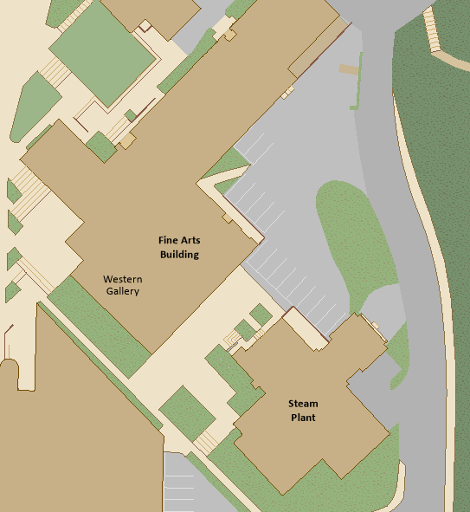
(WWU Campus Map, n.d.)
By: Noah Didehbani, Nicholas Philips, David van Tulder
Sponsor: Scott Dorough Campus Energy Manager
12/11/2020

Table of Contents

Executive Summary 3

Introduction 4

Methodology 5

Results 5

Recommendations 7

Monitoring and Evaluation 8

Budget 8

Conclusion 9

References 11

Appendix 12

Executive Summary
Problem statement
Western Washington University’s (WWU) thermal energy needs are being met by an outdated Steam Plant which is both carbon and energy intensive. The Steam Plant is especially inefficient during summer months further costing the University. The Steam Plant releases 2,428 tons of CO2/year into the environment while costing WWU $627,929/year in natural gas consumption (Energy Dashboard, 2020). Upkeep alone costs the university $1.9-2.8 million/year (UMP, 2020). WWU’s current system has an increasing possibility of aging components breaking with no replacement parts as those parts have been discontinued. The combination of this with concerns over decreased efficiency and carbon emissions make now an optimal time for action. Stakeholders are interested in an eventual hot water conversion but are held back by daunting upfront costs compared to long payback periods. WWU is also limited by how potential solutions will interact with its hilly terrain and cold temperatures which prevents easy, copy paste solutions from other universities. Maintaining all building’s constant access to heat further complicates the process. The scale at which implementation will happen also makes immediate system wide conversion difficult to obtain.
Description of Project
The due diligence of facilities management has kept the WWU steam plant running from 1946 to present day, but it is overdue for an upgrade with modern systems. This report will outline the amount of energy used by WWU’s heating system and then lay out first steps to move away from it. Since replacing the steam plant is limited by reasons presented above, this project looked at incremental solutions with options to increase clean energy in the future. The initial change to the current system will fit into a long term strategy so that no investments undergone by the university turn into a dead end. Paring systems upgrades with carbon offsets in the form of sequestration on the short to medium time horizon of 15 years will allow WWU to meet its goal of carbon neutrality by 2035.

Summary of Recommendations
In order to improve efficiency and related emissions, WWU’s heating system must undergo an incremental hot water conversion paired with thermal energy storage (TES), heat recovery chillers and carbon offsets. Replacing WWU’s Steam Plant and all of its thermal energy capacity with a more efficient system will be most cost effective if done incrementally. These recommendations align with WWU’s values of sustainability, are easily implementable, and put WWU one step closer to Carbon neutrality. WWU should look to the benefits to the environment and an increase of PR which will drive the decision making in this process. For example, the recommendations presented will help WWU to reach the UN Sustainable development goal number 7 and 9 as described below. This report will look at the complexities and components of hot water upgrades that could be made to the steam plant now and be built off of in the future.

Introduction

Statement of Need
WWU needs a more efficient campus heating system which can save WWU money, decrease carbon emissions, and provide for integration with clean energy alternatives to natural gas. This is because WWU’s outdated heating system parts have lived well past their median service lives and parts for repairs have become discontinued. The replacement of these machines allows an opportunity for new clean energy solutions to come to the forefront. In order to decrease contribution to climate change, WWU needs to start the conversion to a carbon neutral heating system now. The implementation of the recommendations in this report will lead to demonstrable benefits for the environment and the students who live, learn and lead within it. Whatever action is taken based on this report must allow WWU to accommodate energy demand, reduce the current carbon footprint, and provide further integration with clean energy technologies. The initial measures taken to reduce carbon footprint should be sequestration and investments towards hot water thermal energy systems.

Project Goals
The goal of this project is to offer an implementation strategy of steam to hot water conversion systems that drive home WWU’s sustainable principles while remaining economically viable. This will require a viable buffer to meet load during summer months, during which facilities management may come in and replace the inefficient infrastructure. The recommendations made here aim to continue to streamline WWU’s process towards carbon neutrality by 2035.

Background Research
This project was started in the fall of 2020. Students used information provided on Western Washington Universities Energy Dashboard and Utilities Database to show the inefficiencies of WWU’s business as usual baseline. The Western Utilities Master Plan was also referenced extensively to provide information on possible options to improve the steam plant. Other references include Scott Dorough, Campus energy manager, and Scott Locke who is the manager of the energy contractor UMC. Scott Dorough sponsored this project as well as provided vital information on the current heating systems at WWU and feasible thermal investments. Scott Locke provided information on the pricing of a thermal storage system. Case studies of other universities were frequently referenced to give litmus tests of feasibility.
The synthesis of this information delineated the deficiencies of WWU’s steam heating system. These deficiencies are due to the increased surface area of steam compared to hot water. This increased surface area allows for higher pressure in the pipes, more heat lost through conduction and more heat lost during steam flashes. Steam also requires large amounts of fuel to reach its high temperatures. Pipes need to be preheated to distribute steam. During low load months, such as the summer, pipes are often cold due to infrequent use therefore the Steam Plant incurs additional inefficiencies. This leads to overall emissions of 7,033.3 tons of CO2 attributed to steam use which is 77.7% of emissions (Energy Dashboard, 2020). Offsetting these carbon emissions each year would cost around $70,000 - $150,000 per year (British Petroleum, 2020).

Methodology

Case studies included University of British Columbia (UBC) and Brown University which both invested in steam to hot water conversion. Also included was a case study of the University of New Hampshire, and their efforts in thermal energy storage. These case studies were then distilled into their essential data such as relevant characteristics of the local environment, number of buildings, building size, student body size, costs of conversion, costs of business as usual, costs following conversion, and the strategy of implementation. These campuses were then compared to WWU’s to analyze what could be used or changed to apply to WWU’s system and local environment.
The Western 2017 Utilities Master Plan (UMP) was referenced for information on specific infrastructure tailored to WWU’s proposed energy upgrades. Students also referenced statistics on WWU’s energy use and compared it to the electric schedule 49 tariff under which WWU’s energy is priced. The infrastructures proposed were compared and contrasted for how they could apply to WWU’s geotechnical system and the budget allowed. The experts in the field included Scott Dorough and Scott Locke. Scott Dorough was referenced for his experience with the Utilities Master Plan, current on campus renovations and insight into budgets and implementation of a hot water conversion on the WWU campus. Scott Locke was referenced for his experience with the cost of thermal energy storage units. Considering the opinions of faculty management, energy experts, and engineers at WWU highlighted important motivations and related complications for the project.

Results

Any proposed steam to hot water system conversion for Western Washington University requires the consideration of many factors applied to an implementation strategy. Similar projects such as UBC’s Steam to hot water conversion and the insight of energy experts who understand the systems in play are the strongest resources at WWU’s disposal for a smooth thermal energy conversion. The private energy contracting company UMC Inc. estimated in Western’s 2017 UMP that a hot water conversion at a cost of $38,000,000. This and more extensive hot water upgrades shown on graph 2 indicate the largest future savings and reduction in carbon emissions.
The University of British Columbia recently finished a massive steam to hot water conversion through interim upgrades spanning almost 7 years and costing 88 million dollars. Conversion from steam to hot water at Western would look similar except scaled down. The first measures taken and buildings converted would be under the discretion of energy experts at Western. Scott Lock at UMC has an understanding of the hot water system and gave a ballpark estimate on what conversions to hot water for a small connected group of buildings at Western would look like (See Recommendations). He also noted that it is the largest opportunity Western has for sustainable energy change. New Hampshire provided the cost estimate of a thermal energy storage tank for a university that is similar in size. New Hampshire built a singular storage tank for its university. More information is necessary to ensure the most efficient choices are made. A possible engineering study has been suggested to investigate the more technical side of this project.

Graph 1, Monthly Gas Usage Jan-Dec 2019 for Western Campus (See Appendix A) showed how WWU usage of gas spikes during high load months of the winter. Total natural gas consumed for the 2019 calendar year was around 190,000 Mbtu. This is the gas usage which is the gas most relevant to carbon offset and was used to calculate costs for offsetting WWU’s Steam Plant emissions.
Graph 2, Western’s 2017 Utilities master plan proposed systems ROM (see appendix B) is from the WWU 2017 Utilities Master Plan and it displays the costs, yearly savings, carbon reductions, and simple payback period for each efficiency upgrade possible for the WWU campus. Part of this project's recommendations include incrementally switching from steam to hot water. This table displays the long term cost of around $40,000,000, 17% carbon reduction, and 16 year estimated payback period. This project focuses on incremental change, but long term costs and emissions reductions are important to note.

Recommendations

Facilities management and engineers working with WWU should develop a plan to convert all of WWU’s steam heating to a hot water heating system. Hot water is more efficient as it is more thermally dense than steam and can operate at a lower temperature. Facilities management should invest heavily into heat recovery chillers so a major portion of WWU’s future hot water can be heated electrically. University of British Columbia still relies on gas to heat much of their hot water but by implementing efficient heat recovery chillers WWU will be one step ahead of the game in reaching carbon neutrality as the grid cleans itself up. Electric heating will also play into other sustainable options such as solar heating if it became cost effective or relevant to the university in the future.
Transitional heating solutions, like WWU’s future hot water system, are the first step of a much larger movement to move WWU’s current heating system off of fossil fuels. The installment of said chosen machinery will allow WWU to incorporate more renewable energy sources into the heating of WWU. The Centralized heating system WWU uses is similar to those used in St. Joseph’s hospital in Bellingham and the downtown area. Therefore, changes made at WWU could be exemplary for those possible in the downtown circuit and at St. Joseph’s. The effort to move off of fossil fuels allows WWU to put into practice the values it sets forth in its Sustainability Action Plan. The project aligns with the Sustainable Development Goal #9: Ensure resilient infrastructure, promote inclusive and sustainable industrialization and foster innovation as well as #7: Affordable and clean energy. The end goal of this project is to move WWU one step closer to complete carbon neutrality by 2035.
Choosing a group of buildings that can be connected through chilled water loops will allow for effective implementation of heat recovery chillers, operating with 1000ton tank thermal storage tanks with temperatures of 120-170 degrees Fahrenheit. The technology is readily available, the York Titan Centrifugal Chiller as well as Mayekawa’s heat pumps, which use C02 as refrigerant, are modern top of the line thermal energy solutions that fit the incremental needs of these upgrades. Scott Locke, who works as the manager of energy services for the private energy contractor UMC helped propose these systems, but the choice of chiller will be up to the discretion of energy experts at WWU. Below are potential chilled water loops proposed by Scott Locke and employees of UMC from Western Washington University’s 2017 UMP. Chilled water loops like these serving multiple buildings can still run into similar problems a single campus wide chilled water loop system may have, but they are operating on a smaller scale making them more desirable.
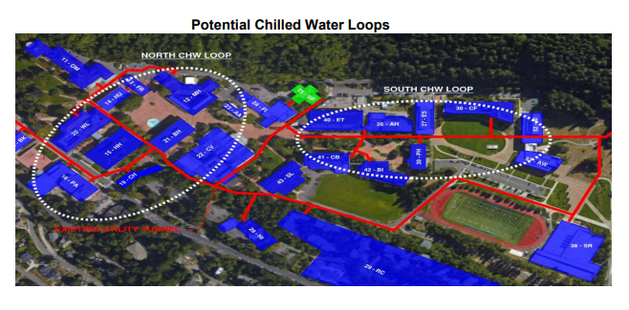
Figure 1, Underground pathways for potential chilled water loops.

Starting with groups of buildings close to WWU’s steam plant seems like a logical area to begin conversions. Facilities management at WWU have noted an alternate approach similar to UBC’s steam to hot water conversion being more effective. Starting farther away from the Steam Plant and providing other ways to heat water with systems already available and eventually connect the entirety of the system. Regardless, the hot water conversion suggested would require replacing steam pipes with hot water pipes and implementing both a heat recovery chiller and a thermal storage tank. A complete package for a group of buildings being efficiently heated by hot water, lowering the Steam Plant’s load and reducing related emissions. Because heating load is the lowest in the summer months, buildings should undergo the conversion during this time. Conversions should begin this coming summer on buildings chosen by the discretion of energy experts. Costs can vary depending on problems or lack thereof. Connecting 3 to 4 buildings (which matches the capacity of 1000 ton chillers) via chilled water loops and hot water piping for a fully finished system will cost WWU anywhere from 5 to 10 million dollars estimated by Scott Locke. A finished conversion will serve as a foundation for future hot water upgrades and play into WWU’s strategy of incrementally upgrading to an efficient hot water system.
Conversions should begin in the summertime or perhaps a few months prior, so it can be done before thermal load picks back up in WWU’s heating season. Potential conversion projects will consist of a target group of buildings connected through chilled water loops and powered by heat recovery chillers. Once a project is complete, energy experts and engineers should be looking at the next group of buildings to undergo a conversion. Ideally within 20 years the WWU’s thermal load will be met entirely with a more efficient, less carbon intensive hot water system. If this project recieves limited funding, it could take up to 50 years. That makes broad support from the faculty that much more important. These are expensive and complex projects, but it is WWU’s next and largest opportunity to drive home sustainable change.
Although efficiency upgrades will reduce emissions, WWU will still be emitting carbon. This project’s recommendation includes complimenting efficiency upgrades by offsetting WWU carbon emissions through the purchase of carbon offsets. Specifically, by purchasing carbon offsets through British Petroleum’s Colville Forestry Management Project in Washington. This form of carbon offset focuses on sequestering carbon through improved forest management (Global environmental products [GEP], 2020). Carbon sequestration is done through the process of photosynthesis where trees, plants, and grass take carbon dioxide out of the air and store it within biomass and soil (“Carbon Sequestration”, 2016). Another reason to purchase carbon offsets that use sequestration is that they also provide additional benefits such as water quality, soil management, and biodiversity (GEP, 2020). It is important to note that the gas currently coming into the Steam Plant is the gas that needs to be offset. For a reference of how much gas that will be, during the 2019 calendar year the Steam Plant consumed around 190,000 Mbtu of natural gas (Energy Dashboard, 2020). This project is aiming for upgrades to begin next summer and continue incrementally for years to come.

Monitoring and Evaluation

The success of this project will be tracked through whether or not it is implemented in the next 3-5 years. Once implemented, the success will be measured through overall systems efficiency which equates to cost savings and emissions reductions. Looking directly at emissions and energy use after changes to the system have been made is the easiest and most accurate way to measure the success of systems changes and plan for additional system upgrades. With limited funding it is unlikely the University will see a massive change in cost savings and emissions reductions from the Steam Plant on the short time horizon. The success of this project depends on these reductions and should be monitored over the next decades to come. The results of which should be shared with WWU’s energy stakeholders and the student body.

Budget

The planning horizon for this project is 10-50 years. There will be a variety of changes being made to the system throughout this time period. The university is limited by available money for investment and will not be making large expensive upgrades in the near future. If Western were to remain using a steam system the long term costs would be budgeted at $1,900,000-$2,850,000 per year for steam plant production equipment, district steam piping, and district condensate piping (“Western Washington University Utilities Master Plan Update”, 2017). The Steam Plant also consumes around $630,000 per year in natural gas consumption (Energy Dashboard, 2020).
In the long run, converting the whole campus from steam to a hot water system alone will cost $38,000,000, with an estimated simple payback period of 16 years (“Western Washington University Utilities Master Plan Update”, 2017). To improve efficiency while staying within the confinement of Western’s budget, this project proposed an incremental short term approach which involved converting select buildings from steam to hot water, heat recovery chillers, and hot water thermal energy storage tanks. For short run costs of storage tanks, this project has looked at similar installations of thermal energy storage (TES) tanks at other universities. The University of New Hampshire calculated the cost of a chilled water thermal energy storage tank to be around $2,000,000 with estimated payback periods of around 5 years. The University of New Hampshire was assisted in calculating the total cost of a TES tank by DN Tanks and RMF Engineering (Kinson, 2017). For WWU’s project, it will be beneficial to get similar assistance from UMC, Inc. who is one of the state Department of Enterprise Services energy service contractor partners. UMC inc. Manager of Energy Services, Scott Locke, has given a rough estimated cost of $5,000,000-$10,000,000 for converting 3 buildings to hot water and pairing these upgrades with heat recovery chillers and hot water thermal energy storage on Western’s campus. These are complex systems and given Western’s geo-technical profile, an engineering study by WWU or UMC would be required to get a more specific cost estimate.
As shown in graph 2’s projected emissions reductions, efficiency upgrades alone will not meet WWU’s goal of becoming net zero by 2035. It is necessary to compliment upgrades with carbon offsets to account for natural gas burnt during the transition. Offsetting the gas coming into the Steam Plant, which is the gas most relevant to carbon offsets, will cost around $30,000-$50,000 per year. This estimate was calculated using WWU’s 2019 Steam Plant’s natural gas consumption and British Petroleum’s Carbon Offsets Natural Gas (CONG) estimated cost of 15-25 cents per Mbtu (Armstrong et al., 2020). The offsets considered for purchase are through the Colville Forestry Management Project, in Colville Washington, where they sequester carbon in order to offset emissions.

Conclusion

With WWU’s current thermal energy needs being met by a natural gas powered steam plant, energy stakeholders at WWU need to be looking toward the future and reducing these emissions. WWU’s Sustainable Action Plan aims at being a carbon neutral university by 2035, if WWU wants to achieve this without a large recurring cost for carbon offsetting, taking action now is the most plausible course.
The scale of this project limits action due to funding and precious university dollars that can be allocated in a range of places. Therefore, the most practical approach to weaning off of the Steam Plant is an incremental one that allows for upgrades that can be built for decades to come. This project has found a hot water conversion from steam allowing for the implementation of thermal energy storage as the most promising and viable step in achieving WWU’s sustainable energy goals. Achieving this conversion and weaning of natural gas requires implementing heat recovery chillers and related systems changes. The Steam Plant can likely be replaced in a 10-50 year period. Things are further complicated by the universities heating needs that need to be met while changes to the Steam Plant are being made. Because summer is the lowest load period for the university's thermal energy needs this would be the time to start making changes to the current system and preparing for even more energy upgrades. A hot water thermal energy storage system would allow WWU to increase efficiency and reduce emissions while having the option to pursue a multitude of paths. As mentioned, WWU will not be able to reach its goal of becoming net zero through efficiency upgrades only. It is important to compliment efficiency upgrades with carbon offsets in order to reduce as much of WWU’s impact on global climate change as possible. Carbon offset projects that use sequestration are recommended due to the additional benefits that they provide beyond storing carbon.
The success of this project will be determined by improved systems efficiency which equates most importantly to emissions reductions and cost savings. Looking at WWU’s energy use and respective emissions over a long time horizon will yield more encouraging results than the change from the initial investments. Any action made to wean off the Steam Plant’s thermal energy is a step in the right direction for the university. While it can be difficult to know where or how to start, it is important to get the ball rolling now for these changes and to set precedent on the importance of clean energy and carbon neutrality at WWU.

References
Energy Dashboard. (2020). Retrieved November 23, 2020, from https://energy.dudesolutions.com/BETA/?bbID=WWU1DASH
British Petroleum. (2020). Carbon Offset Natural Gas Infosheet [Brochure]. Retrieved November 22, 2020, from https://view.highspot.com/viewer/5fb2fceaa2e3a9105fdd48d0
Operations-0666.jpg. (2015). Retrieved November 23, 2020, from https://facilities.princeton.edu/news/the-princeton-energy-plant
WWU Office of Sustainability. 2020. Sustainability Action Plan. Retrieved from https://cpb-us-e1.wpmucdn.com/wp.wwu.edu/dist/6/4099/files/2019/02/Sustainability-Action-Plan-2017-FINAL.update02.06.2019-179c9tc.pdf
Armstrong, J., Go, B., Samuels, D., Scott, Z. (2020). Exploring Low Carbon Solutions [Webinar]. BP. https://event.on24.com/wcc/r/2825847/B4C2094341B9EDA16D414E541B6034F5?mode=login&email=phillin5@wwu.edu
Global environmental products (GEP): What we do. (n.d.). Retrieved December 09, 2020, from https://www.bp.com/en/global/bp-global-energy-trading/what-we-do/global-environmental-products.html
Service, Forest. “Carbon Sequestration .” Carbon Sequestration, 2016, www.fs.fed.us/ecosystemservices/carbon.shtml.
Wilson Engineering, LLC, et al. Wilson Survey / Engineering, 2017, pp. 1–266, Western Washington University Utilities Master Plan Update: Bellingham Main Campus, file:///Users/nickphillips/Downloads/Utilities%20Master%20Plan%20(12).pdf.
Kinson, Jaclyn. AASHE, 2017, pp. 1–70, Energy Storage Strategies for the University of New Hampshire, hub.aashe.org/browse/publication/18926/Energy-Storage-Strategies-for-the-University-of-New-Hampshire-A-Feasibility-Analysis-of-Energy-Storage-Opportunities-on-the-Durham-Campus.
WWU campus map. (n.d.). Retrieved December 15, 2020, from https://www.wwu.edu/map/
Puget sound energy, Electric Tarrif G, Schedule 49, High voltage general service (2020). Accessed 12/11/2020
S. Dorough, (10/5-12/2/2020) Personal communications
S. Locke, (11/28/2020) Personal communications

Appendix A
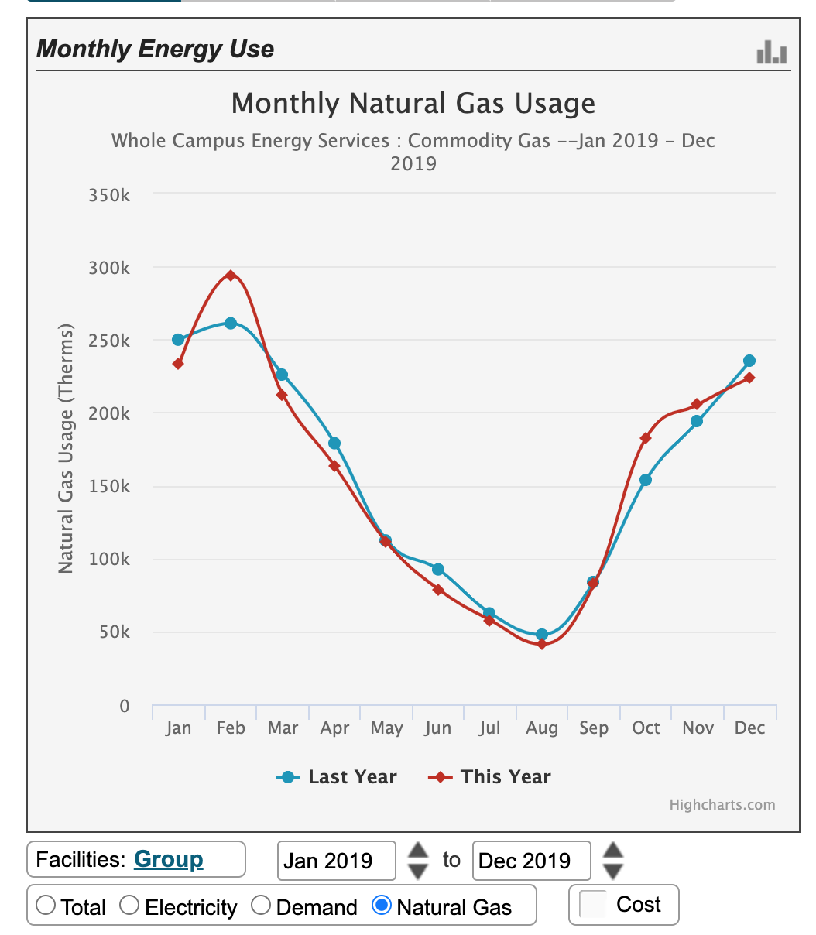
Graph 1, Monthly Gas Usage Jan-Dec 2019 for Western Campus
Appendix B
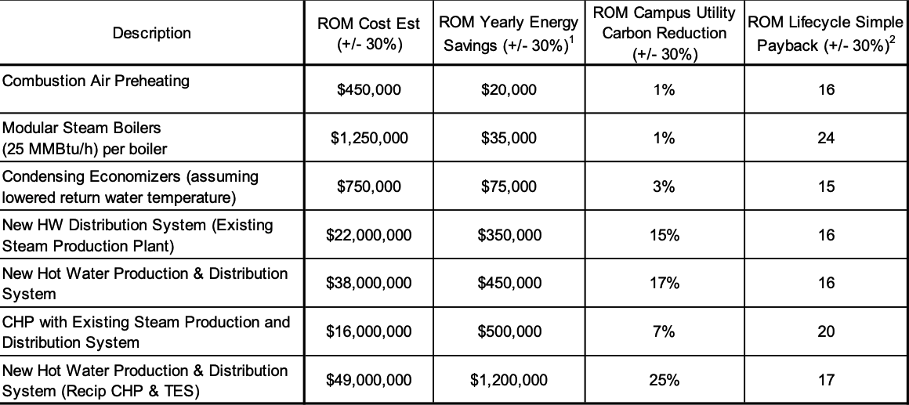

Graph 2, Western’s 2017 Utilities master plan proposed systems ROM

