Home Sweet Homestay:
Can WWU Support a Homestay Program?

By: Lauren Adams, Sierra Bavik, and Ashleigh Mason

ENVS/UEPP 471: Campus Sustainability Planning Studio
Professor Jill MacIntyre Witt

Project Sponsor: Julia Burns, Program Manager, Off-Campus Living, WWU

December 8th, 2022

Table of Contents

Executive Summary 4
Introduction 5
Methodology 6
Results 7
Case Studies 7
Interviews 10
Recommendations 12
Monitoring and Evaluation 18
Budget 18
Conclusion 18
Appendix 19
A. Application and Form Examples 19
B. Interviews 26
References 29

Executive Summary

Problem Statement
Bellingham’s rental costs rose 19% just last year, invoking a dramatic reduction in housing accessibility. Causal to this is Bellingham’s rental vacancy rate of 1-2%, well below 6-7%, the range considered healthy, creating a prohibitive level of competition (Larson & Paulson, 2022). However, Bellingham’s single-family homes are under-occupied (City of Bellingham, 2018, p. 16), meaning the number of bedrooms is greater than that of occupants. As college students represent over 20% of Bellingham’s population (Western Washington University [WWU], 2021) and are highly unlikely to own homes, they constitute a large portion of those impacted by rent increases. The majority of students in Bellingham attend Western Washington University (WWU) (College Tuition Compare, n.d.). WWU only has unit capacity on-campus and off-campus for 29% and 8% of its students, respectively (City of Bellingham, 2018, p. 23), making WWU a prime location to begin mitigating this issue.

Project Description
This project investigates the feasibility of creating a domestic homestay program at WWU. Implementing this program would mitigate the harm to students caused by rent increases. Research identified the costs, staffing and program models, and background check procedures of relevant programs. A variety of similar programs gathered as case studies provided an estimation of expected costs and staffing requirements and suggestions on program intentions, among other considerations for WWU to include. The case studies researched include homestay programs run by higher education institutions and other groups that cover a variety of intentions: domestic, international, short-term, long-term, need-based, and mentorship-focused. Additionally, interviews with key actors in similar programs and WWU staff in relevant departments addressed practicality and garnered attention to potential concerns. Together, case studies and interviews informed the following recommendations.

Summary of Recommendations
Recommendations for the furtherance of this program include:
- Identify what existing departments, platforms, and strategies WWU has or uses that the homestay program can utilize.
- Identify who is interested in hosting or staying and what they expect.
- Specify which students’ needs the program intends to address.
- Set rent in a way that aligns with the program’s intentions.
- Identify local laws and WWU policies that pertain to the program’s scope, capacity, and potential.
- Maintain awareness of and contact with Utah and Boise State University (Boise).
- Decide and act on the suggestions not considered in this paper that will help implementation.
- Plan for expansions of the program.

Introduction

Statement of Need
Housing in Bellingham is increasingly unaffordable. Compared to the number of prospective or in-need renters, too few rental options exist. While this impacts all renters, students comprise an especially at-risk population as they likely balance total independence, tuition requirements, and high workloads for the first time. As WWU’s housing capacity accounts for less than a third of its student body, WWU’s growth is partially responsible for reducing nearby rental vacancies and subsequently increasing rent. The default response to unaffordable rent is construction to increase housing availability and reduce demand. Less conventional methods are seldom considered, like tapping into room vacancies in single-family homes. New construction inherently produces emissions, among other environmental harms. To counter this, Bellingham must accommodate housing needs by implementing alternative and resourceful options.

Project Goals:
This project seeks to establish the viability of a domestic homestay program at WWU by analyzing WWU’s existing infrastructure and other organizations’ compositions of active homestay programs.
Alternative housing options can counter dramatic increases in rent for off-campus housing. One option is for WWU to implement a domestic homestay program that pairs students with alumni, community members, and former or current staff. Doing so will mitigate housing insecurity and demand for new housing. As a bonus, this program can foster mentorship and professional and educational connections for students.
Facially, sustainability may be perceived as having a siloed focus on resource preservation, but mainstream understandings are broadening to encompass social-environmental interactions. The Sustainable Development Goals of the United Nations cosign this, as does WWU’s vision for the Sustainability Engagement Institute to “develop… a more sustainable, just future grounded upon economic vitality, well-being, environmental protection, and social justice” (WWU, 2022, p. 3). This report and its recommendations largely reflect this focus on generating social and economic well-being. Comparatively, this report’s relevance to environmental sustainability is less significant, although demand for emissions and resources is undoubtedly reduced as utilizing existing rooms minimizes the need for construction.

Background Research
Initial research led to the discovery that this project entered largely uncharted territory. Some domestic homestays exist in universities across the country, but none identified have WWU’s intention of providing accessible housing, fostering relationships, and reducing demand for the construction of new units. Additionally, few of these programs have a structure similar to this project’s, which is a significant factor in other program considerations. The programs examined below were chosen because their homestay structures are applicable to WWU. From these, valuable aspects were identified and used to inform recommendations.

Methodology

Methods Used and Data Collection Process
Case study and interview data collection methodologies were determined to best complement the goals of the homestay project in its early stages of development. A staff member for the Utah case study was interviewed; information from the interview is included in the case study section, as is information from documents provided by the interviewee. Data from case studies were discussed in interviews to gauge opinions which informed recommendations on which aspects apply to WWU.
Programs were researched and dissected to identify common threads, possible areas of inadequacy, and their WWU-applicable aspects to understand the potential form for a domestic homestay program at WWU. This involved reading articles and program websites and clarifying information via email and phone calls. Primarily case studies were existing homestay programs at higher education institutions in Washington state. Some exceptions are included due to the relevance of their missions or particular practices. Pertinent qualities to analyze were the program’s goal, length of stay, who hosts, who stays, cost and process of financial exchange, and amenity, location, application, background check, and other requirements for hosts. Additionally, it was necessary to consider the location of each program, as community and alumni attitudes vary by university, so a successful homestay program in another state may not see the same results in Bellingham.
Interviews were conducted via email or phone and video calls to determine (1) what operations exist in various WWU departments to support a homestay program, (2) to gain more in-depth information on case studies, (3) to understand student needs and how a homestay program can help, and (4) to understand best practices and risks related to such programs and. Interviewees, mostly WWU staff, were selected because their positions are highly involved in housing, alumni engagement, organizing student resources, or ethical processes. Interview questions focused on alumni-student relationships, availability of existing systems and infrastructure, laws and policies, risks, and student, university, and community needs.
While the case studies aided this project, there are very few programs similar to the vision for WWU; all found university domestic homestays are in development or pilot stages, which added to this complication.
Overwhelmingly, homestay programs serve international students. Some have relationship-oriented goals like WWU, but these programs charge students market rent and do little to address the power structure that results from creating a landlord-tenant relationship which may complicate the goal of building a connection between host and student.

Results

Case Studies
The following case studies clarified which aspects of the researched homestay programs are copyable and which require adjustment to the program WWU envisions. Homestay programs take many forms to cater to various needs and intentions. Most common are long-term stays for international students in colleges and universities seeking to ease students’ integration with the school’s local community by housing them with community members. Less common programs serve domestic students or individuals with short-term or affordable housing needs, affordable. Overall, homestay programs serve many purposes, including introducing non-residents to a new city by matching students with engaged community members, fostering academic relationships by pairing alumni, faculty, or staff with students, and functional approaches for those in need of immediate or transitional housing.

University of Utah (Utah) Home Away from Home, Salt Lake City, UT
Utah’s Home Away from Home pilot program is included as both a case study and an interview with Bethany Hardwig who, provided forms on the program’s processes which were reviewed and mentioned here.
This program, introduced in the fall of 2022, provides students with year-long stays in Utah alumni, faculty, or staff homes. The program has nine homestay placements and plans to grow to 16 in the spring. Summary in Interview B5. This responds to a predicted influx of students whose housing needs, on and off campus, are not accounted for and seeks to improve student experiences by fostering connections to the university and matching them with hosts of similar interests. To do so, Utah utilizes the 60% of alumni who remain near Utah’s campus in addition to faculty and staff. Many of these alumni desire a sustained, productive connection to the university and saw homestays as a significant way of pursuing this. For students, this program costs $2,600 per semester, less than market rent, all of which is given to the host. Notably, this payment is considered taxable income for the hosts. The positive reception by alumni is responsible for this price, as potential hosts requested for the program to reduce its cost to ensure accessibility and comfort for students.
Importantly, Utah’s program scrutinized the potential for upsets before piloting and thought-out best resolution practices. One mitigation tactic is requiring students to pay the university, which transfers payments to the hosts. In doing so, the program reconciles its goal to build relationships with necessitated financial exchanges by avoiding landlord-tenant relationships which may arise from having students pay hosts directly. Other pertinent tactics are the program’s monthly check-ins with hosts and weekly emails to hosts and students. Both exist to ensure the needs of students and hosts are met by clearly communicating where helpful resources exist and ensuring that a third party is available in case of host-student conflict. These objectives are evidently furthered by the program’s requirements which override the need for a lease by having students and hosts (1) provide three non-familial references in their applications, (2) sign term agreements, and (3) fill out a form on the condition of the home. Entire forms are found in Figures A1-A5.
The structure of this program is highly applicable to what is envisioned for WWU. Specifically relevant is their goal to foster connections, the stay lengths, the variety of hosts, and that it does not discriminate between international and domestic students or otherwise. The sole exception to this is that freshmen and minors are not eligible for the program. Presumably, this is to ensure a certain level of maturity and self-sufficiency in student participants by promoting the formative experience of a more average college introduction for new students. The student interest in Utah’s program suggests that domestic students are interested in homestays which may predict that WWU students will receive a similar program positively.

Washington State University’s (WSU) ​​Community Hosting & Homestay Program, Everett, Spokane, the Tri-Cities, and Vancouver Campuses
WSU’s homestay program provides short-term stays with community members for the university’s medical students during their six-week clinicals at satellite campuses. In addition to housing, the program seeks to engage students with the new community. Hosts are required to “Provide lodging within a thirty minute drive of campus. Provide the student internet access within their lodging. Provide a private bedroom for the student’s use… Provide access to cookware and kitchen space for the student’s use during the intersession weeks. Provide the student a house-key for use during the intersession weeks.” See Figure A6 for more detail on host requirements. Pursuant to the community engagement goal, hosts are strongly encouraged to participate in “Local Exposure Activities, Community Connections, and Community Nights.” (Washington State University [WSU], n.d.-c). Unique to this program compared to other case studies is that hosts are volunteers and not compensated (WSU, n.d.-a).
Relevant here is the example of a functioning short-term homestay, a need expressed by WWU. See Interviews B2 and B4 for more information. Also, this is one of two exclusively short-term case studies, and an instance in which hosts are not paid, something for WWU to consider.

Whatcom Community College’s (WCC) Homestay Program, Bellingham, WA
WCC’s homestay program provides a new cultural experience for international students by participating in the host’s daily activities. Stay length depends on each student’s study duration, often three to nine months, beginning quarterly. Families of all structures or individuals who pass the initial approval process, meet these requirements, and agree to WCC’s “International Programs: Homestay Program: Student/Host Expectations” may host. See Figures A7 and A8 for application forms and requirements. As for transferring payments, students are responsible for paying hosts directly. The cost to students is $750 to $800 a month, but this will likely rise in response to the increases in market rent (Housing office at Whatcom Community College [WCC], personal communication, November 18, 2022).
This program is local to Bellingham, which foreshadows success for WWU in terms of community member interest and reception. Additionally, WCC allows varied stay lengths and has reasonable requirements.

Edmonds College’s (Edmonds) Homestay Program, Lynnwood, WA
Edmonds’ Homestay Program serves international students by assigning them to host families with strong interests in cultural exchanges and building connections by including the student in family activities and daily life. Students are committed to staying for at least one quarter. The program’s definition of family includes “husband and wife, husband and husband, wife and wife, as well as single parent households.” (Edmonds College [Edmonds], n.d.-a). This program engages hosts interested in the lifestyle involved with introducing an international student to a new environment. Requirement specifics are in Figure A9.
Additionally, host families must provide food for three meals per day and prepare an evening meal at least five nights a week. Hosts are compensated monthly with a 27-dollar nightly stipend (around 800 dollars a month) to cover food and expenses. Edmonds’ website explicitly states, “The stipend is not intended for rent.” and that “Families may not bill students for additional expenses or request any funds from students without speaking with the Housing Office.” (Edmonds, n.d.-b) These procedures address some concerns related to power imbalances between hosts and students.
From Edmonds, WWU should include similar bedroom and distance requirements and clarify the intention behind costs for students to hosts. Also applicable to WWU is their variation in stay lengths by student schedules. That said, it is unclear whether the minimum stay commitment would be necessary or productive for WWU to include, as doing so may come off as strict and unaccommodating to potential hosts and students.

Cocoon House’s Connections Host Home Program, Everett, WA
Cocoon House has a variety of programs that operate to reduce housing instability and related risks. Important here is their Connections program, which temporarily houses youth with volunteer trained hosts. (Cocoon House, n.d.-b) The 12 to 17-year-old youths stay with hosts for a maximum of 21 days while receiving case management support from Cocoon House staff. The provision of meals and basic needs are included for free. To become qualified, hosts must complete an application, interview, background check, and training (Cocoon House, n.d.-a).
Cocoon House incorporates a few details that distinguish its program from others. These represent the services and considerations necessary for the population it targets, which is markedly more vulnerable than populations considered in the programs above. Important to WWU are the program’s goals and host requirements. As Cocoon House focuses solely on youth experiencing housing insecurity, the process for host eligibility is significant. If WWU were to take on a similar goal, similar strict requirements would be advisable.

Interviews
Some interviews prompted further research, which is included in the section for the prompting interview and identified by footnotes.

Pertinent interviewees at WWU included: Julia Burns, the manager of Off-Campus Living; Jon Stubblefield, the Resource Navigator and Program Manager of Basic Needs; Victoria Martinsen, the Senior Director of Alumni and Constituent Engagement; and Lorrie Bortuzzo, the manager of the Western Success Scholars Program. Individuals listed above are involved in the most relevant offices to housing, alumni engagement, and student resources at WWU.
Interviewees not affiliated with WWU were Bethany Hardwig, Development Director of the University of Utah’s Office of Alumni Relations, and Samya Lutz and Katy Sullivan, from the City of Bellingham’s (COB) Planning and Community Development department. Hardwig continues to play a crucial role in operating the University of Utah’s Home Away from Home program.

Jon Stubblefield, Resource Navigator and Program Manager of Basic Needs, WWU
Stubblefield mentioned recent data on housing-insecure students and suggested the Basic Needs website for other survey data on students who were homeless, housing insecure, or in foster care before attending WWU. Importantly, this data can be accessed by future homestay program staff to address these students’ needs directly. He also suggested determining if WWU can subsidize rent if the program serves need-based students. See summary in Interview B2.

Victoria Martinsen, Senior Director of Alumni and Constituent Engagement, WWU
Martinsen relayed key information on WWU alumni. First, was that alumni generally want to engage with and help students. Second, she settled concerns on whether the population of WWU alumni in Bellingham is large enough to support a homestay program. Third, similarly to Utah alumni (see Interview B5 for more information), WWU alumni are unlikely to request that students pay market rent. With this, she considered setting payments so that hosts break even. Lastly, she stated that this program could further her office’s goals by ensuring alumni hosts have positive experiences by ensuring quality in communication and host-student matches, transparency on expectations and requirements, and engaging hosts with WWU via events or otherwise. See Interview B3 for more detail on Martinsen’s interview.
This interview also brought awareness to WE Connect, the platform promoted by WWU’s alumni office, which connects students to alumni mentors. WE Connect has a program that matches students and alumni by factors like hobbies, goals, jobs, and industries of interest, which are communicated by a user-matching quiz. The platform also has groups for discussions on similar topics.

Lorrie Bortuzzo, the manager of the Western Success Scholars Program, WWU
Bortuzzo addressed how a homestay program may be helpful to students and what departments or organizations may be important supplements for this program after implementation. These include WWU Off-Campus Living, WWU Basic Needs, Western Success Scholars, Northwest Youth Services, and Opportunity Council. Importantly, she reaffirmed that both short and long-term homestays would be useful to support the variety of housing circumstances experienced by students. Similarly to many interviewees, Bortuzzo is concerned that funding and a full-time position may limit the program’s capacity. She added that the staff member should have experience with low-income and housing insecurity issues and solid case management skills. Full email responses are provided in Interview B4.

Bethany Hardwig, Development Director, Office of Alumni Relations, University of Utah
Hardwig was an incredibly informative contact on domestic homestay programs due to the integral role she had in the inception of and has in conducting Utah’s homestay program.
First, she explained that the program does not have a lease or security deposit. These are replaced by a customs agreement which contributes more to student-host connections. See Appendix B for full interview transcripts. Second, she stated the number of people in positions related to the program is nearly 40. The related groups include the Board of Governors, which work on alumni relationships and fluctuates around a dozen members (University of Utah [Utah], n.d.-b), around 20 Office of Alumni Relations staff (Utah, n.d.-a), three of whom specifically work with the program (Utah, n.d.-c). Positions specific to the program include a program manager and communications manager. Third, she explained program conventions. These include weekly, separate emails to students and hosts, monthly Zoom meetings with hosts, and the process for conflict resolution. If a serious conflict arises between the host and student, the student’s statements are deferred to, the student is immediately removed, and the university pays for immediate housing before working towards a resolution. Fourth, she relayed that hosts are not required to do anything extra, like cook meals, but that the program functions best for hosts and students who want a community and suggests that hosts support students uniquely in accordance with their match. Also, student participants are still allowed to have a meal plan with the University, so the pressure on hosts to provide meals and groceries is limited. See Interview B5 for more specifics.
Additionally, Hardwig briefly explained the practices she used to hire program staff. She emphasized that interviewees were not considered if they avoided or denied that a serious issue between the host and student was inevitable. Partially this stems from recent safety concerns at the University. Still, in general, this is a good practice to ensure that staff working in such a program are competent and proactive.

Samya Lutz, Housing & Services Program Manager, and Katy Sullivan, Development Specialist, City of Bellingham’s Planning and Community Development Department
The interview with Lutz and Sullivan addressed the potential for conflict between WWU’s program and the COB. While neither work directly with code related to this program, they overwhelmingly believed that the program and city code could exist harmoniously. One process that future hosts may need to comply with is the permit approval process for short-term rentals, which takes two to three weeks. Importantly, they recommended that the COB and WWU produce a Memorandum of Understanding (MOU) or a Memorandum of Agreement (MOA) to outline the program and the roles of both the COB and WWU, so both parties have clarity on each other’s positions and roles. Otherwise, they emphasized the importance of WWU pursuing this program collaboratively and with transparency to gain the support of residents or the COB and to avoid any suspicion or potential backlash. See Interview B6 for the interview transcript.

Recommendations as a Timeline for Implementation

When sub-recommendations are included, it is to differentiate between the projected specifications necessitated by program intention.

Identify what existing departments, platforms, and strategies WWU has or uses that the homestay program can utilize.
This recommendation serves as a reminder to avoid spending unnecessary time on establishing the program by prematurely creating new websites, platforms, or processes.

Departments
Assuming this program is housed in Off-Campus Housing, consider what communications with other relevant departments look like and what they can offer in terms of experience, advice, or support for the program. For example, Martinsen expressed that the alumni office can support but not run the program.

WE Connect
This platform can be used to identify engaged alumni to contact about the program. Also, it may be useful to have alumni hosts and students join this platform to both increase their connections with WWU and have them report their matching quiz responses so homestay program staff can match interested participants. If possible, this matching process would be expedited by creating a separate page on WE Connect. This could include additional quiz questions on the lifestyle and housing preferences of potential program participants and giving access to non-alumni interested in hosting.

WWU Website Pages on Housing, Alumni or Educational Connections, and Financing
These will come up early in search results and conversations for students inquiring about housing, professional relationships, mentorship, and affordability.

Identify who is interested in hosting or staying and what they expect.
To ensure the program serves students and hosts from its start, discover the populations of each who are interested in becoming involved, specifically in the context of a pilot program. This process can uncover what details and considerations are important to future participants and what imbalances exist between host and student intentions. Additionally, this may instruct and ease the program’s growth by generalizing where to focus outreach efforts for additional hosts and students. One method for doing so is to add the option to WWU’s housing-related pages, acknowledging that the program doesn’t exist yet and directing people to contact someone or fill out a survey to state interest when the program launches. If the program includes or solely serves housing-insecure students, WWU has self-reported records identifying the students who should be contacted. See Interview B2.
The freshman and minor restrictions from Utah’s program may be a positive inclusion for WWU’s relationship-building goals, but not if the program is need-based. The rationale for including this restriction to foster relationships is that it encourages new students to learn what they want and favors students who are closer to graduation and likely want more advice.
As for potential hosts, Martinsen suggested contacting alumni who have engaged with WWU (see Interview B3), so a survey could be emailed to professors or staff and alumni with known contact information. The survey could prompt recipients to share the email with others who fit specific categories and may be interested. Importantly, the survey should ask whether those interested in hosting own or rent a home, in addition to seeking questions, concerns, and reasons for interest in the homestays. Doing so would also identify issues and circumstances that still need to be considered. Martinsen also suggested that advertisements can avoid attracting profit-driven hosts by stating that a nominal fee is included without specifying an amount, so potential hosts are not deterred by assuming they will lose money to the program. See Interview B3.

Specify which students’ needs the program intends to address.
A pertinent consideration while starting this program is whether it will replicate the Utah program’s mentorship focus or if its purpose is to address housing and financial insecurity. This will inform the following recommendations, which differentiate between a focus on mentorship and need. Within either context, roommate matching forms are not sufficiently comprehensive. If the program intends to create relationships, relationships reminiscent of landlord-tenant dynamics should be avoided. The issue here is an inherent power dynamic that may not exist in policy or action but is an unavoidable interpretation by students or older hosts.

Community building/mentorship
If this path is chosen, a plan is needed for fostering connections between students and hosts. Utah’s program focuses on building community and providing mentorship. This requires reconciling lifestyle similarities with interests and career paths, which involves more steps than putting a student in a room. WWU could also incorporate something similar to the events and activities provided in WSU’s program.

Need-based
WSU and Cocoon House are the most useful models if this program provides short-term need-based housing. Despite a difference in goals, these two are specifically applicable because they have short-term stays, and neither require the individuals staying to compensate hosts. That these programs are free but differ in goals suggests that interested hosts may not desire compensation from WWU students for a short-term need-based stay.
If tailored generally to serve students by their housing security, great consideration is needed regarding the program’s ability to make an impact. Of course, any positive effect is substantial in reducing housing instability. Still, this program will start with a small capacity, and alternatives may exist with more influence for addressing housing issues. Also, as a need-based pilot program, there are more significant risks related to student experiences. Piloting in this context is testing a program on a highly vulnerable population. At any stage of this program, far more concern and oversight of host-student relationships are needed because of this vulnerability. The student is not becoming housing secure in any permanent sense, so if there is an irreconcilable occurrence between host and student, the student is reintroduced to the volatility experienced before they got the room. Whereas students intending for a mentor would experience a loss from a negative relationship with a host, the risk for students who need this alternative housing option is trauma.

Set rent in a way that aligns with the program’s intentions.
Utah’s program asks for significantly less rent from students compared to their dorm and off-campus housing options. If WWU does this, how will rent be determined? If the purpose of this program is to foster connections, how will it avoid attracting people who need cheaper rent? Is rent lower than the market rate for dorms or off-campus options? It may create conflict if the rent for the program is less than the norm for on and off-campus housing, especially if students in need are not targeted, which may garner controversy. In both cases, asking for rent appears counterintuitive to the program’s goals, so the price should reflect (1) the labor and costs hosts will incur and (2) the student’s responsibility to respect the home rather than the host’s financial intentions.

Community building/mentorship
To avoid creating a landlord-tenant relationship between hosts and students, Utah has students pay rent to the university, which transfers it to the hosts rather than having students pay hosts directly. This may be a valuable inclusion for WWU’s program to ensure the relationships it builds are healthy.

Need-based
A potential issue with making this program need-based is the attraction of people who see hosting as an opportunity to make money, as they are not responsible for forming a relationship with the student. Care should be taken to ensure the rent price will not unduly burden students. Preventing this burden may require case-by-case agreements between the student and WWU and WWU and the host. This communication chain should prevent students from feeling guilty or ashamed about their needs. Stubblefield suggested finding out if WWU can subsidize costs for students. See Interview B2. The set price should be compensation for amenities and effort from the host rather than a source of profit. This is to mitigate the chance of attracting hosts who do not care about what they provide the student and may be more willing to neglect this responsibility and harm students.

Identify local laws and WWU policies that pertain to the program’s scope, capacity, and potential.
The interview with Hardwig introduced multiple legal concerns about university involvement in non-traditional off-campus housing. Hardwig’s law degree enabled her to prepare for and reconcile legal issues with the program. Assuming those responsible for implementing this program at WWU are without similar experiences, a staff member should be dedicated to avoiding legal problems primarily during the pilot and be available throughout the program’s maintenance. This does not require a full-time lawyer but rather a position that includes researching relevant laws and understanding how these are interpreted and applied.
Specifically, WWU policy on student-employee relationships and transferring money between students and potential host groups should be accounted for.
In the interview with Lutz and Sullivan, they suggested that WWU send a memorandum of understanding to the COB before piloting a homestay program. This memorandum should outline the program, what it does, and the roles of WWU and the COB.

Community building/mentorship
If the program is meant to foster relationships between adults and students, there are many potential unethical situations. To mitigate these, look into state or city laws and WWU policies that govern power imbalances and that delegate responsibility for harm. Also, make an action plan for dealing with these situations and discuss these with the host and student participants.

Need-based
If this program supports students in need, identify legislation and policy that inform the ability of like programs to transfer money and that guide such sensitive interactions.

Maintain awareness of and contact with Utah and Boise State University (Boise).
WWU should keep track of developments with Utah and Boise’s progress to expedite its process of implementing a domestic homestay program. It is most important to consider developments related to mitigating housing insecurity or unavailability and improving students’ experiences. Caile Spear from Boise communicated that Hardwig introduced Utah’s program to Boise, which prompted Boise’s interest in working on its homestay program. This suggests that Boise’s program will apply aspects of Utah’s program to a different context similar to the implementation path likely for WWU’s program. The Utah program is already implemented, and it appears the Boise program is on a faster track for implementation than WWU’s program. In remaining aware of these programs, WWU can incorporate their improvements while implementing the program more efficiently by learning from and adjusting in accordance with new information about Utah and Boise’s programs.

Decide and act on the suggestions not considered in this paper that will help implementation.
The following suggestions came from various interviews and emails but could not be completed this quarter.
- Introduce the homestay idea to Katy Lenning (Katy.Lenning@wwu.edu), the Program Support Supervisor for Occupancy, Communication, Administrative Services & Technology in On-Campus Housing. Ask for her opinions and suggestions.
- Contact the Retired and Emeritus Professor’s group about the homestay to determine interest and receive suggestions.
- Contact current faculty members about the homestay to determine interest and receive suggestions.
- Contact graduate students to see if they are able to host, are interested in hosting, or are interested in staying.
- Determine in place connections WWU has with community members and whether these are able to support a homestay program. If not, determine what can be done to strengthen community connections for the purpose of a homestay program.
- Review WWU’s codes of conduct to ensure all potential host demographics are appropriate.

Plan for expansions of the program.
Student demand and experiences are likely to drive the program’s expansion. So, assuming the program is implemented and gains popularity, it is important to ensure that an increase in student demand specifically is accounted for. Jumping on the opportunity presented by a demonstration of student demand is a promising way to expand the program. That said, expansion may require additional staff members, advertising, funding, and general resources.
In consideration of the program’s potential to address students in need of immediate or affordable housing, it is important to ensure that their needs are adequately accommodated by an organized staff and process.

Monitoring and Evaluation

Generally, the success of this program is likely to be reflected in student satisfaction with their experience at WWU and their homestay placement. This can be monitored by surveys that request responses about happiness, confidence in courses, positives and negatives associated with homestay placement, and housing-related stress being given before, during, and after students’ homestays. Host satisfaction may be tracked similarly.

Community building/mentorship
Depending on the program’s goal, success may mean that relationships between students and alumni, the community, and WWU are strengthened. This may be measured qualitatively by comparing the amount of interest that students and alumni express in interacting with each other. Another aspect to track is both student and eligible host intrigue, which may represent hosts and students outwardly sharing positive experiences and knowledge of the program spreading.

Need-based
The project’s success may be tracked by how many students are diverted from becoming housing insecure or worsening housing insecurity. Students may be asked to report their experiences during and after the program to embolden this data.

Budget
The budget should account for one position dedicated to managing the program and potential supplemental roles. Supplemental roles may include someone responsible for communicating between students and hosts when the program is active, and a smaller position dedicated to advertising the program. This could look like an additional two dedicated staff members or additional part-time positions for other staff at WWU.

Conclusion
Utilizing room vacancies in single-family homes as housing for WWU students will mitigate housing insecurity and prevent emissions related to the demand for new housing construction. In doing so, WWU can foster alumni and community member relationships with students and aid students experiencing housing and financial instability. The recommendations boil down to identifying potential hosts and students for the program and taking care in its inception to protect students and ensure positive and productive experiences.

Appendix A. Application Examples
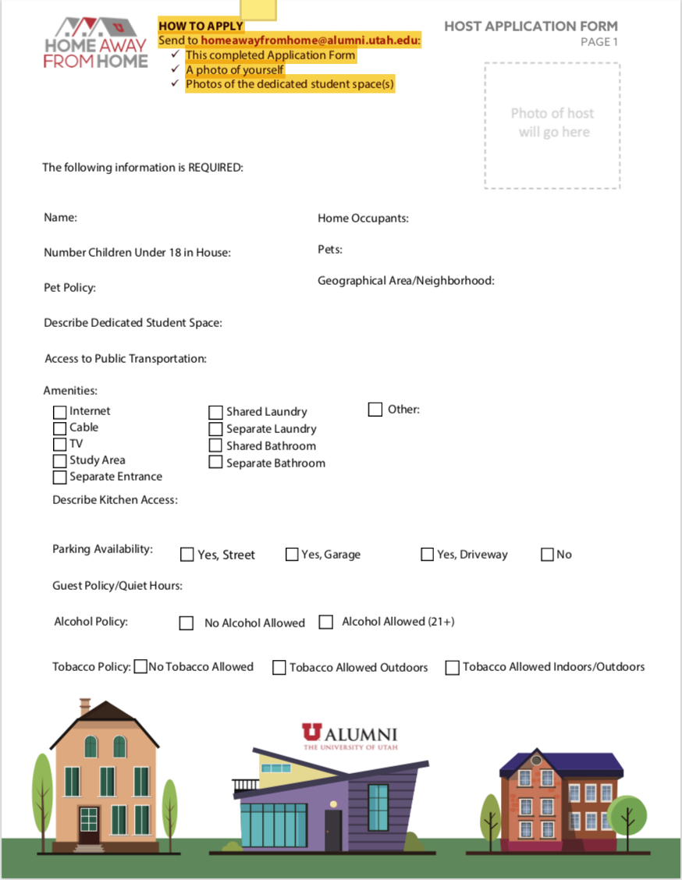
Figure A1. Utah Host Application
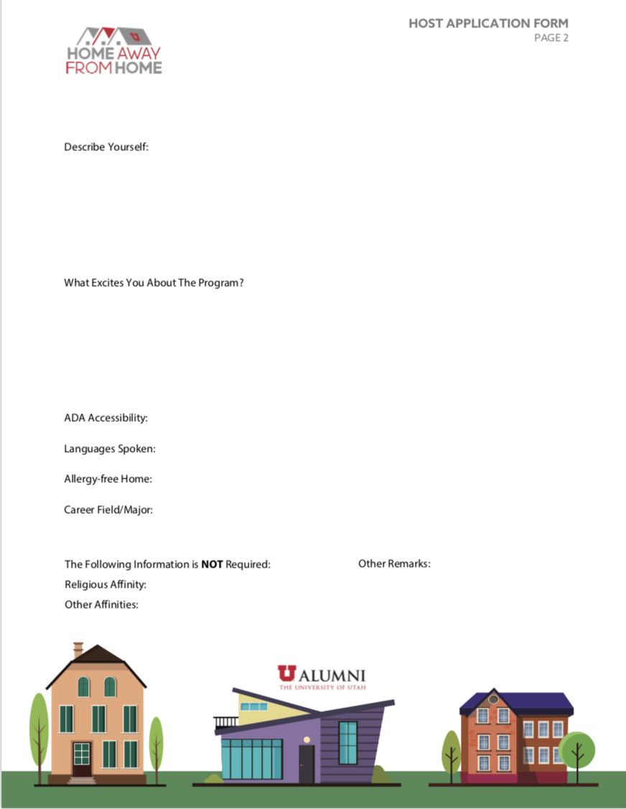Figure A2. Utah Student Application (only aspects that differ from host version)

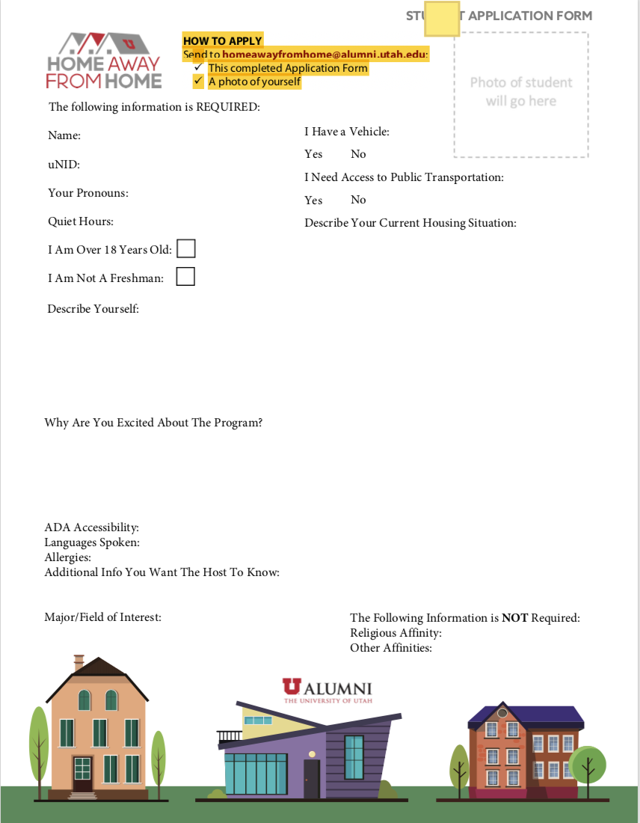

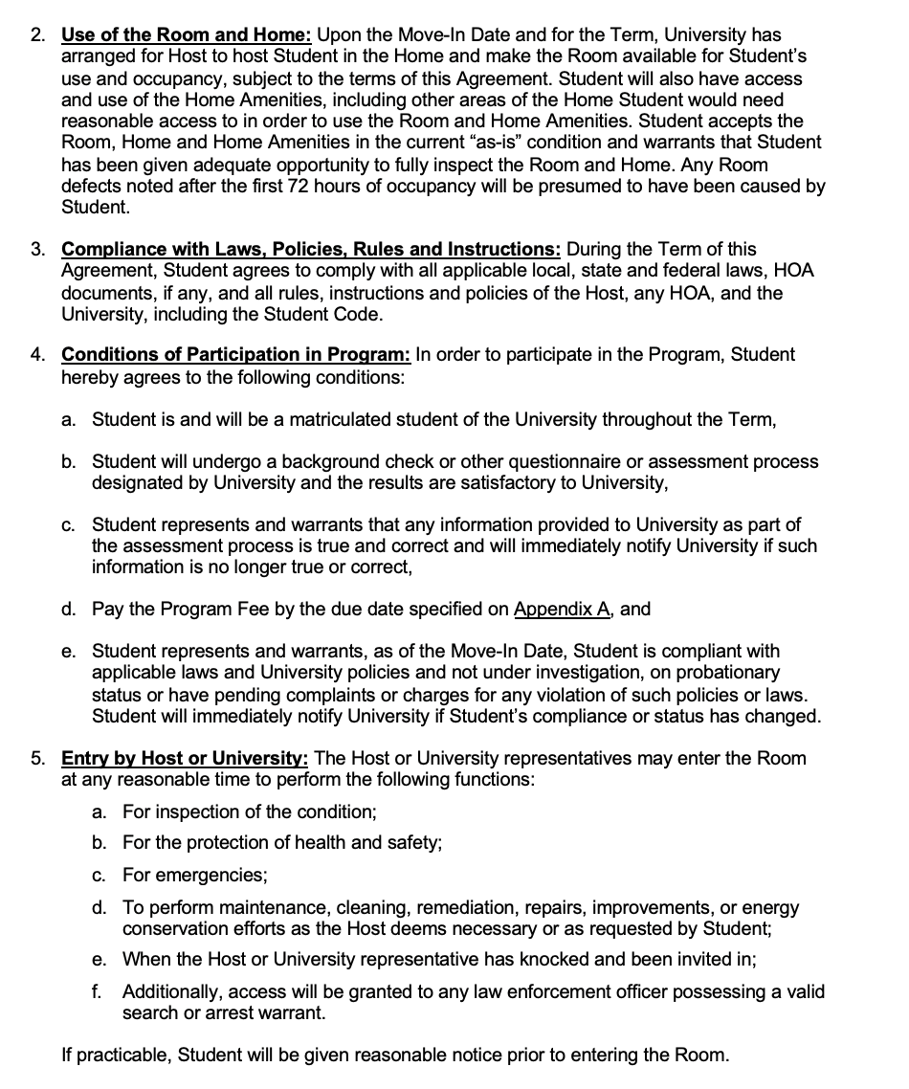
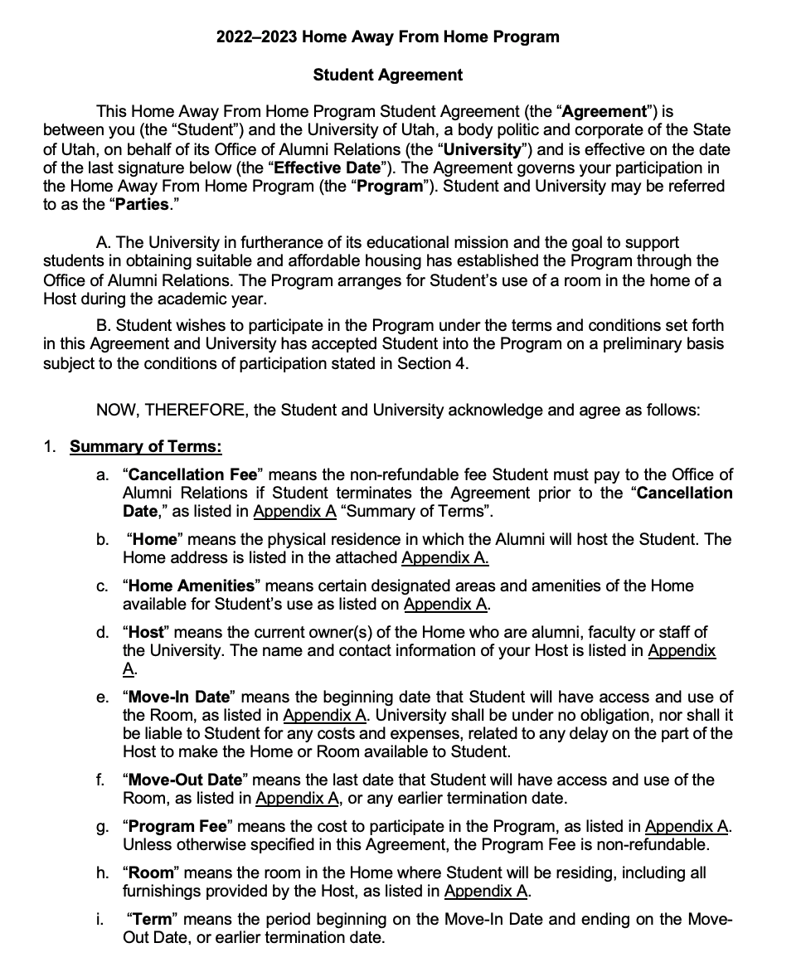
Figure A3. Utah Student and Host Agreement Form (host agreement varies slightly)
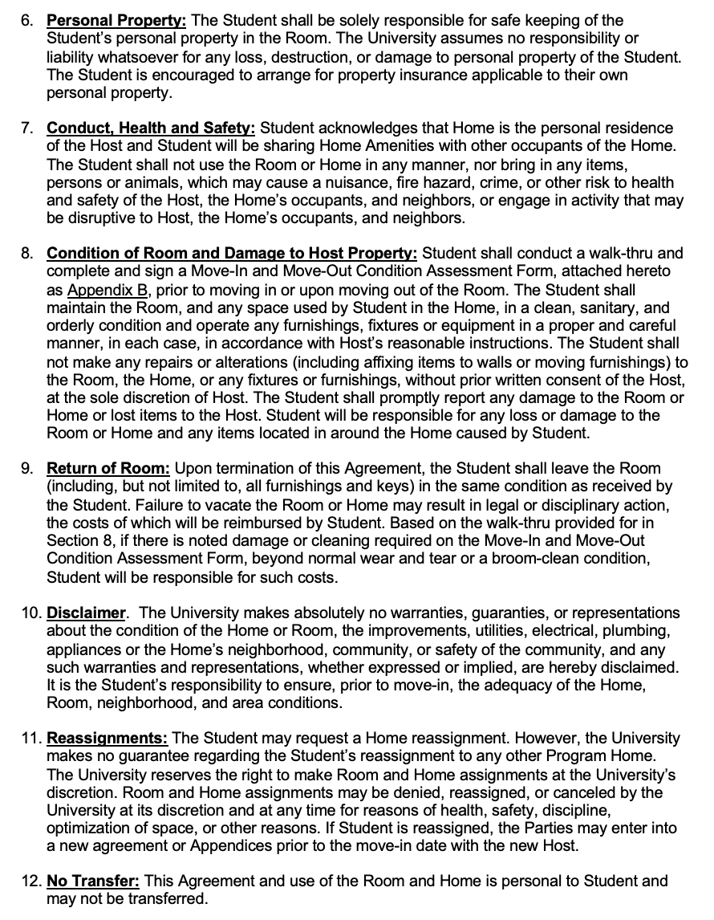

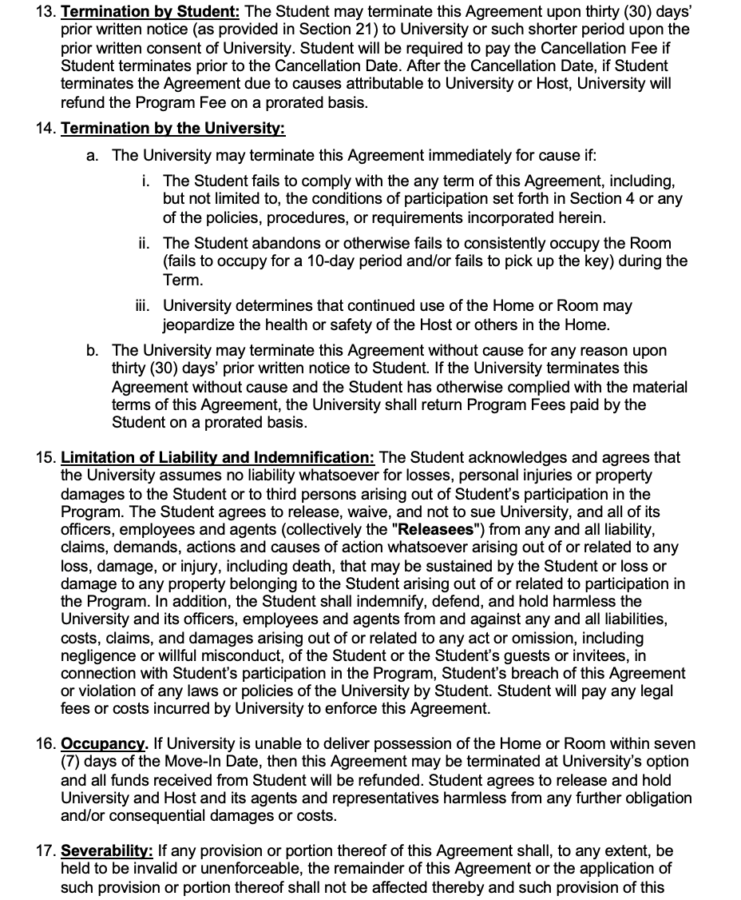

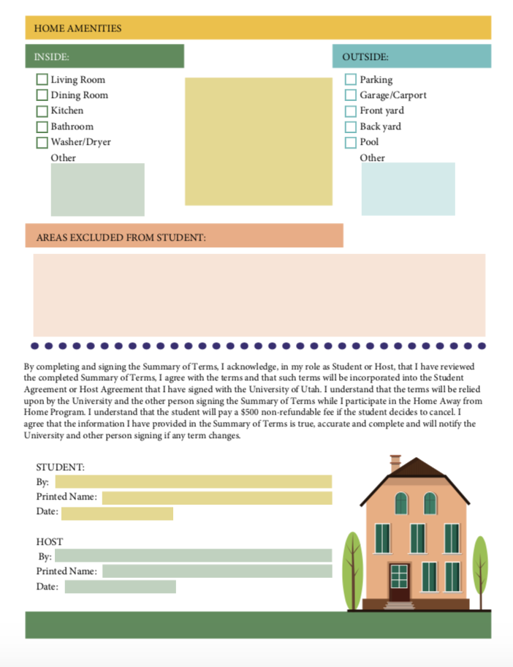
Figure A4. Utah’s Summary of Terms Form
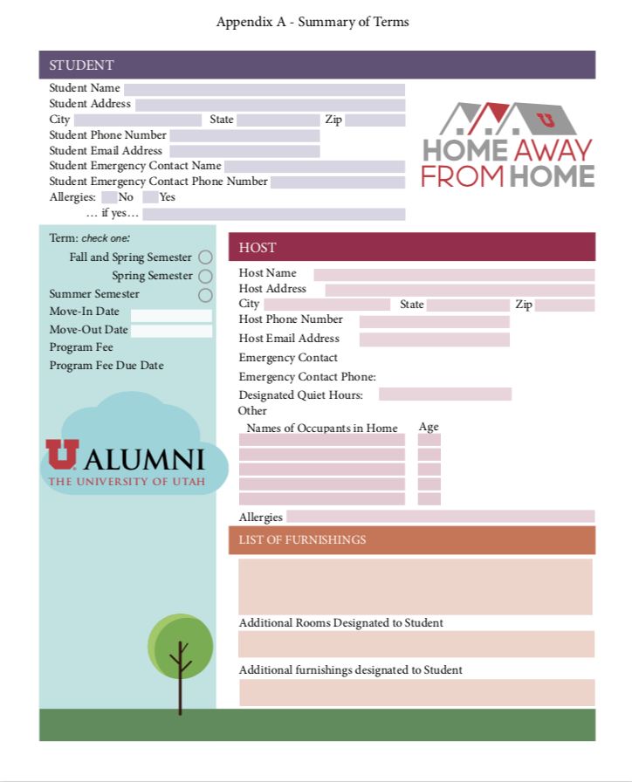

Figure A5. Utah’s Move-In and Move-Out Figure A6. WSU Host Duties, (WSU, n.d.-c)
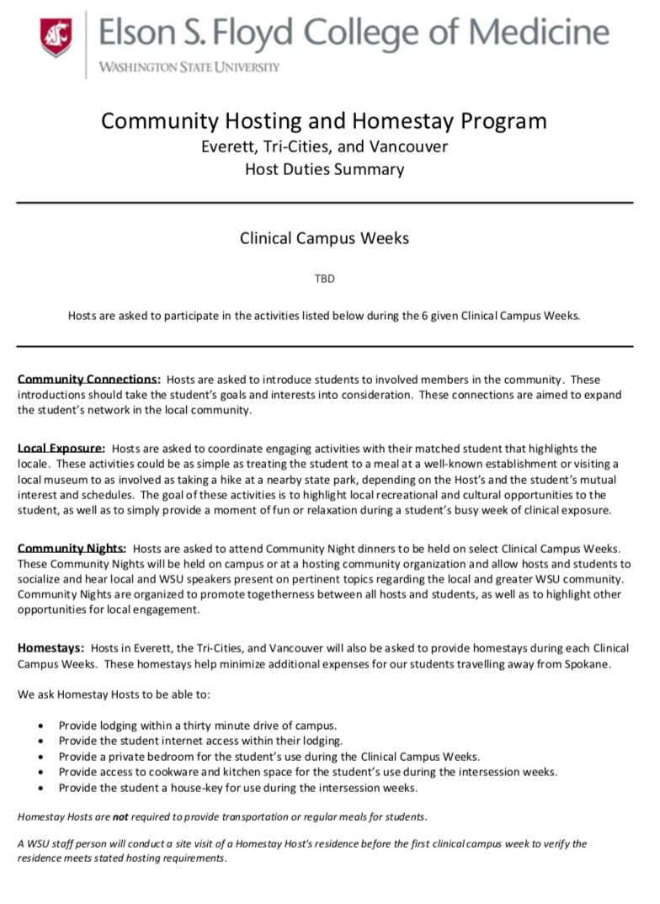
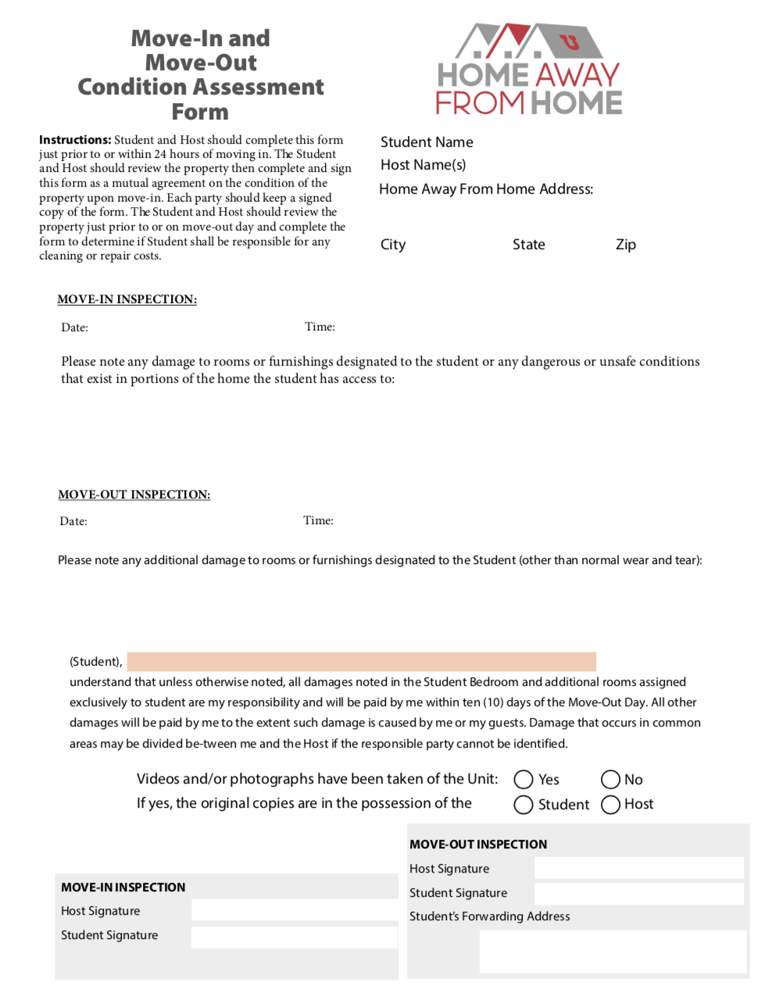
Condition Assessment Form

Figure A7. WCC’s Student and Host Expectations. (WCC, n.d.-b).
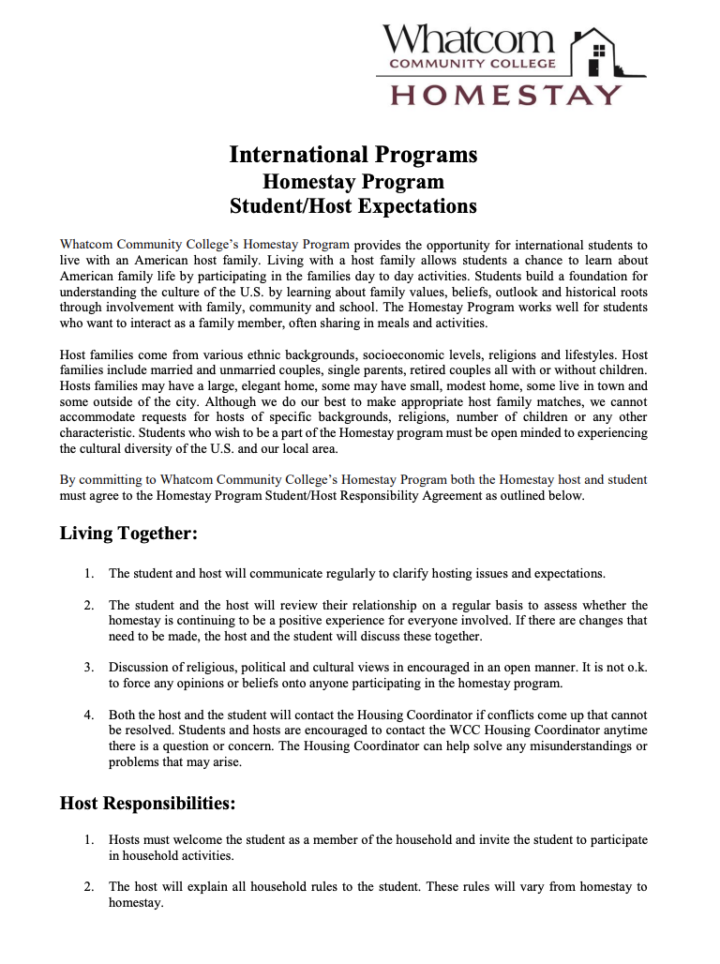
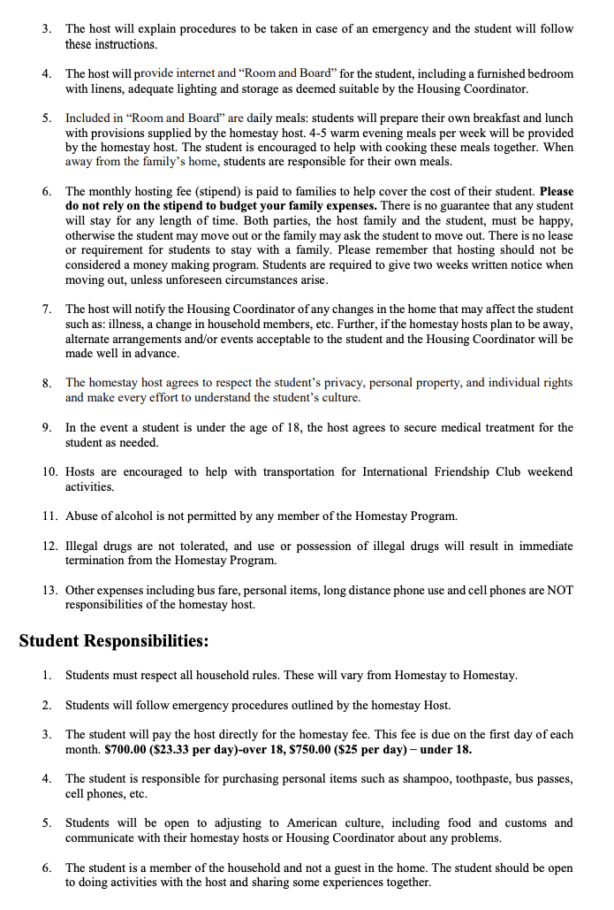

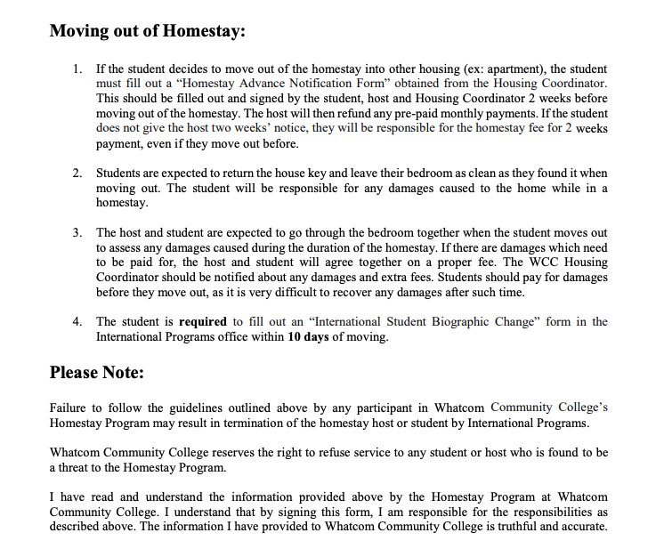
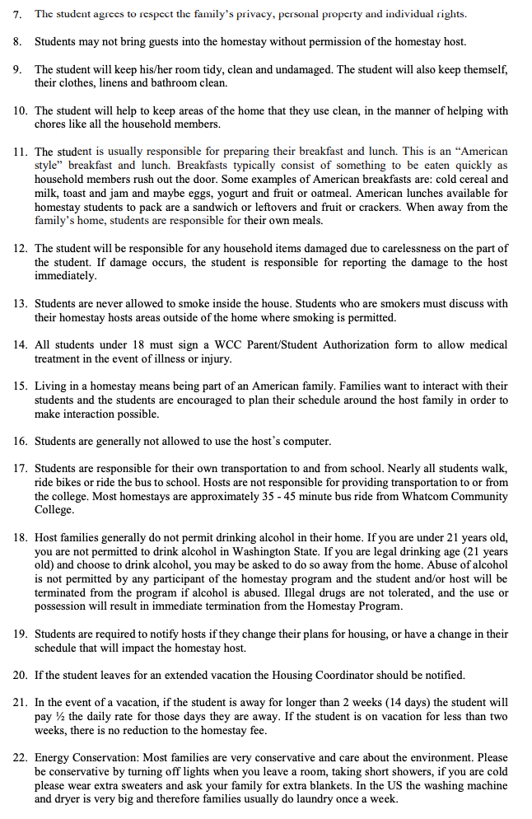

Figure A8. WCC Host Requirements (WCC, n.d.-a)
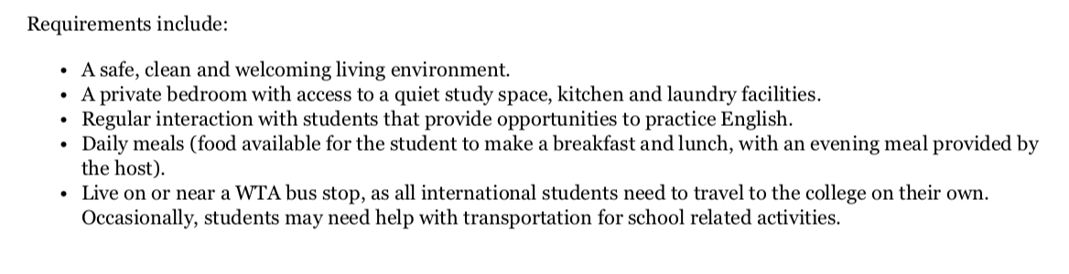

Figure A9: Edmonds Host Requirements (Edmonds, n.d.)
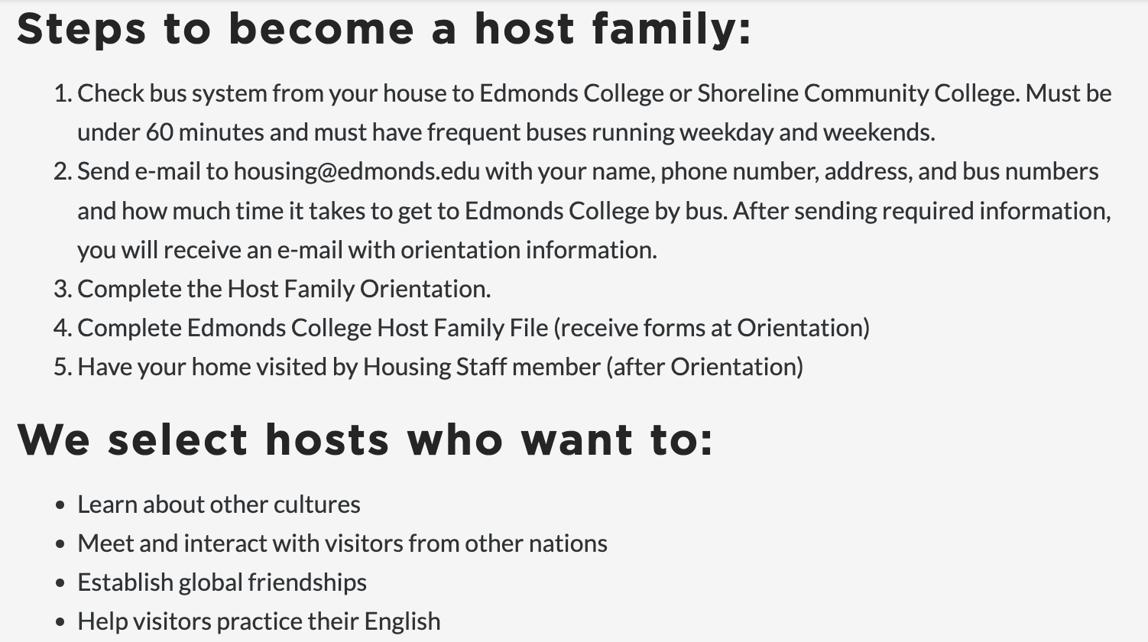

Appendix B. Interviews

Interview B1.
Interviewee: Julia Burns, burnsj21@wwu.edu
Interviewers: Lauren Adams, Sierra Bavik, and Ashleigh Mason
Other Attendee: Jon Stubblefield
Date and Time: October 3, 2022, 15:30
Location: Zoom

Description
Interviewing Julia Burns, the manager of Off-Campus Living at WWU and the sponsor of this project, helped to define the scope of this project further and to understand what additional information is needed and what work was already completed. Jon Stubblefield provided comments and insights regarding his experience as the Resource Navigator and Program Manager of Basic Needs.

Questions and Answer Summaries
- How long will students stay?
- One year is ideal. There is demand for short-term housing if a student is studying abroad or graduating soon.
- What students do you want to target with the program? those experiencing financial/housing instability, out of state, or anyone?
- Either or both, whatever is found to be most needed or practical.
- Are you aware of similar programs other than Utah’s?
- Short-term homestay at WSU. Look at the National Student Exchange program.
- Utah’s program hosts are primarily alumni. Is there similar alumni retention at WWU? Do you have a feel for the dynamic between students and Bellingham community members?
- Interview Victoria Martinsen in alumni engagement at WWU, retired professors’ group, grad students, and maybe current faculty members.
- Ask Martinsen: Do you know how many alumni remain in Bellingham? What do you think alumni are open to? Are alumni connected with students?
- Are there any other stakeholders we should contact?
- Lorrie Bortuzzo, manager of the Western Success Scholars Program.

Interview B2.
Interviewee: Jon Stubblefield, stubblj@wwu.edu
Interviewers: Lauren Adams, Sierra Bavik, and Ashleigh Mason,
Date and Time: November 9, 2022, 15:30
Location: Zoom

Description
Stubblefield, the Resource Navigator and Program Manager of Basic Needs at WWU, was interviewed to understand more about what students are experiencing, what they need, and what may help.

Questions and Answers
- Who do you believe this program should cater to? Should all students have access? Should housing-insecure students be prioritized?
- Data on students who have experienced homelessness/housing insecurity/foster care is recorded. Basic Needs website has survey data on students who have or are experiencing housing insecurity.
- If the program is transitional/short-term and need-based, see if WWU can subsidize student rent.
- How feasible would piloting this program be for your department? What changes/improvements would be necessary? (Like Utah hiring more staff)
- Likely need more staff, could have a student position (from any major/field).
- Is there anyone else we should reach out to?
- Katy Lenning, On-Campus Housing.
- How do you foresee implementation of the homestay program in terms of student access? How will students know it is available? Are there any gaps in providing resources that may impact the success of the program in the short or long term?
- If the program is need-based, it could reach out to students who are on record as being housing insecure/former foster kids.
- Do you foresee any pushback from Bellingham residents/city officials/landlords, or other stakeholders?
- Not sure.
- Do you have any questions/ideas/concerns for us?
- Not at the moment.
Notes
Stubblefield agreed that one factor host eligibility should be contingent on is whether they own their home, as this increases security for students during their stays.

Interview B3.
Interviewee: Victoria Martinsen, marti450@wwu.edu
Interviewer: Lauren Adams
Date and Time: November 16, 2022, 12:00
Location: Teams

Description
The interview with Martinsen, the Senior Director of Alumni and Constituent Engagement, was organized to unveil dynamics between alumni, students, and WWU to predict if alumni may be viable hosts.

Questions and Answers
- What percentage/number of alumni live within a reasonable commuting distance of WWU?
- Check with alumni data services.
- Is there data on whether local alumni rent or own homes?
- There might be. Ask the data team.
- I saw that Western Front is working on an article about alumni perceptions of housing affordability. Are you aware of any similar articles/studies relevant to our project?
- Not aware.
- University of Utah alumni asked their homestay program to lower rent for students. What do you assume WWU alumni attitudes are on rent?
- Alumni likely won’t request that students pay market rate for rent. Maybe set up payments so hosts break even and are unable to participate for financial incentives. When advertising the program, acknowledge that a nominal fee is included, so potential hosts know they aren’t going to lose money, but don’t provide specifics so profit-driven individuals aren’t attracted.
- Are WWU alumni likely to be excited by the opportunity to host a student? Is the community between alumni and current students strong enough to support this program? If not, what may foster this?
- Unsure, in general, alumni want to help. Reach out to alumni who have engaged with WWU and ask if they are interested.
- What kind of relationship should the program intend to create between host and student? Solely providing housing or working with students to mentor or advise on shared experiences or fields of study?
- Either likely differs by individual alumni.
- Do you have experience with or knowledge on fostering alumni-student relationships? What has been successful? How may the program utilize existing platforms/methods for fostering these relationships?
- WE Connect is a mentoring program with a questionnaire and system that matches students to alumni.
- What could the program include to further any of your office’s goals?
- The Alumni Office’s goals are to receive “time, talent, and treasure” from alumni. Metrics for measurement include if they attend an event, volunteer, do philanthropy, and have interactive communication.
- The program should make sure alumni have a positive experience by ensuring quality in communication, making good host-student matches, and being clear with expectations and requirements.
- An example of something directly related to WWU’s alumni engagement goals is inviting hosts and students to campus events.

Notes
Alumni office can support, not run program. Program may be limited by alumni availability. Figure out how to monitor if program is creating relationships (if that’s what program chooses).

Interview B4.
Interviewee: Lorrie Bortuzzo, bortuzl@wwu.edu
Interviewers: Lauren Adams, Sierra Bavik, and Ashleigh Mason
Date and Time: December 2, 2022, 12:26 (questions sent) - December 5, 2022, 9:36 (answers received)
Location: Email

Description
Bortuzzo, the manager of the Western Success Scholars Program at WWU, was interviewed to understand more about her department’s role in helping students and how it could benefit a homestay program.

Questions
- What potential issues should we be aware of? Do you foresee any limiting factors?
- You address the key potential issues in the work you have done. Limiting factor in implementing this program would be funding for the full-time manager of this program.
- Is there anything you’d like to see from the program? In what ways could the program function for housing-insecure or low-income students facing housing insecurity?
- A program like this could provide another option for students in securing affordable and safe housing. In addition, and as you stated in your presentation, this provides WWU Alumni the opportunity to stay engaged and support WWU students. There are opportunities for students in this program to increase their social capital by meeting with WWU Alumni. Friendships, mentorships, and creating a sense of community and belonging could be a very positive outcome from implementing a program like this.
- Would short-term or long-term homestays be of more use?
- Short-term and long-term homestays would be beneficial. Short-term are needed as students face unforeseeable situations that puts them at risk of being unhoused. Some examples:
  - Rent increases forces a student to leave their current stable housing as they cannot afford the increase. They are at risk of homelessness until another stable and affordable housing situation arises.
  - A student halfway through the term is kicked out of their parent’s home for sharing that they are LGBTQ.
  - Halfway through the academic year student finds mold in their current housing and has to leave for health reasons but due to lack of housing has to couch surf.
- Long-term would provide alternative affordable housing for traditionally underrepresented students in post-secondary education.
- Could this project operate at a scale large enough to make it a viable option for students experiencing housing insecurity?
- In my opinion, yes I do feel this project is a viable option for students experiencing housing insecurity.
- Utah’s program is not classified as on-campus housing, making it ineligible for direct financial aid. If this policy applies to WWU, what options are available for a student unable to afford the program?
- To work with on and off-campus professionals such as WWU Off-Campus Living, WWU Basic Needs, Western Success Scholars, Northwest Youth Services and Opportunity Council.
- Do you know if financial aid could apply at WWU?
- Best to consult professionals in the Financial Aid office.
- Does anyone in your department have a position related to this project? Do you have any staffing recommendations (ex., Have one staff member w/ experience with low-income/housing insecurity issues)?
- The Western Success Scholars program is a voluntary campus support program for students at WWU who are an unaccompanied homeless youth or a student who has experienced foster care. Many students in the program are receiving the Passport to Careers scholarship and are eligible for the support services offered through the Western Success Scholars program. Currently we have one full-time staff person who is the Program Manager. We are currently in the process of hiring a Program Coordinator. Implementing the Home Sweet Homestay program I feel would need one full-time staff member with experience on low-income/housing insecurity issues, as well as, strong case management skillset.
- https://wss.wwu.edu/
- https://wsac.wa.gov/passport-to-careers

Interview B5.
Interviewees: Bethany Hardwig, bethany.hardwig@alumni.utah.edu and Victoria Martinsen
Interviewers: Lauren Adams, Sierra Bavik, and Ashleigh Mason
Other attendees: Lorrie Bortuzzo, Julia Burns, and Jon Stubblefield
Date and Time: October 17, 2022, 15:30
Location: Zoom

Description
Hardwig from the University of Utah’s Office of Alumni Relations created and implemented their Home Away from Home program. This interview was powerful in understanding what made this program successful, how the program runs, and what, if anything, could have been improved in planning and implementation. Martinsen was originally only attending, so questions were not prepared, but she was able to answer a few questions that came up in the meeting.

Questions and Answers (Hardwig)
- How long are students’ stays?
- One year during the pilot phase.
- What students do you target with the program? - financial/housing unstable people, out of state, or anyone?
- In the pilot phase, anyone interested is allowed.
- Student eligibility only depends on willingness to comply with a background check, provide a non-familial reference, and have above freshman standing.
- Other similar programs?
- Boise State is working on one similar to Utah’s.
- Is there a significant alumni-to-student/university relationship? If not, what was necessary to foster a relationship for this program?
- 60% alumni stay around the University. Many alumni are eager to help students.
- How is the program structured?
- Nine students now will increase to 16 in spring 2023.
- It takes around a week to be placed, so not the fastest housing arrangement if a student needs housing immediately.
- No security deposit, lease is replaced with a customs program to create community and connection between student and host.
- The Board of Governors has 12-15 members who work on alumni relationships with the University. They are generally aware of what is happening on campus.
- Related staff: alumni relations totals around 30, homestay program 3, communications manager (for hosts and students).
- Program includes program manager and communications manager.
- Hosts and students each get separate emails every other week. For students, this includes information on campus events. Hosts meet on Zoom once a month.
- If an issue arises between host and student, deference is given to student’s position, student is immediately removed, the university pays for immediate housing, and they resolve the issue.
- Did you consider other groups as hosts? If so, why were they not included?
- Alumni, faculty, and staff are included as potential hosts.
- What students have been interested?
- How are students matched to hosts?
- Match with each other in a private “Forever Utah Alumni Network” group.
- How much does it cost? How are hosts paid?
- $2600 per semester. Student pays school, school pays host to eliminate power imbalance/landlord-tenant dynamic.
- What is expected of hosts? Is it just providing housing, or does it include meals or activities like some programs do with international students?
- Students can still buy a meal plan at the university.
- Hosts are not expected to do anything specific, but the organization of the program works primarily for hosts and students who want community, not transactional/normal housing.
- What’s the incentive for the host? Is there a subsidy?

Questions and Answers (Martinsen)
- What do you think alumni are open to?
- Not sure how alumni would feel, likely some positive reception.
- Are alumni connected with students?
- WE Connect platform interest-matches students and alumni by survey responses.
- How many alumni are in Bellingham/are there enough to support this program?
- Alumni population in Bellingham likely not an issue.

Notes
Currently not enough staff in alumni offices to support a program like Utah’s.

Interview B6.
Interviewees: Samya Lutz (SL) slklutz@cob.org and Katy Sullivan (KS), krsullivan@cob.org
Interviewers: Lauren Adams (LA), Sierra Bavik (SB), Ashleigh Mason (AM)
Date and Time: November 18, 2022, 11:00
Location: Zoom

Description
Lutz and Sullivan, Housing & Services Program Manager and Development Specialist, respectively, were interviewed for a general understanding of COB code restrictions or prescriptions related to the homestay program. They received the questions before the interview, so the questions they answered are interspersed with the edited transcript below.

Questions and Answers
- Students’ rent will ideally be lower than the Bellingham average. If the program becomes big enough to take demand from the rental market, do you foresee backlash from local landlords, developers, or anyone else?
- SL: The first question you asked about was demand and kind of backlash from landlords, developers, and other folks. You know, there’s always NIMBY-ism backlash for, you know, almost everything that happens, but housing is consistently one of the top issues of the community, and anything that is moving this forward in a collaborative way is going to get support, and that’s going to be the dominant way of moving this forward, with support. I think if it starts to be adversarial, you know, that just means we need more collaboration and more kind of buy-in and to maybe bring in some partners and some other perspectives as it moves forward, but this concept in itself there's nothing about [it that I think] would run into such backlash that it would impede moving forward.
- If so, is this something for the program to prepare for, or would any negative responses/threats be moot?
- SL: So then the second bullet is kind of moot, and then you ask about the no more than three unrelated persons.
- May the “no more than three unrelated persons” code become an issue?
- SL: I think … you know, technically, the definition of family doesn’t permit that, but it’s proven to be an unenforceable part of code, and it's been sort of on the list of things to deal with for quite some time. It’s, I think, widely recognized that it’s problematic, and it’s kind of in the dark ages, and it’s unenforceable, so even if complaints are made, there’s nothing really the City can do about it. So, for that reason, I would say you could ignore that.
- LA: Just from Western’s side, if that code goes away, it wouldn't be an issue, but if Western starts the program while the code is still technically there…
- SL: Yeah, I think if this becomes a program, and maybe it starts as a pilot, we would expect there to be maybe a memorandum of understanding or memorandum of agreement MOU or MOA between the city of Bellingham and the University that outlines what the program is, what they’re doing, what the role of the University is, what the role of the City is. In that kind of memorandum, I think there could be clarity given that would appease the University’s concerns about risk in this regard and, you know, probably start as some kind of a pilot program, so MOU or MOA is [a] pretty light approach, but that could morph into something bigger after a pilot period.
- KS: I don't have any more to add on the three unrelated persons code, but happy to follow up with folks internally if there’s further questions on those code definitions and the legal implications associated therein. Let me know.
- The program may provide short-term or long-term housing. Would that change the City’s perception?
- KS: Do we want to talk about short-term versus long-term housing a little bit?
- SB: Yeah, that’d be great
- KS: OK, great. So, this is an area where Samya and I are admittedly not as well versed, this is kind of on the planning side of our department. We reached out to some of our planners to try to get more of an understanding of what the difference is here and what defines short-term rental, and how that is permitted and regulated. So, she got back to us, and for starters, if something is considered long-term housing, meaning that lodging is rented on a monthly basis for 30 or more consecutive nights, there’s no definition for that or special regulations or code carve-outs; that’s just considered long-term housing. She did let us know that short-term rentals, which are defined as a lodging or a use provided to the guest by a short-term operator for a fee for fewer than 30 consecutive nights, have to be approved through a permit approval process. She let us know it’s a pretty straightforward process as long as the property owner lives in the dwelling unit, so the model that you’re proposing sounds like it would be a very straightforward approach, and it would be a two to three-week process they [owner/host] have to get a permit, and they would have to go through an inspection prior to occupancy just to make sure that some basic safety elements are met. If the intention is to have more than two bedrooms and less than five rented, so the plan is to kind of match more than one student per house, then it would actually be a more involved process. It would have to go through a type 2 permit process which involves notice to property owners [and] there’s a mandatory comment period. Which isn’t to say it’s not possible; it’s just to say it’s a much more involved process depending on the appetite of the property owners who are going to participate in this program. I think that would just be kind of a flag that you would want to think through on that side, but short-term rentals are definitely allowable, and it’s [a] pretty easy process if the property owner lives on site, and if it’s just one bedroom being rented out there is a process, so I just want to flag that and that[‘s] only for short-term housing. I don’t know if there’s a set period of time you’re thinking for a full quarter, for a full academic year, but I think as you flesh out the scaffolding of that program, that should definitely be on your radar as you think through the format.
- SB: Yeah, I think we’re bouncing back and forth on if there should be a requirement for how long. It’s probably going to be more than 30 nights consecutively, so that shouldn’t be an issue.
- This program may act as affordable housing. Are there any additional laws to be aware of?
- SB: I don’t know how [much] you guys deal with laws with affordable housing and if you would know if there’s any additional laws or ordinances or anything that would be applicable to this we should be aware of?
- KS: None came to mind when we were thinking about it. A lot of the projects that Samya and I work on involve the direct transfer of public funding, in which case there’s a lot of rules and regulations tied to the funding itself, but if this is just a de facto lease between the student and the leaseholder-the property owner-then there’s nothing really that pricks my ears up on the additional regulation side, but that again might be a code question and something we should run up to our planning folks.
- Are there any other codes or zoning ordinances that we should be aware of, in general?
- SB: OK. That is all the questions we had. Ashleigh or Lauren, do you have any additional ones that come up?
- AM: Nothing I can think of.
- LA: It seems like anything would be brought to the attention of the university if they’re … transparent and everything with the City …
- KS: Yeah, and it’s hard kind of [to] speak in hypotheticals, right? It sounds like a great program, but I think once a draft of [the program] is formatted and is kind of thought through, then conversation begins in earnest about kind of the legal aspects and the specific code aspects. Things come up kind of later in the process, but it sounds like a promising program and a really, really interesting idea for sure.

Notes
- Adrienne Solenberger, Housing Advocate Intern at Opportunity Council
  - Worked as landlord liaison
  - Encourage landlords to take on more low-income people - roommate matching

References

City of Bellingham. (2018). 2018-2022 Consolidated Plan - Section 2: Housing Market Assessment. https://cob.org/wp-content/uploads/2018-2022-section2.pdf

Cocoon House. (n.d.-a). Housing. Cocoon House. Retrieved December 8, 2022, from https://www.cocoonhouse.org/youth-housing

Cocoon House. (n.d.-b). Join our Team. Cocoon House. Retrieved December 8, 2022, from https://www.cocoonhouse.org/join-our-team

College Tuition Compare. (n.d.). Student Population Comparison Between Colleges in Bellingham, Washington. College Tuition Compare. Retrieved December 8, 2022, from https://www.collegetuitioncompare.com/compare/tables/?state=WA&city=Bellingham&factor=student-population

Edmonds College. (n.d.). Edmonds College: Housing - Homestay. Edmonds College Housing and Residence Life. Retrieved December 9, 2022, from https://www.edmonds.edu/housing/homestay-families/

Edmonds College. (n.d.-a). Edmonds College: Housing - Homestay - Host Family Frequently Asked Questions. Edmonds College Housing and Residence Life. Retrieved December 8, 2022, from https://www.edmonds.edu/housing/homestay-families/faq.html

Edmonds College. (n.d.-b). Edmonds College: Housing - Homestay - Payment Information. Edmonds College Housing and Residence Life. Retrieved December 8, 2022, from https://www.edmonds.edu/housing/homestay-families/payment-information.html

Larson, B., & Paulson, E. (2022, May 5). Bellingham rent continues to rise as vacancy rates continue to fall. The Front. https://www.westernfrontonline.com/article/2022/05/bellingham-rent-continues-to-rise-as-vacancy-rates-continue-to-fall

University of Utah. (n.d.-a). About U Alumni. ULink. Retrieved December 8, 2022, from https://ulink.utah.edu/s/1077/20/interior.aspx?sid=1077&gid=1&pgid=565

University of Utah. (n.d.-b). Board of Governors. ULink. Retrieved December 8, 2022, from https://ulink.utah.edu/s/1077/20/interior.aspx?pgid=475&gid=1

University of Utah. (n.d.-c). Home Away From Home. ULink. Retrieved December 8, 2022, from https://ulink.utah.edu/s/1077/20/interior.aspx?sid=1077&gid=1&pgid=4638

Whatcom Community College. (n.d.-a). Information For Homestay Hosts. Whatcom Community College. Retrieved December 8, 2022, from https://www.whatcom.edu/academics/international-programs/info-for-homestay-hosts

Whatcom Community College. (n.d.-b). International Programs Homestay Program Student/Host Expectations. Whatcom Community College. Retrieved December 9, 2022, from https://www.whatcom.edu/home/showpublisheddocument/4059/637112417217370000

Washington State University. (n.d.-a). Community Hosting and Homestay FAQs. Elson S. Floyd College of Medicine Washington State University. Retrieved December 8, 2022, from https://medicine.wsu.edu/md-program/student-affairs/community-hosting-and-homestay-faqs/

Washington State University. (n.d.-b). Community Hosting and Homestay Program. Elson S. Floyd College of Medicine Washington State University. Retrieved December 8, 2022, from https://medicine.wsu.edu/md-program/student-affairs/community-hosting-and-homestay-program/

Washington State University. (n.d.-c). Community Hosting and Homestay Program Everett, Tri-Cities, and Vancouver Host Duties Summary Clinical Campus Weeks. In Elson S. Floyd College of Medicine Washington State University. Retrieved December 8, 2022, from https://s3.wp.wsu.edu/uploads/sites/1506/2020/02/Host-Duties-Summary-Class-of-2024.pdf

Western Washington University. (2022). Sustainability Report 2021. In Sustainability Engagement Institute. https://sustain.wwu.edu/files/2022-01/WWU_Sustainability_Annual_Report_2021.pdf

Western Washington University. (2021). Quick Facts | Admissions. Western Washington University Admissions. https://admissions.wwu.edu/quick-facts

Zumper. (2022, December 8). Average Rent in Bellingham, WA and Cost Information. Zumper - Apartments for Rent & Houses. https://www.zumper.com/rent-research/bellingham-wa

Information unavailable online is introduced below in the “Interviews” section under “Bethany Hardwig, Development Director, Office of Alumni Relations University of Utah.”
Interviews and meetings with Julia Burns were conducted regularly to provide progress updates on research and interviews. Including results from interviews would be redundant as they are diffused throughout this report, so they were excluded. See introductory interview with Burns in Interview A1.
These specifics were not discussed in the interview but found during post-interview research on WE Connect.
Post-interview research on Utah’s alumni website clarified numbers that were estimated in the interview.
The title of the group was not provided in the interview but added to interview notes from their website after.

