Room One
Room One Advocacy Practicum

This position description is from 2021 and will be updated with one for 2022 shortly. This gives a general idea of the organization and related work, while position responsibilities will be updated.
Salary: | $15.00 per hour, 10 hours/week for 10 weeks
Supervisor: | Keri Moore, Health Educator, Co-Lead Okanogan Healthy Youth Program, Advocacy Committee
Period of Employment: | June 21, 2021 – August 27, 2021
Position Requirements: | Enroll in ENVS 471, Sustainability Planning Studio, 3 credits

Overview
Room One is a community voice, powerfully advocating for the health and well-being of all people living in the Methow Valley. We work toward the vision of a rural community where all can thrive by providing direct services, implementing prevention programs, and advocating for meaningful change so we can address root causes of intergenerational poverty and violence.
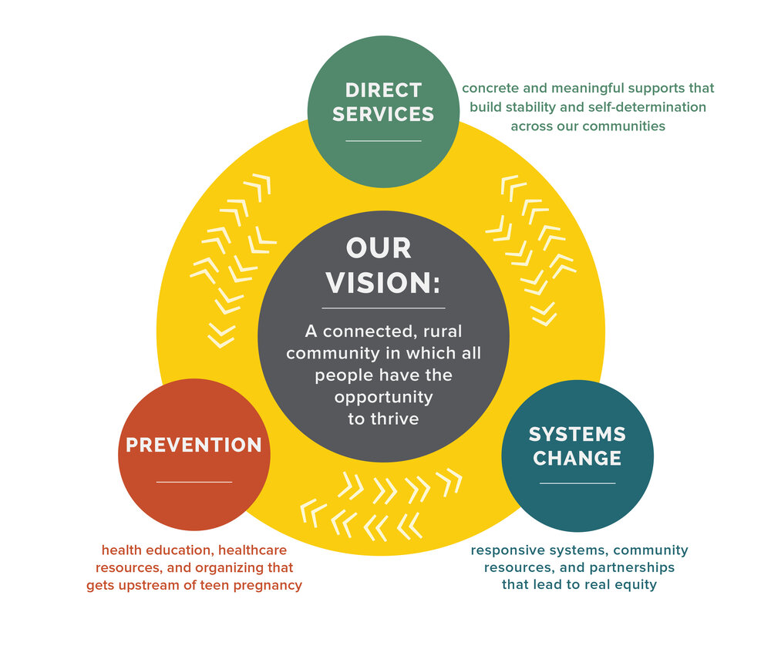

Because of the Methow Valley’s uniquely isolated location, local women, men and children in need of critical human services are often left without advocates and vital resources. The comprehensive services we provide at Room One are directed at preventing violence and interrupting health disparities in our Methow community and strategically across Okanogan County. In every decision to build a program, cultivate a partnership and support a client, we look to our fundamental values of accountability, allyship, agency, dignity and equity for guidance.

The intern will work with Room One’s Advocacy Committee to help develop internal systems, policies and frameworks to conduct responsive and meaningful advocacy for systems change. The intern will support the committee in developing a “case study” for housing advocacy, based on community needs. We anticipate 1 day/week of independent research on advocacy tools and 1 day/week meeting with Advocacy Committee members to build internal systems, identify next steps for housing solutions, write advocacy policies and participate as a thought-partner in creating the Room One Advocacy Charter and Platform. Schedule can be somewhat flexible.

Responsibilities
The intern will work a combination of remote, independent research (½) and in-person collaboration (½).
The independent research will include careful reading of current 501(c)(3) non-profit advocacy tools, laws and structures. This research will allow the intern to participate as a collaborative partner in the design and implementation of the Room One Advocacy Charter and Platform. Other responsibilities might include:
- Attending staff/board meetings that pertain to Room One’s direct service, prevention and advocacy work
- Participating in meetings with other area nonprofits to gain local knowledge on how other organizations manage their advocacy work
- Writing draft policies or frameworks with Advocacy Committee
- Use current advocacy needs (such as affordable housing in the Methow Valley) to test new advocacy tools and frameworks

Required Qualifications and Experience
- Ability to work alone and complete projects in a self-directed manner
- Strong reading, writing and research skills
- Familiarity with Google Suite applications like Google Docs and Slides
- Ability to work in a team, give and receive feedback
- Ability to work collaboratively, including co-writing and co-editing

Educational/Professional Benefits
- Experience working with one of the Methow’s keystone nonprofit organizations focused in the sustainability of its community members’ health and wellbeing
- Gain knowledge in the laws and structures of nonprofit advocacy
- Experience designing and implementing an advocacy strategy: a transferable skill for all kinds of sustainability initiatives

To apply complete this application form: | https://forms.gle/wokrqBDKkSG8ABU98  Application review begins April 19 and will continue until positions are filled
For all questions, please contact Joshua Porter: | Porterj7@wwu.edu

