The Future of
Sustainability Ambassadors:
Program Recommendations for Fall, 2022

By: Gil Oswald Zhaxael Gepte, Samantha Goetze, and Shyann Young

ENVS 471: Campus Studio Planning, Sponsor: Lindsey Macdonald, Associate Director, Sustainability Engagement Institute

December 10th, 2021

Table of Contents

Executive Summary………....…….…………..3

Introduction………………...…….……………4

Methodology…………………….….…………5

Results……………………….…......………….6

Recommendations……………..….…………..20

Monitoring and Evaluation…………..………..24

Budget…………………………..……………..25

Barriers..............................................................29

Conclusion……………………...……………..30

Appendix ……………………......….…............31

References …………………..……...................44

Executive Summary

Problem Statement

As Western Washington University’s Office of Sustainability has transitioned to the Sustainability Engagement Institute in 2021, various programs running through the institute are also making changes. One of these programs is the Sustainability Ambassadors, who conduct student outreach and educational events in the campus’s residence halls. Since COVID-19, the program was put on hold with plans for re-implementation in Fall, 2022. It has faced numerous challenges in achieving successful outreach, which is reflected in its Sustainability Tracking, Assessment & Rating System (STARS) student educators program rating of 1.04 out of 4. Considering current efforts to improve WWU’s STARS ratings, as well as the recent Sustainability Engagement Institute changes and archival of the Sustainability Ambassadors program, it is an ideal time to reimagine and improve the program.

Project Description

This project researches 15 Sustainability Ambassador programs (of various names, commonly Eco-Reps) across the country with highly regarded student educators’ programs based on their STARS ratings. The findings are organized into 22 categories and analyzed based on common elements and notable aspects of the programs. The broad categories for inventory include programming, funding, curriculum, organization and structure, and best practices. A set of recommendations for WWU’s Sustainability Ambassadors to adopt is then offered based on the analysis. The budget recommendations are based on three schools with exceptional programs: Oregon State University, University of Colorado Boulder, and University of Vermont. The next steps for the Sustainability Ambassadors program’s re-implementation and potential barriers are then discussed.

Summary of Recommendations

The recommendations for the renewed Sustainability Ambassadors program are organized into three areas: programming, structure and organization, and marketing. The program should utilize a tiered structure wherein first year members are compensated in credits and more committed positions in hourly payment. A permanent staff position could also benefit the program. To promote unity, the program should consider the option of organizing Ambassadors into groups with sustainability topic focuses that each work on different elements of the same campaign. The Sustainability Ambassadors should also expand to a campus-wide focus to advance the program’s impact on the student body. With this, they should collaborate with other sustainability efforts on campus. The Ambassadors must consider in-depth onboarding and ongoing training to provide team building and teach members about sustainability, leadership, marketing, and event planning. Ideally, the program should focus on quality over quantity to achieve effective outreach. Independent passion projects and funded project proposals could offer students personalized experiences with the program. The Sustainability Ambassadors should also re-market as a prestigious career building internship program that offers professional development skills and opportunities. The program must emphasize advertising and utilize feedback, records, and annual reports.

Introduction

Statement of Need

Historically and in modern times, individuals, institutions, and broader societal systems function unsustainably, and not just in the environmental sense, but in all four pillars of sustainability: ecology, social equity, human health, and economic vitality. Education and awareness efforts play a critical role in transforming the unsustainability of these systems and combatting its effects. Educational institutions are a big part of educating students and making space for students themselves to peer-educate. Universities can be sites for social progress, provide a foundation of knowledge for change, and motivate and equip future leaders (Kestin et al., 2017). Western Washington University, while having made great strides in achieving sustainability (as evident in the school’s silver STARS rating), still has a long way to go to be sustainable and to improve student efforts around sustainability outreach. WWU's Sustainability Ambassadors program aids in making the university more sustainable, as well as educating individuals on sustainable lifestyle choices. It has been highly regarded for its impact on students and is one of the longest running programs of its kind (Alyssa Tsukada email, 2021). However, the program has faced challenges in achieving successful outreach and engagement and requires recommendations (based on the successes of similar highly regarded programs in the nation) to more successfully meet its goals.

Project Goals

The Sustainability Ambassadors are hoping to improve their program to better spread sustainability awareness, improve campus and individual sustainability, and engage first year students to provide opportunities towards future sustainability action on campus. Improvements must be made in the curriculum, programmatic elements, participation and engagement, and organizational structure. This project aims to provide recommendations in these areas to help create a more robust program. Recommendations will be based on comprehensive research of 15 of the most highly rated Eco-Reps programs in the United States (based on STARS ratings).

Background Research

The WWU Sustainability Ambassadors program began in 2007 and has since seen many changes. Most recently, the program was defunded due to COVID-19 and reduced to virtual educational meetings for Ambassadors (no outreach or campus events) during the 2020-2021 school year. It has been archived for the 2021-2022 school year (Alyssa Tsukada email, 2021). The newly transitioned Sustainability Engagement Institute—formerly the Office of Sustainability—is looking to reimagine the program and reinstate it in Fall, 2022.
Across the country, university programs like the Sustainability Ambassadors have been implemented—the first having been created in 2001 at Tufts University. The programs go by many different names but are commonly called Eco-Reps, which is the name this paper will use to refer to other universities’ programs. WWU’s Sustainability Ambassadors chose its name to account for the fact that it addresses all four pillars of sustainability—not just ecology. The “Student Sustainability Educators: A Guide to Creating and Maintaining an Eco-Rep Program on Your Campus” defines Eco-Rep programs as “student-based programs that: Focus on sustainable living practices, are based in residential buildings, use peer education techniques, [and] have a direct relationship with or are supervised by an employee of the institution” (Erickson, 2012). Many Eco-Rep programs began as, or expanded to be, campus-based instead of residence-hall based in order to extend their influence and accessibility. Eco-Rep programs center around promoting individual sustainability behaviors and institutionalized sustainability through peer-to-peer education. They include training the student educators (i.e. Reps or Ambassadors) in sustainability and leadership skills. Each Eco-Rep program is different and must be specific to its campus culture and needs. Still, among the successful Eco-Rep programs in colleges and universities nation-wide, proven practices have been developed, which are discussed in this project.

Methodology

Data was collected by gathering information from 15 university’s Eco Rep programs. Three criteria were put in place for selecting the 15 programs: (1) a STARS rating of 3.5/4 or above for the Student Educators Program, (2) access to information, and (3) inclusion of peer institutions and reach schools (to ensure variety and diversity in the research). The Sustainability Tracking, Assessment & Rating System (STARS) is a “transparent, self-reporting framework for colleges and universities to measure their sustainability performance” (AASHE, n.d.). The framework measures overall sustainability on a scale of reporter, bronze, silver, gold, and platinum, as well as sub-scores such as the Student Educators Program. This rating looks at peer-to-peer education programs in which students are trained to become experts in a sustainability topic. The rating considers the number of trained student educators, hours worked, the number and percentage of students served by the educator program, program descriptions, how student educators are selected, training descriptions, and financial and administrative support descriptions (AASHE, 2021).
Other data and information were found through the program websites, social media sites, schools' sustainability reports, and the STARS database. Interviews and questionnaires were used to fill in the information gaps not available online and to obtain different perspectives about the programs, including WWU’s. These various forms of information were used to create an inventory catalog of things to be analyzed and used for context purposes. The inventory for analysis includes 5 broad categories: (1) Programming (e.g., design, implementation, events and campaigns, training, admissions processes, compensation, multi-year components, and target audience), (2) Funding (e.g., amount, funder), (3) Curriculum (e.g. topics for outreach and training), (4) Organization and structure (e.g., staff involvement, coordinator/mentor positions, peer leadership, department oversight, average number of Reps), and (5) Best practices and successes. These categories help to understand how the programs’ ins and outs work and what makes them successful. The inventory also includes necessary background/miscellaneous information about the university's population size, location, STARS rating, Student Educators Program rating, year of implementation, etc. This information will not be analyzed but, rather, will help to provide context for the analysis.
The results are also displayed in charts to show commonality in program practices across the schools. The inventory and interview methods offer varied perspectives and both subjective and objective information that help to build a picture of why the 15 universities have high STARS ratings and successful Eco-Rep programs. This holistic and detailed information informed the recommendations for WWU’s Sustainability Ambassadors.

Results

Results have been laid into a written summary format for each university—including Western—with information from the inventory and interviews. Additional data is depicted in several charts and graphs, including STARS ratings, dorms vs. campus-wide scope, funder(s), compensation (credit, paid, internship, volunteer, or variations of multiple), undergraduate population numbers, the grade levels that can participate in the program (first-year only, first and second year, or all undergraduates), and the average number of Reps each year. The entirety of results is available in the appendix, including an Excel spread sheet of the full inventory, budget sheets, interviews, and other collected data.

Western Washington University Sustainability Ambassadors

This information describes pre-COVID-19 school years. WWU’s Sustainability Ambassadors was created in 2007 and has a student educators program rating of 1.04/4 (WWU STARS AASHE, n.d.). The program is funded $22,500 annually by University Residences and run through the Sustainability Engagement Institute (Miller, Memorandum, 2019). Its mission is to create “a culture of sustainability that extends beyond the boundaries of Western’s Residence Halls” by increasing sustainability awareness (in all four pillars of sustainability) and engaging in informative dialogues with student residents about implementing sustainability in their daily lives (Miller, Mission, 2019). The program aims to “broaden sustainable education at Western through residence hall and campus-wide events and by providing resources for furthering the sustainable practices of residents during both their stay on campus and for the rest of their lives” (Miller, Mission, 2019). The organizational structure involves a coordinator, assistant coordinator, one intern, six mentors (students with one-year prior experience in the program), and Ambassadors (Miller, Program Structure, 2019). The mentors’ roles are to support first-year Ambassadors, facilitate meetings with their residence hall group, and conduct a year-long independent sustainability project. Most recently, there have been at least two Ambassadors for each of the nine residence halls.

Figure 1
WWU Sustainability Representatives Program Organizational Structure
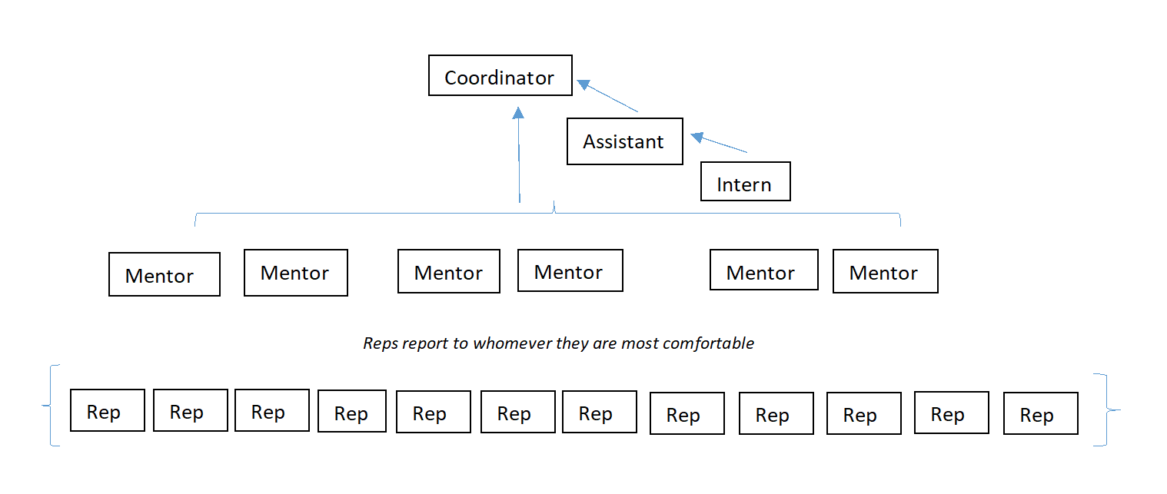
(Miller, Program Structure, 2019)

The Ambassadors are defined as “motivated student volunteers working to further sustainability and environmental justice in their own residence hall” (System Account, 2019). They must live in the residence hall they represent and act as a liaison between residents and the Sustainability Engagement Institute. First-year Ambassadors receive one credit per quarter for their work, whereas the mentor, intern, assistant, and coordinator positions are paid ($12.00 to $14.50 depending on the position). Ambassadors attend weekly program meetings (which often include guest lecturers), meetings with their residence hall group, and hall council meetings. Their primary responsibilities are to:
“1) provide residents an opportunity to engage with nuanced ideas of sustainability; 2) integrate environmental justice into the Reps’ understanding of sustainability; 3) provide opportunity for residents to develop leadership, communication, event planning, finance management, and other professional skills; 4) implement and maintain sustainability projects in the residence halls” (Miller, Memorandum, 2019).
Each quarter, Ambassadors are required to host three events in their residence hall (but may also include campus-wide elements), tour(s), and attend one speaker event (Miller, Program Expectations, 2019).

Bowdoin College Eco Reps and Sustainability Assistants

Eco Reps at Bowdoin are rated with 4/4 student educators program score. Each Rep at Bowdoin works 2-4 hours a week and has a consistent work time or a weekly meeting with office staff. Peer-to-peer outreach by Eco Reps and Sustainability Assistants has included: social media projects educating Bowdoin community about green initiatives, coordination of panel discussions on aspects of environmentalism, raffles of sustainability/conservation prizes for participation in interactive educational programs, showing of films, creation and coordination of eco events, clothing/stuff swaps, research into climate action plans, Sustainability website maintenance, Earth Week Celebrations, mindfulness workshops, and Carbon Food Print evenings in the Dining Halls (AASHE STARS, peer outreach, 2019).
In a personal interview, Keisha Payson (Bowdoin’s Associate Director of Sustainability) stated that the program attempts “to reach the broadest number of students, so sometimes our messaging is seen as too basic for the real dedicated environmental students because they are beyond it.” She also emphasized that “students usually love our energy conservation dorm competition, Free Cycle – which redistributes items from our end of the year move-out program, coffee houses, clothing swaps, podcasts, local food diners they have a Sustainability Outreach and Programs Manager who oversees the hiring, training, and overall supervision of the students” (Payson Interview, 2021).
All but the eight first-year Eco Rep positions (one for each of the eight first-year residence halls) are hired in the Spring and begin working in the Fall. In the 2018-2019 school year, all Eco Reps and Sustainability Assistants earned $11.25/hour and worked approximately 24 weeks (about 5 and a half months) over the two semesters. This funding comes out of the Sustainability Office budget. Additionally, much of the Sustainability Outreach Coordinator's time is spent supporting the Eco Rep program and mentoring the individual Eco Reps/Sustainability Assistants. The Sustainability Office also provides financial support for outreach programming through the purchase of raffle prizes for programs, food for events, campus vehicle rental and gas for trips as necessary, and an end of year dinner for Eco Reps/Sustainability Assistants (AASHE STARS, peer outreach, 2019). “The goal is to hire students who will both serve the Sustainability Office well, and who will benefit from the workplace experience, mentoring, and leadership opportunities that the job provides” (AASHE STARS, peer outreach, 2019).

Contact: Keisha Payson, Associate Director of Sustainability cpayson@bowdoin.edu

For more information visit Green Office Certification | Bowdoin College

University of Colorado, Boulder Eco Reps

The Eco Reps of Boulder, Colorado apply for a full year program with a year of curriculum. Rated 3.81/4 student educators program score, these Eco Reps move in early for one week of intensive training starting with a three-day overnight retreat. They are trained in program development and outreach and are provided with a 14-chapter manual for the year. There are weekly meetings to learn about and apply various aspects of sustainability including Environmental Justice, Water and Food Access, Energy, technology, Personal Health, and more. It is made specifically for the first- and second-year dorms (STARS, peer education, 2018).
Shane Guinan, the current main representative of the program at UC Boulder, also shared that in addition to the Reps, there are 2-3 coordinators that are paid to work and advised by a full time Sustainability Manager in Residence Life. He noted the highlight of the program is their heavy emphasis on environmental justice. Some barriers in the program Shane shared include COVID-19 related issues (which lowered the number of Rep to only 15) and the recent move of offices (to Residence Life) which has made it tricky to get new employees on board with the program. His advice for a good program was, “I think one of the keys of any organizations is to not stagnate and be willing to update regularly to meet the needs of your student body” (Shane Guinan interview 2021).

Contact: EcoReps@colorado.edu or Shane Guinan at shane.guinan@colorado.edu

For more information visit EcoReps | Housing & Dining | University of Colorado Boulder

University of California Irvine Earth Reps

Earth Reps of UCI are students training and community building internships for undergraduate on-campus residents offering education, skills, and hands-on experiences broadly related to sustainability. Rated with a 3.78/4 student educators program score, Earth Reps serve as sustainability ambassadors in Student Housing. On campus internship and credit, the program targets all first-year students and others living in residence halls, with the long-term goal of having a designated number of Earth Reps for each of the residence complexes. Reps work 3 hours/week. (AASHE STARS, peer outreach, 2021).
Reps take three or more training courses on sustainability topics at UCI (waste, water, energy, carbon neutrality, social/economic justice, food, and gardening) as well as related skills in community and action planning. There are several community building social or campus events, opportunities to contribute to student led actions forwarding behavior change and peer-to-peer learning, opportunities to contribute to a student-run blog and social media campaigns. Course credit is available through 1.3-unit University Affairs course (AASHE STARS, peer outreach, 2021).
Students that contribute to a student-run blog, social media campaigns, and several community building social or campus events work with other Earth Reps and sustainability program staff to create and complete at least one action project on a chosen topic each quarter. Curriculum and excursions are designed by Student Housing Sustainability Program staff together with the UCI Sustainability Initiative, Sustainability Resource Center, and other campus and community partners.

Contact: Rachel Harvey, the Student Housing Sustainability Program Manager at raharvey@uci.edu.

For more information visit Home - EarthReps - UCI Housing Sustainability | UC Irvine

Florida State University Eco-Reps

Eco-Reps at FSU are student ambassadors charged with increasing sustainable behaviors through peer-to-peer education. They are rated at 3.77/4 for the student educators program score. Eco-Reps participate in bi-monthly sustainability education from the Eco-Reps student coordinator, highlighting a different issue each month. Eco-Reps take what they have learned to their residence halls and develop peer-to-peer programs to engage students in fun sustainability-themed programs. Eco-Reps table at various campus events and conduct food waste audits in the dining halls to reach a diverse audience (AASHE STARS, peer outreach, 2018).
The Eco-Reps student coordinator is the program lead who oversees Eco-Reps recruitment and maintains regular communication with volunteers. With guidance from the Sustainable Campus Program Coordinator, Eco-Reps plan programming and sustainability themed events across campus. The entire program focuses on developing leadership and a diverse understanding of sustainability. Besides the elected and non-elected Reps, there is also leadership teams for Reps staying over the usual year-long program (FSU Eco-Reps, 969 Learning Way, Tallahassee, FL, n.d.).
Eco-Reps are selected several ways. One way is through Inter-Residence Hall Council (IRHC) elections where-in one Eco-Rep per residence hall complex is elected through IRHC and are asked to attend IRHC-U—an all-day intensive orientation. Eco-Reps also attend the Eco-Reps Retreat to learn about sustainability and plan program goals for the year. Second year Eco-Reps are part of the leadership board-students living off campus attend meetings and volunteer at events. Finally, Invitation by Sustainable Campus staff or student coordinator.
FSU Facilities provide financial support for the Eco-Reps program staff as well as funds for events and necessary educational materials. Sustainable Campus, funded through Facilities, provides the day-to-day operations of the program. FSU provides funds for two main student staff with high level oversight by the Program Coordinator, Campus Sustainability Graduate Assistant who develops pre and post assessments to measure student engagement and creates a mentor/support system to meet with student program coordinator to provide guidance for Eco-Reps (AASHE STARS, peer outreach, 2018). Also, a Student Program Coordinator (the program lead) oversees Eco-Reps recruitment and maintains regular communication with volunteers. The student program coordinator plans meetings and outreach events as well as oversees general operation of the bi-monthly meetings and training. The student program coordinator also maintains regular communication with close partner organization, the IRHC Executive Board, to make the most of Eco-Reps belonging to Sustainable Campus and Hall Council.

Contact: James (Jake) Tidwell, Sustainability Graduate Assistant jmtidwell@fsu.edu

For more information visit Eco-Reps | Sustainable Campus (fsu.edu)

Columbia University Eco Reps

The Columbia Eco Reps are highly rated with 4/4 student educator program. They are divided into 3 committees that all work on different projects: Dining, Living Green, and Conscious Consumption (Columbia eco reps' website, n.d.). At the beginning of each semester, the Eco Reps leadership (Executive Board: 2 Co-Presidents, 1 Secretary, 1 Media Liaison, 1 Treasurer) sends out applications to join Eco Reps and host an introductory meeting (AASHE STARS, peer outreach, 2018). They have stated that creating individual committees helped them create better change on campus.
New Eco Reps are accepted throughout the year to engage as many students as possible in the programs. Eco Reps from the previous year conduct training to the new Eco Reps. Additionally, ongoing guidance and training are provided by Housing, Dining, and Environmental Stewardship (AASHE STARS, peer outreach, 2018).
Students apply to become an Eco Rep and commit to a set of responsibilities and to work a set number of hours each week to fulfill them. The Eco Reps are a group of students working in partnership with the Dining, Housing, and Environmental Stewardship departments to make Columbia’s campus more environmentally sustainable. Undergraduate Eco Reps supervise and encourage a sustainable lifestyle in their residence halls on campus by implementing recycling programs (such as videos demonstrating how items are recycled on campus), encouraging students to save energy (through the Annual Energy Challenge), and creating educational events for the students. Their work entails publicizing available environmental services, serving as a bridge of communication between students and the administration, facilitating campus projects for a reduced university ecological footprint (AASHE STARS, peer outreach, 2018). A Columbia Eco Rep was once a paid position but the Eco Reps themselves chose to operate on a volunteer basis and put their salaries into a programming fund to use on green initiatives totaling approximately $15,000.
“Green Sale” is where they sell lightly used room furnishings and other household and office goods – most of which are donations from the Give + Go Green event at the end of the school year. Earnings from the Green Sale also help to fund the Eco Reps program for the academic year.

Contact: Eugenia Lee, co-president of Eco Reps ejl2181@columbia.edu

For more information visit the program’s webpage at https://www.columbiaecoreps.com

Dickinson College Eco-Reps

Dickinson College (a private liberal arts school) implemented its Eco-Reps program in 2009 (Dickinson Sustainability, n.d.). The 4/4 rated student educators' program has 30 volunteer positions and one paid coordinator, with staff oversight from The Center for Sustainability Education (CSE) (Dickinson STARS AASHE, n.d.). Reps work about three hours a week, attending a one-hour long meeting per month and hosting one education event, project, or campaign per semester. Meetings include discussions with CSE staff, Sustain IT Workshops, and events for self-improvement and leadership. The program has a social media focus and emphasizes resource accessibility. Reps act as a liaison between CSE and students and are also required to conduct place audits. The program’s structure has changed over the years from residence-hall based to the option for Reps to represent campus communities other than residence halls (i.e., departments, athletic teams, clubs, Greek organizations, academic buildings) in 2015. This structure changed again in 2021, with Reps now being organized into groups based around sustainability topics (Emily Pikturna personal interview, 2021). These sustainability topics have included social justice, economic opportunity, environmental sustainability, recycling and composting, sustainable living and eating, and energy conservation. Common events have been recycling and compost management, clothing exchanges, movie nights, hikes, bicycle cooperatives, electronic waste collection, Local unity (a cooking event), potlucks, volunteering, campaign sponsorships, and power downs. The program has a budget of $3,160 per year, which includes $2410 for student wages and $750 for program expenses such as materials, food, and prizes (Neil Leary email, 2021).

Contact: Emily Pikturna (Eco-Rep Coordinator) pikturne@dickinson.edu\

For more information visit the program’s webpage and check out the 2020-2021 program manual at https://www.dickinson.edu/info/20052/sustainability/2977/eco-reps/2

Princeton University Eco Reps

In 2004, Princeton University (private Ivy League school) created their Eco Reps program, which has a 4/4 student educators program rating (Princeton, 2020; Princeton STARS AASHE, n.d.). The program is run through the Office of Sustainability which has staff members that oversee the program and conduct project approval (Office of Sustainability Princeton University, 2020). Eco Reps has a structure of 2-3 co-presidents, Leaders, a Blog Team, Social Media Team, Greening Events Team, and unpaid Eco Reps Members (who may attend trainings and events at varying levels of commitment). Leaders must conduct three outreach projects, lead sustainability training for first-year students, and attend one Peer Leader training per semester. This program is residence-hall based and campus-based, with Leaders being required to live in the resident halls they represent.
All Reps besides the unpaid members are required to attend project planning meetings, sustainability training sessions, biweekly all Eco Reps meetings, and an onboarding session with Office of Sustainability Staff. Paid positions are compensated $13.50 an hour for four to six hours a week. Reps who assist with Reunions also receive free housing. This program has a one-year commitment. The work Reps do align with the school’s Sustainability Action Plan. Reps are also encouraged to collaborate with other student groups on outreach projects and the Greening Events Team offers consultation sessions to help other groups make their events sustainable. The program also holds information sessions for interested students. The events and training are often around reuse and recycling, with emphasis on social and environmental justice (Kristi Wiedemann email, 2021). Funding is allocated on a semester-by-semester basis depending on the number of Reps and which projects they’re interested in. Event examples include sustainability study breaks, challenges, move watch parties, book clubs, trivia, and game nights, writing blog articles, Instagram Takeovers, "Steps with the Reps videos," clothing swaps, Greening Princeton Reunions, Greening Move Out, resale program, research, and forward planning (i.e. manuals, social media).

Contact: Lisa Nicolaison (Office of Sustainability Engagement and Communications Manager) ln2@princeton.edu and Kristi Wiedemann (Office of Sustainability Assistant Director) kristiw@princeton.edu

For more information visit the program’s webpage at https://sustain.princeton.edu/news/2020/apply-now-be-ecoreps-leader-2021

DePauw University Sustainability Leadership Program

DePauw University (a private liberal arts school) has a 4/4 rated student educator program: the Sustainability Leadership Program (DePauw STARS AASHE, n.d.). This program was created in 2012 and extended in 2015 to add a structured, tiered system, which has provided the opportunity for Eco Reps to advance to paid positions and more in-depth sustainability work (DePauw Office of Sustainability, 2020). First year members have the option to be unpaid volunteers and work one hour/week with optional attendance at meetings or, alternatively, work two to three hours/week with required attendance and involvement in projects. Second-year members are Project Managers who are paid, work three to five hours/week, and lead small group meetings and projects. The three Student Directors have three semesters of prior experience and are paid, work five to six hours/week, assist with programming, lead large group meetings, train managers, and complete one individual project per semester. The program also employs independent interns, who must have one year of prior experience, are paid, work three to four hours/week, attend meetings, and conduct an independent project. Interns include sustainability, transportation, thrift store, and farm interns. The Office of Sustainability’s Director of Sustainability and the Farm Manager oversee the program and the former leads training courses. There is an average of five working groups per semester that are based around a single topic each (i.e., climate justice, sustainability consulting, zero waste, campus farm, conservation education, forestry, thrifty tiger, environmental racism).
The Sustainability Leadership Program has a campus-wide focus and encourages members from various backgrounds and majors in support of the program's diversity and accessibility emphasis. Members attend weekly meetings, learn from environmental professionals, participate in team building games, and attend an annual leadership camping retreat. Groups must each hold at least one sustainability-related campus awareness event per semester, each of which must have an outreach component. Examples of events are the move-in and -out recycling initiative, composting programs, community bikes program, sustainable Fridays (in which members offer produce from the campus farm, do a clothing thrift, and offer awareness of sustainable projects), environmental consulting, reusable to-go containers in campus cafes, and operating the campus thrift store. Completion of three semesters in the program and one leadership retreat will earn members a Certificate of Completion at graduation. The program offers detailed guides on Sustainable Events and Zero Waste for members to refer to. The program has an annual budget of $3,000—$1500 for conferences and $1500 for travel costs and paying speakers—plus money for student wages (Claire Dorner personal interview, 2021).

Contact: Claire Dorner (Director of Sustainability and Assistant Farm Manager) clairedorner@depauw.edu

For more information visit the program’s webpage and check out the reports in the left-hand sidebar at https://www.depauw.edu/offices/sustainability/sustainability-leadership-program/

Colorado State University Eco Leaders

The Colorado State University (a public research university) Eco Leaders have been around since 2011 and have a 4/4 student educators program rating (CSU STARS AASHE, n.d.). The program is run through Housing and Dining Services and has an impressive budget of $55,000 annually, which includes $3,300 stipends for every Eco Leader’s housing cost, $2,600 for off-site overnight training, $5,000 every 5 years for iPads, and other indirect funding for events and prizes that Eco Leaders run with other programs (Mary Liang email, 2021). Members also earn 3 credits per year taking a required class—titled Introduction to Sustainability Engagement—that serves as the academic component of the program (CSU Housing & Dining Services, n.d.). There is a required week-long training before school begins that includes a two-day retreat. Members also attend a mid-year reflection retreat. Members dedicate approximately five hours a week to the program—which is a year-long commitment—and are required to live on campus. The Eco Leaders target residents and students that eat at campus dining halls. Each residence hall (15) and on-campus apartment (3) have a dedicated Eco Leader that resides there. This allows the leaders to engage in 20-35% of residents each year. The program also has one peer mentor, a Sustainability Coordinator, and four advisors from Housing & Dining Services. The program strives for a diverse group of Leaders that represent multiple identities, perspectives, and majors. Eco Leaders must complete an independent project in the spring semester and assist other groups on campus with sustainability events and campaigns. Eco Leaders assist with RecycleMania, Green Warrior, annual waste audit, plate waste audits, Earth Week, Environmental Eats, Move In Day, and Pack it, Store it, Donate it. Housing & Dining Services also provides access for Leaders to submit research and project proposals to the Sustainability Fund. Curriculum and event topics include waste reduction, energy conservation, social justice, economic sustainability, sustainable transportation, recycling, and composting.

Contact: Mary Liang (Assistant Director of Sustainability) mary.liang@colostate.edu

For more information visit the program’s webpage at https://housing.colostate.edu/about/sustainability/eco-leaders-program/

University of Vermont Eco-Reps

The Eco-Reps program at the University of Vermont (public Ivy League) was first implemented in 2004 (UVM Office of Sustainability, n.d.). It has a 3.99/4 student educators program rating (UVM STARS AASHE, n.d.). It is run through Residential Life and the Office of Sustainability. The program offers paid and work study positions beginning at $10.96 an hour and increasing with years of employment. It is organized into five community teams with one manager and three change agents each. Managers supervise and work on a specialty area while the change agents carry out the programming and are required to live on campus. Each change agent also completes an individual passion project over the year. Managers work seven hours a week and change agents about 4.5. Each team is centered around a residential learning community (a residence hall), but every campaign must have both a campus-wide element and a residential learning community element.
The Eco-Reps’ target audience is undergraduate residential students. Each community team campaign has 5-15 events or behavior change strategies targeted to their residential learning community. Campaigns include action-based steps to decrease individual and institutional environmental footprints and can also involve case studies. Reps must do one day of training at the beginning of the year and ongoing weekly training in the form of informational meetings that often feature guest speakers. Curriculum topics include climate, energy, food, justice, transportation, water, waste, and well-being. The Eco-Reps have a strict selection process in which applicants are scored on a rubric to gauge their reliability, experience, potential to learn new skills, and passion for sustainability. The program emphasizes equity, accessibility, community, and mental health. It also focuses energy into having a large social media presence, including newsletters in the form of email campaigns. Reps also provide extensive feedback each year to help improve the program. UVM’s Eco-Reps have an annual budget of $35,000: $30,000 for student wages from Residential Life and $5,000 in operating funds from the Office of Sustainability (Caylin McCamp email, 2021).

Contact: Caylin McCamp (Program Coordinator) caylin.mccamp@uvm.edu and the general Eco-Reps email ecoreps@uvm.edu

For more information visit the program’s webpage and check out their social media sites in the right-hand sidebar at https://www.uvm.edu/sustainabilityoffice/eco-reps-program

University of Louisville Eco Reps

The Eco Reps program at the University of Louisville has shown great success, named winner of the organization’s 2014 Multimedia MVP2 Award since the implementation of the program only 2 years prior. The University holds a gold STARS rating as well as a 4 out of 4 in the student educator program. Their Eco Reps program welcomes all the undergraduates' students to participate, providing volunteer and compensation positions via credits or paid jobs as well as internship opportunities. The University of Louisville hosts an average of 23,246 undergraduate students. It provides the opportunity for students to continue their commitment through the Eco Reps Advanced Program, a training program at the University of Louisville developing focused projects. The school offers training videos for programs separately including topics about transportation to urban composting. The Eco Reps have gained momentum due to the number of students in the program. The program allocates $10,000 from the Office of Sustainability to the events, campaigns, and compensation for the mentors. Though much of their work has been helped with volunteers, it has made a drastic difference in their budget allocation. Eco Reps are expected to partake in the monthly meetings and activities their program holds as well as discuss their own sustainability activities in a public forum.

Contact: Brian Barnes (Director) brian.barnes@louisville.edu, 502-338-1338

Oregon State University Eco-Reps

One of the top schools in the West focusing on sustainability is Oregon State University, which holds 75.29 points in the STARS rating as well as a 4 out of 4 in the student educators' program. Funding is supplied by several departments including $1,500 from The Sustainability Office, $4,500 from Campus Recycling, $1,500 from the University of Housing and Dining Services (UHDS), and $1,500 from the Community Engagement and Leadership (CEL). The total budget is $9000 for program expenses covering compensation, events, and campaigns. Paid representatives work a low of 2.82 hours per week to a high of 6.24 hours per week.
Eco-Reps debuted at Oregon State in the Fall of 2012, assisting in the advancement of sustainability information and programs on campus. Eco-Reps are in charge of instilling a sustainable culture in the resident halls where they dwell. Residents are educated about sustainable lifestyles and resources, and they help with outreach and marketing as well as planning and executing sustainability-related events. They also keep their hall's composting program up to date. In addition to that, the Eco Rep work tactics regarding outreach communication vehicles such as tabling, flyers, door to door contact, impromptu interactions, social media presence, and Eco Rep boards. Eco Reps are also tasked to maintain an outreach log, tracking the contact counts, feedback, and takeaways. This is key because this is information the Eco Reps can use to find patterns and assess what the program can improve upon. Recycling Audits are also the responsibility of the Eco Reps, in which they track the numbers of random recycling stations and analyze the number of contaminated recyclables.

Contact: Brandon Trelstad brandon.trelstad@oregonstate.edu

For more information visit the program’s webpage: OSU EcoReps Website

University of New Hampshire Sustainability Institute Internship

The University of New Hampshire has a score of 86.09, making it one of the three universities that has a Platinum STARS score and a 4 out 4 rating in the student educator program. They currently have roughly 30 student staff in three roles to which any undergraduate can apply for, including Changemaker Recruiters, Changemaker Coaches, and Sustainability Interns. Changemaker Recruiters help to do outreach and recruit for other programs; there is roughly 5-10 each semester. Changemaker Coaches work as mentors with one of the programs that mentors groups of 1st and 2nd year students primarily around sustainability and changemaking in the regional area. The Sustainability Interns work on operational projects and outreach directly with staff in the office; there are roughly 13 interns. Their funding comes from many different sources. The Sustainability Intern positions are separately funded from the changemaker positions. The changemaker positions have funding form some external sources including the business school and a partner program called Semester in the City. Some of the Intern funding for this year also came from the Sustainability Institute. They are also partnered with the University of New Hampshire Taskforce. The interns are expected to work roughly 10 hours a week.

Contact: Jade Chalkey Jade.Chalkley@unh.edu, (603) 862-8564

For more information visit the program’s webpage: sustainability@unh.edu

Bates College Eco Reps

One of the strongest student educator programs is the Bates Eco Rep program with a 72.58-point score Gold STARS rating and a 4 out of 4 student educators' programs. This program has granted students an opportunity for a work study position responsible for the work on the Bates carbon emissions report, composting and recycling initiatives, and the improvement of their website and social media presence. The Eco Reps target the incoming freshmen that are undergoing their orientation through providing them classes regarding sustainability. They also train the JA and RC’s—the students that monitor the halls in their campus much like RA’s. The Eco Reps are chosen very intensively compared to other programs. They go through the process of a formal interview with the inclusion of cover letter, resume, and required skills.

Bates College holds an Eco-Service Day that takes place every year during their short term. Students are asked to participate and come together to take part in numerous projects regarding sustainability, including planting trees in the campus’ community garden, cleaning and clearing the trails that students hike on in Lewiston, and fixing up the bike racks on campus. Their program also welcomes all undergraduate students with the tiered structure of positions. It accepts 10 unpaid and 24 paid undergraduate students per year. The first-year students in the program are unpaid workers and 2nd year students in the program are tasked with higher responsibilities and commitment. This is funded at $16,000 by the Sustainability Office.

Contact: Thomas K. Twist ttwist@bates.edu

For more information visit the program’s webpage: https://www.bates.edu/sustainability/get-involved/get-involved-for-students/ecorep-program-2/

University of Victoria Green Team
The University of Victoria, residing in Canada, holds the “Residence Green Team.” With a score of 80.17 Gold Star rating and a 3.90 out of 4 score in the student educators' program. The University has shown that their program has made a big difference in the student body. The Res Green Team is based out of Sustainability Living Learning Community (SLLC). The program targets all the students that are living in the halls and is the main proponent in providing the first-year students with information about volunteering opportunities. Each Representative is required to go through initial training before moving forward. The program is partnered with the Office of Campus Planning and Sustainability. They are responsible for hosting and planning events such as “Love-A-Mug” week (where the Representatives hand out vouchers for students that are seen using reusable mugs, cups, and water bottles) and Lighten Up! (an event that targets bike riders, providing them lights students can attach on their bikes encouraging more biking and bike safety).
The Res Green Team does not offer pay as a way of compensation. It is considered a club with high reward academically. Students are offered a reference letter upon completing their commitments as a Res Green Team Member as well as a resource for other curricular opportunities. The Green Team members are expected to work the 36 weeks of the school year, an average of 2 hours per week.
Contact: Mike Wilson (Director, Campus Planning and Sustainability) ocpsdir@uvic.ca, 250-472-5433

For more information visit the program’s webpage: https://www.uvic.ca/sustainability/involved/clubs/index.php

Graph results

Figure 2
University STARS Ratings by Rank
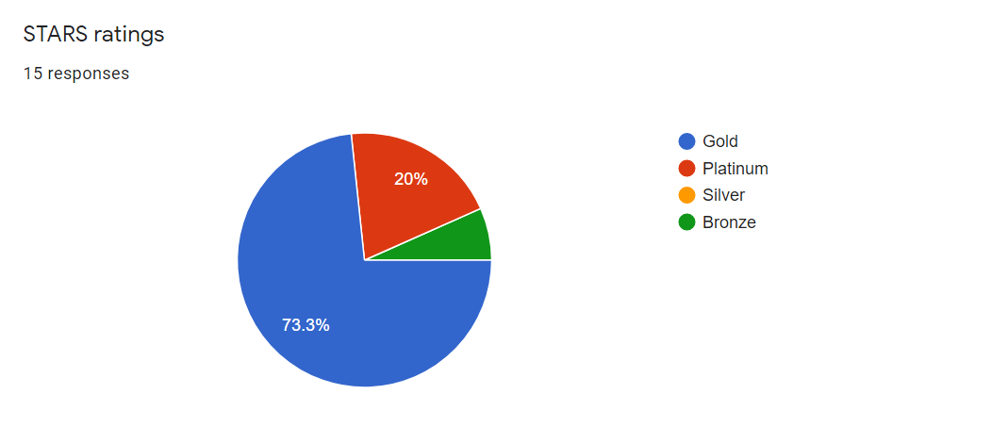
Figure 3
Exclusive Program Focus on the Dorms or Other
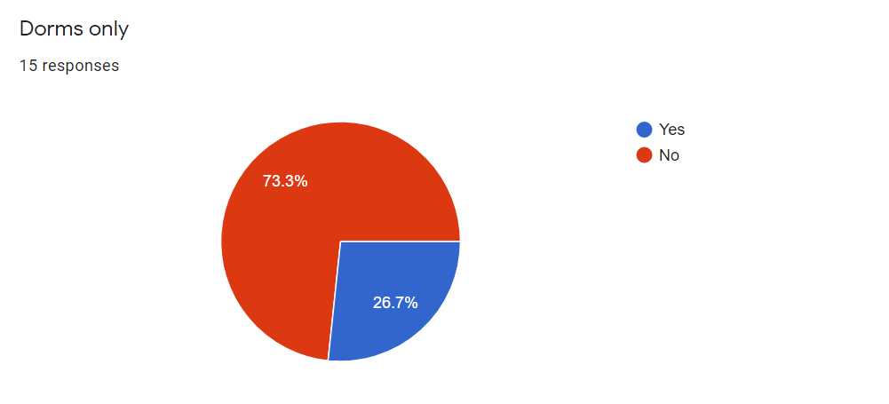
Figure 4
Sources of Program Funding

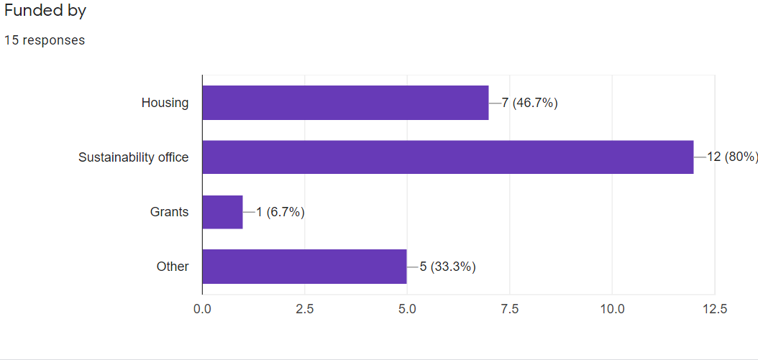
Figure 5
Student Compensation for Program Participation
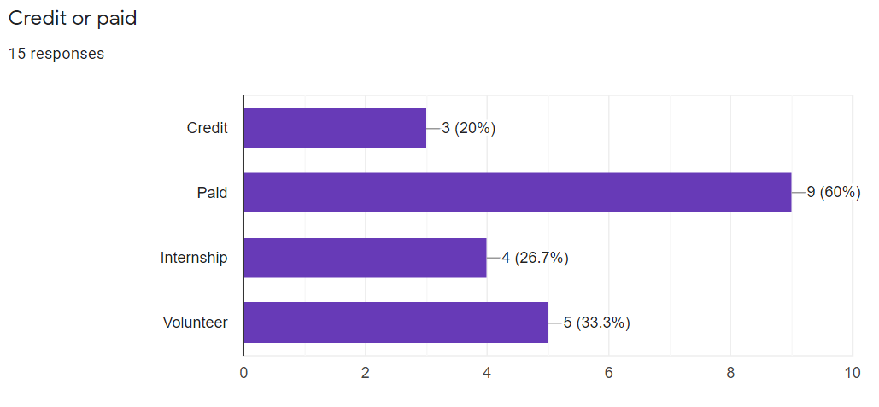
Figure 6
Undergrad Populations at Each University
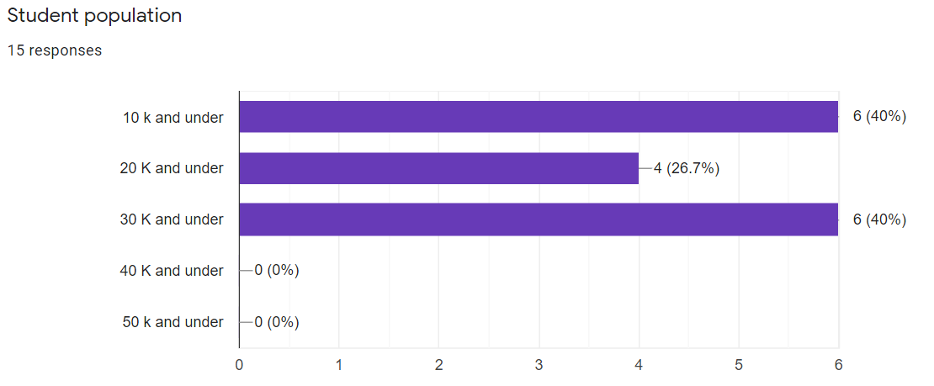
Figure 7
Grade Levels that Participate in the Program
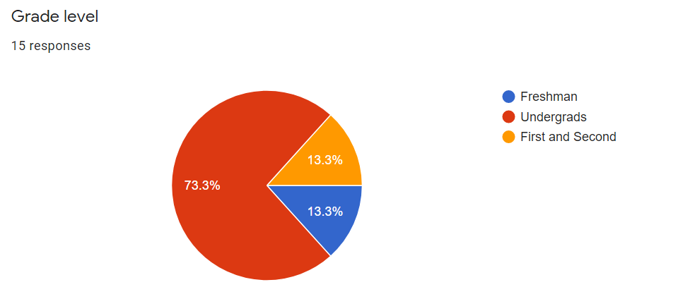
Figure 8
Average Number of Reps in Each Program
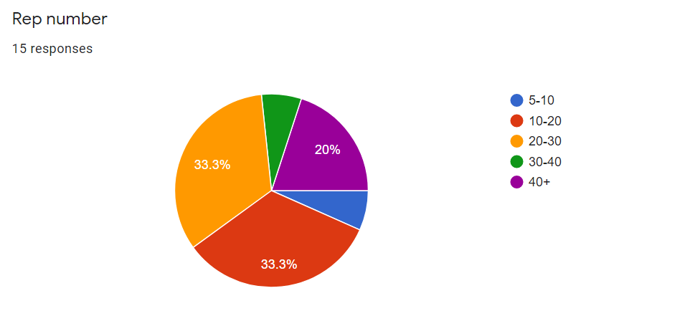
(Inventory Data Google Form Graphics, 2021).

Recommendations

Based on the findings of the most common practices and best practices from the 15 highly rated Eco-a programs—and considering the logistics of WWU’s Sustainability Ambassadors program—the following are recommendations for the future Sustainability Ambassador program’s programming, structure and organization, and marketing. A timeline and next steps for the program are also provided.

Programming

The analysis from this project shows that 73.3% of the 15 schools have a campus-wide focus, as opposed to strictly residence halls. Dickinson College has stated that their Eco-Rep program began in the residence halls but was re-defined to focus outreach on the entire campus, which helped the Reps impact more students, campus communities, faculty, staff, and the college’s decision-making (Dickinson Sustainability, n.d.). Some programs, including the University of Vermont’s (UVM) Eco-Reps, require every campaign to have a campus-wide element and a residence hall element. Some programs only require one campus-wide campaign per quarter. To increase outreach on campus, the Sustainability Ambassadors should extend their target audience to include campus-wide elements in one of these ways.
A campus-wide focus would also open opportunities for Sustainability Ambassadors to collaborate with other sustainability groups and efforts on campus. Such a collaboration could drastically benefit the program’s outreach and academic components, as well as help to institutionalize the program and secure greater funding. As the most recent coordinator, Alyssa Tsukada, has been working on, the program should initiate round table discussions between sustainability groups and stakeholders on campus, which could lead to partnerships and collaborations. Moreover, Sustainability Ambassadors could offer consultation sessions for groups that are holding events on campus to advise and support them in making their event more sustainable. Princeton University’ Greening Events Team and DePauw University’ Sustainability Leaders offer this service. Colorado State University (CSU) and UVM’s Reps dedicate a portion of their time to assisting other sustainability events and campaigns on campus. Additional collaboration can occur through conferences. Many programs require Reps to attend regional or national sustainability conferences, which can be great learning experiences and offer an opportunity for students to network and share ideas. Adding this requirement for Sustainability Ambassadors should be considered, budget permitting.
Most of the 15 programs have academic components, which the Sustainability Ambassadors should explore. For one, schools such as Princeton University and CSU have in depth onboarding training. CSU’s Eco Leaders have a required week-long training before school begins, including a two-day retreat and a mid-year reflection retreat. DePauw University also offers team building games and an annual leadership camping retreat. Most other programs have a one-day training required at the beginning of the year, semester, or quarter, as well as weekly meetings with academic components. Along with teaching sustainability topics and leadership, these training courses should provide team building to help boost comradery and morale among students. The academic component should also include lessons on effective marketing and event planning. Notably, Ambassadors should be taught how to advertise their events through community-based social marketing. Community-based social marketing focuses on behavior and psychological change through direct personal contact—as opposed to information-only campaigns—and entails “uncovering barriers to behaviors and then, based upon this information, selecting which behavior to promote; designing a program to overcome the barriers to the selected behavior; piloting the program; and then evaluating it once it is broadly implemented" (McKenzie-Mohr, 2000). Program coordinators should be offered even more extensive training “in topics such as organizational and program management, behavior change theory, community-based social marketing, sustainability concepts and education, and student employee and volunteer management” (HUB AASHE p. 9). Weekly meetings could also feature speakers from these and other sustainability areas, which both UVM and DePauw University’s programs do. CSU’s Eco Leaders have a required academic component in the form of a three-credit (per year) class titled Introduction to Sustainability Engagement, as well as a paid outreach component in the form of a housing stipend. WWU’s Sustainability Ambassadors should include an academic component—in one of the ways exemplified here—that emphasizes sustainability learning, team building, and marketing lessons in onboarding and ongoing training.
Turning to the outreach component, many programs—including UVM and CSU—require each Rep to complete an independent project. UVM’s Eco-Reps refers to this as a passion project (examples found here). These projects are student-driven and can be centered around any sustainability topic the student is interested in. They can be research-based or project-based and are funded by the Office of Sustainability. Such an opportunity encourages students to get involved on campus, dive deeper into an issue they are passionate about, and develop skills related to problem-solving, leadership, project management, creativity, self-motivation, and more. Sustainability Ambassadors should either encourage or require similar independent projects. Independent projects can also be an incentive for participation in the program as it offers a unique opportunity for students. Funding for these projects could possibly be sourced from the Sustainability, Equity, and Justice Fund as student sustainability projects align with the purpose of the grant.
The Sustainability Ambassadors must also value quality over quantity in their events. Dickinson’s Eco-Reps coordinator Emily Pikturna stated in a personal interview that while it’s beneficial to have a consistent presence on campus, their program has found that fewer, more productive events are more impactful on the student body. Dickinson’s Eco-Reps hold one event per semester, which all 25 Reps work on. Similarly, DePauw and UVM’s programs require each community team to plan one project or campaign per semester. With fewer events, each could be allocated more funding and have a greater impact on WWU’s students. These academic and outreach recommendations will help the Sustainability Ambassadors fulfill their goals, including advancing outreach, encouraging individual and campus-wide sustainability, and equipping their Ambassadors with knowledge and skills to help them be successful sustainability leaders.

Structure and Organization

Many programs utilize a tiered structure based on commitment level and compensation. DePauw University’s Student Leadership Program is an ideal model for a tiered structure. DePauw has an impressive, tiered organization with varying positions available based on involvement, commitment, experience, and compensation (Claire Dorner personal interview, 2021). The tiered structure decreases turnover rate in the program, allowing members to become knowledgeable about the program and gain the skills necessary to achieve their outreach goals. It also allows the program to not limit the number of students that can be involved in the program, as only some of the students are paid. DePauw’s structure also includes a permanent staff position dedicated to the program, as well as one with partial dedication (the Farm Manager). Such a position would offer knowledge and experience that only someone who has worked with the program for years could provide. A permanent position could also take over the paperwork, allowing the coordinators to focus their time on the program, planning meetings, and supporting mentors—a need that has been expressed by the most recent coordinator.
Following the tiered structure, more experienced and committed students would be paid—beginning with minimum wage and increasing with commitment level (see Budget section). 60% of the 15 programs researched pay their Reps. Paid positions incentivize participation in the program and ensure that Reps are held accountable for their responsibilities (Claire Dorner personal interview, 2021). Payment also makes Sustainability Ambassadors the student’s job, allowing them to commit their time to the program as opposed to having to split their time with another job. To incentivize first year students, credit may be offered that accurately reflects the amount of work required. Students previously involved in WWU’s program have expressed that the number of credits (one per quarter) and paid hours have not been sufficient in accounting for time they were required to work each week. Credit for first-year members should be strongly considered because paying all Ambassadors would limit the number of students that could participate in the program due to budget restrictions. In order to increase the student educators program rating, Sustainability Ambassadors must increase the number of students enrolled for credit/payment as well as the percentage of students served by peer-to-peer educators. Along with these methods of compensation, there are alternative ways to incentivize students to participate in the program. CSU’s program provides opportunities for Reps to submit research and project proposals to the school’s Sustainability Fund. DePauw University offers a Certificate of Completion upon graduation for students that complete three semesters in the program and one leadership retreat.
DePauw’s structure also offers a variety of positions that attract students interested in distinct roles (such as sustainability, transportation, thrift store, and farm interns) and commitment levels. Similarly, Princeton University's Eco Reps offers a structure of two to three co-presidents, 15 paid Eco Rep leaders, a Blog Team, Social Media Team, Greening Events Team, and unpaid members with varying levels of commitment (they attend training and events, and sometimes help plan/conduct them). The option of different teams with specific positions and topics attract students with diverse interests as it offers multiple types of experience and skill-building opportunities.
With the suggested campus-wide focus, there is the possibility of organizing Ambassadors around working groups, as opposed to residence halls. Dickinson College’s Eco-Reps used to be organized by residence hall but found this structure unproductive because the Reps had no shared goal and were separated in ways that prohibited them from working all together or being familiar with what other groups were doing (Emily Pikturna personal interview, 2021). Now, the Reps are organized into four working groups, each based on a sustainability topic (the current topics are food, water, waste, and environmental justice). Each semester, the Reps work on one project all together and each working group is responsible for their aspect of the project. This helps build community and teamwork and allows each project to be of higher quality since all the Reps can apply their ideas and skills to the project. WWU’s Ambassadors could be organized not by location, but by their skills and interests. This would allow members to dive deep into a sustainability topic they are passionate about and attract students with different interests. Each team should have an experienced mentor. Ambassadors can also be moved around each quarter as the sustainability topics change, allowing them to work with different students. WWU’s Sustainability Ambassadors should consider a tiered structure, dedicated team, or intern roles, and working groups in their reimagining of the program.

Marketing

Considering the professional opportunities discussed in the programming section, the Sustainability Ambassador program should re-market itself as a prestigious career-building program by emphasizing the professional skills, opportunities, and achievements it can offer. To be more prevalent on campus and garner more participation both within the program and at programming events, the Sustainability Ambassadors must clearly define itself (as a club, class, internship, or job, etc.) and explicitly state what students will get out of it. The program should strongly consider the definition of an internship. Internships can be paid or volunteer positions and are typically oriented around professional learning experience in a field of academic or career interest. Students may be more interested in an internship because it has potential to help them in the professional arena. The University of New Hampshire, University of Colorado-Boulder, University of California-Irvine, University of Louisville, and Florida State University each define themselves as internships.
WWU’s Sustainability Ambassadors should also ensure that it advertises itself in alignment with not just environmental sustainability, but the other three pillars of sustainability as well. Although the program already focuses on all four pillars, this is not well advertised and thus fails to attract students that may be interested in the health, economy, and equity aspects of sustainability. The program should explicitly market some of its other attributes as well, such as the sense of community it provides—not just within the community of ambassadors, but in interactions with students in residence halls and on campus during events. Moreover, if the program can collaborate with other campus groups and sustainability stakeholders, students will have the opportunity for greater campus involvement that can lead to relationships and opportunities in their time at WWU. This should also be emphasized in marketing efforts in order to increase program participation.
As for events, there should be greater advertising of—and funding to—food and prizes to incentivize participation. At Dickinson College’s Eco-Rep events, students get raffle tickets for engaging in activities, creating a system in which the more students engage, the more chance they have of winning (Neil Leary email, 2021). Most prizes are low-cost items, but there are a few valuable items that are raffled. Sustainability Ambassadors should secure ways to advertise the program and events, possibly through the school newspaper, newsletters, social media, list services, tabling, flyers, or bulletin boards (Erickson, 2012, p. 8). Princeton University’s Eco Reps have a dedicated blog team and social media team, while DePauw University has a single marketing intern. WWU’s Sustainability Ambassadors could dedicate a person or team to marketing/advertising, whose job could include running a blog, posting to social media, taking, or collecting photos from events, creating flyers, or updating the program’s website. Alternatively, all Ambassadors should be required to engage in marketing and advertising efforts for their events. Information on marketing and clearly defined descriptions of the program’s expectations, goals, campus sustainability information, and Ambassadors’ roles should be included in a manual available for Ambassadors. Emily Pikturna stated that having a detailed and updated manual has greatly benefited Dickinson’s Eco-Reps by providing them with something to refer to and helping to overcome the issues of student turnover (personal interview, 2021). The Sustainability Ambassadors must devote effort to advertising because of the positive feedback loop it creates (Meadows, 2009): more funding allows for more outreach and awareness, which will lead to more participation in the program and at programming events, further allowing Sustainability Ambassadors to achieve their outreach goals.

Timeline

This one-quarter project offers recommendations that will be considered by stakeholders and the Sustainability Ambassador coordinator for the remainder of the academic year as they plan the reimplementation of the program. The program will be implemented in Fall of 2022, with some pre-implementation in the summer (such as preparing material to be included in student orientation and to be sent out to students) to increase awareness of the program among new and returning students. The Sustainability Ambassador program will be ongoing and monitoring and evaluation will be necessary to gauge the success of the program and to continually improve it. In the future, another report based on research and offering recommendations for the Sustainability Ambassadors would be beneficial as WWU’s needs and the program’s possibilities change. Moving forward, the Sustainability Engagement Institute and University Residences should collaborate to discuss the future of the program. Moreover, greater discussions with the university and other sustainability groups should be had about the role Sustainability Ambassadors need to play and the possibilities for the program.

Monitoring and Evaluation

Monitoring and evaluation methods are crucial tools for the reawakening of the Sustainability Ambassadors program at WWU. They can be used to see if the program is meeting intended goals as well as the satisfaction of students and staff. The monitoring and evaluation will be divided into two main categories: the impact of the program on the student body and the successes in its curriculum. The fuel of this program is the Ambassadors and the staff. It is thus also important to evaluate the Ambassadors needs and satisfaction regarding the program.
To ensure that the program is on track with its goals, it is important that the Ambassadors log their progress through monitoring outreach numbers. Surveys provided to the members/participants and staff are also important feedback. This step is key to the progression of the program for it lays out the gaps the team needs to improve the programs’ overall effectiveness. At the tail end of the Spring quarter, it is crucial to conduct a major evaluation of the previous year, asking overarching questions such as “what were the successes in the program,” “what can be done better for next year,” and “what didn’t work for us last year.” The Ambassadors must also look over the horizon for inspiration and explore different Eco Rep programs again for inspiration. These steps are then rinsed and repeated quarterly or yearly to ensure that the program is constantly evolving and adapting to meet Ambassador and campus needs.

Annual Program Reports
An annual report is a detailed account of the programs’ operations over the previous school year. The purpose of annual reports is to inform stakeholders and other interested parties about the programs’ activities and financial performance. In the annual program report, the Ambassadors will be tasked with documenting:
  - Status of the STARS rating
  - Campus Waste and Energy Consumption Data
  - Student Educators Program Rating
  - Retention of Sustainability Representatives and Staff
  - Funding
  - Partnerships
  - Programs and Events held
  - Participation and Attendance information
  - Sustainability Action Plan Report updates
The annual program report is pivotal for the progression of the program. It can use the information gathered above to determine what has worked in the past and the changes that can be made to improve it. Such records can also be used in reports to funders and to demonstrate the need for more funding.

Feedback

It is the priority for the Sustainability Ambassadors to develop and adapt to their maximum potential. As seen from other institutions, it is possible to create an efficient and effective program. Popular methods of collecting feedback would be:

- Post-event surveys
- Email-embedded survey links
- Comment sections on the program website
- Social Media Polls
- Campus or residential quarterly surveys
- Collaborative discussions for Ambassadors to provide feedback

Budget

For the Sustainability Ambassadors program to be effective, sufficient funding is necessary to incentivize participation, maximize outreach, and support the Ambassadors. The suggested budget for the Sustainability Ambassadors in the 2022-2023 school year is based on the previous budget for the program as well as sample budgets from three exceptional programs researched in this paper: Oregon State University, University of Colorado-Boulder, and the University of Vermont. These samples were used as models for developing WWU’s program budget.
Colorado Boulder’s 2019 annual budget breakdown is based on the number of Eco Reps (40 students for 2019) and coordinators (2) in the program to formulate a budget of $7,000 for student wages. Programming supplies and training materials (i.e., manuals, t-shirts) were budgeted to $2,290.75. Day trips and workshops budgeted $1440, while the annual overnight trip was allocated $9,413. The total annual budget comes to $21,143 (Boulder, Colorado 2019 budget sheets, Shane Guinan Interview 2021). A separate example budget tracker provided by the college also gave an estimate for events/prizes/campus initiatives at $4,500 (Colorado Boulder Budget tracker for 2022, Shane Guinan Interview 2021).

Figure 9
University of Colorado Boulder 2019 Eco Reps Budget
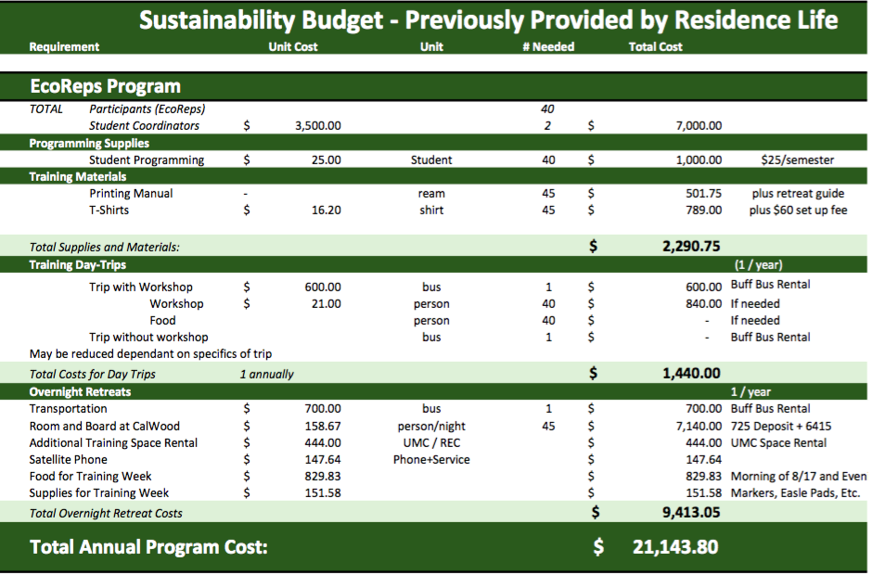
Provided by Shane Guinan Interview

Figure 10
University of Colorado Boulder 2019 Eco Reps Budget
Provided by Shane Guinan Interview

Oregon State University’s Eco-Reps budget is based on how much funding is contributed by their partner office. It includes program events and workshops, wage expenses, printing, supplies and other miscellaneous expenses.

Figure 11
Oregon State University 2020 Eco-Reps Budget

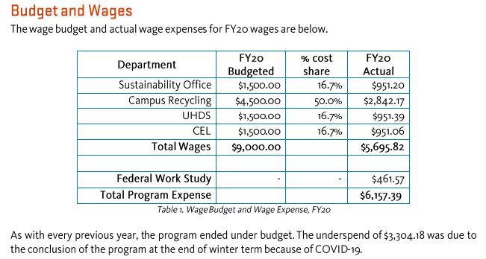
Collected from the Oregon State University Eco-Reps website FY 2020

The University of Vermont Eco-Reps program budget is divided into passion projects, campaigns, professional development, training, uniforms, technology, and other. The following budget breakdown shows budgeted and actual programming money spent in 2020 and 2021, as well as the predicted budget for 2022. Each year, programming costs have a limit of $5,000, which is funded by the Office of Sustainability. In addition to the budget for programming, Residential Life provides $30,000 for Eco-Rep employee wages. This comes to a total of $35,000 for the program’s annual budget.

Figure 12
University of Vermont 2020-2021 Eco-Reps Budget
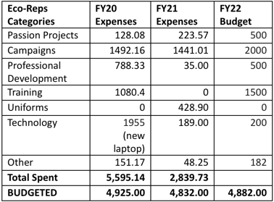
Provided by Caylin McCamp Email
The following figure is the suggested budget for WWU’s Sustainability Ambassadors in the 2022-2023 school year. Because there are so many unknown variables that will impact the actual budget—such as the funding amount, number of mentors, which recommendations the program decides to incorporate, etc.—the budget is purposefully broad. It includes the recommendation of a tiered structure wherein new recruits with lesser time commitments would be offered credit and the more experienced mentors would be paid. The hierarchical structure allows for no maximum number of Ambassadors that can participate in the program, which is important to develop a robust and accessible program. It also incentivizes Ambassadors to stay with the program longer to be promoted to a paid position. This budget is closely based on the Sustainability Ambassadors’ budget from 2019-2020 (prior to COVID-19). The research from this project indicates that Eco Reps programs can be effective with minimal budgets. Thus, it is not necessary to restructure the previous budget of the program. The 2019-2020 budget of $37,000 will be sufficient for the recommended changes. The ratio of funding to the Ambassadors vs. campaigns and events will need to be reconsidered as the program potentially accounts for changes such as passion projects, conferences, and retreats. The proposed budget also accounts for the increase in minimum wage. If possible, the program is strongly encouraged to increase funding to support the outreach goals and to fairly compensate student participation. Funding could be sourced from the Sustainability Engagement Institute, University Residences, an SEJF grant, and other campus funds (which the Ambassadors could make a case for if they decide to expand to a campus-wide focus).

Figure 13
Proposed Annual Budget for WWU’s Sustainability Ambassadors
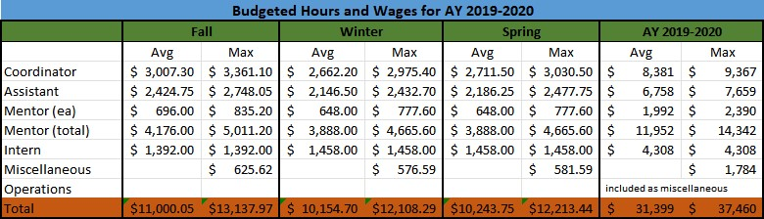

The main goal of the program is to create a more equitable and sustainable campus through peer-to-peer education and outreach. Workshops and other outreach events are key to engaging with the whole student body. The following is a list of activities gathered from this paper’s research to engage students in no- and low-cost ways:

- Move-in and out Recycling Initiative
- Recycle Mania
- Invasive Species Removal
- Eco-Crafting Events
- Raffles
- Gardening Projects

Barriers

Each school's program is tailored to them specifically because of what funds are available, the undergraduate population, etc. There are likely going to be barriers for WWU in reimplementing the Sustainability Ambassadors. Barriers could include the current state of the various sustainability stakeholders on campus not having enough communication to collaborate on this specific project. There has been confusion in the past about the roles of different sustainability office(s) and organizations on campus (Terence and Dora zoom interview, 2021). As the office is now an institute, it has left some programs (like Sustainability Ambassadors) in limbo with questions about who will be responsible for running and funding them. This will need to be addressed when rebranding the program. The Sustainability Ambassadors have worked independently in the past and not been able to collaborate or coordinate with other campus groups. This limits the success of the program and overall campus sustainability efforts because less students are reached and efforts may be wasted if multiple groups are attempting to play the same roles. The Sustainability Ambassadors should focus on collaborating with other sustainability efforts to further their outreach and make more effective use of their time and money. The program should also look to create positive feedback loops driven by funding dedicated to campus engagement and outreach.

Conclusion

Many schools have had to reimagine their Eco-Rep programs since the effects of COVID-19. Even with their high ratings, these programs are continually evolving in accordance with the times and needs of their students and faculty. WWU’s Sustainability Ambassadors could benefit from looking into the successes of these other highly rated programs. Notably, the Sustainability Ambassadors should consider expanding their campus outreach and collaborating with other groups on campus, which will result in a more holistic sustainable campus experience and reach a more diverse crowd of students. In their structure and organization, the Ambassadors should also think about a tiered structure, compensation, and working groups to more effectively reach their goals and better support students. As for marketing, the program should emphasis all four pillars of sustainability and rebrand as a prestigious career-building internship in order to incentivize participation from diverse students. They should also incorporate team building and intensive training for their Ambassadors. Finally, the program should value quality over quantity in their events to achieve more effective sustainability outreach.
This project’s findings should provide inspiration for the Sustainability Ambassadors. However, the examples and budgets from other schools must be considered in WWU’s context, including what is possible for the program and what role it needs to fulfill. The program should be continually re-evaluated as the campus needs and possibilities change. Moving forward, greater discussions with the university and other sustainability groups should be had to discuss the future of the program. The recommendations and models of the most successful Eco-Rep programs will help the Sustainability Ambassadors conduct their critically important sustainability work.

Appendix

Caylin McCamp E-mail (11/4/21 10:28 AM), University of Vermont

How much funding does your school's Eco-Rep program receive (per quarter, semester, or year, etc.)?
- From ResLife: $30k in wages for Eco-Rep employees
- From Office of Sustainability: $5k in operating funds, 35% of my job is running the program so you could say 35% of my salary ($17k)

How is funding allocated? Would it be possible to provide a breakdown of the program’s budget and how it uses funds (i.e. for events, prizes, paid positions, etc.)?

Figure 14 (same as figure 12)
University of Vermont 2020-2021 Eco-Reps Budget
Eco-Reps Categories | FY20 Expenses | FY21 Expenses | FY22 Budget
Passion Projects | 128.08 | 223.57 | 500
Campaigns | 1492.16 | 1441.01 | 2000
Professional Development | 788.33 | 35.00 | 500
Training | 1080.4 | 0 | 1500
Uniforms | 0 | 428.90 | 0
Technology | 1955  (new laptop) | 189.00 | 200
Other | 151.17 | 48.25 | 182
Total Spent | 5,595.14 | 2,839.73
BUDGETED | 4,925.00 | 4,832.00 | 4,882.00

What are some highlights, best practices, or biggest successes of the program?
- Check out our annual reports for highlights and successes (righthand bar)
- Passion projects are a favorite of Eco-Reps (also in right hand bar)

What are some barriers the program has or is facing?
- Res life gives us money but isn’t involved in the program otherwise. We are considering moving away from our “one Eco-Rep per res-hall building” model for this reason and hiring the most qualified students regardless of residence instead of having residential criteria.
- Because of this res life funding our purview is on campus focused. We don’t do anything for off campus students or in the community. Sometimes Eco-Reps want to do more than what our charge allows.
- It is so hard to get students to come to events but offering programming is a core responsibility of Eco-Reps. I’m always trying to get Eco-Reps to think beyond date/time/place events and do more behavior change interventions (see here), but it is hard to get that on their radar.
- Eco-Reps sometimes want to be activists and change the UVM systems, but that isn’t their job. Their job is to communicate the existing programs that students can get involved with. This can cause tensions, especially when students wear multiple hats and are organizing protests against in their student role but representing UVM in their paid role.
- We are small and not well understood on campus. Many people think we are a club.

Do you have any recommendations for how to achieve an effective Eco-Reps program?
- Check out all these resources: https://drive.google.com/drive/folders/0B2WgxGeFQJDxc081eXVwZjJDUFU?resourcekey=0-mFV2Pv31BuU_XXtdryAGSA&usp=sharing, specifically the general resources folder

Mary Liang E-mail (11/3/21 8:59 PM), Colorado State University

How much funding does your school's Eco Leaders program receive (per quarter, semester, or year)?
- This varies annually, particularly during the pandemic.

How is funding allocated? Would it be possible to provide a breakdown of the program’s budget and how it uses funds (i.e. for events, prizes, paid positions, etc.)?
- I can give you a breakdown of how our 2021-2022 Eco Leaders funding was allocated.
  - Student Stipend: $50,000 a year. Each Eco Leader receives a $3300 housing stipend a year ($1650 each semester)
  - Eco Leader Off-Site Overnight Training: $2,600
  - Eco Leader iPad: ~$5,000 every 5 years
  - We run various programs in our office, some with Eco Leader engagement. Eco Leaders don’t run any specific program without our involvement. So while there are other costs for events/ prizes associated with Eco Leaders partnered events, there is no specific line item.

What are some highlights, best practices, or biggest successes of the program?
- The Eco Leader program has been at CSU’s Housing and Dining Services for over 10 years, and each year, we normally engage somewhere between 20% - 35% of all our residence hall and Aggie Village (an on-campus apartment) residents. Eco Actions, one of our largest Fall semester sustainability campaigns with Eco Leader involvement has engaged with over 15,000 residents over the last decade. We find that all halls need a dedicated Eco Leader (one that lives in that residence hall) to make an impact. Door-to -door engagement works. Residents are less likely to engage in sustainability if there is no building sustainability champion (i.e.. an Eco Leader).
- The Eco Leaders program has two components – an academic piece (linked with one of our schools so all students receive credit for this class), and an engagement piece (student housing stipend goes towards 5 hours or engagement each week). This dual component works well for us. As one of our current peer mentors puts it “I also think having both a class component and engagement requirement is important because it gives the Eco Leaders continual training and teaching that they can apply to their work, as well as connection to their cohort. This helps expose the Eco Leaders to a range of sustainability issues and develop ideas for the independent projects.” Eco Leaders complete independent projects in the Spring semester as part of their class.

What are some barriers the program has or is facing?
- Last year, it was difficult for our Eco Leaders to complete virtual engagement. However, it seemed residents were more opened to talking about sustainability (as opposed to this year). Other barriers include measuring impact of sustainability engagement, and ongoing advocacy for raising Eco Leader stipends.

Do you have any recommendations for how to achieve an effective Eco-Leaders program?
- Peer mentors are valuable. These are individuals who have done the Eco Leaders program previously, and are mentors to the current cohort. Peer mentors attend the class and compensated the same as an Eco Leader. They provide a unique perspective, and can offer advice, as they’ve completed the program in the past.
- Try to incorporate an academic and engagement component.
- Training and team-building prior to the start of the academic is also valuable.

Neil Leary E-mail (11/4/2021 1:23 PM), Dickinson University

- Student wage: $2410 (incl. FICA/MEDI)
- Program expense: $750
- Total: $3,160
- The program expenses include materials, food and give away prizes for events. Most give-away prizes are low cost items, a small number are more valuable items that are raffled. Students get raffle tickets by engaging in activities; the more they engage, the more tickets they get, the more chances they have to win. The raffle prizes typically are not strictly speaking for Eco-Rep events, but for larger campus events that the Eco-Reps help organize with our interns, Center staff members, and others.

Kristi Wiedemann E-mail (11/12/2021 9:00 AM), Princeton University

How much funding does your school's Eco Reps program receive (per quarter, semester, or year, etc.)?
- There’s no set amount; funding is allocated on a semester by semester basis, depending on how many EcoReps there are and which projects they want to explore.

What are some common environmental topics that the Reps focus in in their outreach projects?
- Primarily reuse and recycling.

What are some highlights, best practices, or biggest successes of the program?
- The EcoReps are heavily engaged with the Office Sustainability’s annual Move-out & Resale program. For more details, see Guide to Greening Move-Out | Office of Sustainability (princeton.edu)and Move-In Resale+ | Office of Sustainability (princeton.edu). More generally, having EcoReps assigned to specific residential colleges/dorm within which they live has been a success as they can then work with the residential college assistants (RCAs) to integrate specific programming into dorm life, etc.
What are some barriers the program has or is facing?
- As with any program, there are always questions as to the level of engagement students will want to have in such programs (both as leaders and participants) and how to frame the issues the EcoReps work on so that they’re appealing to a diversity of students. Incorporating broad societal issues like social/environmental justice will also be key to build into our programming going forward, and there’s a direct pathway to do so, for example, through reuse/recycling/repair and conscious consumption/purchasing. Moreover, advancing ideas/programming around how to live well within environmental limits is not only a barrier for the EcoReps but Western society more generally.

Do you have any recommendations for how to achieve an effective Eco-Reps program?
- Having the administration’s support can be very helpful in terms of integrating with existing programming, though EcoReps efforts can also be grown from the ground up (in our case, it’s typically been some combination). Along the lines of the last response above, it’s important to frame issues the EcoReps work on in a way that addresses important societal issues while engaging diverse students in the effort.

Alyssa Tsukada E-mail (10/22/2021 2:31 PM)
What is your position in the SReps program and how long have you held that role?
- My role within the program was program coordinator. I was a volunteer rep the 2018-19 academic year. I was the assistant coordinator during the 2019-20 academic year. The Sustainability Representatives Program was then transformed into the Sustainability Ambassadors program for the 2020-21 academic year where I became the Student Ambassador for the Office of Sustainability and continued to coordinate the program. This academic year, I am still working as the Student Ambassador for the Sustainability Engagement Institute; however, with the new transition from being an office to an institute, we have chosen to archive the peer-to-peer education program for this year so we can focus our time and energy towards other student engagement opportunities.
In your experience with the SReps program, what would you say have been the biggest successes of the program?
- I believe one of the biggest successes of the program was the cultivation of a culture of care within the community of individuals passionate about sustainability. I also believe the program truly educated and empowered students to make positive change within their campus and broader community.
What are some of the challenges or obstacles the program has faced or is currently facing?
- Some of the biggest challenges or obstacles the program faced were funding and ability to retain student engagement. I believe those problem went hand-in-hand because we often did not have enough funding in order to have more paid students positions or have access to necessary resources in order to conduct proper outreach and improved student engagement. I believe the quick tur-around rates of leadership within the program also posed a bit of a challenge. This is also related to lack of funding in a way. Prior to budget cuts, there were six paid mentor positions and three paid leadership positions: the intern, assistant coordinator, and head coordinator. This made it so when the coordinator graduated/left the program, the other two leadership positions would shift up and limit the learning curve. With budget cuts, the intern, assistant coordinator, and mentor positions were dissolved, and only one student was left with the responsibility of the program.
What would you like to see implemented or improved in the program? Are there any areas you would like to receive recommendations on from the results of our project?
- I believe the program has plenty of room to grow; however, no one solution is coming to mind. One thing that I think would have been better is if the program were more well-known and collaborated more directly with other student groups on campus. This is something we are currently working on while the program is dormant through our development of the Sustainability Round Table initiative which aims to facilitate meaningful collaboration and communication between all students involved in sustainability club and programming across the Western campus. I am happy to receive recommendations on any areas from the results of your project.
Do you have an opinion on whether SReps should be paid or earn academic credit for their work?
- I believe the number of hours put in by all members of the program should be fairly compensated by Western, especially given the fact that the hard work being done is with the aim of having a direct positive impact on the campus and its students. I recognize the use of monetary payment would impose a restriction on the number of individuals able to participate in the program, so I am hesitant to say it would be the perfect solution. However, I see no reason that credit should not be awarded for the student's efforts as long as they are meeting the minimal credit requirements of three hours per week.
Where does the program stand this year after COVID? Is it still running? If so, how many reps does it currently have and is it working on residence hall events? What does the future of the program look like for the rest of the 2021-2022 school year?
- As stated above, the program is currently archived. Instead, my Student Ambassador position is oriented towards developing and coordinating other institute initiatives that promote sustainability engagement across campus while directing students to alternative student opportunities such as AS clubs, committees, and project implementation through the use of SEJF funds. I am happy to expand more on this if it would be helpful at all.
Notes from Claire Dorner Interview, DePauw University (11/10/2021)
How much funding does your school's Sustainability Leadership Program receive (per quarter, semester, or year, etc.)?
- There are different budgets each year impacting how many students that can be hired. About 20 students paid minimum wage to work up to 5 hours a week. Lack of accountability comes from not enough payment, students look elsewhere for income. I recommend paying reasonable hours, goal 8-10 hours with fewer students and higher pay. Program funding $1500 for conferences and $1500 for travel, also can be used for speakers ($100 each at least). The cost of living is lower in Indiana, consider this.
Funder?
- Program is Office of sustainability and school funds it annually
What are some highlights, best practices, or biggest successes of the program?
- Variety of topics
- speakers from all places
- tiered structure of commitment to break down barriers of sustainability
- give students the power to choose topics/projects they want to do (student-driven).
- The director meets with students
- draw connections between all issues—sustainability is in everything, encourage collaboration between groups on campus.
- Allowing students from many majors to be involved.
- Claire and the farm manager are the staff members for the program.
- Marketing, photos, connect w campus marketing team, update market materials/website often, have a student media intern to post regularly and update.
What are some barriers the program has or is facing?
- Lack of accountability because low wages. Trying to be a prestigious career building program, not just a club.
- The current structure is one meeting per week but this only lets the events and learning be surface level so they are moving to each Claire/farmer manager/intern/volunteer day doing one program/meeting per month, putting power in student's hands.
- School has financial issues, rural low income town, liberal arts.
Recommendations?
- Interns (have sustainability, thrift stores, farm interns), fewer interns working more hours
- Build comradery through monthly huddles with all interns.
- Proposal competition, professional develop opportunities. Students to write proposals, possibility to implement it in spring. Funding to proposals and student projects.
- Have a sustainability symposium with staff to reward students and allow them to present on work they did. keeps students thinking about end goal and to know their work is valued/appreciated. Appreciation/value from staff (rewards and presentations end of year, certificate of competition)
- Lower turnover rate w tiered structure to earn payment
- Prestigious career building program (proposal competition w chance for funding to be implemented, certificate of completion
- Accountability (payment, end of year goals)
- Fewer students w higher payment, students must be knowledgeable/dedicated, others can participate without compensation, sreps to be main job and focus due to it being their source of income.
- Student driven to ensure passion in topic, students pick topic and event, many options sustainability in everything, speakers on variety of topics, students from all majors
- Collaboration w other campus groups (marketing, thrift store) and with each other (intern huddles)
- Students and staff to do less but do those things better, not just surface level
Notes from Emily Pikturna Interview (11/11/2021), Dickinson University
What are some highlights, best practices, or biggest successes of the program?
- Quality trumps quantity, a consistent presence on campus is good but needs to be productive. They used to organize by residence halls, but this separates reps and has no overall mission (don’t know what other reps doing). Now they are in working groups—more productive working toward one event/goal. Integrate eco rep ideas into programming, listen to what volunteers want to do. Community building among peer educators will help to have stronger power on campus, be an established group, and allow for shared ideas.
What are some barriers the program has or is currently facing?
- Separation by residence hall is not productive. How the program was integrating eco reps wasn’t effective because they didn’t have follow ups with reps or contact with an experienced eco rep. Not as much community building.
Other:
- 25 reps
- There have been many iterations of the program.
- This year so far it has celebrated campus sustainability day: the project manager intern coordinated the event, Emily coordinated the eco reps into the event, there were 4 working groups each with a sustainability topic (Water, food, waste, SJ), they came up with interactive activities for campus sustainability day (vegetables as stamp art, cornhole throw bag into compost-recycle-waste). They interact with the community in productive, educational, and fun ways.
- Program manual has explicit expectations, goals, sustainability on campus info, and clarified roles; it is updated every year and helps with student overturn. There is onboarding training each semester for new and returning reps, they go over the manual, get oriented with each other and campus, obtain a base level understanding of what sustainability is.
- Coordinators get paid, eco reps are volunteer positions, which work because the campus is sustainability oriented so there are more than enough volunteers. Funding is sufficient $750, food and prizes (other dept.).
Email Interview from Keisha Payson, Associate Director of Sustainability for Bowdoin
On average, how many representatives does your program have at a time?
- 30
Where does funding for the program come from?
- Sustainability office budget
How much funding does the program receive (per quarter, semester, or year, etc.)? How is funding allocated? Would it be possible to provide a breakdown of the program’s budget and how it uses funds (i.e. for events, prizes, paid positions, etc.)?
- $25k
What office or department is Eco Reps run through?
- Sustainability
Can you provide a brief overview of the management structure?
- We have a Sustainability Outreach and Programs Manager who oversees the hiring, training, and overall supervision of the students
What are some highlights, best practices, or biggest successes of the program?
- Best thing is it reaches students that don’t normally take environmental studies classes – we are trying to reach the broadest number of students, so sometimes our messaging is seen as too basic for the real dedicated environmental students because they are beyond it. Students usually love our energy conservation dorm competition, Free Cycle – which redistributes items from our end of the year move-out program, coffee houses, clothing swaps, pod cast, local food diners
What have been some barriers the program has faced?
- It’s been a tough year and a half- programming during covid is hard!
Do you have any recommendations for how to achieve an effective Eco Reps program?
- Have some general parameters and basic knowledge you want them to spread – but essentially take the lead from them – what are their passions and talents – that will get you the best bang for your buck!

Email Interview with Dora Vaughan, Student coordinator of training and development for WWU
What is your position is currently and what did your role in interacting with the S rep program entails?
- I am a Housing Facilities Assistant (HFA) under Terence, the University Residences Facilities Associate Director. My position is focused on Sustainability Education and managing the Resident Check Out Program (RCP). Residence Hall Reuse Program (RHRP) is a facet to RCP and is a program I created that stemmed from my mentor project as a S Rep mentor 2019-2020. In 2019 I was an S Rep and I was hired for the 2019-2020 year as a Mentor for the Ridge S Reps. In working on my mentor project, Terence was a stakeholder and when Covid hit and the S Rep Program was defunded, he took us on as employees to continue sustainability education as he saw it integral to housing while S Reps were no longer operating.
- Housing Sustainable Living: https://housing.wwu.edu/life-on-campus/sustainable-living
- Resident Checkout Program: https://housing.wwu.edu/resident-checkout-program
In your experience with the S reps program, what would you say has been the most impactful?
- The weekly meetings in S Reps involved education on the 4 pillars of sustainability and awareness of other on campus initiatives that had a focus in sustainability. While being a credited program, I felt this was one of few opportunities for students to gain this knowledge. The education was in relation to what was happening locally but also what Western was (or wasn’t) doing to fulfill the 4 pillars and goals of the Sustainability Action Plan (SAP). I found my passion for environmental education within this program and was able to tie in my Leadership Studies minor to the work I did as a mentor. Creating these relationships on the basis of sustainability was integral to my sense of belonging and connection to Place.
What has been the programs successes in the past?
- My thoughts on the success of the program was the direct tie to the Office of Sustainability, which encompasses the Sustainability Equity and Justice Fund (SEJF) which we all contribute towards as students AND being UR Housing backed. The program advocated for use of these funds for student led initiatives, like RHRP (self-promo), to institutionalize sustainable practices and accountability for assessment on SAP goals.
What were some challenges/obstacles that the program has faced and is currently facing?
- We like to think of the work we are doing as HFAs as the 2.0 version of S Rep education, which I think has a vital presence in the residence halls. As with most engagement initiatives, we struggled with, well, engagement. Attendance to meetings and the efficacy of spreading education was low. Our most popular event was without question clothing swaps, where we instilled conscious consumerism into a current and relatable topic for college students: cheap goods and fashion. With a core group of S Reps and mentors, we sometimes struggled to share the importance of what we were learning in an interactive and intentional way.
What would you like to see implemented or improved in the program?
- I wish S Reps was still accessible to residents as it provided me a connection point to involvement on campus. I am incredibly grateful for the connections I have and continue to make and I wish the best for the evolving Sustainability Ambassadors program in the works within the Sustainability Engagement Institute. I hope that with The Sustainability Student Ambassador Coordinator, Alyssa, we can make the dream of ‘round tables’ come alive where all stakeholders in facets of sustainability work across campus are connected and the expectations and targets of the university are met through responsible action and accountability for accomplishing students’ wishes of a more sustainable campus that does the work behind the scenes. I hope students can again be credited for their involvement in sustainable work and advocacy on campus and the SEJF can be used to its fullest potential.

Email Interview with Shane Guinan, Assistant Director for Leadership & Social Justice Residence Life University of Colorado, Boulder

- “First for some context, our Eco Rep program sits within Residence Life and had formerly been with our Environmental Center where they were unable to find success with this as a first year initiative. With this shift, it allowed us to create a pre-arrival experience for our students with a retreat that then translates into a yearlong experience with weekly meetings focused on an eco justice curriculum with some programming expectations for the participants.”
On average, how many representatives does your program have at a time?
- Pre-COVID we had about 50 Eco Reps per year and they would live in halls across campus. With COVID we saw a decline in numbers (partially due to decreased marketing) so we currently have about 15 Eco Reps and are hoping to grow that number back up for next year. This group is managed by 3 Eco Rep Coordinators (10 hour/week student leaders who are compensated) and was advised by a full time Sustainability Manager in Residence Life.
Where does funding for the program come from?
- Funding for the program is provided by Residence Life, though there is some collaboration with the Environmental Center for specific initiatives.
How much funding does the program receive (per quarter, semester, or year, etc.)? How is funding allocated? Would it be possible to provide a breakdown of the program’s budget and how it uses funds (i.e. for events, prizes, paid positions, etc.)?
- I am attaching this year’s budget and our pre-COVID budget
- 2019 EcoReps Budget (1) Boulder C.pdf
- EcoRep _ Budget Tracker FY 22 - Summary .pdf
What office or department is Eco Reps run through?
- Residence Life with partnership to the Environmental Center
Can you provide a brief overview of the management structure?
- This group is managed by 3 Eco Rep Coordinators (10 hour/week student leaders who are compensated) and was advised by a full time Sustainability Manager in Residence Life.
What are some highlights, best practices, or biggest successes of the program?
- The curriculum that we have to weekly teach our Eco Reps about various aspects of environmental justice is huge. Additionally, the pre-arrival retreat off campus is noted as one of the most important parts of the experience. Finally, programming is really how the program shows its campus impact and we are working to continue to build out more concrete expectations.
What have been some barriers the program has faced?
- Budget and understanding of the program as new staff have stepped in. Newer staff don’t understand why this program sits with Residence Life and so we continually need to justify the program. Additionally, the program began as a community/hall council position which did not allow for the program to be sustainable year to year and needed intentional recruitment and support from a professional staff in the early years.
Do you have any recommendations for how to achieve an effective Eco Reps program
- Nothing in addition to what is above right now. We are currently evaluating changes we may need to make to the program to freshen it up to our department expectations and to meet the needs of our students and campus. I think one of the keys to any organization is to not stagnate and be willing to update regularly to meet the needs of your student body.
Email from: Jade Chalkley from Sustainability Institute in the University of New Hampshire.
On average, how many representatives does your program have at a time?
- We currently have roughly 30 student staff. We have 3 student staff roles including Changemaker Recruiters, Changemaker Coaches, and Sustainability Interns. Changemaker Recruiters help us to do outreach and recruit for other programs and there is roughly 5-10 each semester. Changemaker Coaches work as mentors with one of our programs that mentors groups of 1st and 2nd year students primarily around sustainability and changemaking in the regional area. Our Sustainability Interns work on operational projects and outreach directly with staff in our office and we have roughly 13 of those interns.
- Where does funding for the program come from?
Our funding comes from many different sources. The Sustainability Intern positions are separately funded from the changemaker positions. The changemaker positions have funding form some external sources including our business school and a partner program called Semester in the City. Some of the Intern funding for this year also came from funding we received to do STARS. This is a complicated question. I’m not sure there is a simple answer.
What office or department is Sustainability Institute Internships (or whatever the program is called for that school) run through? Can you provide a brief overview of the management structure?
- The Changemaker Coaches and Recruiters are managed by the Changemaker Collaborative which is the student facing arm of the Sustainability Institute. Changemaker Recruiters are directly managed by a staff member in the changemaker collaborative as their role directly relates to our partner program with Semester in the City and recruitment for that program. The Changemaker Coaches are managed by me the Sustainability Peer Education Coordinator and they are managed mostly as an entire group with a small subgroup of 2 lead changemakers who assist managing the larger group. The Sustainability interns are managed partially by myself in regard to their hiring, logistics, collaboration, and learning outcomes but they have a separate supervisor depending on their project focus (Communication interns work with our communication director, Energy Interns work with our sustainability program director who coordinates stars etc.).
What are some highlights, best practices, or biggest successes of the program?
- Some highlights of our program are that we have drastically expanded this program partially due to additional full time staff capacity and partially from additional STARS Funding. One thing that has assisted in some strategic planning across all our programs in implementing learning objectives for all the programs that are the same but have slightly different rationalization. Some other big successes in transitioning to having more student staff is having our orientation and training available on canvas rather than in person. This minimizes scheduling at the beginning of the semester, encourages our different programs to interact with each other in discussion boards, and allows us to have more people from our Full-time staff to be able to do trainings and sessions so that they can preview many of the staff they will work with. We also have a streamlined application for all these positions to allow students to easily see the connections between them as well as to apply to multiple positions. This streamlined application also allows for only one application to check and review during hiring rather than 3.
What have been some barriers the program has faced?
- Some barriers we have faced for all our programs continually is timing and staffing. To have a successful program this is key because you want to make sure students are getting as much out of it as they can and getting individual attention. Other barriers can be slowdowns in project goals so it’s always important to have them set before the semester starts and ensure with everyone needed for those projects that the goals are clear and there is a set timeline.
Do you have any recommendations for how to achieve an effective Sustainable Internship program?
- I am happy to send you materials like our leaning objectives, Student application, work plans etc. I am also happy to meet and clarify anything as well as answer more questions.
Terence Symonds and Dora Vaughan Interview (November 5, 2021)
Is something already in works for next year? HFA goals for program/continuing work rn?
- create permanent staff position for sustainability
- sus coordinator staff in UR, not happening rn. Admin support to take over admin stuff coordinators did so students can focus on other things.
University residences has funded the program in the past ($22,500 year for salaries and resources?) but shared w office of sus, do you have any idea about funding for next year? Is it a possibility for the SEJF grant to fund it? Are there other sources for additional funding? Is there someone we can contact to get more info about potential funding/budget?
- 2 years ago, UR stopped funding SRep, last couple years, HFA took on 2-33 student focusing on sustainability, to continue residence hall reuse (RHR) and start focusing on sus educ and solid waste audits etc. in UR, operational sustainability. Build off this year and try to get volunteers next year, hire permanent staff, build back up sus programs. Sus ambassador (Alyssa) and Mia (staff sus ambassador help staff). Coordinators from groups went away from office of sus as it transitioned. Need to synchronize things everyone’s doing (zero waste coordinators, UR HFA, SRep).
- HFA operationalize—env education, SRep 4 pillars, no space for discussions and learning from each other. More credits, struggling to get more credits
- Just first year students in past, looking to get more students
- Programs that didn’t continue through covid
- Where SEI headed, Sus action plan, UR budget needs to build operational sus. UR working with Sei in future, pace set up UR and control funds, UR shape its w inpur from SEI, work w Lindsey on educ and creativity, supplement to add more resources
- How to grow current infrastructure/positions w resources on campus, incr support (credits), prioritize what we need to do, offer ideas who could collaborate with
- U Rise (list of objectives want to come out of a year on campus in res halls)
- Funding recommendation similar to previous funding, relates to U Rise objectives
- Sus round table, get all stakeholders doing sus work-->collaborate, synchronize
- AS sustainability, res hall sus, ambassadors, zero waste. Srep to link all of these campus sus work.
- Prioritize sus action plan. Investing in things that will save $ in future (PSE light)
Google form data- Lindsey Macdonald’s WWU email has access to back end:
https://docs.google.com/forms/d/1oSsNeKaaAHc2X1An2zVeS-qAVLmmfdHUX5L-A7rNjdA/edit#responses

References

About STARS. (n.d.). AASHE. https://stars.aashe.org/about-stars/

Apply Now to be an EcoReps Leader for 2021! (2020, December 7). Office of Sustainability

Princeton University. https://sustain.princeton.edu/news/2020/apply-now-be-ecoreps-leader-2021

Columbia Eco Reps Website. (n.d.). Ecoreps. Retrieved November 11, 2021, from https://www.columbiaecoreps.com

DePauw Office of Sustainability. (2020). Sustainability Leadership Program 2019 Report. https://issuu.com/depauwsustainability/docs/spring_2019_slp_report__1_

Dickinson Sustainability. (n.d.). Program Manual 2020-2021. https://www.dickinson.edu/info/20052/sustainability/2977/eco-reps/2

Dorner, C. (2021, November 10). Personal Interview between DePauw SLP Director of Sustainability Claire Dorner and Sam Goetze (S. Goetze, Interviewer) [Google Meet].

Eco Leaders Program. (n.d.). CSU Housing & Dining Services. https://housing.colostate.edu/about/sustainability/eco-leaders-program/

Eco-Reps. (n.d.). Dickinson Sustainability. https://www.dickinson.edu/info/20052/sustainability/2977/eco-reps

Eco-Reps Program. (n.d.). The University of Vermont Office of Sustainability. https://www.uvm.edu/sustainabilityoffice/eco-reps-program

Erickson, C. (2012). Student Sustainability Educators: A Guide to Creating and Maintaining an Eco-Rep Program on Your Campus (J. Walton & M. Wagner, Eds.). National Wildlife Federation. https://hub-media.aashe.org/uploads/eco-reps_guide.pdf

FSU Eco-Reps, 969 Learning Way, Tallahassee, FL (2021). (n.d.). Retrieved November 12, 2021, from https://www.globunis.com/US/Tallahassee/1117360848433919/FSU-Eco-Reps

Guinan, S. (n.d.). Personal Interview with Shane Guinan, Assistant Director of Leadership and social justice, residence life (S. Young, Interviewer) [Personal communication].

INTER-RESIDENCE HALL COUNCIL. (n.d.). Retrieved November 6, 2021, from https://sga.fsu.edu/irhc/center.shtml

Inventory data google form graphics. (2021). Google Docs. https://docs.google.com/forms/d/e/1FAIpQLSfG6qrBodbCyW0_zEPPXPuMyV_6vU_hwMn4v8zPxApyrCcFNQ/viewform?edit_requested=true&usp=embed_facebook

Kestin, T., van den Belt, M., Denby, L., Ross, K., Thwaites, J., & Hawkes, M. (2017). Getting started with the SDGs in universities: A guide for universities, higher education institutions, and the academic sector. SDSN Australia/Pacific. https://ap-unsdsn.org/wp-content/uploads/University-SDG-Guide_web.pdf

Leary, N. (2021, November 4). Questions about the Eco-Reps Program [Letter to Sam Goetze].

Liang, M. (2021, November 3). Questions about the Eco Leaders Program [Letter to Sam Goetze].

Meadows, Donella H. Thinking in systems: A primer. London; Sterling, VA, 2009

McCamp, C. (2021, November 4). UVM Eco-Reps Program [Letter to Sam Goetze].

McKenzie-Mohr, D. (2000). Promoting Sustainable Behavior: An Introduction to Community-Based Social Marketing. Journal of Social Issues, 56(3), 543–554.

Payson, K. (n.d.). Personal Interview with Keisha Payson, Sustainability Director of Bowdoin College (S. Young, Interviewer) [Personal communication].

Pikturna, E. (2021, November 11). Personal Interview between Dickinson Eco-Reps Coordinator Emily Pikturna (S. Goetze, Interviewer) [Zoom].

STARS AASHE. (n.d.-a). Program Student Educators Program | Colorado State University | Scorecard | Institutions | STARS Reports. https://reports.aashe.org/institutions/colorado-state-university-co/report/2019-12-06/EN/campus-engagement/EN-1/

STARS AASHE. (n.d.-b). Program Student Educators Program | DePauw University | Scorecard | Institutions | STARS Reports. https://reports.aashe.org/institutions/depauw-university-in/report/2020-06-23/

STARS AASHE. (n.d.-c). Program Student Educators Program | University of Vermont | Scorecard | Institutions | STARS Reports. https://reports.aashe.org/institutions/university-of-vermont-vt/report/2017-03-01/EN/campus-engagement/EN-1/

STARS AASHE. (n.d.-d). Program Student Educators Program | Dickinson College | Scorecard | Institutions | STARS Reports. https://reports.aashe.org/institutions/dickinson-college-pa/report/2021-03-05/EN/campus-engagement/EN-1/

STARS AASHE. (n.d.-e). Program Student Educators Program | Princeton University | Scorecard | Institutions | STARS Reports. https://reports.aashe.org/institutions/princeton-university-nj/report/2018-02-28/EN/campus-engagement/EN-1/

STARS Student Educators Program. (2021, July 13). AASHE. https://stars.aashe.org/resources-support/help-center/engagement/student-educators-program/

Student Educators Program | Bowdoin College | Scorecard | Institutions | STARS Reports. (n.d.). Retrieved November 11, 2021, from https://reports.aashe.org/institutions/bowdoin-college-me/report/2019-02-28/EN/campus-engagement/EN-1/

Student Educators Program | Columbia University | Scorecard | Institutions | STARS Reports. (n.d.). Retrieved November 11, 2021, from https://reports.aashe.org/institutions/columbia-university-ny/report/2018-08-29/EN/campus-engagement/EN-1/

Student Educators Program | Florida State University | Scorecard | Institutions | STARS Reports. (n.d.). Retrieved November 11, 2021, from https://reports.aashe.org/institutions/florida-state-university-fl/report/2018-12-19/EN/campus-engagement/EN-1/

Student Educators Program | University of California, Irvine | Scorecard | Institutions | STARS Reports. (n.d.). Retrieved November 11, 2021, from https://reports.aashe.org/institutions/university-of-california-irvine-ca/report/2021-08-11/EN/campus-engagement/EN-1/

Student Educators Program | University of Colorado Boulder | Scorecard | Institutions | STARS Reports. (n.d.). Retrieved November 11, 2021, from https://reports.aashe.org/institutions/university-of-colorado-at-boulder-co/report/2018-03-23/EN/campus-engagement/EN-1/

Sustainability Leadership Program. (n.d.). DePauw University Office of Sustainability. https://www.depauw.edu/offices/sustainability/sustainability-leadership-program/

Symonds, T., & Vaughan, D. (2021, November 5). Personal Interview between WWU University Residence Staff Terence Symonds and Dore Vaughan (S. Young, S. Goetze, & G. Gepte, Interviewers) [Zoom].

Tsukada, A. (2021, October 22). Sustainability Reps Questions [Letter to Sam Goetze].

University of Colorado Boulder 2019 budget break down. (n.d.). 2019 EcoReps Budget (1) Boulder C.pdf

University of Colorado Boulder budget summary for 2022. (n.d.). EcoRep _ Budget Tracker FY 22 - Summary .pdf

UVM Office of Sustainability. (2021). UVM Eco-Reps Annual Report 2020-2021. https://issuu.com/uvm.sustainability/docs/annual_report_2021_edited

Vaughan, D. (n.d.). Peronsal interview with Dora Vaughan: Wwu Questionnaire (S. Young, Interviewer) [Personal communication].

Wiedemann, K. L. (2021, November 3). Questions about the EcoReps contact [Letter to Sam Goetze].

