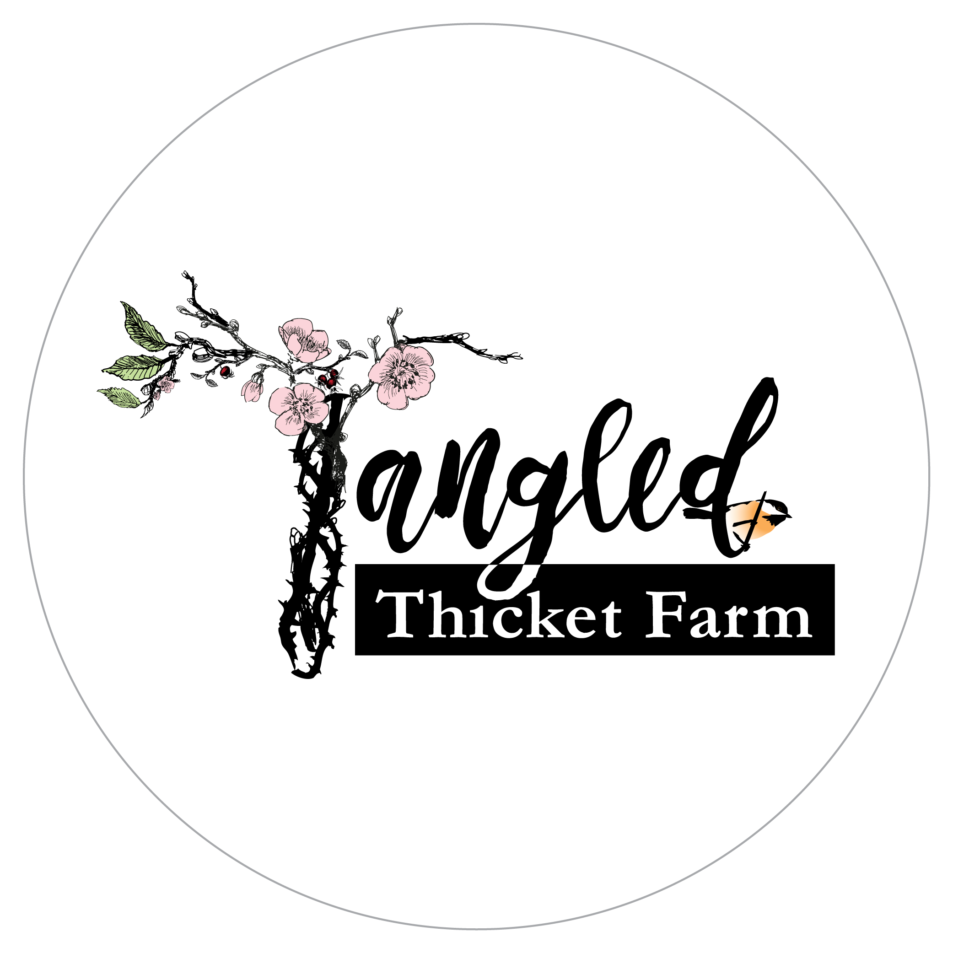
Tangled Thicket Farm
19460 East Hickox Road
Mt. Vernon, WA 98274

2021 CSA Membership Agreement
We, the farm, wish to provide you with fresh, local, seasonal food and you, the member, wish to receive a portion of our harvest. This agreement outlines our shared commitments to that relationship. By purchasing a Farmshare, you agree to the terms and conditions outlined herein. Please retain a copy of this agreement for your records.

Becoming a Member of Tangled Thicket Farm
CSA stands for Community Supported Agriculture, which is basically a subscription for vegetables. Members pay up-front to secure their share. We farmers then use the money to buy seeds and equipment and get food growing. Then, every other week, beginning in mid/late May 2021 to mid October 2021, we deliver fresh, local vegetables to our CSA members.

We keep our CSA farmshares limited, so as to enable us to work one-on-one with you to make sure your drop-off/pick-up location works well for you, and that we get your input and feedback on the fruit and vegetables you would like to see most. Please do not hesitate to contact us with questions or concerns.

Growing Practices
We believe in providing fresh, seasonal, local veggies from our farm to your home. We believe people should have a relationship with their food, one that gives back to both you and the land. We believe in transparent farming practices and being open and honest about all inputs used on our farm, and we welcome pre-arranged visits when appropriate (as safe COVID-19 protocols allow). We do not use synthetic fertilizers or pesticides, and we strive to avoid any seed that has been modified in ways beyond cultivation.

We do use composted and aged animal manures as fertilizers, physical barriers and crop rotations as pest and disease deterrents, and use organically-approved sprays and amendments. Most of the seed we use is certified organic; some is not. This depends on availability, cost and performance. In practice, we prefer to use local organically certified seed as these seeds carry traits that work well in our farming system.

Shared Risk
Members of our farm get the opportunity to share in the abundance of a local Pacific Northwest farm. With that opportunity, there are risks associated with our growing season. We are committed to minimizing those risks; yet risks will always remain. We promise to do our best to provide you with a bountiful share each delivery week. The quantity and type of produce, however, may vary from week-to-week due to weather, insects, or other production factors despite our best efforts.

By joining our CSA, you are agreeing to share the risk of crop failure with us and our other members. We will work to compensate for any failed crops by filling your box with other crops grown on the farm that are ready for harvest at that time. If a large portion of crops fail, we may not be able to deliver any products in some weeks. Should this happen, members will be contacted directly, as soon as possible to discuss options for remediation. However, it is unlikely that we would be able to refund memberships or even partial memberships as the money is used to fund the season’s expenses. Please take this into consideration when joining the CSA.

Shared Reward
When production of our CSA crops are especially abundant, we will pack as much as possible into your share. However, we don’t want to overwhelm our members or deliver so much produce that it goes to waste. Occasionally, we may contact you to see if you'd like to receive a larger quantity of a certain crop to preserve through canning, freezing, or drying. Otherwise, when we feel that members have received enough of certain crops, we handle the surplus by selling it through other avenues or donating to local food banks. If you have any questions about this please feel free to contact us.

Dropping Off / Picking Up
You are responsible for picking up your share from the biweekly pick-up location. This season, we are searching for a new drop off location in Belligham, and will notify you as soon as we have located one.

Pick up at the farm in Mount Vernon is also available and encouraged if you live nearby. There is a discount for picking up on the farm!

You are responsible for observing the pick-up site rules, which are as follows:
- We will set a day and time for pick-up, and let everyone know well in advance of pick-up, as well as adding a reminder text message for those who request one. Please pick up your share within the timeframe stated.
- Be respectful of host and property at the pick-up locations.
- Bring your own bags or boxes to transfer your produce, and flatten/stack the re-usable, sanitizable crates that we are now using.
- We have extended our CSA season, so you can skip one pick-up if you are going on vacation, and we will add you to the last week's pick-up. Please arrange this as far ahead of time as possible.
- If you cannot otherwise pick up your share, you will need to arrange for someone else to pick it up for you. You are responsible for explaining the pick-up procedure to your substitute.
- Shares that are not retrieved within the designated pick-up time will be forfeited for that week.

If unforeseen circumstances arise, please contact Tangled Thicket Farm as soon as possible, as we certainly will try to accommodate emergencies.

Produce presentation
You will be receiving the freshest produce available short of growing it yourself. That being said, shares will come packed unwashed for the most part, which is the safest way to process and share fruit and vegetable produce. Please take the time to properly wash and store all produce each week once received.
Farmshare Options for the 2021 Season
Both share types come in 10 boxes, distributed every other week. We will work to add produce that lasts longer than a week within every box. If we have continued produce at the end of the season, we will offer an optional add-on for those interested.

Farmshare Type | Farmshare Size | Price
Large | Feeds family of 4, or 2 veggie lovers | $375 ($350 for farm pick-up)
Regular | Feeds family of 2, or 1 veggie lover | $250 ($225 for farm pick-up)
Sponsored  Farmshare | Feeds a family of 4+ who could use the extra support; we locate members of the Whatcom or Skagit community, often college students or foster families, and share the cost with you. We can offer up to 5 sponsored farmshares. | $275
w/Eggs | Substitution or addition by arrangement, $7/dozen free-range, local soy-free and GMO-free (mostly organic but not certified) feed.

If you are Paying in Full: payment is due by May 1, 2021. If you are paying Half Now/Half Later: the first payment is due by May 1, and the second payment due by August 1. We will send you a reminder invoice as needed.

Work Exchange
Please let us know if you'd like to get a discounted box in exchange for some farm work. There is work here for every type of body, and we welcome the company!

Payment Methods
Paid up front, your membership fees provide us with money to purchase seed and equipment before the season starts, and we appreciate your commitment.

Checks are preferred and can be mailed to the address above. We will send you a receipt through email when we receive your payment. We also accept Venmo payments (@jskenyon). And we do take credit card payment for an additional fee; please contact us if you would like that option.

Communicating with Us
The best way to communicate with us is via email or phone. You can contact us by email at tangledthicketfarm@gmail.com or by phone/text at 773-729-0385 (Joanna’s cellphone). We will do our best to respond as soon as possible.

We will communicate with you primarily by email, but also text messages for those who are comfortable with that modality. When you sign up, you will be added to our distribution list. Please read your emails from us, and take the survey we send out towards the beginning of the season. We depend on being able to communicate important information such as necessary changes to your distribution schedule or to our farm events. Once a month, we will email a newsletter giving you information about the crops available that week, recipe ideas, or other farm related news. By purchasing a membership share, you agree to the terms and conditions outlined herein. Please retain a copy of this agreement for your records.

