Improving the Effectiveness of Project ZeNETH Through Targeted Curriculum Building

By Alex Mayberry, Becca Pitts, and Emma Nebeker
Primary Sponsor: Kellen Lynch
Institutional Sponsor: Institute for Energy Studies

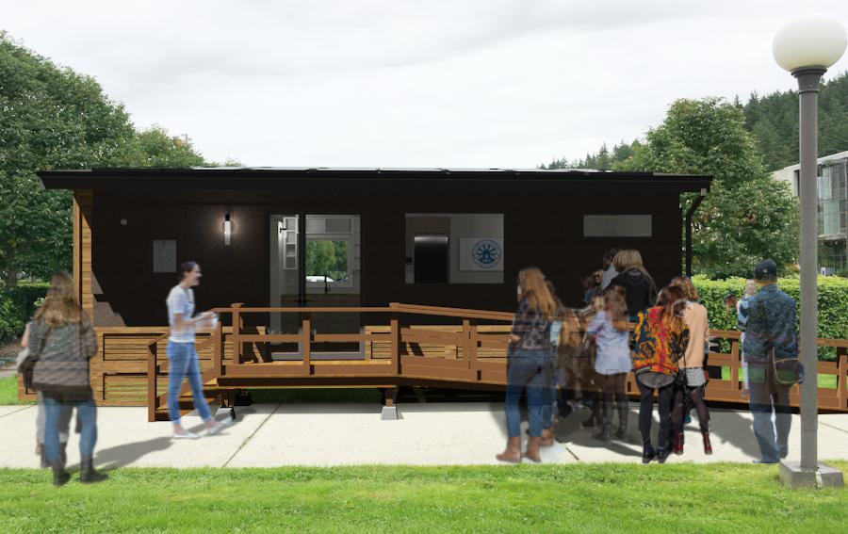

Table of Contents

Title Page 1
Table of Contents 2
Executive Summary 3
Introduction 4
Methodology 6
Results 7
Recommendations 8
Monitoring and Evaluation 9
Budget 10
Conclusion 11
Appendix I 12

Executive Summary

Project ZeNETH is a program through Western Washington University’s Institute for Energy studies that is working to build a net zero and off grid tiny home on WWU’s campus to educate students about net zero energy systems, and global climate change issues.
Though Project ZeNETH has made great strides already, more vital steps need to be taken to reach the project’s goal of using the house to inspire a future sustainable building practice. The over 20 person Project ZeNETH team generated strong momentum while creating the tiny home, but the project so far reaches only to Huxley college. The breadth of Project ZeNETH needs to be extended to other departments and fields of study, but the building alone will not serve to educate students without a corresponding curriculum. Many students learn the most from things when they analyze or synthesize information about it, but many cannot learn from this project since they are not even aware of it. Because of this, the overall problem that our project addresses is creating a curriculum.
Many disciplines converge to create a complex understanding of Project ZeNETH. Urban planning, building sciences, design, renewable energy systems, electrical grid systems, housing economics, and environmental studies are some of the possible perspectives to hold up to tiny homes. Using our lesson plan which lays out a lecture, in person tour prompt, and essay reflection questions, professors and club officers can plug this tiny house module into their existing curriculum without previous knowledge of tiny homes. The lecture illustrates why tiny houses are significant, the tour prompt points out each important example of sustainable design, and the reflection and research essays push students to more deeply consider aspects of the tiny house relevant to the course. A lesson plan for Project ZeNETH brings Project ZeNeth into a classroom setting as a tool for education and inspiration. This will involve exposure to the project through a PowerPoint presentation explaining the project, further comprehension of the project through literature review or individual class projects, and eventually field trips and walkthroughs to cater to kinesthetic learning, after the tiny house is built.
Since the work on this project is not near to done, our recommendations will be vital to the continuation of project ZeNETH on Western Washington University’s campus. It is recommended that a step by step tour prompt be created for giving tours of the project. It is also recommended that a network of professors be created to facilitate interdisciplinary relationships. This group could collaborate and give their students a more cross disciplinary experience.

Introduction
The Project ZeNETH building needs to be used in a meaningful way that educates students about energy efficient building and tiny houses. Project ZeNETH was created to address the community need for a housing system that works for both people and the planet. As the future consumers and community members of the housing market, students need to understand that what they demand will shape their towns.
The project goal is to develop a core lesson plan that introduces: critical lenses such as ecological sustainability, and social equity to examine the current housing paradigm; the concept of an ecological footprint and how tiny living affects it; energy systems and their draw in tiny homes; and the components of a tiny house and energy efficient design illustrated through analysis of the Project ZeNETH.

Background Research

Teaching Green Building Pedagogical Framework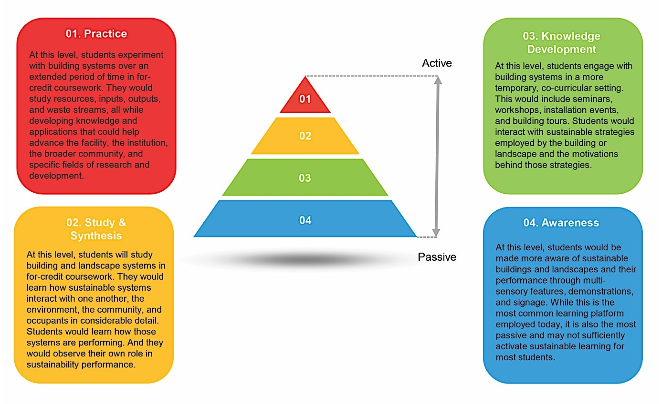
Figure 1.0 (Campbell, 2017)

“Teaching Green Buildings” are buildings specifically designed and used, to teach about sustainability while also being sustainable buildings, usually LEED certified.
This is the framework that was used to create the Project ZeNETH curriculum. While practice is the most effective level of involvement to learn about green buildings, it is also the most difficult to simply plug into a class. The bottom three levels of involvement in Figure 1 guide the curriculum. Knowledge Development, the green section in Figure 1, makes the most sense for how much time professors are likely willing to invest in an additional course module. The lesson plan uses awareness, the blue section in Figure 1, to recommend the creation of interpretive signage in and around the Project ZeNETH building to call out significant details for the public. We used knowledge development to create the lecture about the building to learn context and details of tiny homes. Study & Synthesis, the yellow section in Figure 1, is used to guide the reflection questions that will lead to a deeper understanding of systems affecting sustainable housing.

Tiny House Movement
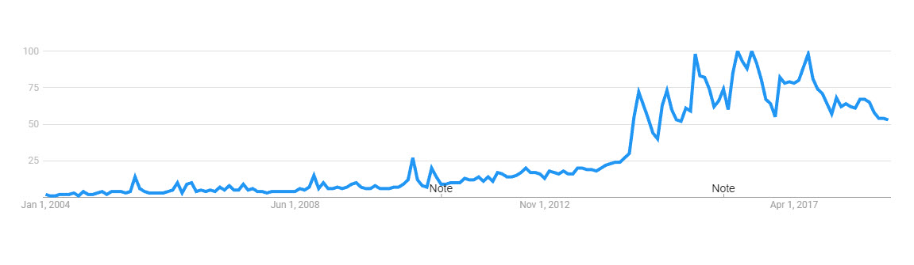
Figure 2.0 (tinyhomebuilders.com)

One of the first tiny homes was built back in 1999 by Jay Shafer. After this, interests grew but it wasn’t until 2014 when the show ‘Tiny House Nation’ first aired on Netflix which exposed more people to the building of tiny homes thus creating a movement. (tinyhomebuilders.com)

University Tiny houses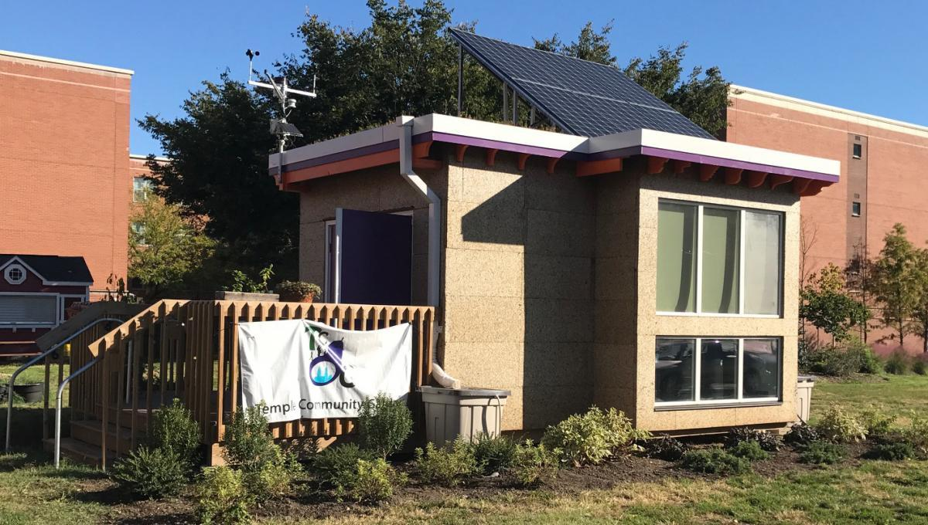

Figure 3.0 Temple University Office of Sustainability (https://sustainability.temple.edu/temple-tiny-house)

The 175 sq ft Temple University net zero tiny house was built in their Community Garden in 2017. The building is a permanent structure that was designed and built by students in for-credit-courses. The Temple Community Garden runs the building and in a brief interview said, “Our Tiny House is mainly used for our community garden club. We start all of our seeds inside before moving them outside. We also run our weekly farm stand where we give away our produce we collected from the garden to the community.” The building is also used as an educational tool for the students and community members who have access to periodic tours. Also, “Some of the sustainability professors will bring their classes by to have a lecture in the garden and talk about all of the sustainable initiatives in the tiny house and in the garden.”
Take away: At Temple professors use the net zero tiny home to teach if it fits into their class, but there is no program to include it.

Methodology

Due to the fact that the tiny home for Project ZeNETH is still in the permitting stages, the research for this project was based on both the goals of the project, and the current state of the project. The research also largely involved looking at other schools incorporating net zero tiny home curriculums, and the systems of tiny homes in general (specifically net zero and off-grid ones). To research this aspect of the project, we looked into net zero energy systems that are specific to tiny homes. This involved reading manuals, blogs, and other project websites that discuss the energy systems that are needed to reduce the consumption in tiny homes. It also involved diving deeper into researching the specific systems that are popular among net-zero and off grid tiny home builders, and what made them energy efficient.

Since our curriculum includes an agglomeration of different topics into one succinct lesson, each team member researched one aspect of Project ZeNETH: Becca, Project ZeNETH building specs; Emma, net zero energy systems; and Alex, tiny houses, teaching green buildings, policy.
The findings were compiled into a lesson plan with the learning objective to understand the implications of housing types on the community and the environment.

Results (Lesson Plan)

Classes
Industrial Design - space efficient design, circular materials
Urban Planning – Accessory Dwelling Units (ADUs), infill, zoning, energy efficient design, Affordable housing
Energy Institute - Energy efficient design, solar/battery system

Learning objectives:
- Develop critical lenses such as ecological sustainability, and social equity to examine the current housing paradigm
- Understand housing is a cultural paradigm that can be changed
- Recognize the ecological effect of large single family housing
- Understand the correlation between larger ecological footprint and a larger house
- Explore personal openness to tiny living
- Learn about tiny house energy systems
- Learn what is a tiny house

In class lecture (20 minutes)
Presentation: https://docs.google.com/presentation/d/1T_37O4dsENq7k-crVXD-RWGsxgbJZP7X3OjktesfPSg/edit?usp=sharing

- Title

- History of Housing in America:
The tiny house movement is an architectural movement that has a history. Since the beginning of time there have been small houses that met a family's needs without over reaching their means. In Bellingham, that looked like a Bungalow, a small compact suburban home.
One controversial figure in small affordable home history has been the mobile home. While it was extremely cheap, it was also cheaply made and didn’t conform to American suburban aesthetics. Also, their occupants were often poor white people and for that reason, across the nation, almost all cities have exclusionary zoning policies against tiny homes requiring them to be in designated mobile home parks. (Evans, 2018)

- Home Size and the Suburbs
The average home square footage has increased from 1,535 sq ft in 1973 to 2,480 in 2011 (Schwartz, 2014). This eventually has led to the McMansion - A derogatory term for an overly ornamented, oversized, over budget suburban home. Tiny homes are said to be a reaction to this high water mark in American materialism.

- Tiny Home Vs. Net Zero Energy Building
Although they fit together seamlessly, tiny homes and net zero energy buildings are quite different. What makes a tiny home a tiny home? You can either have a tiny home that is on a permanent foundation, but the problem that many face here is following local building codes which often dictate minimum square footage of the tiny home. Building a tiny home on a trailer however is not governed by local building codes. Tiny homes on trailers are a much more common building style, as the building is mobile and able to transport.

Although it has its disadvantages, the main one being the strict dimensions. To be able to transport it on the road the maximum dimensions without a special permit is 8 feet 6 inches wide and 13 feet 6 inches tall and 40 feet long. But as many have found out, houses that are longer than 32 feet become very difficult to transport.

There are many reasons for people to go tiny, for some being a craving for a simpler life, others wanting to travel, and others wanting to scale down their footprint. An average sized home can “produce up to 28,000 pounds of greenhouse gas emissions” whereas a tiny home is in the range of 2,000 pounds. Because of the reduced square footage the tiny homes draw about 194 kilowatt hours annually compared to an average sized home using more than 12,000 kilowatt hours. Lastly, if an average sized home were halved, its total life upkeep costs would drop 36% (tinyhomebuilders.com).

Now, what makes a building net zero energy? This is when the amount of renewable energy that the building is producing is equal to the amount it consumes. In addition, if the building consumes more from the electric grid like at night, then when the building is creating an excess of energy, like during a sunny day, it will return the excess energy to the grid.

Now going off grid, which Project ZeNETH has done goes a step further. Going off grid means that the building is not drawing energy from anywhere but what it is creating, all around the clock. Off grid buildings often include more solar panels and batteries that can work to absorb and store more power (energy.gov). (Option video net zero building vs off grid building, about 2 minutes)

- Energy Consumption in Tiny Homes
In tiny homes, like most buildings, the main systems that contribute to energy consumption are heating and cooling, and light and electricity (Tobias, 2019). In order for the tiny home to be net zero, these are the systems that need to be altered to run sustainably. Before we dive into more specific aspects, one of the biggest things that influences energy consumption is the size of the home (Constellation, 2017). A smaller space inevitably means that less energy is used, since there is less space to heat, cool, and illuminate (Constellation, 2017).. In addition, a smaller building requires less energy to build, which increases the sustainable aspects of the home overall.

- Heating and Cooling
One of the energy consuming systems mentioned before was heating and cooling. Before even choosing energy friendly heating and cooling methods, a tiny home in itself consumes less due to the smaller space requiring heating and cooling (Constellation, 2017). But there are additional methods that can be added to further reduce their energy consumption within these systems.

One of the systems that is very often used in net-zero and off grid tiny homes is a heat pump (Tobias, 2019). Despite its name, heat pumps can both heat and cool a home. Unlike traditional heaters that create heat and cool, heat pumps move warmth of coldness from the outside to the inside of the building (Energy.gov). This warming or cooling can come from the air, ground, or water depending on the specific type of heat pump used (Energy.gov). Since heat pumps do not require as much energy bringing heat in as traditional pumps do generating heat or cold air, pumps end up with an energy savings of over 50% in comparison to traditional methods (Tobias, 2019).

Another popular system is the mini-split (Constellation, 2017). A mini-split is a heating and cooling system that is made to regulate temperatures in small rooms. They are very energy efficient, and help reduce consumption because of the small size and low number of ducts, preventing any heat escaping (Fujitsu, n.d.)

- Lighting/Electricity
Another thing that consumes energy in tiny homes is lighting, and electricity systems (Tobias, 2019). Like with heating and cooling, the tiny home itself reduces energy consumption in comparison to regular homes before even adding additional measures. It is a smaller space, which requires less light bulbs to be lit (Tobias, 2019).

One method that many tiny home users choose is LED bulbs. LED stands for light emitting diode. LED bulbs use 75% less energy than standard bulbs, making them way more efficient and long lasting (Energy Star).

Electricity goes along with lighting. Many tiny home owners choose to use solar panels as a net zero or off grid energy source (Constellation, 2017). Solar panels are a renewable energy source, as they get power from the sun. Solar panels are often placed on the roof of tiny homes, and convert sunlight into usable power (Constellation, n.d.) They are very useful and efficient, and also cut down on the use of nonrenewable energy sources (Constellation, n.d.)

- Ecological Footprints:
An individual ecological footprint is the most common method of analysis to understand human impact on the environment. The method calculates in global hectares (gha) how much land is needed to sustain one person’s lifestyle. By analyzing an occupant’s ecological footprint while living in conventional housing compared to their lifestyle in a tiny home researchers have learned what effect tiny houses have on the sustainability of an occupant’s lifestyle. (Saxton, 2019)

- The Ecological Footprint of a Tiny Home
On average, occupants reduced their ecological footprint from 7.0 to 3.9 global hectares after moving to a tiny home. (Saxton, 2019)
Occupants, on average saw a decrease in all 6 criteria, the largest being the ecological footprint of their housing needs, the second and third being transportation and consumption habits. (Saxton, 2019)

- What is Project ZeNETH?:
Project ZeNETH is a 250 square foot net-zero energy off grid tiny home on wheels. This building exemplifies the possibilities that energy efficient tiny homes hold. ZeNETH stands for zero net energy tiny home and has multiple plans of use, including a meeting space for students and faculty, a learning lab where you can interact with and learn from the tiny home, and as a food pantry for students.

- Design:
The interior of Project ZeNETH includes a kitchen equipped with an energy efficient cooktop, electric oven and high performance fridge, a modular dining space, a low waste bathroom, a storage loft and a bed on tracks above the dining space to easily convert into a bedroom area. The building is net zero and off grid due to many working parts that include, a Mitsubishi ductless heat pump, a small cove heater from Heating Green, a Tesla Powerwall 2.0, a 5.1 Kw roof mounted solar Photovoltaic array built by Silfab solar and installed by Western Solar and a Smart micro-inverter set up from Enphase Energy.

- The Tiny House Movement:
The tiny house is a new type of residence like an apartment or single family home. It is the next iteration of the mobile home, trailer, and RV. Within the Tiny House Typology, they can be designed for specific functions, such as suburban infill, transitional homeless housing, affordable housing, high wildfire risk housing, off-grid, and sharing economy rentals such as Airbnb.

Tiny House Walk-thru (20 minutes)
The professor or a designer from A1 Design Build will lead the students on a tour of the building pointing out all the specific features and design decisions. This includes mentioning all the features that were discussed in the PowerPoint such as energy consuming systems and design methods, and anything else that is relevant to each class (e.g. pointing out interior layout choices to design students).

Essay Reflection Questions
Along with the lecture and eventual field trip/tour, students will be asked to complete a short paper based on their new knowledge from Project ZeNETH’s tiny home. Below are prompts for these papers, specific to different educational disciplines, but professors may also choose to customize these prompts based on the individual course content of each of their classes.

Example essay prompts include:

Marketing: Would education about tiny homes change a consumer’s future housing decisions?
Economics: What are the dynamics of supply and demand in regard to a certain type of housing?
Urban Planning: When have markets shaped an urban area and how do these case studies inform the potential impact of a mass movement of housing consumers seeking to downsize?
Urban planning: How could tiny homes be built in suburban single family zones?
Social Services: What is the impact of an increased housing stock on homelessness? Could more tiny homes in the community help lower homelessness?
Economics: As the owner of a large company that is expanding its campus and wants to incorporate a more sustainable business model, research the benefits and downfalls of both off grid buildings and net zero energy buildings and decide which would be the most environmentally and economically effective.

Recommendations
Our project speaks to the sustainability project at WWU because it is working to encourage students to be involved in sustainability by starting a personal discussion with them.

Our recommendations take the larger picture into account because they are working towards the future progression of Project ZeNETH, and the larger goals of the project. Social and environmental systems are at play. Social because our project requires community involvement and action, and environmental because the whole project revolves around sustainability for the future of the environment.

The lesson plan does not require the tiny home to be built, so it could be implemented as soon as next quarter. But with our recommendation to restructure the curriculum once the home is built, that new curriculum would include a walkthrough tour of the tiny home, and would not be able to be implemented until the home is actually built and on campus. That being said, our recommendations are as follows.

- Alter the curriculum to include a walk-through of the tiny home, or a field trip to it once the tiny home is actually built. This will add a hands on aspect to the curriculum, that we believe will be very influential to how students absorb the content.
- Create interpretive signage for the public to learn about Project ZeNETH with labels and diagrams of important systems.
- For our project sponsor, we recommend observing the progress of the tiny home and being prepared to alter the curriculum. These changes to the curriculum will need to come hand in hand with the tiny home being on campus, so it will be imperative to be aware of these changes and ready to advance the alterations to the curriculum.
- We recommend someone be in charge of promoting our work. As we can see in the past, this topic does not get enough attention. In order for this project to continue to progress, someone needs to continue to advocate for and increase expansion of our curriculum. If it does not get continual work after this quarter, it will likely not get the attention that it deserves.
- Contact professors to create an interdisciplinary network of professors who are interested in collaborating using the Project ZeNETH as a model to explore affordable housing and energy efficient design.
  - Courses: ENVS 360, ENRG 101, ENRG 360
  - AS clubs: Energy Union, Environmental Student Union, Net Impact, Students for Renewable Energy, Western Urban Planners

Monitoring and Evaluation

Since our project will not be implemented until further quarters, we will not be the ones performing monitoring and evaluation. How to monitor and evaluate the success of the effectiveness of Project ZeNETH will be determined by the next set of people working on the project, and the project sponsors.

For those who will be monitoring it, the success of this curriculum development project will be measured by the amount of teachers who use our lesson plan. The lesson plan when used means that more students will be exposed to net zero tiny homes and how they work, which will indicate the success of our project. Keeping track of how many professors, classes and total number of students can serve as measurements for success.

In the future, sponsors may also want to track the amount of students using the tiny
home outside of the courses using the lesson plan, or the amount of students that live in tiny homes or net zero homes to measure the extended success of the project as a whole.

Budget

The following budget will be for future use, once the tiny home is built and on campus. Since the building is not yet built, the curriculum does not involve any monetary aspects, being that it will be incorporated into already existing classes. However, a budget will be necessary once the tiny home is built in order to pay for a tour guide for the field trips, and pamphlets to be placed inside the home for interested students. Based on this, the following table is an estimate of what the budget will eventually include after the home is built and ready for people to be inside of it.

 | price | quantity | cost
A-1 Design Build Tour Guide | $100 | 1 | $100
Project ZeNETH Building Systems Spec. Pamphlets | $0.03 | 100 | $3
 |  | TOTAL | $103

Conclusion

There are problems with the American housing system such as suburban sprawl, housing shortages, energy inefficient building techniques, and the use of fossil fuel based energy. Tiny homes can address all of these problems. Project ZeNETH was designed to solve all of these problems rather than just house someone which is a big difference from the status quo. This idea needs to be spread throughout the student body as they are not just students, but future homeowners. A lesson plan that gives context for tiny homes and energy efficient design coupled with experiencing a physical example has the power to alter our understanding of housing. The future acceptance and implementation of the lesson plan by professors seem to be the largest main points to consider moving forward. To address this, a lesson plan and a list of suggested courses that will benefit from an additional Project ZeNETH module are provided. While these ideas need to reach all students, in order for them to be accepted by professors, classes in more directly related fields such as urban planning, energy systems, and industrial design classes provide the most direct educational beginning.

Appendix

Bibliography

Campbell, D. P. (2017, August 18). Sustainable Learning: Turning high-performing Facilities into Buildings That Teach. Retrieved June 7, 2020, from https://www.asumag.com/green/sustainability-initiatives/article/20855772/sustainable-learning

“Energy Secrets of the Tiny House Movement.” Constellation Residential and Small Business Blog, 21 Aug. 2017, blog.constellation.com/2017/08/21/what-is-tiny-house-living/.

“Heat Pump Systems.” Energy.gov, www.energy.gov/energysaver/heat-and-cool/heat-pump-systems.

Evans, Krista. (2018). Integrating tiny and small homes into the urban landscape: History, land use barriers and potential solutions. Journal of Geography and Regional Planning. 11. 34-45. 10.5897/JGRP2017.0679.

“Learn About LED Lighting.” Learn About LED Lights | ENERGY STAR, www.energystar.gov/products/lighting_fans/light_bulbs/learn_about_led_bulbs.

Saxton, M. W. (2019) The Ecological Footprints of Tiny Home Downsizers: An Exploratory Study [unpublished doctoral dissertation]. Virginia Polytechnic Institute and State University.

Schwartz A (2014). Housing Policy in the United States. New York:
Routledge.

“Solar Energy Solutions.” Constellation, www.constellation.com/solutions/for-your-home/home-energy-options/solar.html.

Tiny Home Builders. (n.d.). Tiny House Movement. https://www.tinyhomebuilders.com/help/tiny-house-movement

Tobias, Michael. “Design Guidelines for a Net Zero Tiny House.” TinyHouseDesign, 19 Mar. 2019, tinyhousedesign.com/design-guidelines-for-a-net-zero-tiny-house/.
“What Is a Mini-Split? - FUJITSU GENERAL United States & Canada.” FUJITSU GENERAL America, Inc., www.fujitsugeneral.com/us/residential/what-is-a-mini-split.html

Zero Energy Buildings. (n.d.). Retrieved from https://www.energy.gov/eere/buildings/zero-energy-buildings

