Blueprint for Sustainability: A Framework for Facilitating Community Cooperation and Engagement in Response to Climate Change Focused Projects

Authors:
Dani Iwami, Jacob Hills, Anna Sievers

Stakeholder:
Lindsey McDonald

May 14, 2020

Table of Contents

Executive Summary --------------------------------------- 2
Introduction ------------------------------------------------- 2
Methodology ------------------------------------------------ 3
Results ------------------------------------------------------- 5
Recommendations ------------------------------------------ 5
Monitoring and Evaluation -------------------------------- 6
Budget -------------------------------------------------------- 6
Conclusion --------------------------------------------------- 6

Executive Summary
Every community is faced with the challenge of how they will combat climate change. They will require a unique set of approaches specific to the assets they have within their community. The Blueprint for Sustainability intends to address some of the issues that come with implementing climate change projects. These issues include but are not limited to predisposed language, community involvement, and proper assessment after the project is implemented.
In some communities, terms such as “climate change” or “global warming” have implicit meanings that can deter residents from supporting sustainability projects in their community. These terms are highly politicized while reinforcing the divide between political groups. The Blueprint for Sustainability suggests diction that accommodates everyone. Community projects need to empower community members in order to retain the longevity of the sustainability project (Mathie & Cunningham, 2003). It is necessary to construct a shared meaning for the project through the practice of appreciative inquiry (Mathie & Cunningham, 2003). Appreciative inquiry is “a process that promotes positive change by focusing on peak experiences and successes of the past” (Mathie & Cunningham, 2003). If residents feel as if the project was done to them versus for them, then residents will lack intrinsic value towards changes in their urban environment. The project’s impact on the community and climate emissions is difficult to quantify yet a necessary challenge to face. Oftentimes there will be some sort of a delay effect between the project and change within the community. Maintaining clear communication between the partnering groups will be imperative for the proper assessment of the sustainability project.
An analysis of city-university partnerships around the country shed light onto what actions other partnerships were taking to implement their climate change projects, as well as what made these projects successful. The research consisted of cities similar in size and environment to the Whatcom/Skagit County region of Washington. Resources include city comprehensive plans, climate action plans, local news articles, and peer reviewed studies on Asset-Based community development strategies. The data found serves as the foundation for the deliverables we are providing.
The Blueprint for Sustainability will include two deliverables. The first is a flow chart modeling the critical steps communities could take to be successful. This framework will offer suggestions focused on sustainability, inclusiveness, and empowerment of community members. Research illuminated how important yet difficult it is to quantify the effects of a project, since proper assessment is specific to the project at hand. However, despite the individuality of each potential project, effects of the project are focused on the triple bottom line: social, environmental, and financial. Metrics such as CO2 emissions saved, vehicle miles traveled, rate of erosion, etc. play an important role in quantifying success, but success is not solely based on environmental stewardship. The second deliverable will be a survey given to community members in order to collect their insight. It is important that residents are knowledgeable about the changes in their community in order to protect the longevity of the project itself.
Each project will have its own unique set of challenges. Recommendations by the Blueprint for Sustainability can act as a framework for how to approach or mitigate common and critical challenges in the implementation process. The Blueprint for Sustainability recommends Asset-Based community development strategies as part of the implementation process. In order to be as inclusive as possible, community leaders need to be at every delegation meeting. Community members can often self-organize and drive the development process themselves, tapping into “unrecognized assets.” Local government has the responsibility of re-politicizing the concept of participation (Mathie & Cunningham, 2003). The Blueprint for Sustainability recommends an overarching focus on a professional shift from thinking about people as “objects to fix” to “assets to tap”.

Introduction
Statement of Need
As climate change advances, communities face new and unique challenges regarding how to live sustainably. This project is an important aid in helping Whatcom/Skagit County communities adjust to the new reality of climate change by addressing areas of sustainability that need improvement. This will ensure the overall health and future of the community and the environment.
Project Goals
This project will create a framework for climate change focused community projects that the Sustainable Communities Partnership (SCP) can apply to various partnered communities in and around Whatcom/Skagit County. This framework will emphasize community involvement and decision-making alongside the SCP. Actions will be taken based on expressed needs regarding a predetermined climate change theme or themes. This framework will also be sensitive to the inflammatory nature that terms like ‘climate change’ hold in certain communities and will make sure to use discourse that’s viewed more positively, such as ‘land use’ and ‘improvements’. Ideally, this framework will be used to facilitate cooperative and successful measures to address selected climate change themes in various communities. The deliverables of this project include a sample survey, a detailed flowchart detailing steps the SCP can take when collaborating with a community, and a sample guide to quantifying results.
Background Research
We have conducted background research into several case studies that could be used to inform the SCP’s objective. The communities in these case studies have been successful in their own climate change mitigation efforts, and the SCP may be able to implement similar tactics when working with communities of Whatcom/Skagit County on climate change focused projects.
Case Study 1:
The city of Shoreline, WA has been a leader for climate action in the Seattle area. Their detailed climate plan seeks to reduce greenhouse gas (GHG) emissions and outlines four sectors of climate action that address this: energy and water; materials and waste; transportation, land use and mobility; and urban trees, parks and open spaces. Within each of these four sections, the plan expands upon what has been done, what targets are still left to be met, and what the community can do to help. Within the energy and water sector, Shoreline has implemented LEED Gold buildings which help to lower energy and water usage. Additionally, Shoreline has replaced 56% of its conventional streetlights with LED streetlights to conserve energy. In the material waste sector, Shoreline has increased the number of solar power waste compactors around the city. For transportation, land use and mobility, Shoreline has focused on making bicycle and pedestrian transportation more efficient and accessible, as well as access to public transportation. Finally, in terms of urban trees, parks, and open spaces, Shoreline as prioritized the protection of trees and the restoration of wildlife habitats in parks. All these initiatives are ways that local Whatcom/ Skagit County communities could begin to improve sustainability.
Case Study 2:
In Long Beach, CA, the Office of Sustainability is working on several different projects to get residents more aware of climate change. These projects consist of an EV Charger Giveaway, workshops for sustainable gardening, compost pilot programs, green business recognition programs, urban agriculture incentive zone program, and so many more. These are just a few of the projects they have created to get residents and local businesses more involved to fight global warming. Every year, they publish an Annual Work Plan that details their actions in order to identify projects and programs that will be prioritized for the coming year. This is a good example because it is from a city that is a leader in sustainability. Long Beach is home to a diverse group of people. It is important to realize that sustainability projects encompass people from every walk of life. As a college environment, Western Washington University supports a great deal of diversity, and therefore it is imperative the university applies information that is applicable and available. Examples include the Urban Agriculture Incentive Zone (UAIZ) Program, which offers tax incentives for a five-year contract to property owners to use their vacant lots as a place to grow food. It supports local farmers and creates produce grown locally by residential enthusiasts. It also builds a sense of community where residents can practice a common trade. Bellingham, WA is much less dense than Long Beach, CA, and thus the average lot size, climate, and culture make it attractive to begin a UAIZ Program in connection to the Office of Sustainability.

Methodology
Data will be collected in two ways. First, by studying different approaches communities have taken to successfully implement climate change projects into their cities. This includes non-profit organizations, public private partnerships, local governments, and university partnerships. Studying methods that have already been implemented will provide different insights as to what could be the best approach for the Whatcom/Skagit County region. This project is intended to be a tool for community and sustainability leaders in the region, so it is necessary to use credible data from trustworthy sources. This project will provide strong and concise recommendations for both small and medium sized cities in the Whatcom/Skagit region. The second form of data collection will be through community surveys. This tool will provide more personalized information, tailored to the needs of the specific community at hand. In combination with the first method of data collection which provides more overarching information, the specificity and directness of the second method will provide a well-rounded base of knowledge for the partnership to work with.

Results
Deliverable 1 - Flowchart
Figure 1 – Flow chart depicting the basic steps to university and
community partnership (information modified from Liebert, 2017)
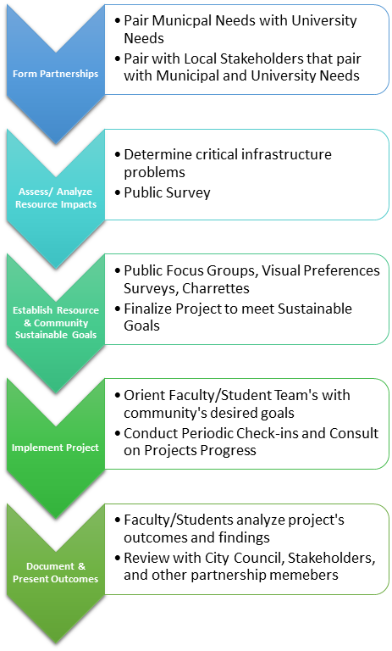

Shoreline Restoration Example:
A joint project between Western Washington University (WWU) and the City of Bainbridge Island to monitoring their shoreline ecological protection system was performed in 2019. Detailing this project into the flowchart exemplifies how the flow chart can fit in any cooperation project.
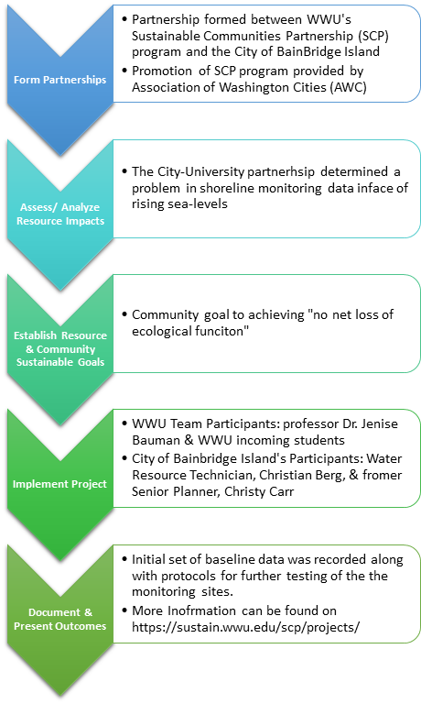

Deliverable 2 – Survey
Below is a detailed breakdown of an example survey that can be tailored accordingly based on the community at hand.
Who?
The survey will target all relevant community leaders and at least 75% of the community itself. The exact number of people surveyed will depend on the size of the community at hand, given that the model accounts for small towns anywhere from <5,000 residents, to medium towns between 5000 and 100,000 residents.
Why?
Distributing the survey to community leaders provides the perspective of those with a broader understanding of community needs. Distributing to community members would provide the perspective of those who could bring insight that big-picture leaders may overlook.
How?
The survey will be distributed in two formats to anyone 18 years of age or older. The survey will be distributed by email account to for those who may not have convenient access to mail service or ballot boxes. It will also be distributed by mail to account for those without access to a computer.
When?
The date of distribution and collection of the survey would be at the discretion of the SCP.
What?
Polarizing language and terms such as ‘climate change’ and ‘sustainability’ will be avoided. Instead, the survey will attempt to utilize language more familiar and welcomed by the community at hand. That exact language will vary depending on the community and their values, so the following are merely examples of possible survey questions that can be adjusted accordingly:
· What do you think are the most pressing issues that need to be addressed in your community? What do you think would be the best way to address these issues?
· In what areas do you think your community is most successful?
· How important are better hunting grounds/wildlife habitat to your community?
· How important are more parks/green spaces to your community?
· Do you think your community should increase its alternative transportation systems (more bike lanes, sidewalks, pedestrian trails, etc.) to your community?
· Do you think your community should improve on its recycling/trash collection?

Recommendations
It is crucial that measures be taken to ensure the cooperation of the public, and not simply relying on the City Council and/or stakeholders involved in partnership. By involving the mass public throughout the planning and implementation process of the project, the public will be invested in the success and longevity of the project.
This also means that phrasing is an important part of how the goal of the project is communicated. Terms such as “climate change” or “carbon emissions” can alienate large portions of the community. Science can be a great way to analyze the problem but does not help to persuade policy decisions amongst a large spectrum of ideologies. Stecula, Dominik A. & Merkley, Eric describe three framing problems to keep in mind: economic costs, conservative ideology, and uncertainty in climate change risk (https://www.frontiersin.org/articles/10.3389/fcomm.2019.00006/full).
Asset-Based Community Development (ABCD) Strategies can be used as an approach for community mobilization. It functions on the basis that community members can recognize hidden or informal assets within their group which maximizes the system in place. It is more likely to inspire “positive actions for change in a community than is an exclusive focus on needs and problems” (Mathie & Cunningham, 2003). Mathie and Cunningham formed some examples of what these methods could typically include
- Collecting stories of community successes and analyzing the reasons for success
- Mapping community assets
- Forming a core steering group
- Building relationships among local assets for mutually beneficial problem solving within the community
- Convening a representative planning group
- Leveraging activities, resources, and investments from outside the community
ABCD strategies work seamlessly for sustainable community partnerships because they are concerned with community mobilization rather than institutional reform. These strategies promote a policy environment conducive to the needs of the community.
Recommended sources to identify potential stakeholders and municipal organizations that have cooperated in climate change projects in the past.
- http://mrsc.org/Home.aspx
- https://www.planning.org/policy/guides/adopted/climatechange.htm
- http://www.transformgov.org/articles/local-sustainability-and-climate-policy-more-talk-action
- https://sustain.wwu.edu/scp/projects/
- https://www.seattle.gov/Documents/Departments/OSE/Accelerator/TUA_Detail_Overview.pdf
Timeline is too variable to be implemented without any results. It is safe to say that the timeline can be a few months to a year based on the type of project.

Monitoring and Evaluation
Success of this project can be tracked in two ways. First, on how closely the SCP and the partnered community follows the steps provided in the flowchart. If the community can smoothly follow each step as proposed by this project without significant challenges or setbacks, this project can be considered successful. If challenges or setbacks arise, the flowchart will need to be edited for successful future use. Second, success can be measured based on how relevant and useful the information gathered by the survey is to the SCP. If the information collected provides valuable insight into the wants and needs of community members in a way that can direct the project, this project can be considered successful. If the information collected is irrelevant or missing key elements needed to make an educated decision regarding the direction of the project, then the questions, targets, or other aspects of the survey need to be revised for future use.

Budget
A possible budget for this project should include account for potential work study student labor that would be a part of implementing the flowchart in community partnerships. Work study students would receive the minimum wage in Bellingham, WA, which is $13.50 per hour. Therefore, the expected number of work hours should be calculated prior to hiring to ensure that the budget has enough funds to cover the payment of a work study student. The budget should also include funds for payment for a graphic designer who could finalize the artistic form of the flowchart. A professional graphic designer would cost anywhere between $20 to $100 per hour depending on their credentials, reputation, and experience. Alternatively, a work study student with experience in graphic design could be hired from within the university both to reduce cost and increase student involvement. Finally, the budget should include funds for the creation and distribution of hard copy mail-in surveys to community leaders, the cost of which would vary depending on the size of the community at hand.

Conclusion

Climate change projects do not only benefit the environment. Each entity discussed can benefit from unique changes in their urban environment. Universities, stakeholders, and community members play a critical role in the implementation process. During each step of the process, delegates must be conscious of predisposed language, community involvement, and proper assessment after the project is implemented. By following the flowchart paired with Asset-Based Community Development strategies, leaders in the planning process will have a clear outline of how to tackle the environmental, economical, and social challenges climate change presents. One of the major benefits of local government working directly with community leaders is the attention to social assets. Community members can fuel local associations and informal networks given the authority to do so. Climate change is a huge multi-faceted problem that affects each community differently. Residents are knowledgeable in ways that outsiders may not be able to grasp due to their unfamiliarity with informal networks within the community. With a problem as big as climate change, it is necessary to maximize every asset a community has within the project’s implementation process.
The work does not just end once it is implemented. Proper assessment of the project must be taken into consideration through surveys to see how the community has benefitted or if there are changes that need to be made. The information gathered will provide valuable insight on just how successful the project was. If communities follow the flow chart and find the project unsatisfactory, the flow chart can be tweaked for future use.
Tackling climate change will not be a linear path. There will be challenges in every sector that are induced by political ties, family values, economic factors, and more. The Blueprint for Sustainability intends to serve as a clear and concise framework for communities to use towards the inevitable problem of climate change. By using the flowchart and information discussed, any community can maximize their assets to ensure a successful implementation process.

References
Liebert, M. A. (2017). AASHE Campus Sustainability Hub. Retrieved June 10, 2020, from https://hub.aashe.org/browse/publication/18765/Connecting-Cities-and-Campuses-through-Climate-Leadership-Initiatives
Mathie A. & Cunningham G. (2003). From clients to citizens: Asset Based Community Development as a strategy for community-driven development, Development in Practice, 13:5, 474-486, DOI: 10.1080/0961452032000125857
Long Beach Office of Sustainability, (2010). Sustainable City Action Plan.
Cascadia Consulting Group. (2013). Shoreline Climate Action Plan.
http://www.shorelinewa.gov/home/showdocument?id=14091

